
PROJECT
Submitted To:-
Mr. Ankit Verma
Submitted By:-
Name – Ajay Chauhan
Section – BCADS21
Roll Number – 1240258047

SCHOOL OF COMPUTER APPLICATIONS

NO SQL and DBaas 101 (NO SQL)
(BCADSN13202)
PROJECT

1. Complex Filters & Projections

Q1: - List the names and departments of students who have more than 85% attendance and are s
skilled in both "MongoDB" and "Python".

Query: -

db.students_full.find(
{ attendance: { $gt: 85 }, skills: { $in: ["MongoDB", "Python"] }})

Output: -

- Nothing will show up because there aren’t any students who have both ‘MongoDB’ and ‘Python’ skills and more than 85% attendance.

- Use comparison operators like $gt (greater than).

- Apply array matching with $all to ensure multiple elements exist.

- Use projection to show only required fields.

- Build compound filters using multiple conditions.

Q2: - Show all faculty who are teaching more than 2 courses. Display their names and the total
number of courses they teach.

Query: -

db.faculty_full.aggregate(
[{ $project: { name: 1, totalCourses: { $size: "$courses" }}},
{ $match: { totalCourses: { $gt: 2 }}}])

Output: -

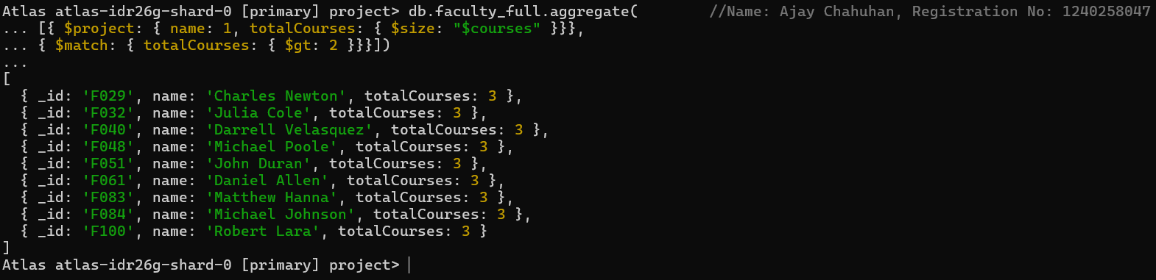

- Use $project to create computed fields.

- Use $size to count array elements.

- Combine $match after projection for conditional filtering.

- Understand aggregation pipelines.

2. Joins ($lookup) and Aggregations

Q3: - Write a query to show each student’s name along with the course titles they are enrolled in
(use $lookup between enrollments, students, and courses).

Query: -

db.enrollments_full.aggregate(
[{ $lookup: { from: "students_full", localField: "student_id", foreignField: "_id",
as: "student_info" }},
{ $unwind: "$student_info" }, { $lookup: { from: "courses_full", localField: "course_id",
foreignField: "_id", as: "course_info" }},
{ $unwind: "$course_info" }, { $project: { _id: 0, student_name: "$student_info.name",
course_title: "$course_info.title" }}])

Output:-

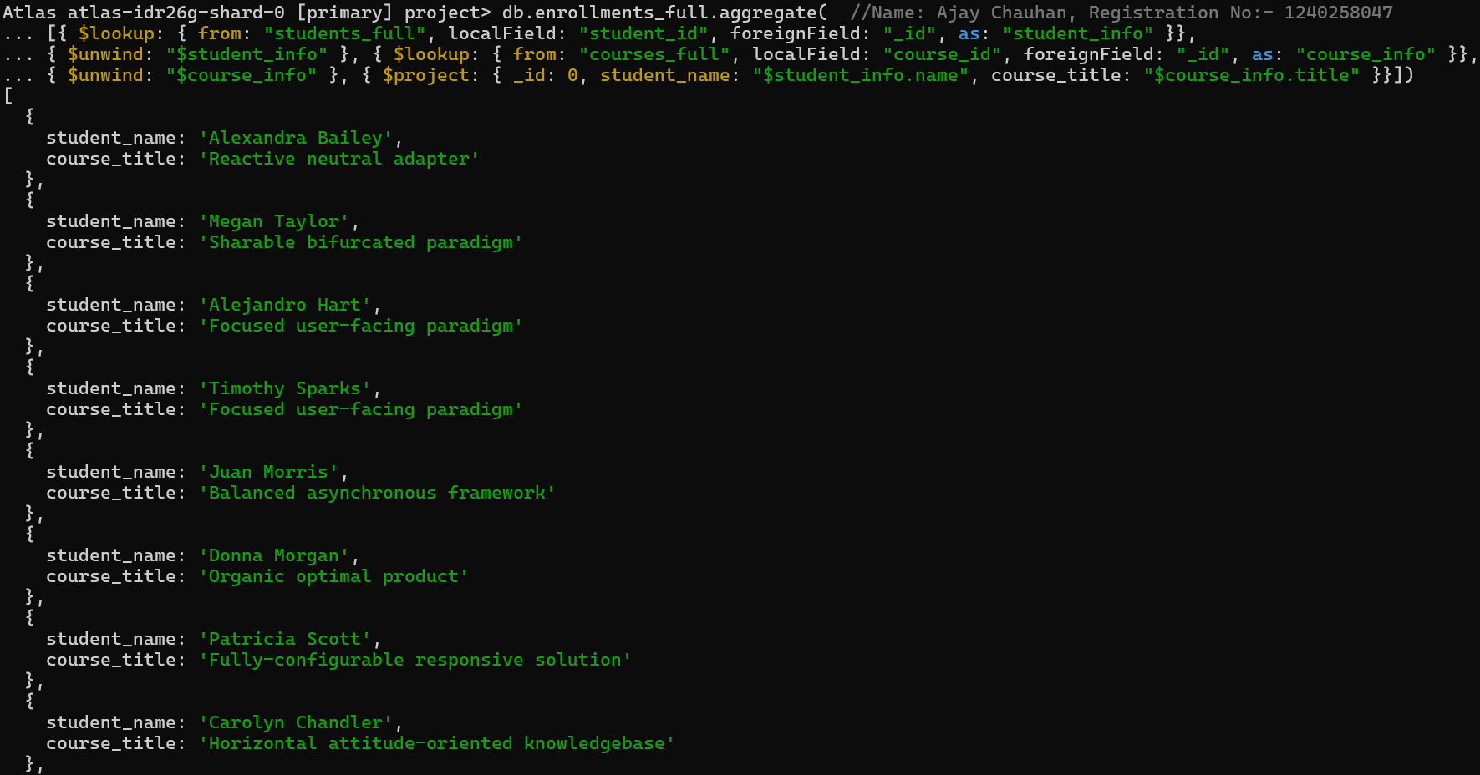

- Use $lookup for joins between collections.

- Combine multiple $lookups for complex relationships.

- Use $arrayElemAt to extract single values from arrays.

- Understand MongoDB’s relational-like linking.

Q4: - For each course, display the course title, number of students enrolled, and average marks
(use $group).

Query: -

db.enrollments_full.aggregate(
[{ $group: { _id: "$course_id", total_students: { $sum: 1 }, avg_marks: { $avg: "$marks" }}},
{ $lookup: { from: "courses_full", localField: "_id", foreignField: "_id", as: "course_info" }},
{ $unwind: "$course_info" },
{ $project: { _id: 0, course_title: "$course_info.title", total_students: 1, avg_marks: { $round:
["$avg_marks", 2] }}}])

Output:-

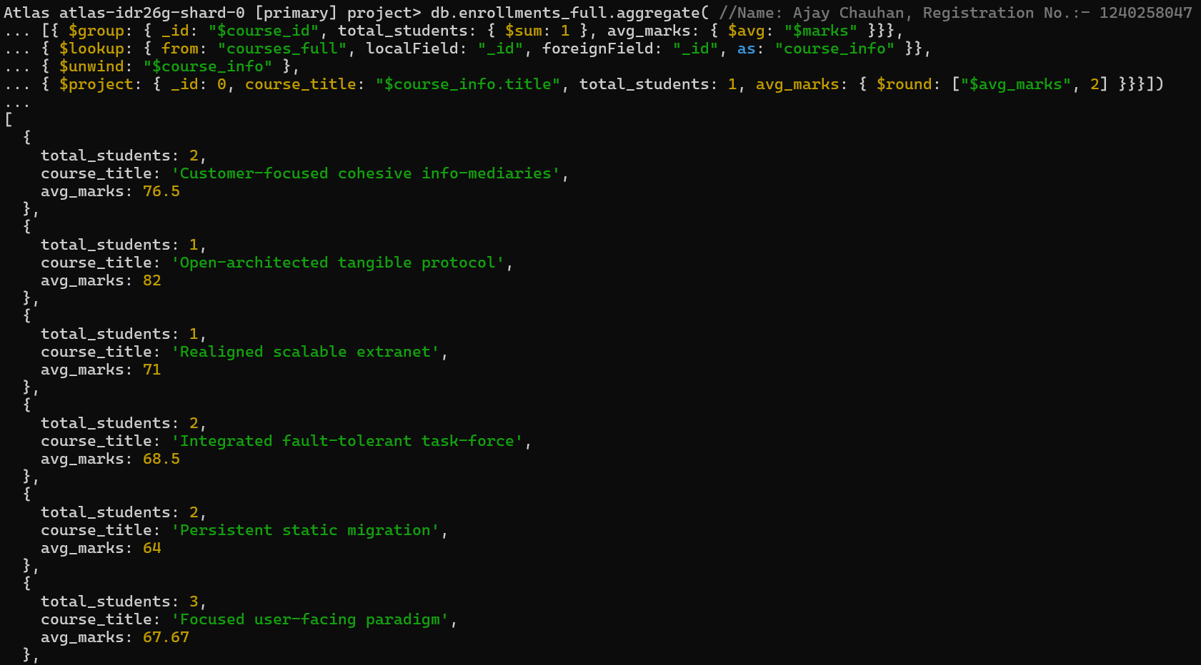

- Use $group for summarizing data.

- Use $avg and $sum to calculate aggregates.

- $unwind helps to deconstruct arrays.

- $project to rename and structure output.

3. Grouping, Sorting, and Limiting

Q5: - Find the top 3 students with the highest average marks across all enrolled courses.

Query: -

db.enrollments_full.aggregate(
[{ $group: { _id: "$student_id", avg_marks: { $avg: "$marks" } } },
{ $sort: { avg_marks: -1 } },
{ $limit: 3 },
{ $lookup: { from: "students_full", localField: "_id", foreignField: "_id", as: "student_info" }},
{ $unwind: "$student_info" },
{ $project: { _id: 0, student_name: "$student_info.name", avg_marks: { $round: ["$avg_marks", 2]
}}}])

Output:-

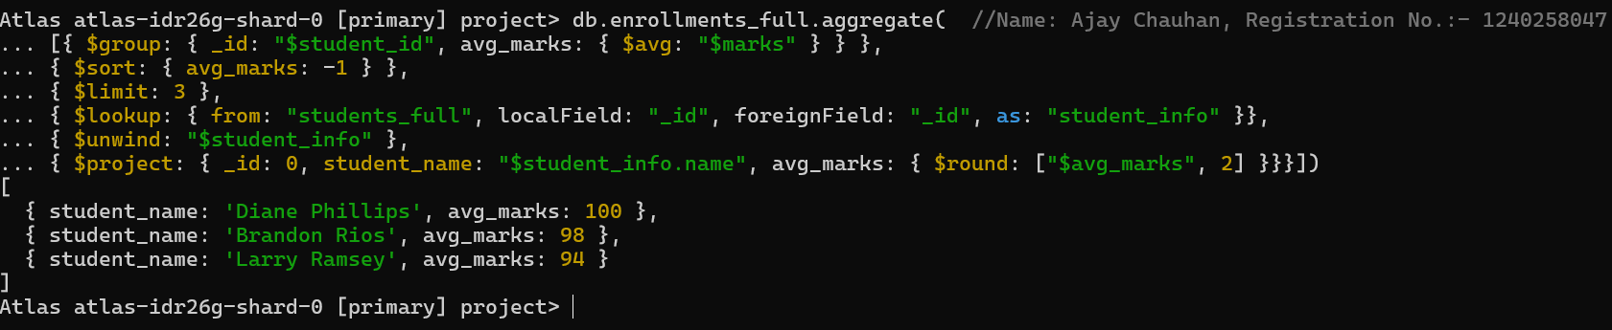

- $sort sorts data in ascending/descending order.

- $limit restricts results to top records.

- $group for calculating averages.

- Combining joins with grouping.

Q6: - Count how many students are in each department. Display the department with the highest
number of students.

Query: -

db.students_full.aggregate(
[{ $group: { _id: "$department", totalStudents: { $sum: 1 }}},
{ $sort: { totalStudents: -1 }},
{ $limit: 1 },
{ $project: { _id: 0, department: "$_id", totalStudents: 1 }}])

Output:-

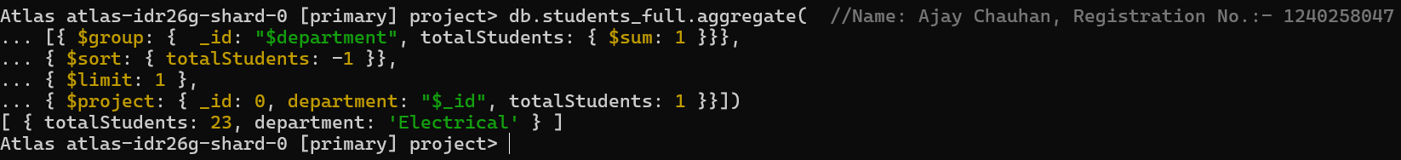

- Count items per category with $sum: 1.

- Use $sort to rank results.

- Identify top-performing or most populated groups.

- Apply $limit to get top results.

4. Update, Upsert, and Delete

Q7: - Update attendance to 100% for all students who won any "Hackathon".

Query: -

db.students_full.updateMany(
{ activities: "Hackathon" },
{ $set: { attendance: 100 }})

Output:-

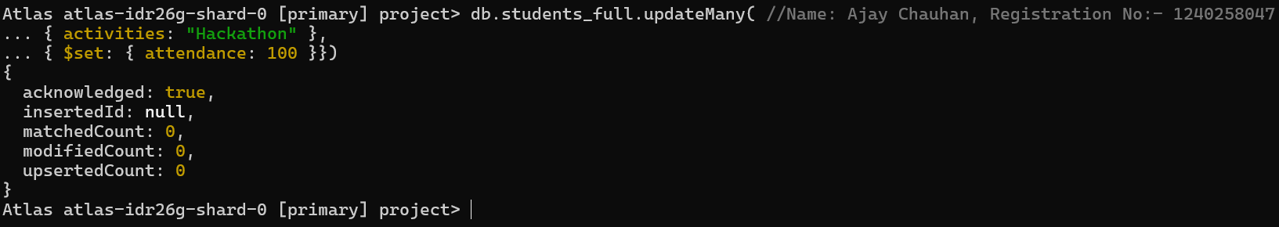

- Use updateMany() for bulk updates.

- $set modifies specific fields.

- Target documents via nested fields.

- Understand bulk updates with filters.

Q8: - Delete all student activity records where the activity year is before 2022.

Query: -

db.activities_full.deleteMany(
{ year: { $lt: 2022 }})

Output:-

- Delete records conditionally using deleteMany().

- $lt filters by less than a value.

- Manage dataset cleanup.

- Apply conditional data management.

Q9: - Upsert a course record for "Data Structures" with ID "C150" and credits 4—if it doesn’t
exist, insert it; otherwise update its title to "Advanced Data Structures".

Query: -

db.courses_full.updateOne(
{ _id: "C150" },
[{ $set: { title: { $cond: [{ $eq: [“$title”, null] }, “Data Structure”, “Advanced Data Structures"]},
credits: { $ifNull: [“$credits”: 4]}}}],
{ upsert: true })

Output:-

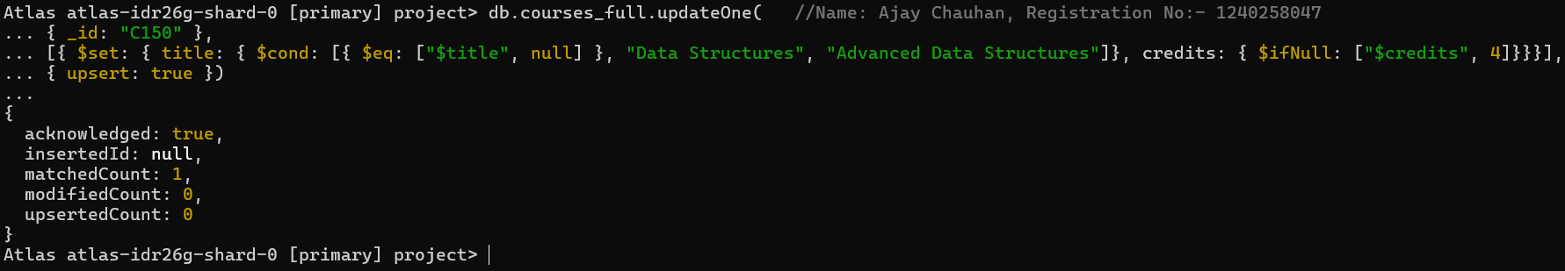

- upsert: true inserts if no match is found.

- $setOnInsert applies only when inserting new data.

- $set updates fields if record exists.

- Handle both insert and update in one command.

5. Array & Operator Usage

Q10: - Find all students who have "Python" as a skill but not "C++".
Query: -

db.students_full.find(
{ $and: [{ skills: "Python" }, { skills: { $ne: "C++" }}]})

Output:-

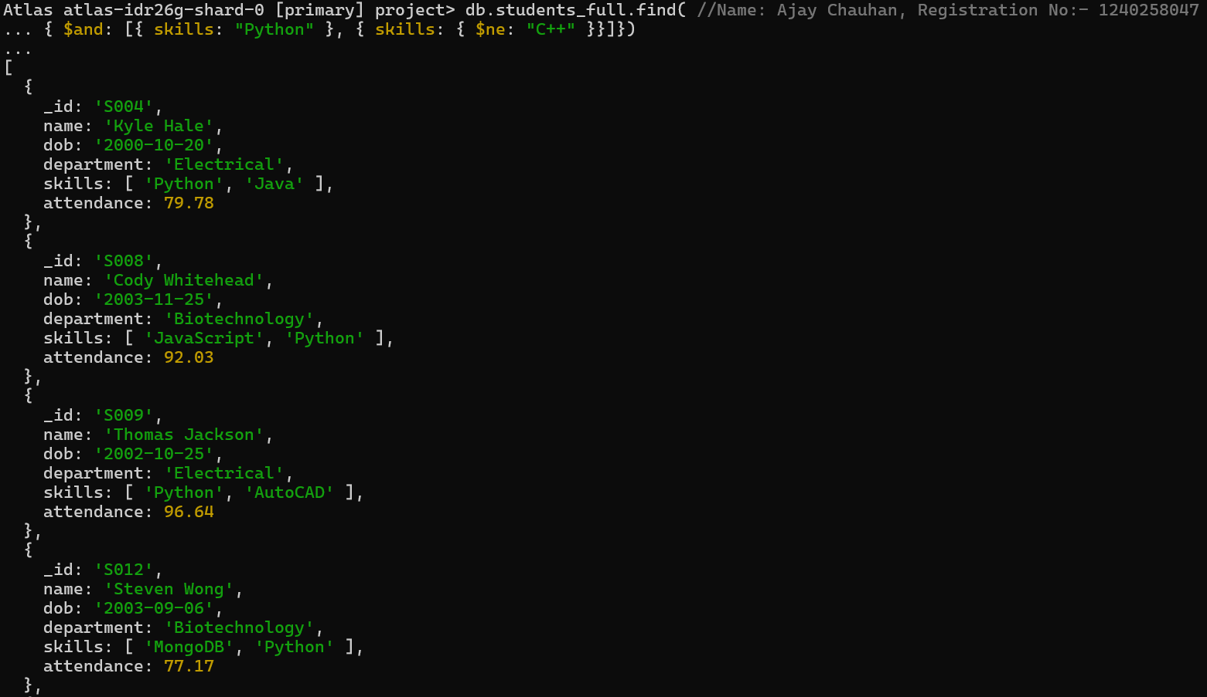

- $in checks for presence in arrays.

- $nin checks for absence in arrays.

- Combine both for exclusive conditions.

- Operate effectively on array fields.

Q11: - Return names of students who participated in "Seminar" and "Hackathon" both.
Query: -

db.activities_full.aggregate(
[{ $group: { _id: "$student_id", activityTypes: { $addToSet: "$type" }}},
{ $match: { activityTypes: { $all: ["Seminar", "Hackathon"] }}},
{ $lookup: { from: "students_full", localField: "_id", foreignField: "_id", as: "student_info" }},
{ $unwind: "$student_info" },
{ $project: { _id: 0, name: "$student_info.name" }}])

Output:-

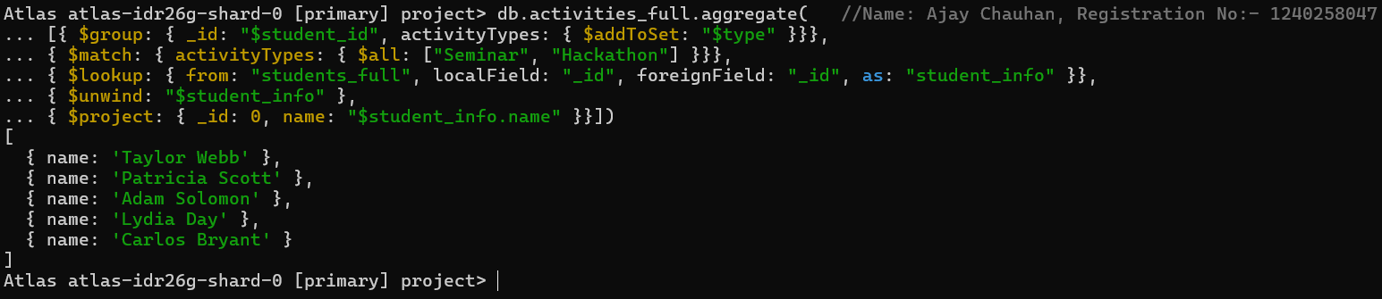

- $all ensures all specified elements exist in an array.

- Simple array querying in MongoDB.

- Combine multiple filters in a single query.

- Efficient participation tracking.

6. Subdocuments and Nested Conditions

Q12: - Find students who scored more than 80 in "Web Development" only if they belong to the
"Computer Science" department.

Query: -

db.enrollments_full.find(
{ course_title: "Web Development", marks: { $gt: 80 }, department: "Computer Science" })

Output:-

- Nothing will show up because there are no students in the Computer Science department who scored more than 80 in 'Web Development'.

- Access nested fields using dot notation.

- Combine multiple field conditions.

- Query subdocuments efficiently.

- Focused filtering by department and performance.

7. Advanced Aggregation (Challenge Level)

Q13: - For each faculty member, list the names of all students enrolled in their courses
along with average marks per student per faculty.

Query: -

db.faculty_full.aggregate(
[{ $lookup: { from: "courses_full", localField: "courses", foreignField: "_id", as: "courseInfo" }},
{ $unwind: "$courseInfo" },
{ $lookup: { from: "enrollments_full", localField: "courseInfo._id", foreignField: "course_id", as:
"enrolledStudents" }},
{ $unwind: "$enrolledStudents" },
{ $lookup: { from: "students_full", localField: "enrolledStudents.student_id", foreignField: "_id",
as: "studentInfo" }},
{ $project: { _id: 0, facultyName: "$name", studentName: { $arrayElemAt:
["$studentInfo.name",0] }, marks: "$enrolledStudents.marks" }},
{ $group: { _id: { facultyName: "$facultyName", studentName: "$studentName" },
averageMarks: { $avg: "$marks" }}},
{ $project: { _id: 0, facultyName: "$_id.facultyName", studentName: "$_id.studentName",
averageMarks: 1 }},
{ $sort: { facultyName: 1, studentName: 1 }}])

Output: -

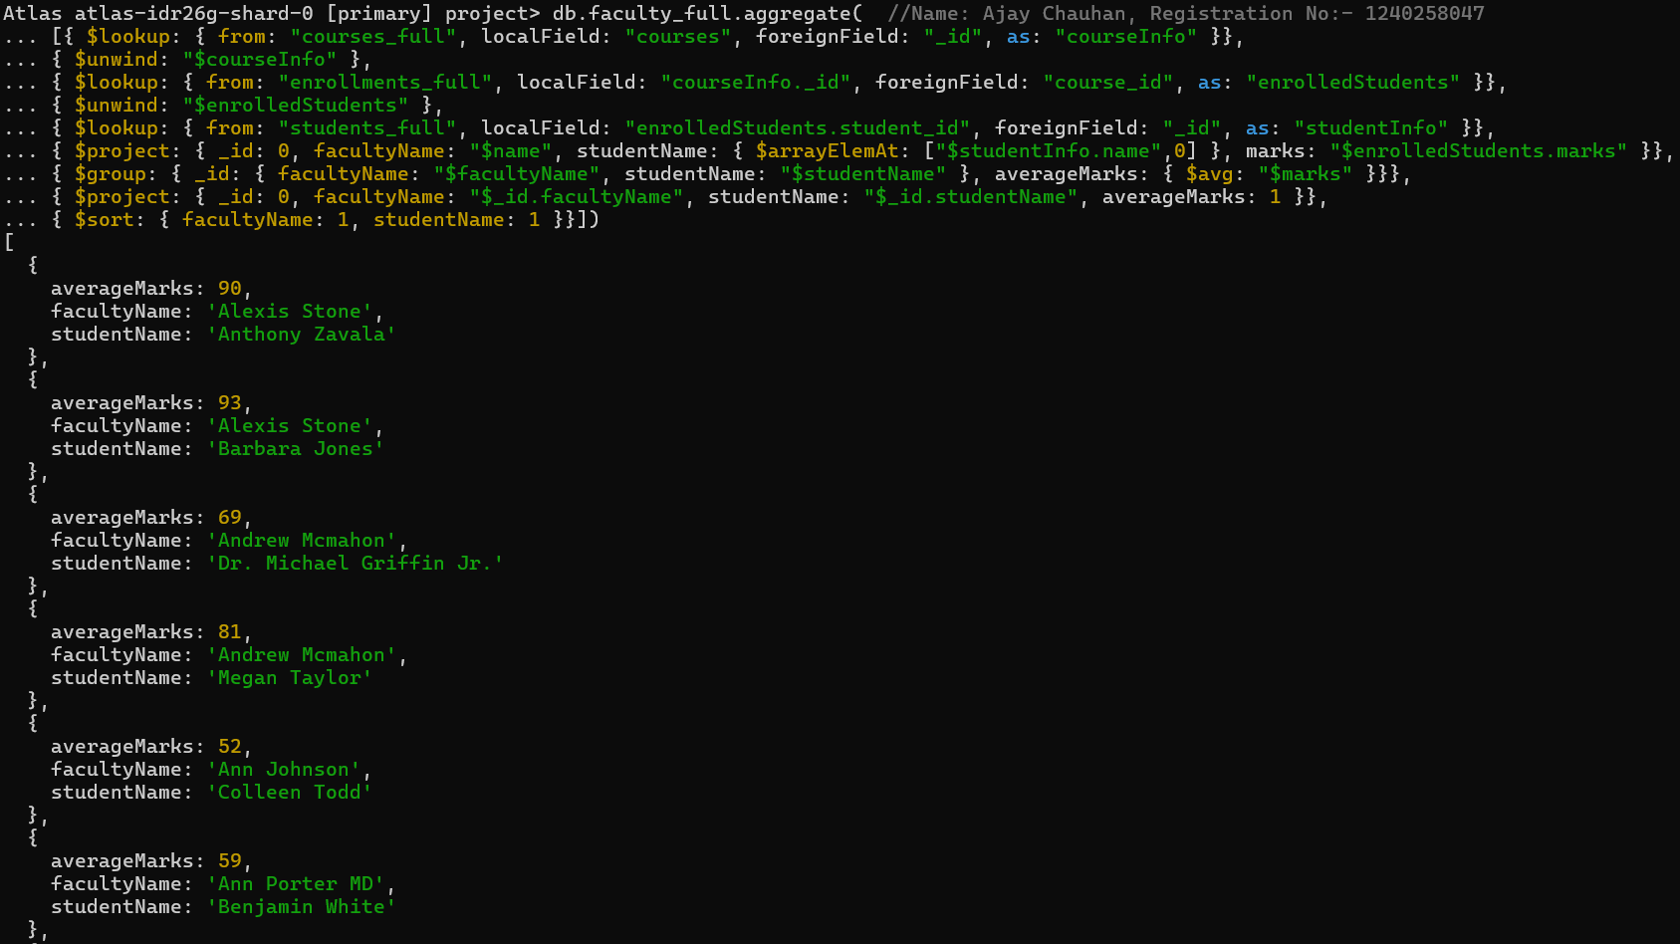

- Multi-level joins using $lookup.
- $addToSet to avoid duplicate student names.
- $avg to compute average marks per faculty.
- Real-world aggregation chaining.
Q14: - Show the most popular activity type (e.g., Hackathon, Seminar, etc.) by number of
student participants.

Query: -

db.activities_full.aggregate(
[{ $group: { _id: "$type", participants: { $sum: 1 }}},
{ $sort: { participants: -1 } },
{ $limit: 1 }])

Output: -

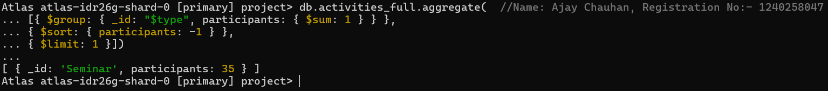

- $unwind to count array elements.

- $group and $sum for totals.

- $sort to rank results.

- Identify “most popular” entities.

