**Andrés de Jesús Gonzalez Melgar**

**Carné: 20004118**

**Laboratorio #4**

**Inciso #1**

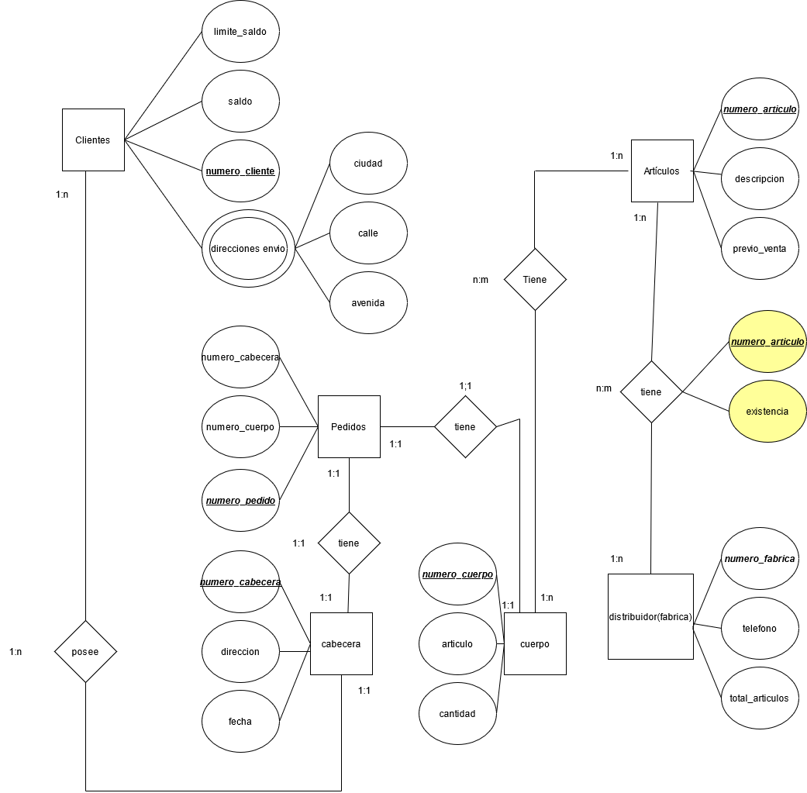

Inciso #2

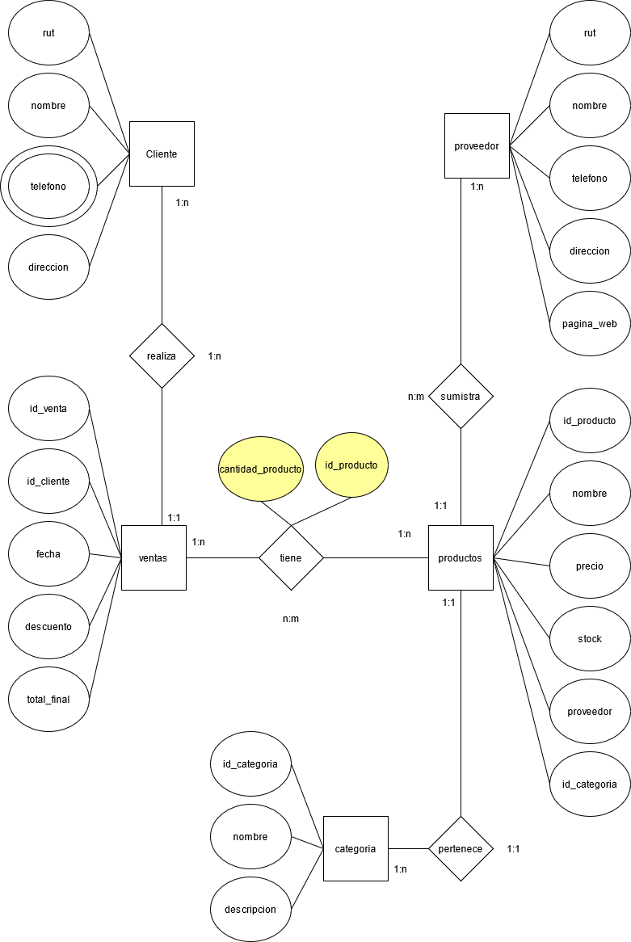

Inciso #3  
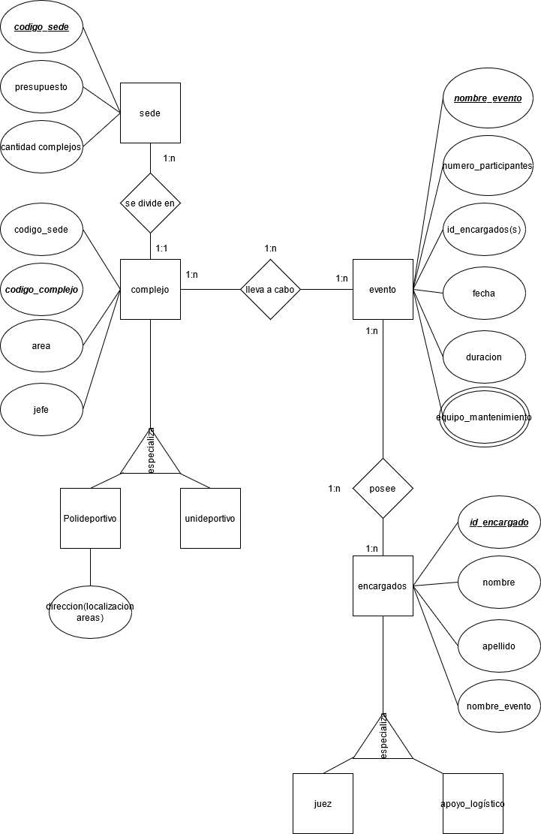

Inciso #4

