Structured Hardening Project: Wi-Fi Control Catalogue Mathematics
Document Identifier: SHP-WIFI-CC-MATH-1.0Version: 1.0Authority Level: S3 — Platform Mathematical SpecificationsStatus: ActiveEffective Date: 26 September 2026

1. Purpose
This specification defines the mathematical structures by which Wi-Fi controls are represented, evaluated, grouped into tiers, mapped to threats, reduced into verification vectors, and consumed by the certification decision process.
Its purpose is to ensure that Wi-Fi control catalogues are:
- deterministic
- threat-bound
- machine-verifiable
- evidence-driven
- tier-compatible
- drift-compatible
- recovery-aware
This specification exists so that future Wi-Fi control catalogues do not become ad hoc configuration lists. Instead, each control must become a mathematically defined predicate over Wi-Fi state, with explicit evidence, dependency, drift, and recovery semantics.

2. Scope
This specification applies to all future SHP Wi-Fi control catalogues, including:
- Wi-Fi Tier 1 controls
- Wi-Fi Tier 2 controls
- Wi-Fi Tier 3 controls
- bounded Wi-Fi certification variants where permitted
It does not itself define the concrete control list. It defines the formal structure those controls must satisfy.

3. Relationship to Higher Authority Documents
This document instantiates the SHP core tier mathematics for the Wi-Fi platform and must remain consistent with the SHP authority hierarchy. S3 platform mathematical specifications instantiate the core mathematics for specific platforms; S4 control catalogues define the actual configuration controls and may not redefine mathematical structures or certification logic.
The control result state space in SHP is not binary-only. The core mathematics defines the canonical result set:
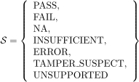
and explicitly distinguishes those states from one another.
The evidence model requires every evidence artifact to be control-mapped, machine-readable, reproducible, and cryptographically auditable.
The decision engine requires deterministic input canonicalisation, tier eligibility predicates, NNC enforcement, and threat coverage validation.

4. Mathematical Universe of Wi-Fi Controls
Let the Wi-Fi platform control universe be
Each element is a distinct Wi-Fi control.
Each control is interpreted as a structured object over the Wi-Fi state space
defined in the Wi-Fi Platform Mathematics Specification.
A control is not merely a string or policy statement. It is a tuple:
where:
- = immutable control identifier
- = tier membership
- = mapped Wi-Fi threat subset
- = required evidence schema set
- = control predicate over Wi-Fi state
- = dependency structure
- = recovery relation
- = drift weight / downgrade severity
- = residual risk vector contribution

5. Wi-Fi Tier Sets
Let the set of Wi-Fi tiers be
with strict ordering
For each Wi-Fi tier , define the required control universe
and the non-negotiable subset
and the negotiable subset
As required by the Charter, failure of any NNC prohibits issuance of that tier, prohibits bounded override of that tier, and forces downgrade to the highest eligible lower tier if one exists.

6. Wi-Fi Threat Mapping Relation
Let the Wi-Fi threat set be
For each tier , define the tier threat subset
Define the threat mapping relation
Validity condition:
This enforces the SHP rule that controls without threat justification are invalid.

7. Control Predicate Semantics
Each control defines a predicate
where is the SHP control result state set.
So for Wi-Fi state ,
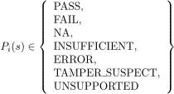
This is important. A Wi-Fi control does not merely return true or false. It returns a full SHP control-state outcome compatible with the core mathematics and decision engine.

8. Reduced Admissibility Map
Define the SHP admissibility reduction map for Wi-Fi controls by reusing the core map:
with the usual semantics:
- for PASS
- for FAIL
- for NA
- for INSUFFICIENT
- for ERROR
- for TAMPER_SUSPECT
- for UNSUPPORTED
These states are not interchangeable.
For Wi-Fi control on device at time , define
and reduced form

9. Wi-Fi Evidence Model per Control
Each control must have a required evidence multiset
Each evidence atom must conform to the SHP Certification Evidence Model, which requires fields such as evidence_id, control_id, platform, tier, timestamp, verifier version, host identifier, evidence type, collection method, raw data, normalized data, result, and signature.
Let the evidence type set for Wi-Fi controls include at minimum:
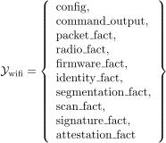
Examples:
- : AP config export
- : observed management frame policy
- : channel, power, band data
- : AP firmware version and signature state
- : VLAN mapping
- : rogue AP scan results

10. Evidence Sufficiency and Integrity for Wi-Fi Controls
Define evidence sufficiency:
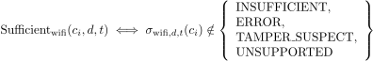
Define evidence integrity:
Define verifier integrity at run level:
This mirrors the core mathematical structure.

11. Wi-Fi Control Result Vector
Define the Wi-Fi control result vector
Define the reduced hardening vector
This vector is the formal Wi-Fi hardening state for device (d) at time (t).

12. Applicability-Filtered Wi-Fi Domains
For tier , define the applicable control set
Define the evaluable control set
Define the integrity-clean control set
As in the core mathematics, NNCs are not allowed to vanish into NA or UNSUPPORTED without platform-defined justification.

13. Wi-Fi Control Weight Functions
Define the control compliance weight for tier
Define the drift weight map
Define the residual-risk contribution map
For Wi-Fi, a natural residual-risk vector basis is
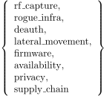

14. Typed Dependency Model for Wi-Fi Controls
A plain dependency list is insufficient. Wi-Fi control dependencies must be typed.
Define dependency types
Define the typed dependency relation
Interpretation:
means requires .
This is more important in Wi-Fi than it first appears. Example:
- PMF strictness may require WPA3 capability
- enterprise identity binding may strengthen a lower-tier WPA3 control
- open guest SSID may be excluded by a high-tier closed-management constraint
- two alternative evidence paths for leakage control may substitute for one another only if formally declared
Define requirement consistency:
Define exclusion consistency:
Define substitution consistency:
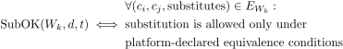
In SHP Strict Mode, substitution must be formal, version-bound, and explicit. Unknown / Requires Testing if equivalence is not formally defined.

15. Wi-Fi Control Families
Define Wi-Fi control families
A practical canonical family set would be:
- : encryption controls
- : authentication and identity controls
- : management frame protection controls
- : segmentation and isolation controls
- : firmware and trust controls
- : radio leakage and channel/power controls
- : rogue AP and rogue device detection controls
- : availability and anti-jamming tolerance controls
- : state sealing and drift detection controls
- : governance / declared-baseline controls
Each family is a subset of platform controls:
For each tier , define the family set
and require
This prevents catalogue drift into unstructured piles of controls.

16. Wi-Fi Compliance Function
For a given tier , define the raw compliance measure over applicable controls:
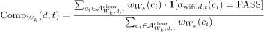
where is the indicator function.
This yields a weighted compliance value in , but this score never overrides NNC logic.

17. Wi-Fi NNC Hard-Gate Function
Define NNC satisfaction for tier :
If any Wi-Fi NNC fails, that tier is unavailable, bounded certification cannot override it, and downgrade must proceed to the highest eligible lower tier. This is mandatory under the Charter and core mathematics.

18. Wi-Fi Threat Coverage Predicate
Controls alone are not enough. The CDE also expects threat coverage validation.
Define the threat mitigation predicate for threat :
Define threat-class satisfaction:
A platform may later refine this from simple existence to stronger coverage cardinality or family-distribution rules, but existence is the minimum valid form.

19. Wi-Fi Tier Eligibility Predicate
Define Wi-Fi tier eligibility as
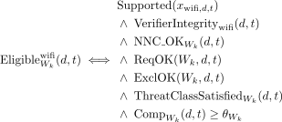
where is the tier threshold.
This aligns with the general decision-engine pattern for eligibility.

20. Wi-Fi Tier Selection Function
Tier selection proceeds from highest to lowest:
If no tier is eligible, the result is Not Certified for Wi-Fi.

21. Wi-Fi Control-Induced Admissible State Sets
For tier , define the admissible Wi-Fi state set
This is the state-space form of the Wi-Fi control catalogue.
It is what makes the later theorems meaningful.

22. Wi-Fi Tier Dominance in Control-Catalogue Form
The Wi-Fi Tier Dominance Theorem becomes operational at the catalogue layer if:
and each higher tier adds at least one effective state-restricting predicate.
Then:
This is how you prevent fake Wi-Fi tiers.
A new tier is invalid if it only adds reporting, commentary, or decorative controls that do not shrink admissible state space.

23. Wi-Fi Control Entropy Interpretation
Define control-induced tier entropy
Then genuine higher-tier Wi-Fi catalogues must satisfy
This is the control-catalogue side of the Wi-Fi entropy reduction result.

24. Wireless Attack Surface Minimisation at Catalogue Layer
Let the wireless spatial attack graph be
Let the set of viable attack paths under tier be
If a Wi-Fi control catalogue is valid and effective, then higher tiers should satisfy
and under real strengthening conditions, at least one of these inequalities is strict.
This makes the catalogue operationally meaningful: higher tiers remove attack paths, not merely add prose.

25. Wi-Fi Drift Function
Define Wi-Fi drift between times and as
Define weighted drift magnitude

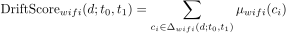
Examples of Wi-Fi drift:
- WPA3 to WPA2 downgrade
- PMF disabled
- WPS enabled
- transmit power changed
- new unmanaged SSID created
- rogue detection mechanism disabled
- AP firmware version changed
- segmentation boundary removed

26. Wi-Fi Downgrade Function
Let prior certified tier be and new evaluated tier
If
then status becomes downgraded.
If no tier remains eligible, status becomes Not Certified for Wi-Fi.
This follows the Charter’s automatic downgrade rule and the CDE model.

27. Wi-Fi Recovery Relation
Each control must define a recovery relation
where is the set of acceptable post-recovery states after failure of .
This enforces SHP control discipline: every control must define what it does, how it is applied, how it is verified, and how it is recovered or rolled back. Controls lacking verification or recovery are invalid under SHP Strict Mode.
For the catalogue mathematics, this means every control must have an explicit recovery map, not merely remediation prose.

28. Canonical Wi-Fi Control Metadata Schema
Each Wi-Fi control must define, at minimum, the mathematical equivalents of the canonical metadata used in SHP control catalogues. Existing Fedora catalogues require immutable control IDs, threat mappings, attack surface domain, category, NNC status, implementation method, verification method, expected state, drift severity, downgrade effect, recovery procedure, and re-verification requirement.
For Wi-Fi, the canonical fields should be:
- control_id
- platform
- tier
- control_version
- specification_version_binding
- threat_mapping
- attack_surface_domain
- control_category
- is_nnc
- control_description
- implementation_method
- verification_method
- expected_verification_state
- drift_severity_if_failed
- downgrade_effect_class
- revocation_trigger_if_failed
- residual_risk_statement
- control_dependencies
- recovery_procedure
- reverification_required_after_recovery
No field may be omitted in the eventual operational catalogue.

29. Canonical Wi-Fi Attack Surface Domains
To keep the catalogue deterministic, define a closed Wi-Fi attack-surface enum:
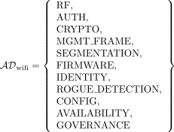
This prevents free-form drift in domain tagging.

30. Canonical Wi-Fi Control Categories
Define a closed control-category enum:
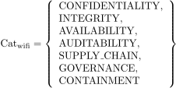
This is consistent with the existing SHP style while adding Wi-Fi-appropriate containment semantics.

31. Example Formal Control Objects
To make the model concrete, here are example control predicates.

31.1 Example: WPA3 Required
Let
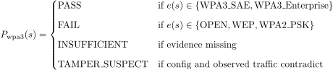
Threat mapping:

31.2 Example: PMF Required
Let
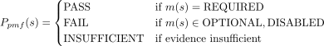
This maps to deauthentication and management-frame exploitation threats.

31.3 Example: Client Isolation Required for Guest/IoT
Let
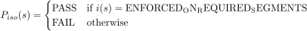
This maps to lateral movement threats.

31.4 Example: Enterprise Identity Binding
Let
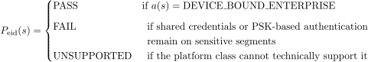
This maps to rogue-client, credential-reuse, and identity-spoofing threats.

32. Bounded Certification Semantics for Wi-Fi
Bounded certification may exclude negotiable controls but must not override NNC absence. The Charter requires bounded certification to enumerate included controls, excluded controls, and residual risk, and it must never imply full-tier equivalence.
Mathematically, for a bounded tier , define a bounded control set
subject to
If this condition fails, the bounded certification is invalid.
The bounded admissible state set is
Residual risk must then be computed over excluded controls:
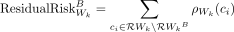

33. Canonical Ordering and Deterministic Evaluation
The CDE requires canonical ordering of inputs; evidence objects are sorted by control_id and verification vectors ordered canonically.
Therefore the Wi-Fi catalogue mathematics requires a total order on controls:
The Wi-Fi verification vector must always be built in that canonical order.
This is mandatory for reproducibility.

34. Compatibility with CEL
The Control Evaluation Language defines deterministic rule objects, evidence bindings, predicates, dependency semantics, canonical serialisation, and audit traces.
Therefore each Wi-Fi control predicate must be translatable into a CEL rule object with:
- rule_id
- control_id
- platform
- tier
- evidence selectors
- normalisation
- predicate logic
- outcome mapping
The mathematics layer does not define CEL syntax, but it requires semantic translatability into CEL.
If a Wi-Fi control cannot be expressed as a deterministic predicate over canonical evidence, it is not operationally valid.

35. Operational Summary
This specification defines the formal mathematics required to make the SHP Wi-Fi control catalogue operational.
It defines:
- the Wi-Fi control universe
- tier control sets
- NNC and negotiable subsets
- threat mappings
- control predicates over Wi-Fi state
- evidence multisets
- sufficiency and integrity predicates
- control result vectors
- typed dependency relations
- control families
- compliance functions
- threat coverage validation
- eligibility predicates
- tier selection
- admissible state sets
- entropy interpretation
- attack-surface minimisation at the catalogue layer
- drift and downgrade functions
- recovery relations
- bounded certification semantics
- canonical ordering
- CEL compatibility
This is the mathematical bridge that turns the Wi-Fi platform model into a real SHP certification system.

