SHP Tier Mathematics Specification
Version 1.0 - Fully Hardened

1. Purpose
This specification defines the mathematical basis for:
for SHP tiered certification platforms.
This specification is a meta-model.
It does not itself define Fedora tier controls or GrapheneOS tier controls. Instead, it defines the formal objects and predicates that each tiered platform mathematics specification must instantiate.

2. Scope
This specification applies to the SHP tiered certification model only.
Define the set of tiered platforms:
At Charter v1.0, the intended tiered platforms are:
Qubes OS is excluded from this tier mathematics because it is defined by the Charter as a distinct, non-tiered High Assurance Certification Class:
and instead belongs to:
This separation is mandatory and not optional.

3. Design Axioms
The mathematics is governed by the following axioms.

3.1 Determinism Axiom
Given identical supported platform state, identical verifier version, identical evidence inputs, and identical specification version, the verifier output must be identical.
Formally:
where is the platform verification function.

3.2 No Opaque Rule Axiom
Every certification decision must be derivable from published predicates, structured verifier output, and platform-defined control mappings consistent with the Charter.

3.3 NNC Hard-Gate Axiom
For any tier , absence of any NNC for prohibits issuance of , prohibits bounded override of , and forces downgrade to the highest eligible lower tier if one exists.

3.4 Threat-Bound Tier Axiom
A tier is not merely a score bucket.
A tier exists only as a certified state satisfying a defined threat-model class.

3.5 Device-State-Time Binding Axiom
Certification binds to a specific device reference, configuration state, issuance time, specification version, and verification tooling version.

3.6 Issuance Authority Axiom
Verifier outputs do not themselves constitute certification.
Official certification exists only upon issuance of an SHP-signed certificate chained to SHP trust infrastructure.

4. Mathematical Universe
For a platform , define the following base sets.

4.1 Controls
This is the complete platform control universe.

4.2 Tiers
with strict platform-local ordering:
This ordering is only meaningful inside platform (P). Cross-platform equivalence is prohibited:

4.3 Threats

4.4 Control Families
where each family is a subset of platform controls:

4.5 Evidence Atoms
Each evidence atom is a verifier-observable fact, artifact fragment, measurement, or platform-state proof input.

4.6 Supported State Domain
is the set of supported evaluation states for platform .
An evaluation state outside is not merely a failed certification posture; it is an unsupported evaluation case.

5. Supported Evaluation State
For a specific device (d) on platform (P), define an evaluation state:
where:
- = hardware identity and platform-defined hardware facts
- = firmware state
- = operating system version/state
- = hardening configuration state
- = version tuple
- = evaluation time
- = metadata required for evaluation
Supported-state predicate:
If false, the verifier must return a supported-state failure classification, not silently fold the device into ordinary control failure.

6. Version Tuple
Define the certification version tuple:
where:
- = Charter version
- = platform specification version
- = verification tooling version
All certification meaning is version-bound to (\nu):
and does not retroactively change except where explicitly security-critical under Charter governance.

7. Control Result State Space
Define the full control result set:
Interpretation:
- : control satisfied
- : control not satisfied
- : not applicable under platform rules
- : evidence insufficient to conclude
- : verifier execution/evaluation failure
- : evidence or execution integrity suspect
- : evaluation outside supported domain for that control/context
Define the admissibility reduction map:
with
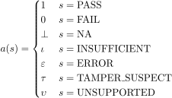
These symbols are not interchangeable. In particular:
This distinction is required to preserve verifier integrity and refusal logic.

8. Evidence Model
For each control , define its evidence multiset:
Each evidence atom may be typed:
where typical evidence types include:
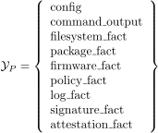
Define the control evidence evaluation function:
so that:
The evidence model is essential because the verification artifact is authoritative and certification decisions must be traceable to verification output.

9. Evidence Sufficiency and Integrity Predicates
Define evidence sufficiency:
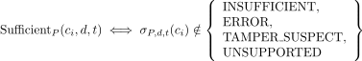
Define evidence integrity:
Define verifier integrity at whole-run level:
Platform specifications may strengthen this further.

10. Control State Vector
Define the control result vector:
Define the reduced hardening vector:
This is the formal hardening state for device at time .

11. Tier Control Sets
For each tier , define:

11.1 Full Tier Control Universe

11.2 Non-Negotiable Controls

11.3 Negotiable Controls

11.4 Tier Threat Set

11.5 Tier Family Set
with

12. Applicability-Filtered Domains
Define the applicable control set for a tier:
Define the evaluable control set:
Define the integrity-clean control set:
NNCs are not freely allowed to disappear into or without platform-defined justification.

13. Control Weight Functions
Define the tier control compliance weight:
Define the drift weight:
Define the residual risk contribution map:
where is the number of residual-risk dimensions in the platform model.
Typical residual-risk vector dimensions may include:

14. Threat Mapping Relation
For each tier , define the threat-mapping relation:
Validity condition:
This implements the rule that every control must map to a defined threat and that controls without threat justification are excluded.

15. Dependency Model
A plain graph is not enough. The dependency relation must be typed.
Define dependency types:
Define the typed dependency relation:
Interpretation:
means requires .

15.1 Requires Predicate

15.2 Exclusion Predicate

15.3 Strengthening Predicate
A strengthening edge does not invalidate tier attainment by itself, but it contributes to completeness and threat-coverage quality.

15.4 Substitute Predicate
Handled formally in the next section.

16. Substitute-Control Model
For any control , define the substitution set:
A substitute control may satisfy the requirement for if platform-defined substitution conditions hold.
Define the substitute satisfaction predicate:
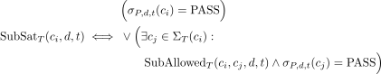
Substitution is not exclusion. It is a formal approved equivalence mechanism within tier semantics.

17. Family-Level Logic
Controls are not just a flat bag.
For each family , define a family evaluation mode:
Define family membership within tier:

17.1 Family Pass Predicate
is defined by .

Case A: All

Case B: Threshold
Define a family threshold .

Case C: Weighted

Case D: One Anchor Plus
Let anchor subset:
Then
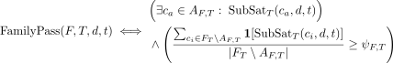
This family logic lets the mathematics reflect real control architecture.

18. NNC Predicate
Define the NNC predicate:
If any NNC fails, then:
This is a hard gate. Bounded certification cannot override it.

19. Compliance Function
Define the clean applicable control set for compliance:
Then define weighted achieved mass:
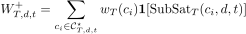
Define total mass:
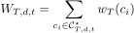
Define compliance ratio:
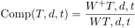
provided .
By construction:
This is a completeness measure, not the tier definition itself.

20. Verification Integrity for a Tier
Define the per-tier insufficient set:
Define the per-tier error set:
Define the per-tier tamper-suspect set:
Define tolerance parameters:
Then tier verification integrity is:
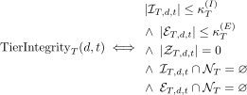
For certification-grade operation, the strongest form is:

21. Threat-Coverage Function
Define threat coverage for tier :
Define full threat-class satisfaction:
Platform specifications may weaken this to a threshold or weighted threat coverage model, but if they do, that rule must be explicit and deterministic.
This prevents tiers from collapsing into mere point totals.

22. Full Tier Predicate
Define the full tier threshold:
Then:
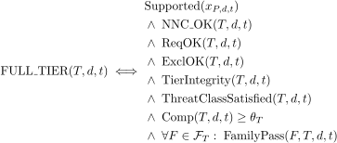
This is the central tier-attainment theorem.

23. Issuance Eligibility Predicate
Tier attainment is not the same as issuance eligibility.
Define issuance eligibility:
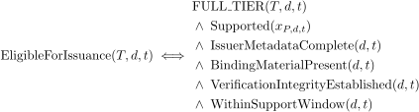
where:
- means mandatory issuance fields are present
- means device/state/version identity material exists
- captures whole-run integrity
- captures platform support scope
This prevents an incomplete verifier run from being mistaken for an issuable certification state.

24. Highest Eligible Tier
Define:
If no tier is eligible:
This is the mechanical downgrade anchor.

25. Bounded Certification Model
Bounded certification must remain distinct from full certification, must not override NNC absence, and must enumerate exclusions and residual risk.

25.1 Exclusion Set
with hard constraint:

25.2 Exclusion Reason Typing
Define the exclusion reason grammar:
where:

25.3 Bounded Effective Control Set

25.4 Bounded Compliance

25.5 Bounded Residual Risk Vector
This is vector-valued, not scalar-only.

25.6 Bounded Predicate
Define bounded threshold:
Then:
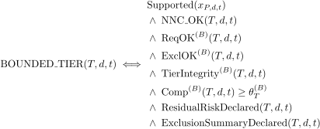
and explicitly:
and
Full certification remains the canonical reference posture.

26. Verifier Output Algebra
Define the verifier output object:
where:
- = device binding reference
- = evidence references
- = key verifier metadata
- = tier candidate evaluation results
- = additional manifest-preparation metadata
Define deterministic serialisation:
such that:

27. Manifest Derivation Function
Define manifest derivation:
where is the set of deterministically serialised machine-readable manifests.
The manifest must include, at minimum:
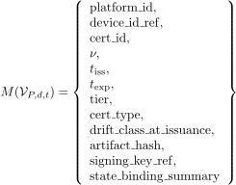
The human-readable certificate is derived from the manifest:
with
and the authoritative object remains the signed manifest, not the rendered certificate document.

28. Artifact Hash Function
Define the authoritative verification artifact hash:
More generally:
for approved hash function , where current minimum is SHA256.

29. Certificate ID Derivation
Define the platform-specific secret salt:
Define platform-specific device identity material:
Define certificate ID derivation:
subject to the properties:
and for :
This enforces certificate-ID derivation and per-platform salt compartmentalisation.

30. Issuance Function
Certification is not the verifier output; it is a later cryptographic issuance event.
Define:
with precedence:
Define the issuance rule:
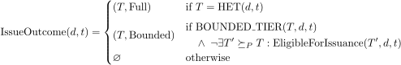
Full certification always takes precedence over bounded certification for the same tier.

31. Certification State Machine
The mathematics must include lifecycle, not just predicates.
Define the certification state machine:
where:

31.1 States
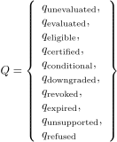

31.2 Events

31.3 Transition Function
with typical transitions:
This state machine is the lifecycle backbone of the certification model.

32. Drift Model
Let
be the reduced hardening vector at issuance and
the reduced hardening vector at later time (t).
Define control-level drift indicator:
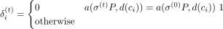
Define drift count:
Define weighted drift magnitude:
Define critical control set:
Define critical drift predicate:

33. Downgrade Theorem
Let the issued tier be:
At later time , define current highest eligible tier:
Then the downgrade theorem is:
and the device is downgraded.
If
then the device no longer holds an issuable tiered certification state.
This is the formal expression of automatic downgrade to the highest eligible tier.

34. Conditional State Predicate
Conditional is not arbitrary. It must be mechanically defined.
Let:
be the platform-defined warning drift threshold and let
be the platform-defined critical downgrade threshold.
Then a typical formalisation is:
This preserves the issued tier while marking material non-tier-breaking drift.

35. Revocation Predicate
Revocation is distinct from downgrade and expiry.
Define four revocation trigger predicates:
- signing key compromise:
- fraudulent verification:
- critical specification violation:
- artifact integrity invalidation:
Then:
with resulting status:
This instantiates the revocation model.

36. Expiry Predicate
Let issuance time be and expiration time be .
Define:
When true:
This is mandatory and automatic.

37. Status Set and Precedence
Define certificate status set:
Define total precedence ordering:
Then status function:
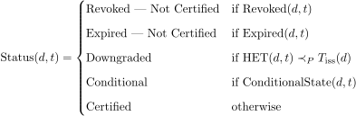
This gives a deterministic status ordering even in overlapping cases.

38. Time/State Validity Function
Define time-validity:
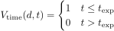
Define state-validity:
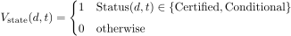
Define active-certification validity:
This expresses the time-bound and state-bound model.

39. Public Verification Projection
Define the public projection operator:
with
where
Conditional and Downgraded are internal operational states unless surfaced by signed certificate logic outside the minimal public page.

40. Certificate-Meaning Non-Retroactivity
Let certificate be issued under version tuple .
Then, absent security-critical revocation:
A later platform or Charter version does not silently rewrite the meaning of the earlier certificate.

41. Refusal Predicate
Some outcomes are not failures of hardening posture but refusals to certify.
Define refusal predicate:
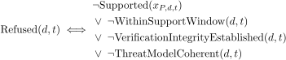
A refusal is not a service failure. It is a governance-protective outcome.

42. Recovery Discipline Constraint
Every control in the platform instantiation must carry recovery predicates.
For each control , define:
where:
- = user-level recovery path
- = support-level recovery path
- = downgrade or revocation transition path
A control lacking recoverability is invalid for shipping:

43. Point-in-Time Attestation Constraint
Certification is a point-in-time attestation, not ongoing monitoring.
Mathematically:
Instead:
must always be re-evaluated through the state and time validity functions.

44. Complete Platform Instantiation Schema
For each tiered platform , a valid platform mathematics specification must provide the tuple:

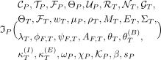
for all relevant tiers .
Without this tuple, the platform mathematics specification is incomplete.

45. Final Canonical Tier Classification Rule
For a tiered platform , the final canonical classification at time is:
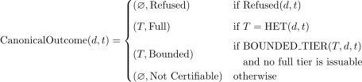
This rule fully separates:
- technical tier posture
- issuance eligibility
- bounded certification
- refusal
- non-certifiable state

46. Plain-Language Interpretation
The mathematics now says, in full:
A device is not certified because it “scores enough points.”
It is certified only if it is on a supported platform, inside the supported evaluation domain, has valid evidence, passes all NNCs for the tier, satisfies the tier’s threat model, satisfies typed control dependencies, satisfies family logic, satisfies the required completeness threshold, satisfies verifier-integrity requirements, and is then formally issued by SHP under the correct version tuple and trust chain.
That is the difference between:
and

47. Structural Assessment
With this rewrite, the SHP Tier Mathematics Specification is now:
- tier-complete
- issuance-complete
- bounded-certification-complete
- drift-complete
- revocation-complete
- expiry-complete
- manifest-complete
- state-machine-complete
- platform-instantiation-complete

