Structured Hardening Project: Network Gateway Platform Mathematics Specification (NGPMS)
Document ID: SHP-NGPMS-1.4Status: ActiveSpecification Class: Platform MathematicsAuthority Layer: S3 — Platform Mathematical SpecificationsEffective Date: 26 September 2026Change Classification: Minor
Dependencies
- SHP Charter v3.0
- SHP Tier Mathematics Specification v2.2
- SHP Certification Evidence Model v2.0
- SHP Certification Decision Engine v2.1
- SHP Network Gateway Threat Model v1.2
Referenced By
- Gateway Tier Control Catalogues
- Gateway Verification Tooling
- Gateway Certification Decisions

1. Purpose
This specification defines the formal mathematical framework used to evaluate the security state of a Network Gateway Platform within the Structured Hardening Project (SHP).
The mathematics defined here provides deterministic reasoning for:
- gateway security state evaluation
- control compliance measurement
- threat mitigation coverage
- adversary capability coverage
- segmentation policy enforcement
- network attack propagation modelling
- configuration drift detection
- route integrity verification
- attack surface measurement
- certification eligibility determination
- certification revocation conditions
All certification outcomes derived from this specification must be deterministic, reproducible, and machine-verifiable.

2. Gateway Platform Definition
A gateway platform is defined as the tuple
Where
Symbol | Meaning
 | hardware platform
 | firmware and operating system
 | configuration state
 | active services
 | network topology context
The universe of all gateway platforms is
Thus

3. Supported Platform Function
Not all gateway devices are certifiable.
Define supported platform set
The supported platform predicate is

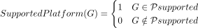
Platforms lacking deterministic inspection capability are excluded.
Examples include
- opaque firmware routers
- ISP-controlled gateways
- cloud-managed routers

4. Gateway Security State Space
Define the gateway security state
Where
Expanded state vector
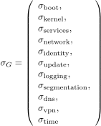

5. State Transition Model
Gateway security state evolves over time.
Define transition function
Where
Symbol | Meaning
 | operator actions
 | external events
 | state transition function
Examples of transitions include
- firewall rule modification
- firmware update
- administrator credential change
- network interface configuration change

6. Gateway Control Catalogue
Define gateway control set
Each control is a predicate
Where
1 = satisfied
0 = violated

7. Control Dependency Graph
Controls may depend on other controls.
Define dependency graph
Where
- nodes represent controls
- edges represent dependency relationships
A control may only be satisfied if all dependencies are satisfied.

8. Control Criticality Weights
Controls are assigned criticality weights
Where

9. Control Compliance Function
Weighted compliance
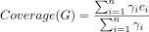

10. Threat Set
Define threat family set
Each threat corresponds to a family defined in the gateway threat model.

11. Control–Threat Mapping
Define mapping
Each control mitigates one or more threats.

12. Threat Mitigation Function
For threat
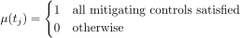

13. Threat Impact Vector
Each threat has impact vector
Where
Symbol | Meaning
 | confidentiality impact
 | integrity impact
 | availability impact
 | trust impact

14. Weighted Threat Coverage
Define
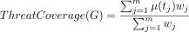

15. Adversary Capability Set
Define adversary classes

16. Threat Capability Mapping
Define

17. Adversary Coverage Function

18. Network Topology Model
Define topology graph
Where
- nodes represent devices
- edges represent connectivity
Gateway node

19. Zone Model
Define zone set
Where

20. Zone Policy Matrix
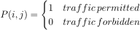

21. Observed Traffic Matrix
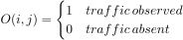

22. Segmentation Violation
A violation occurs if

23. Segmentation Integrity
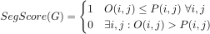

24. Policy Consistency
Define policy consistency function
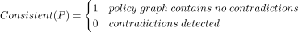

25. Route Integrity Model
Define route set
Expected route set
Route integrity
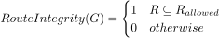

26. Management Exposure Model
Management interfaces
Define
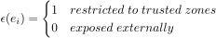
Management score
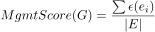

27. Configuration Drift
Baseline configuration
Current configuration
Define drift

28. Configuration Integrity
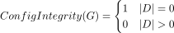

29. Drift Severity
Define drift vector
Severity

30. Resource Availability
Define resources
Capacity vector
Observed utilisation
Availability score
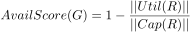

31. Attack Surface Model
Define attack surface set
Surface metric
Hardening reduces this value.

32. Attack Propagation Graph
Define attack graph
Where
- nodes represent hosts
- edges represent attack paths
Gateway node
Propagation probability

33. Evidence Set
Evidence objects
Required evidence
Evidence completeness
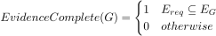

34. Evidence Integrity
Evidence hash
Bundle
Integrity condition
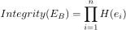

35. Configuration Entropy
Configuration state space
Entropy
Hardening condition

36. Gateway Security Score
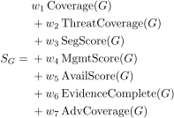
Where

37. Certification Eligibility
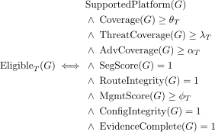

38. Certification Outcome
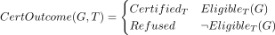

39. Certification Revocation

40. Security Invariants
Security invariants define non-negotiable conditions

41. Tier Dominance Theorem
Tier dominates if
and
Thus

42. Certification Stability
Define stability
Certification is stable if
for interval .

43. Determinism Requirement
Certification decisions must satisfy
for identical evidence.

44. Operational Meaning
This mathematics specification provides the formal reasoning layer enabling
- deterministic gateway certification
- segmentation verification
- adversary capability coverage
- attack propagation modelling
- drift detection
- certification revocation
- configuration entropy reduction
It links the SHP system layers
Threat Model → Control Catalogue → Evidence Model → Certification Decision Engine.

Change Record
Version 1.4 — Active — Minor amendment. Successor to internally identified SHP-NGPMS-1.3; governance, authority and dependency reconciliation only.

