**Project Name: - Skilled Worker Recommendation System**

**Sprint 1:-**

1. **Home Page :-** 
   1. In Home page we are providing some information what we do. (Related to our web site, short introduction)
   2. There will be search box, to search service we are providing or user can check here particular service available or not.
   3. We are showing List of Cities also, where we providing Service.
   4. After selecting appropriate city, it will redirect to login page, if user is not register it will ask to register.
2. **Registration Page:-**
   1. There will be **two** option,
      1. Customer Registration.
      2. Service Provider Registration.
   2. **Customer Registration: -** Here are some textboxes with place holders like Name, Email ID, Mobile Number, Address, City, Pin-code, State, Password and Re-Enter Password with Sign-up Button and one hyper link is given **Already member Sign In? Login Here.**
   3. **Service Provider Registration: -** Here are some textboxes like Name, Email ID, Address, Mobile No, City, Pin-code, State, Password, Re-Enter Password, Skill(Here service Provider can add multiple skills), Upload ID-Proof(Government) and Profile-Photo with Sign-up Button and one hyper link is given **Already member Sign In? Login Here.**
3. **Log In Page: -**
   1. We are Showing two textboxes for Username and Password with Login button
   2. Two hyper link is given one for **Forgot password?** **And new member Sign Up here?**

**Note: -The Sign In page is common for Service Provider and Customer**

1. **Customer Profile Page: -**
   1. Here we are showing user log in Header section of web page, Which Contains two options.
      1. Update profile (here user can update the profile)
      2. Log out
   2. In User profile, we are giving option for Filter Search.
      1. It will have 3 search boxes to search the city, pin code, address to check if the service is available at particular location.
      2. There will be a search box to select the service.
      3. And one search button.
   3. The above filter search result will display below table, based on that user can hire service provider on the basis of their ratings, cost etc.
   4. Based on the selected service provider from the above table it will redirect to new page where we can see service provider name, skill, cost per hour and we have to select date and time to book the service provider.
   5. There will be a one button to confirm the order.
2. **Payment Page :-**
   1. There will be some radio buttons to select the payment method like Debit card, Credit card, UPI and Cash on Delivery.
   2. And one button to place the order.
3. **Service Provider Profile Page: -**
   1. Here we are showing Service Provider log in Header section of web page, Which Contains two options.
      1. Update profile (here Service Provider can update the profile)
      2. Log out
   2. In Service Provider profile, we are showing the Request came.
      1. Service Provider can accept or reject the request.
      2. If Provider are rejecting request, he/she have to give reason.
4. **About Us: -**
   1. Some information about website.
   2. Some links are provided like LinkedIn, Twitter and Gmail etc.
5. **Contact Us :-**
   1. There will be one feed Back form, for the user.
   2. Some telephonic information is also provided, where user can contact for any queries.
6. **Header Section: -**
   1. There will be 3 tabs on the left side of the header.
      1. Home
      2. About Us
      3. Contact Us
   2. There will be 2 tabs on the right side of the header.
      1. Register
      2. Login
7. **Footer Section: -** 
   1. There will be Company name.
   2. And design and developed by @year.

**Sprint 2:-**

1. **Admin Dashboard: -** 
   1. There will be Admin Dashboard through which he can manage the records and history of the customer and worker.
   2. There will be Menu through which admin can manage the whole website
      1. **Service** **:-** here admin can see list of service available
      2. **Manage** **customer: -** How many no of customer are register what type of service they booked all information are visible here.
      3. **Manage Worker: -** The list of workers are given here or they can group or sort by skills they have (all this things can done by Admin only).
      4. **Notification: -** This is notification page for admin through which admin get notification regards the service request.
2. **Verification of Mobile No. (After Sign In using One Time Password): -**
   1. There will be mobile no verification after user register successfully, to avoid fake registration or fraud.
   2. And we can provide captcha during login (For Human Verification).
3. **Forgot Password Reset Link: -**
   1. There will be one link if user forgot password, by click on this link one mail sent to their register mail id to reset the password.
4. **SMS send to service provider: -**
   1. Here we are providing SMS alert for the service provider to notify them, they got request for the particular service.
5. **Order Confirmation Invoice (Optional): -**
   1. After payment page, the order confirmation and bill are send to the customer register email id

**Sprint 3: -**

1. In future we can try to add the local shop available in the area.
2. We can add maps to select the location or address.
3. In future, there will be one mediator who can help the literate people, those having skills to register on the website.
4. Later we can hire worker on the monthly base on their experience.

**Screen Shoots: -**

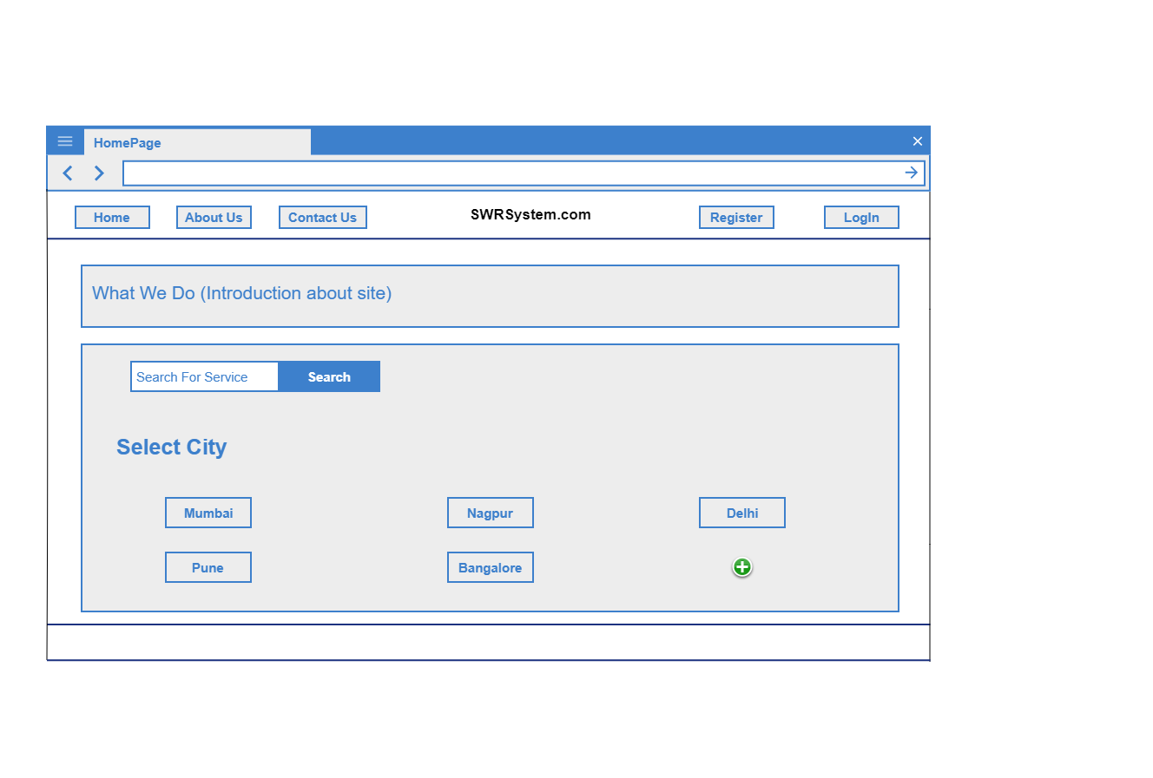

**Home Page**

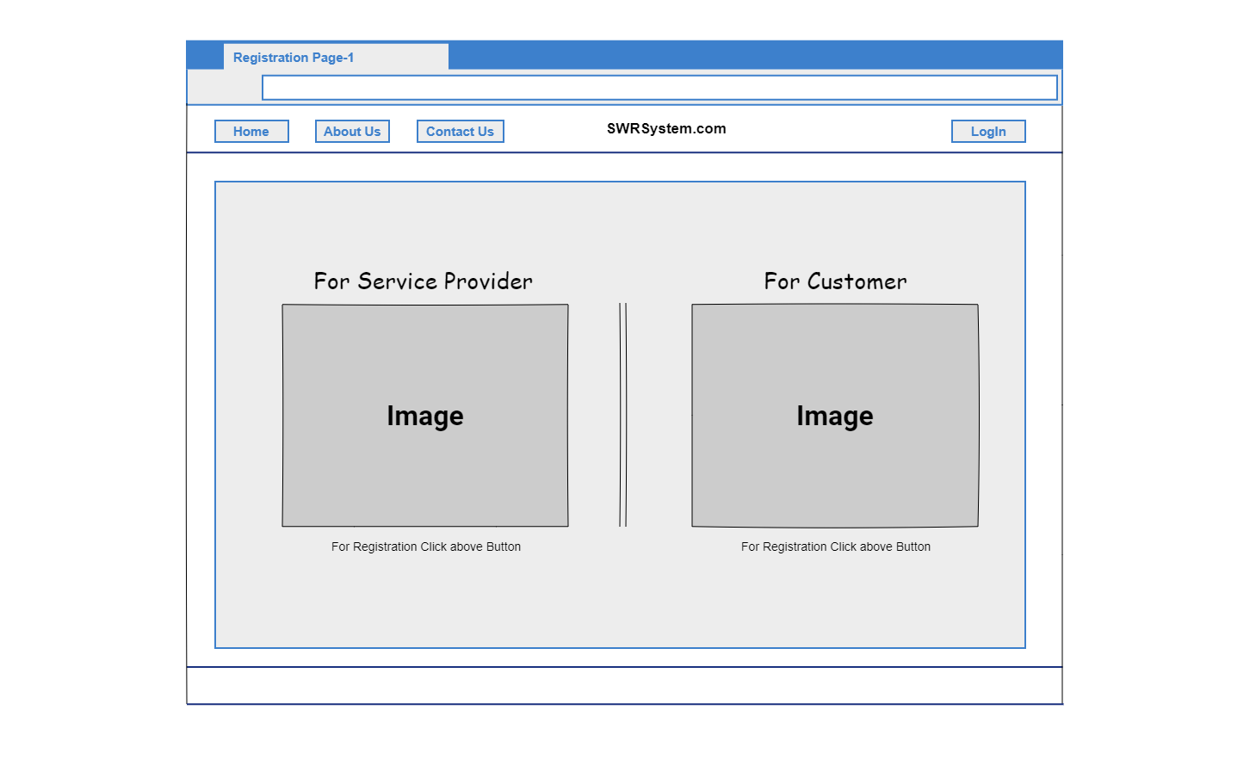

**Registration Page View**

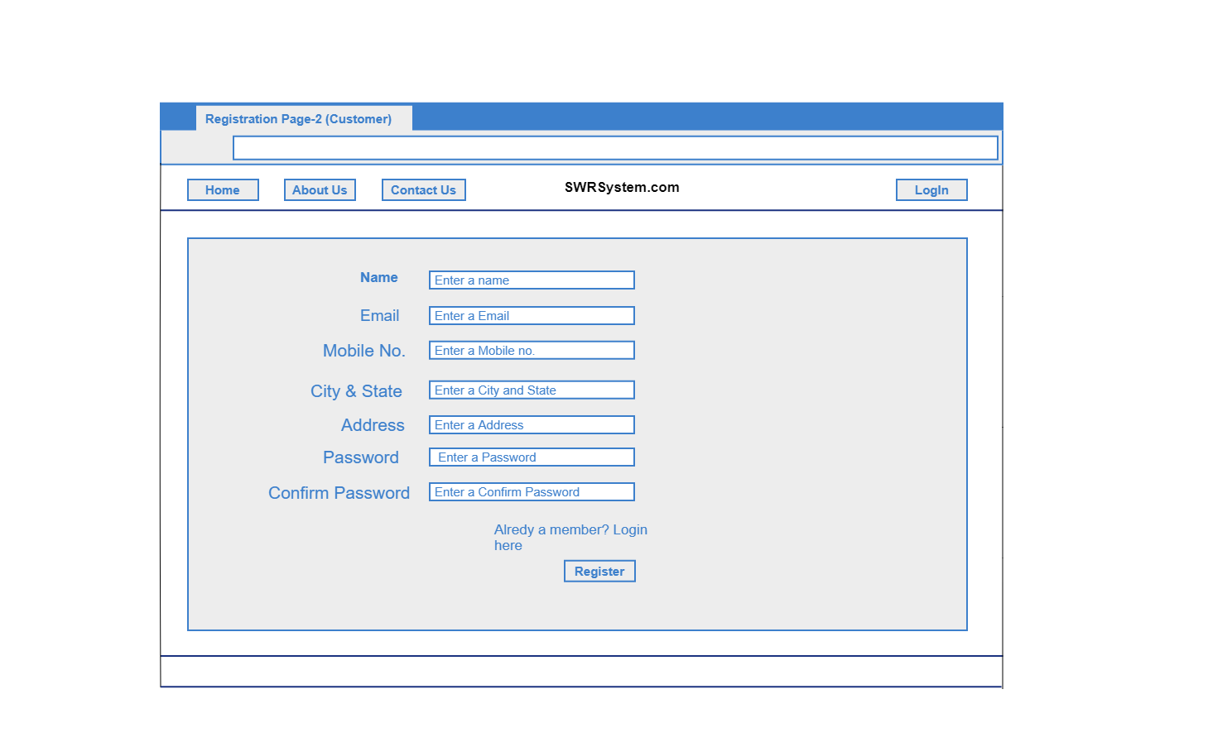

**Registration Page View for Customer**

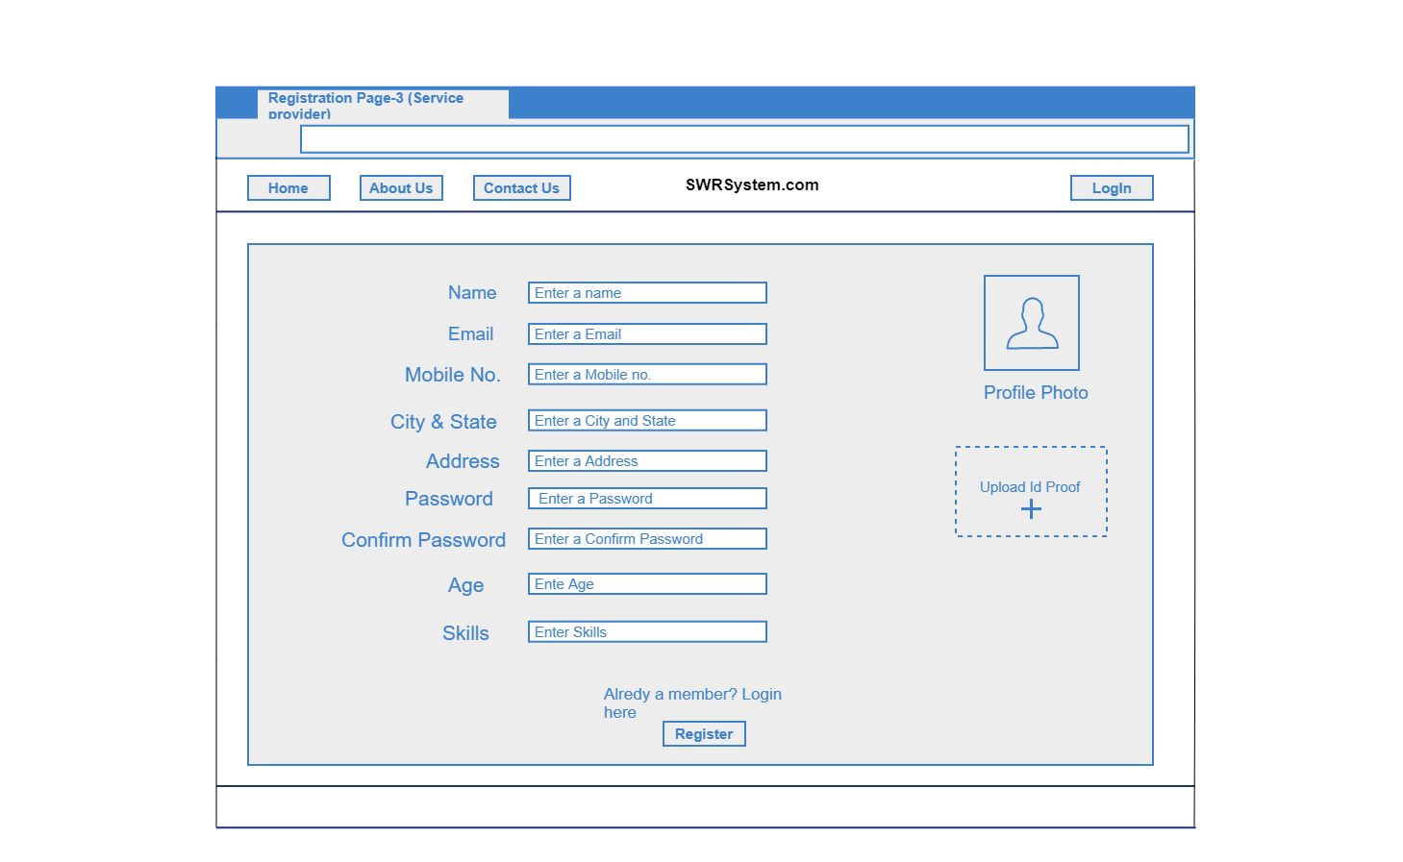

**Registration Page View for Service Provider**

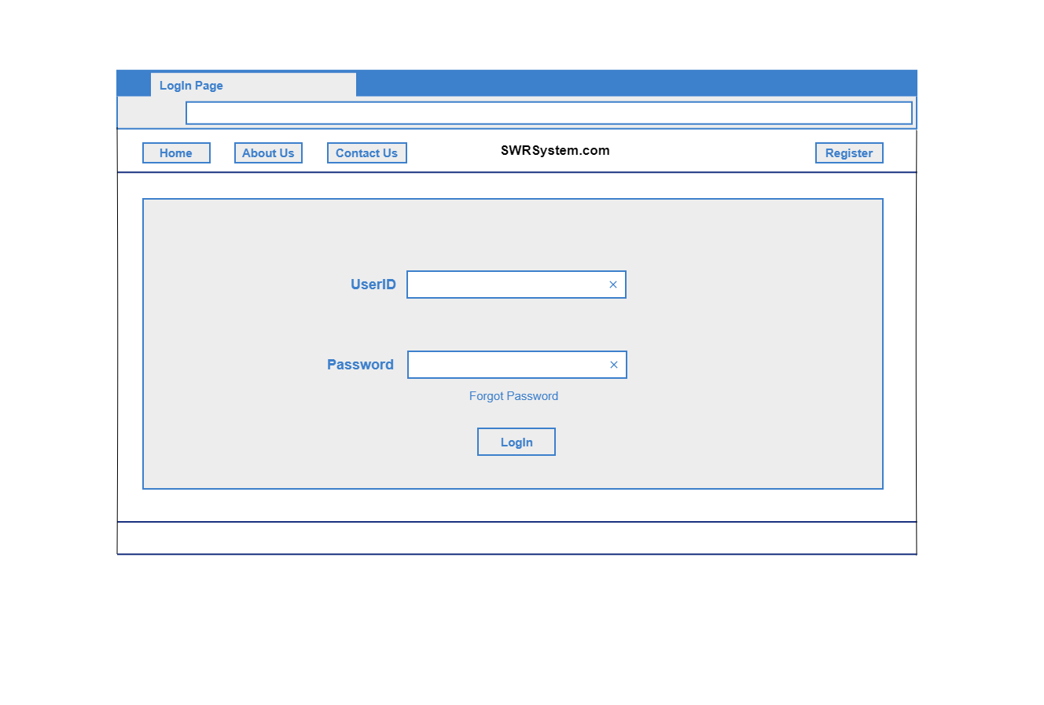

**Login Page View**

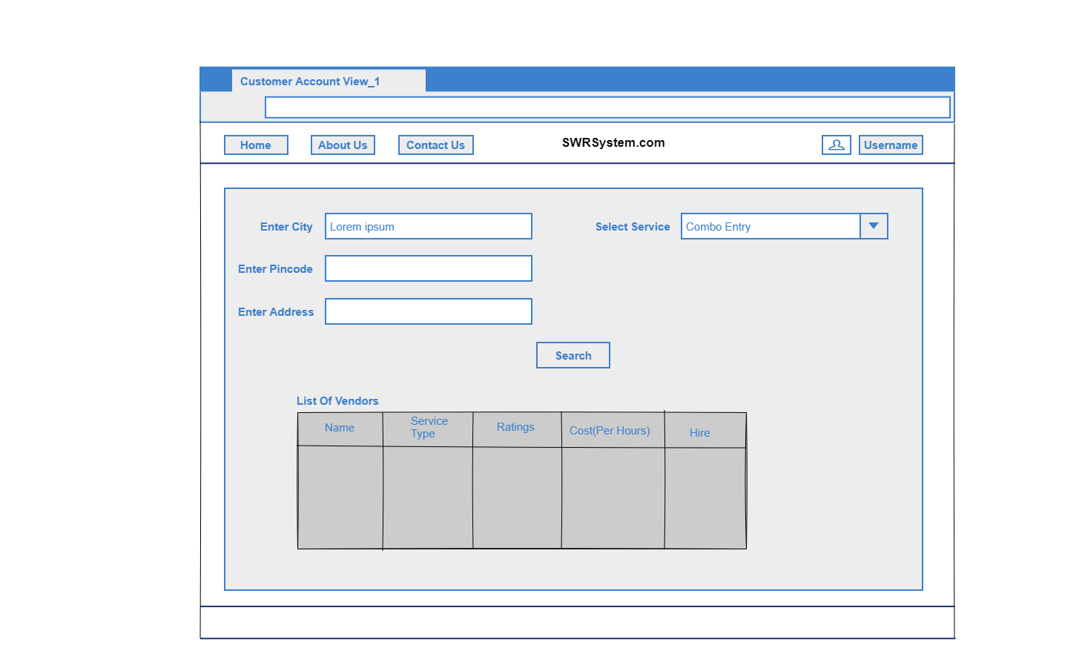

**Customer Profile View (Search for Service)**

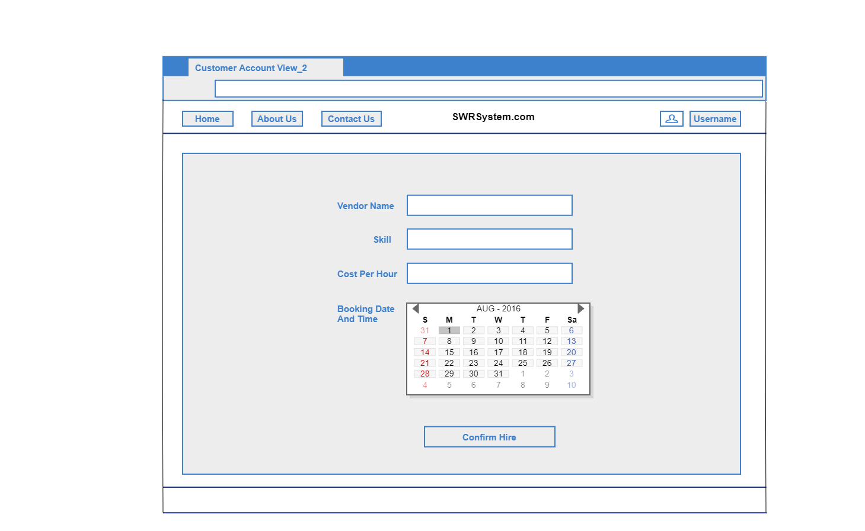

**Customer Profile View (Confirm order Page)**

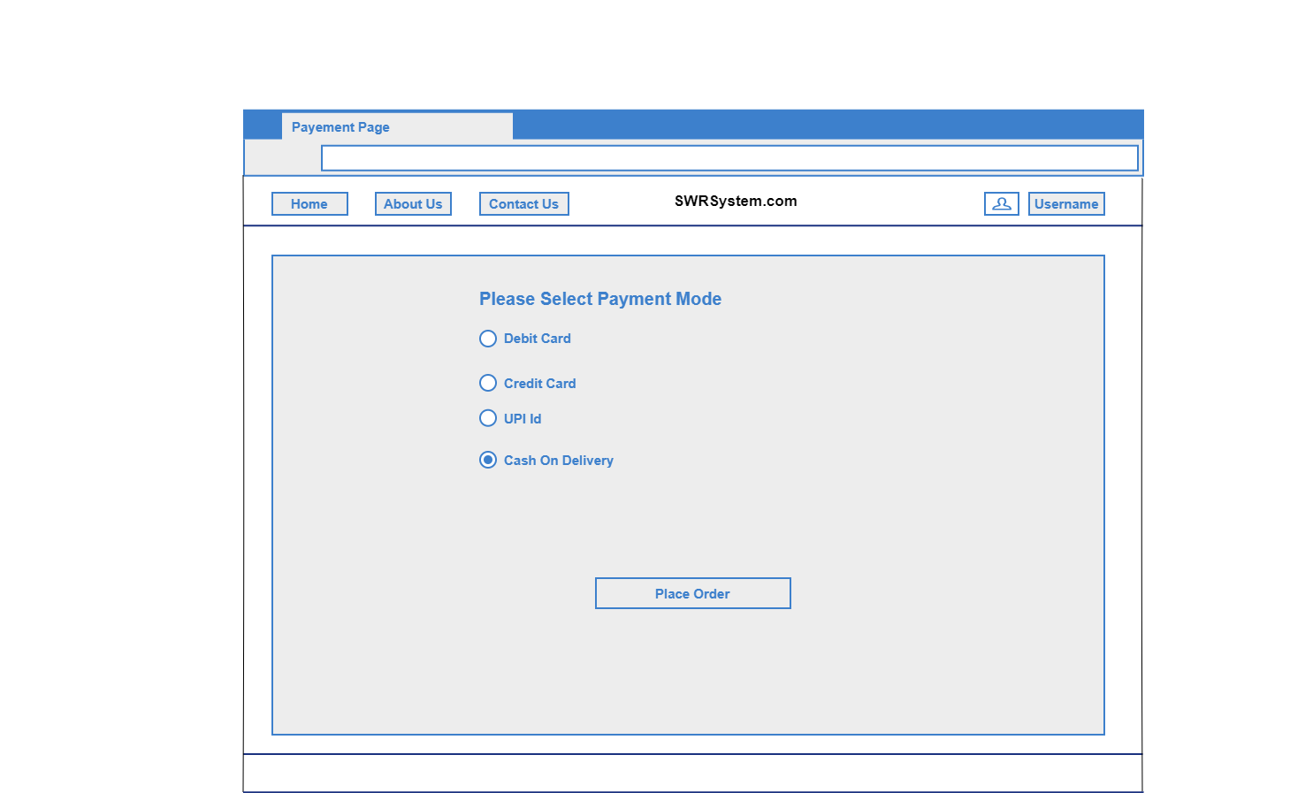

**Payment Page**

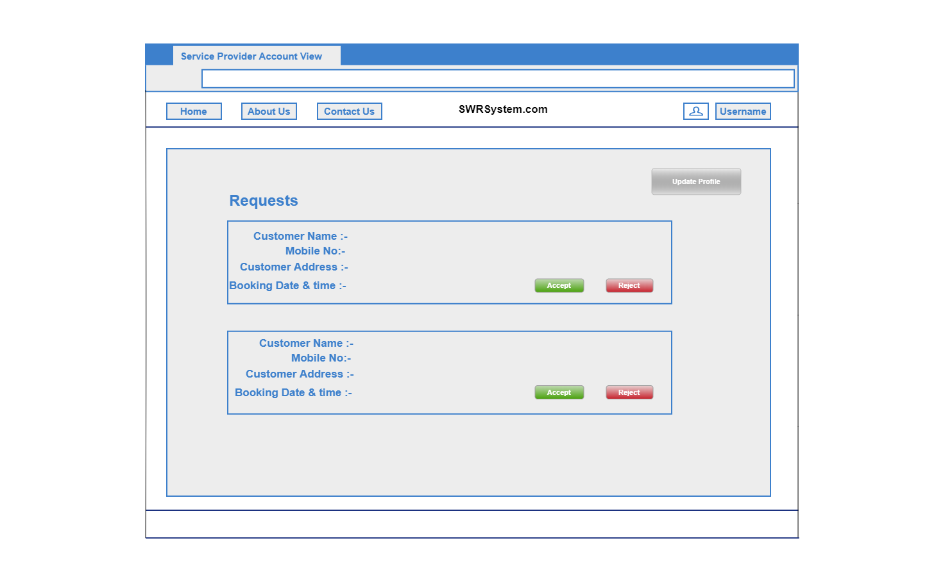

**Service Provider Account View (List Of request show)**

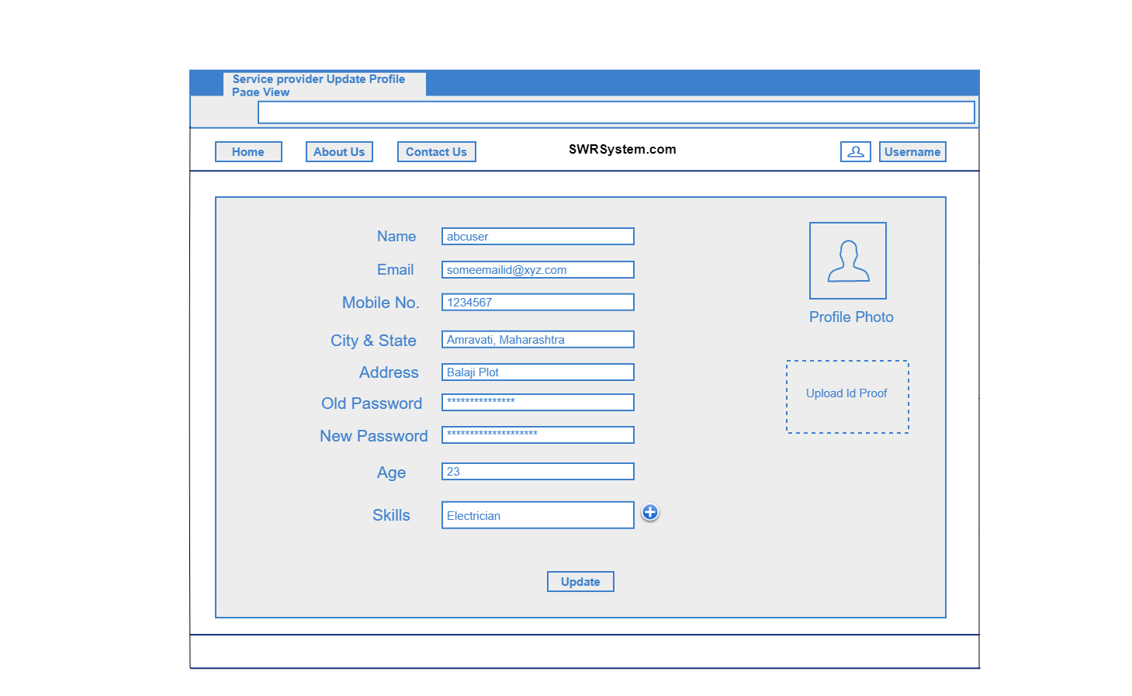

**Service provider Update Profile view**

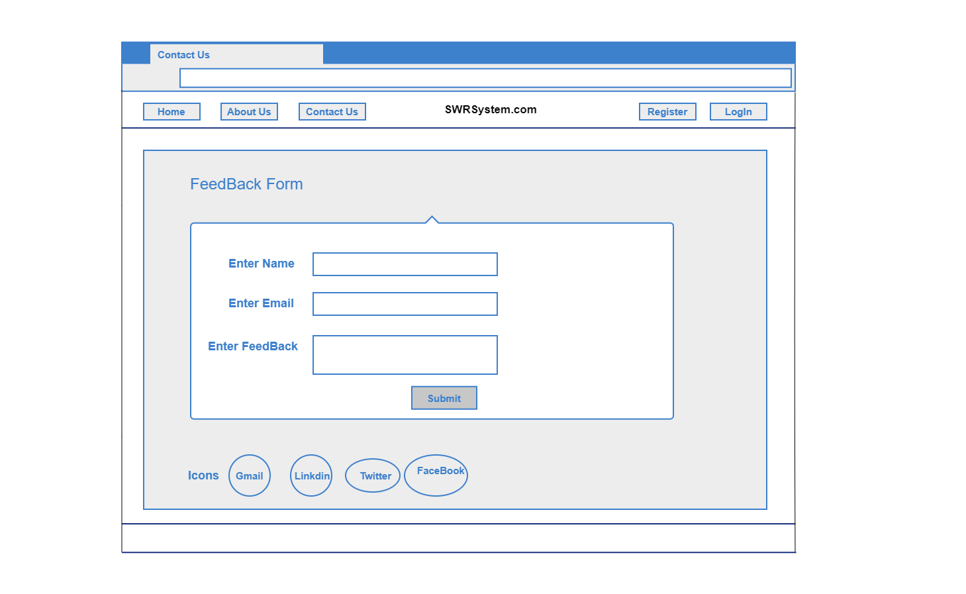

**Contact Us Page**

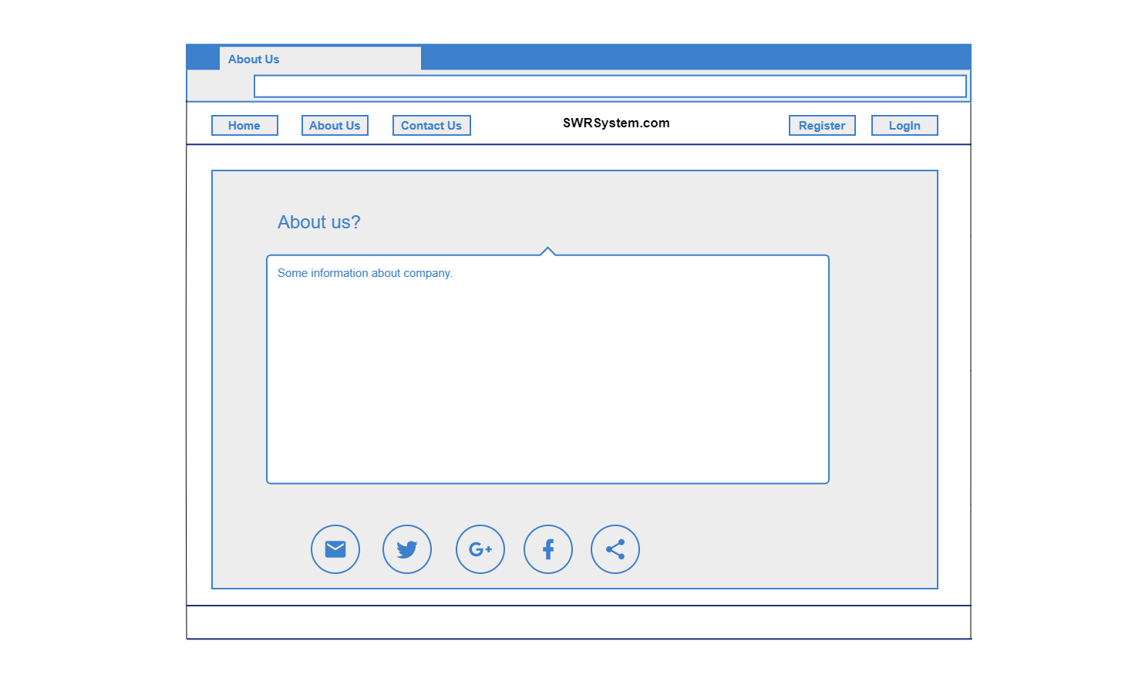

**About Us**