RA2112704010009

ANGELIN J G

T-4

PCA

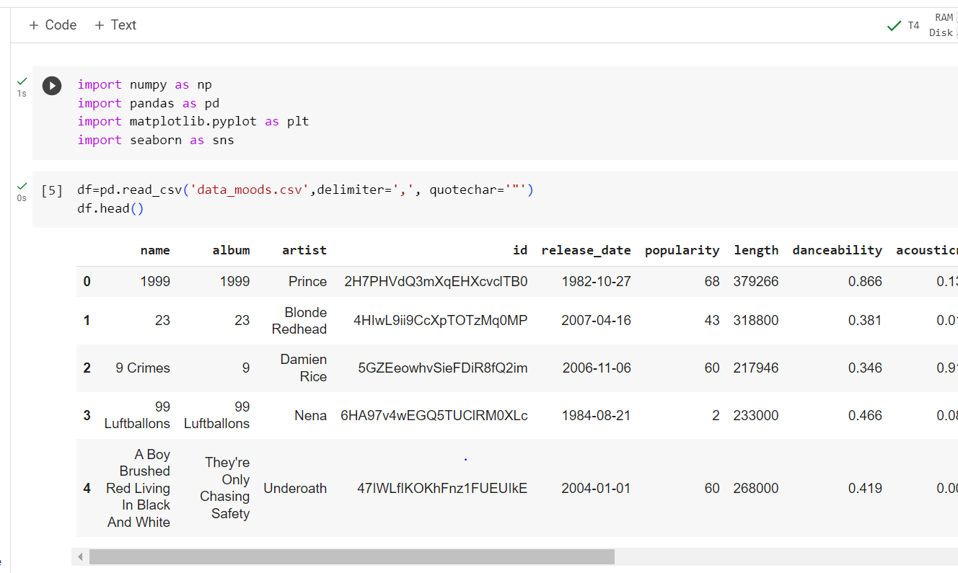

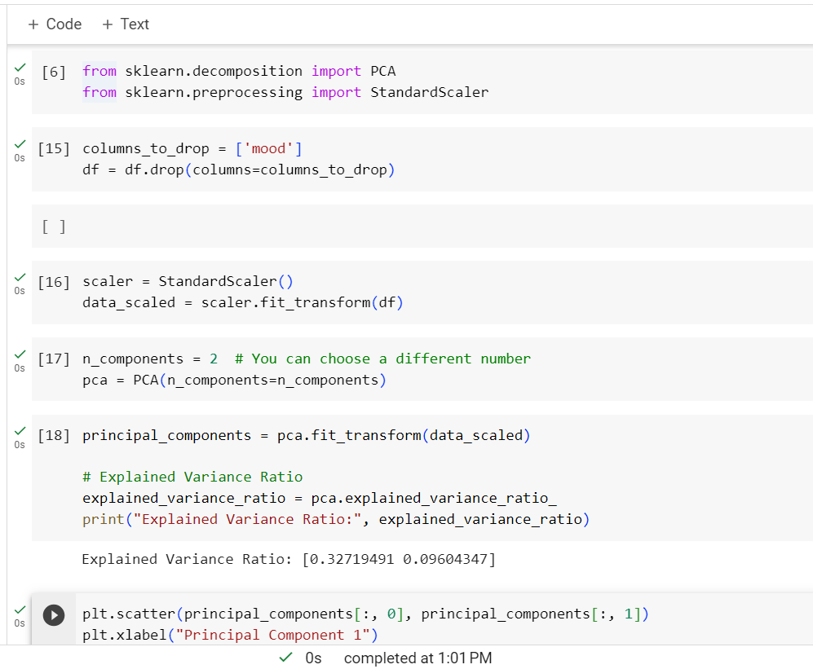

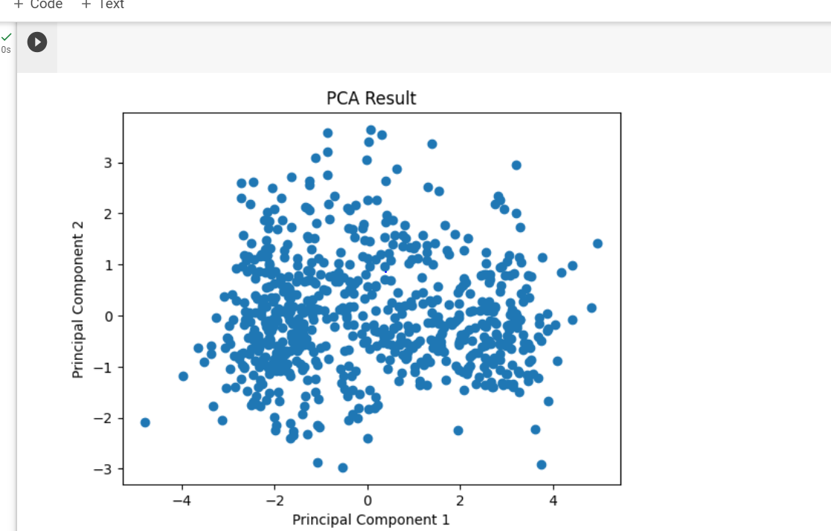

* Standardizes the data using StandardScaler to make it suitable for PCA.
* Creates a PCA object with the desired number of components (n_components).
* Fits PCA on the scaled data and transforms the data into the reduced-dimensional space using fit_transform.
* Calculates and prints the explained variance ratio for each principal component.
* Visualizes the data in the reduced-dimensional space if you have chosen to retain 2 components.