YUVA INTERN – WEEK 2
Data Visualization and Insight Communication using R
Turning a country-year dataset into a clear visual story

Item | Details
Student | [Your Name]
Task | Week 2 – Data Visualization and Insight Communication using R
Dataset | Gapminder-style country-year dataset
Rows / Countries | 1,704 observations / 142 countries
Period | 1952–2007
Main tools | R, ggplot2, dplyr, RStudio

This report focuses on one simple idea: a chart should answer a question. I therefore used different chart types for different questions rather than repeating the same graph with different variables.

1. Introduction
In Week 1, the main focus was cleaning and preparing data. For Week 2, I moved one step forward and focused on how to communicate information clearly through visualizations. I selected a country-year dataset containing life expectancy, population, GDP per capita and continent. The repeated yearly observations make the dataset suitable for both cross-sectional comparisons and trend analysis.
I deliberately did not use six versions of the same chart. Instead, each visualization has a different purpose: ranking, distribution, relationship, change over time, comparison of spread, and correlation.

2. Dataset Overview
The CSV included in this project is the classic Gapminder sample distributed with Plotly's sample-data collection. Gapminder is the underlying public data project, which provides downloadable data and documentation. The project is therefore documented with Gapminder attribution and the original source context.
Variable | Meaning | Type
country | Country name | Categorical
continent | Continent grouping | Categorical
year | Observation year | Numeric / time
lifeExp | Life expectancy in years | Numeric
pop | Population | Numeric
gdpPercap | GDP per capita | Numeric

3. Why this dataset was selected
I chose this dataset because it supports several different forms of visual storytelling. A single year can be used for country comparisons, while the full time period can be used for line charts. GDP per capita and life expectancy also allow a relationship to be explored through a scatter plot. This gives enough variety to meet the visualization requirements without forcing unrelated charts.

4. Data Preparation for Visualization
The data preparation for Week 2 was intentionally light because the purpose was visualization rather than another full cleaning exercise. I checked the structure, selected the variables needed for the charts, converted continent to a factor for consistent ordering, and created a 2007 subset for country-level comparisons.
gap <- read.csv("gapminder.csv", stringsAsFactors = FALSE)
gap$continent <- factor(gap$continent,
levels = c("Africa", "Americas", "Asia", "Europe", "Oceania"))
d2007 <- gap %>% filter(year == 2007)
The choice of 2007 is practical rather than arbitrary: it is the final year in this particular teaching dataset, so it provides a consistent snapshot for comparing countries while the full 1952–2007 period remains available for trends.

5. Visualization 1 – Top 10 Countries by Life Expectancy
Question: Which countries have the highest recorded life expectancy in the 2007 snapshot? A horizontal bar chart is appropriate because the task is a ranking. Horizontal labels are easier to read for country names.
top10 <- d2007 %>% arrange(desc(lifeExp)) %>% slice_head(n = 10)
ggplot(top10, aes(x = reorder(country, lifeExp), y = lifeExp)) +
geom_col() + coord_flip() +
labs(title = "Top 10 Countries by Life Expectancy, 2007",
x = NULL, y = "Life expectancy (years)") +
theme_minimal()
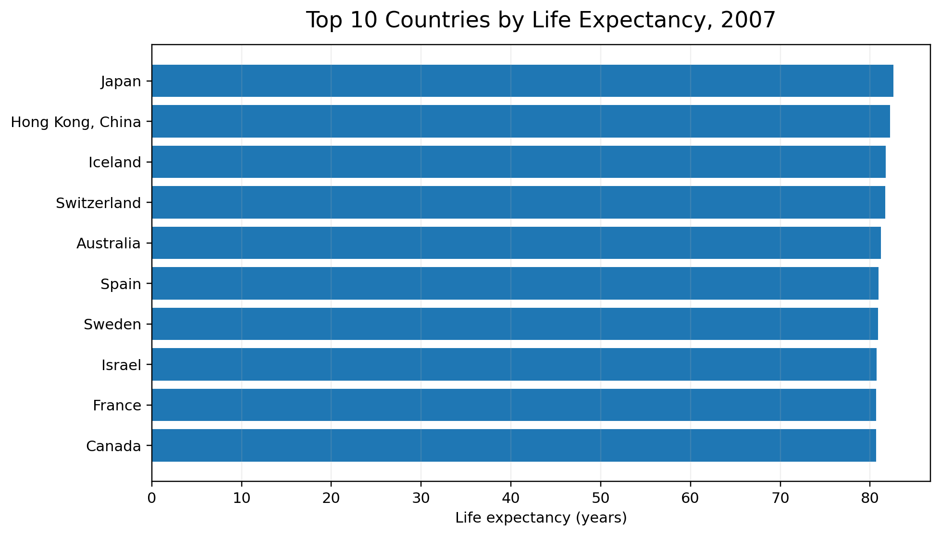
Figure 1. Ranking of the ten highest life-expectancy values in 2007.
The main message is the ordering itself: the top countries are clustered within a relatively narrow high range, rather than one country being separated by an extreme amount from every other country. This chart communicates ranking more directly than a table would.

6. Visualization 2 – Distribution of Life Expectancy
Question: How are life-expectancy values distributed across countries? A histogram is useful here because it shows where observations are concentrated and whether the distribution has a long tail.
ggplot(d2007, aes(x = lifeExp)) +
geom_histogram(bins = 14, color = "white") +
labs(title = "Distribution of Life Expectancy Across Countries, 2007",
x = "Life expectancy (years)", y = "Number of countries") +
theme_minimal()
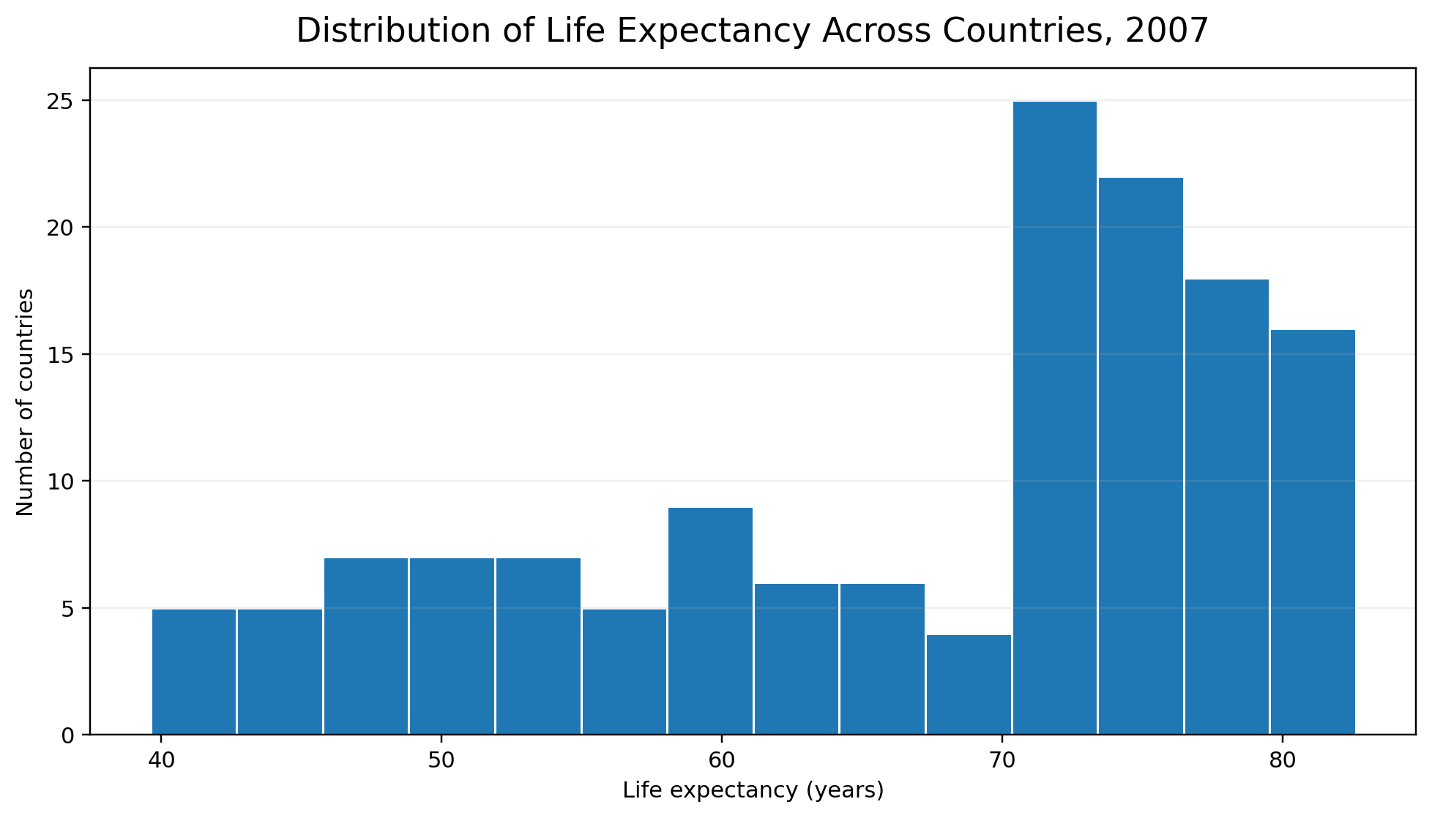
Figure 2. Distribution of country-level life expectancy in 2007.
Most countries fall in the middle-to-upper part of the distribution, while a smaller group appears at the lower end. This is why reporting only an average would hide useful information about how countries are spread.

7. Visualization 3 – GDP per Capita vs Life Expectancy
Question: Is higher GDP per capita associated with higher life expectancy in the 2007 snapshot? A scatter plot is the most direct choice because both variables are continuous. Population is represented by point size, and continent is represented by shape.
ggplot(d2007, aes(x = gdpPercap, y = lifeExp,
size = pop, shape = continent)) +
geom_point(alpha = 0.65) +
scale_x_log10(labels = scales::comma) +
labs(title = "GDP per Capita and Life Expectancy, 2007",
x = "GDP per capita (log scale)", y = "Life expectancy (years)") +
theme_minimal()
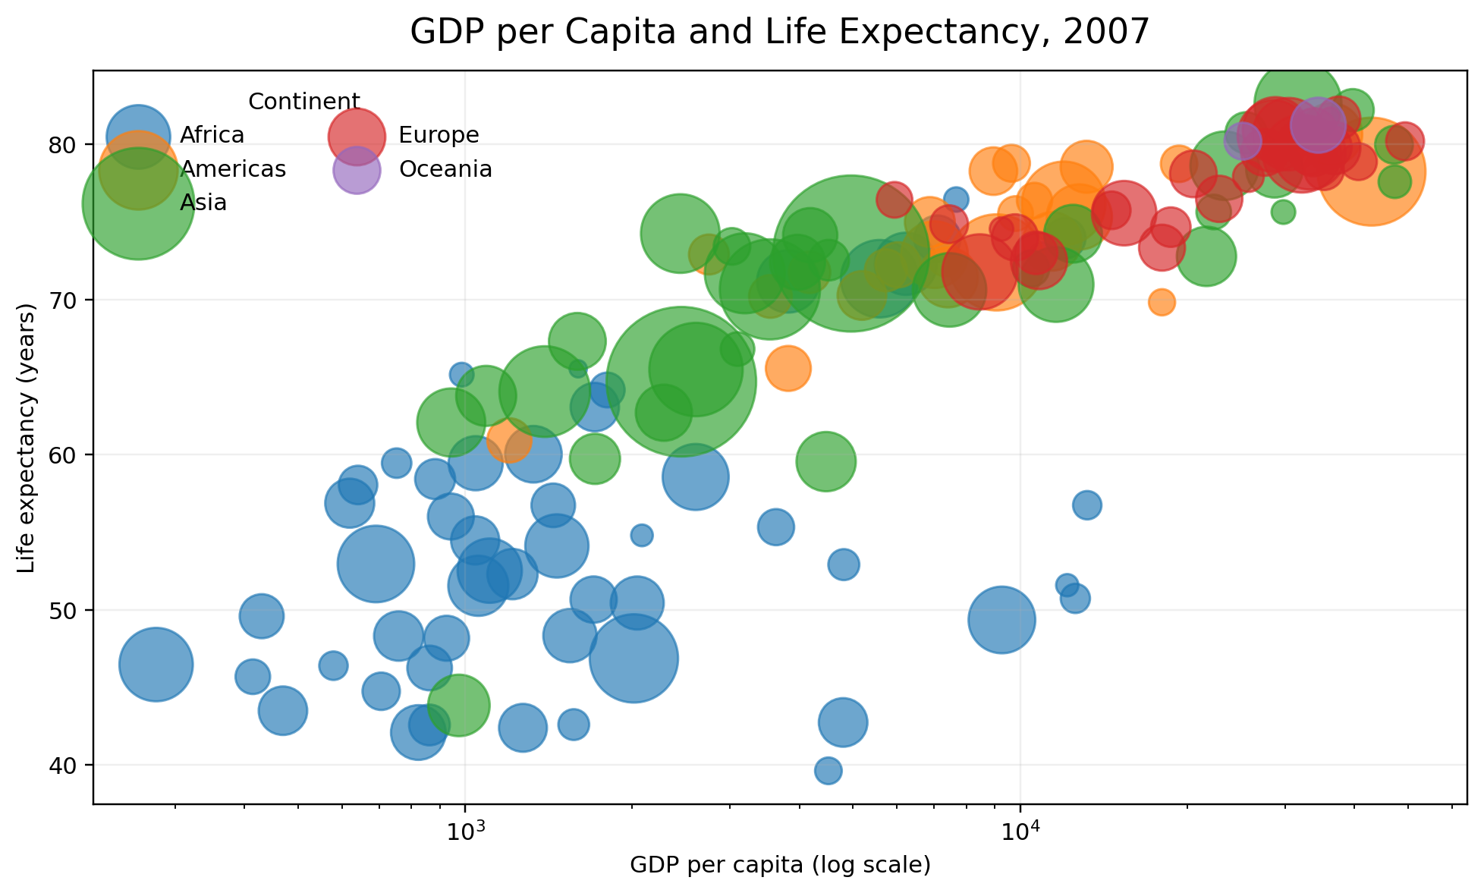
Figure 3. Relationship between GDP per capita and life expectancy in 2007.
The points show a clear positive pattern: countries with higher GDP per capita generally also have higher life expectancy. The relationship is not perfectly linear, and the log scale is important because GDP per capita spans a very wide range. The chart should be interpreted as an association, not proof that GDP alone causes the observed differences.

8. Visualization 4 – Life Expectancy Trend Over Time
Question: How did average life expectancy change across continents between 1952 and 2007? A line chart is appropriate because the horizontal axis represents time and the viewer needs to see direction and change.
trend <- gap %>% group_by(year, continent) %>%
summarise(avg_lifeExp = mean(lifeExp), .groups = "drop")
ggplot(trend, aes(x = year, y = avg_lifeExp,
group = continent, shape = continent)) +
geom_line() + geom_point() +
labs(title = "Average Life Expectancy by Continent Over Time",
x = "Year", y = "Average life expectancy (years)") +
theme_minimal()
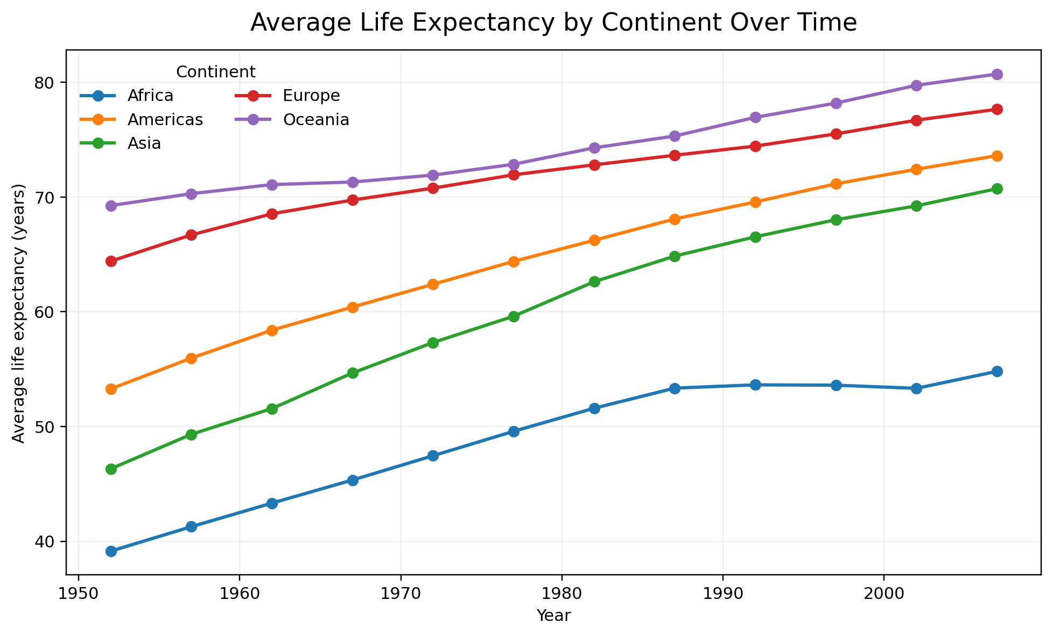
Figure 4. Average life expectancy trend by continent.
The overall average life expectancy in the dataset increases from about 49.1 years in 1952 to about 67.0 years in 2007. The lines also show that the pace and level of change differ by continent. This makes a time-series chart much more informative than comparing only the first and last values in a table.

9. Visualization 5 – Distribution by Continent
Question: How different are the life-expectancy distributions across continents in 2007? A boxplot was selected because it shows the median, spread and unusually low/high observations in a compact way.
ggplot(d2007, aes(x = continent, y = lifeExp)) +
geom_boxplot() +
labs(title = "Life Expectancy Distribution by Continent, 2007",
x = "Continent", y = "Life expectancy (years)") +
theme_minimal()
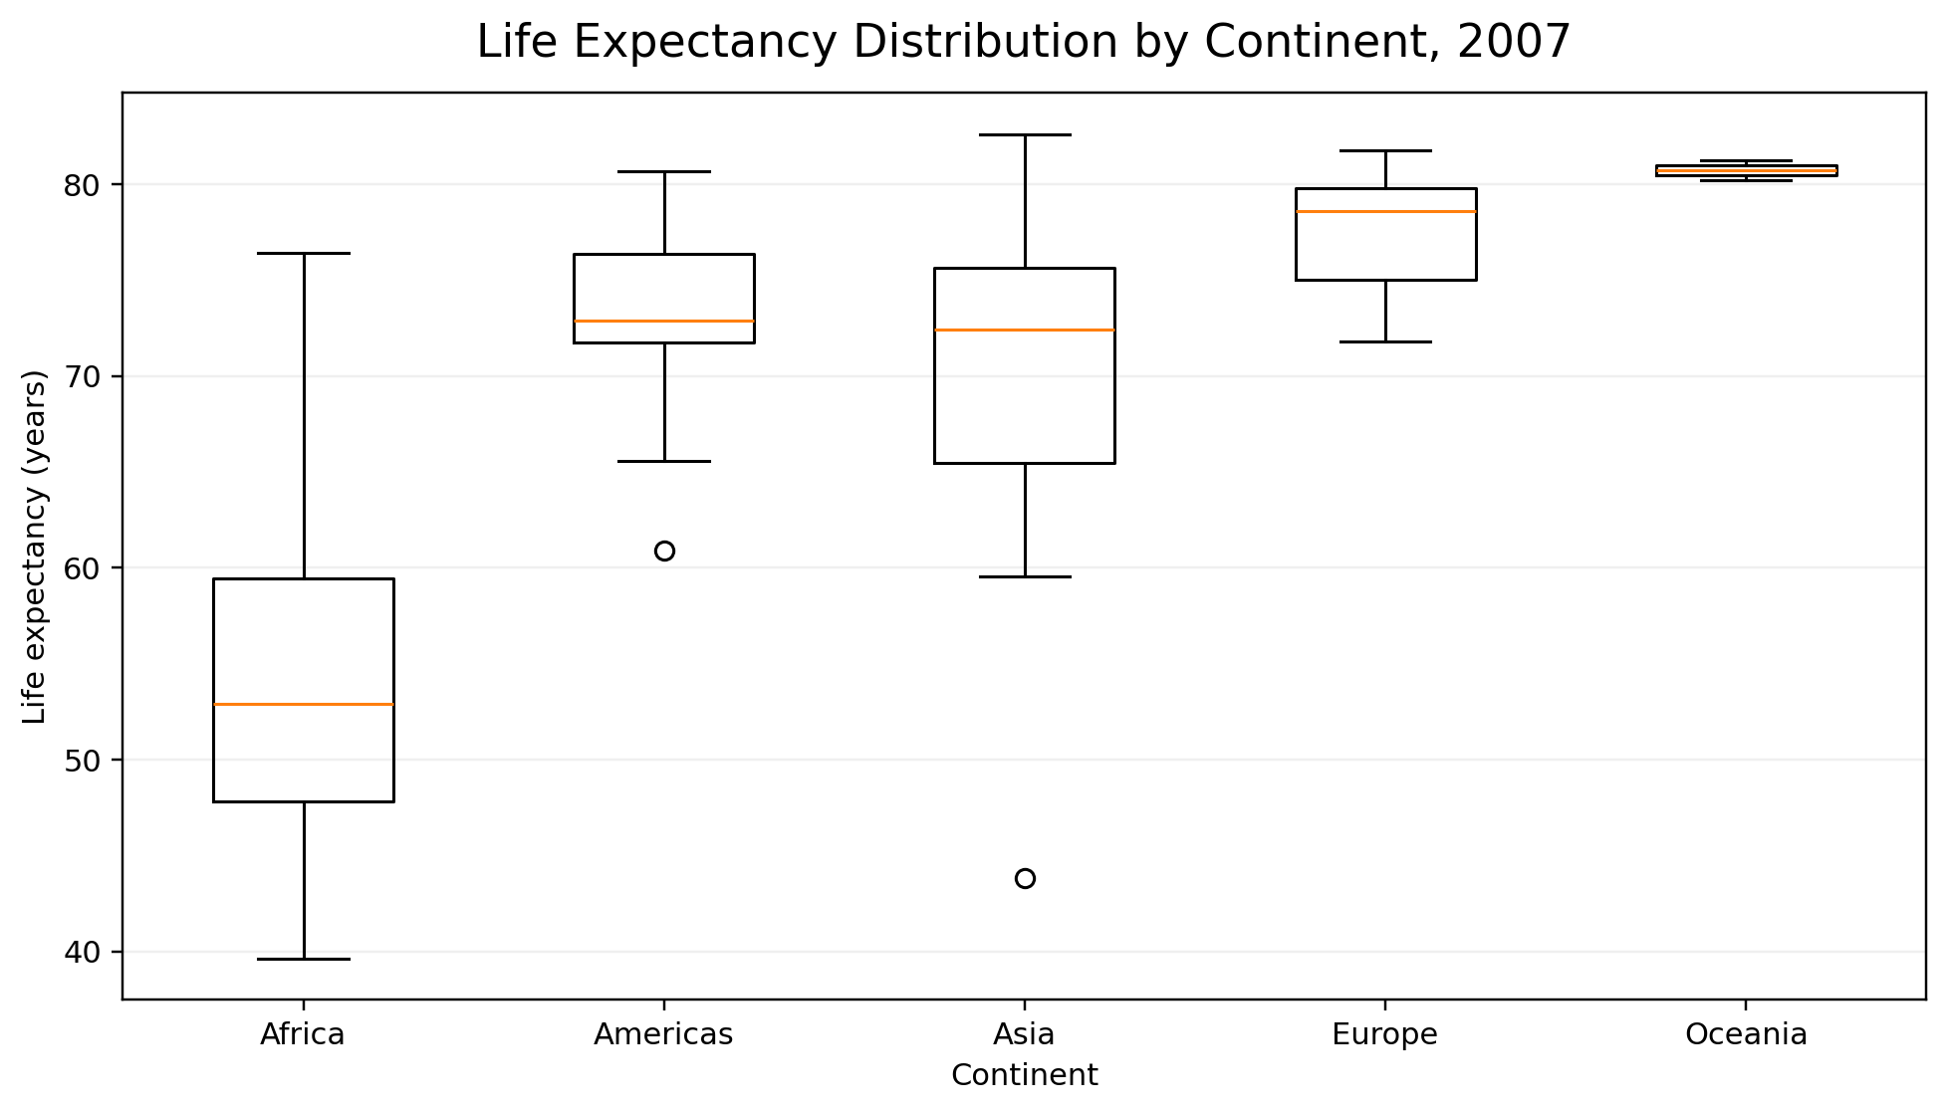
Figure 5. Distribution of life expectancy within each continent in 2007.
This chart adds information that a simple average can miss. Two continents can have similar averages but different spreads. The boxplot therefore supports a more careful comparison of the distribution rather than only the center.

10. Visualization 6 – Correlation Heatmap
Question: How strongly are life expectancy, population and GDP per capita linearly related in 2007? A heatmap makes a small correlation matrix easier to scan than a printed table.
cor_matrix <- cor(d2007[, c("lifeExp", "pop", "gdpPercap")],
use = "complete.obs")
cor_long <- as.data.frame(as.table(cor_matrix))
names(cor_long) <- c("Variable1", "Variable2", "Correlation")
ggplot(cor_long, aes(Variable1, Variable2, fill = Correlation)) +
geom_tile() + geom_text(aes(label = sprintf("%.2f", Correlation))) +
scale_fill_gradient2(limits = c(-1, 1)) + theme_minimal()
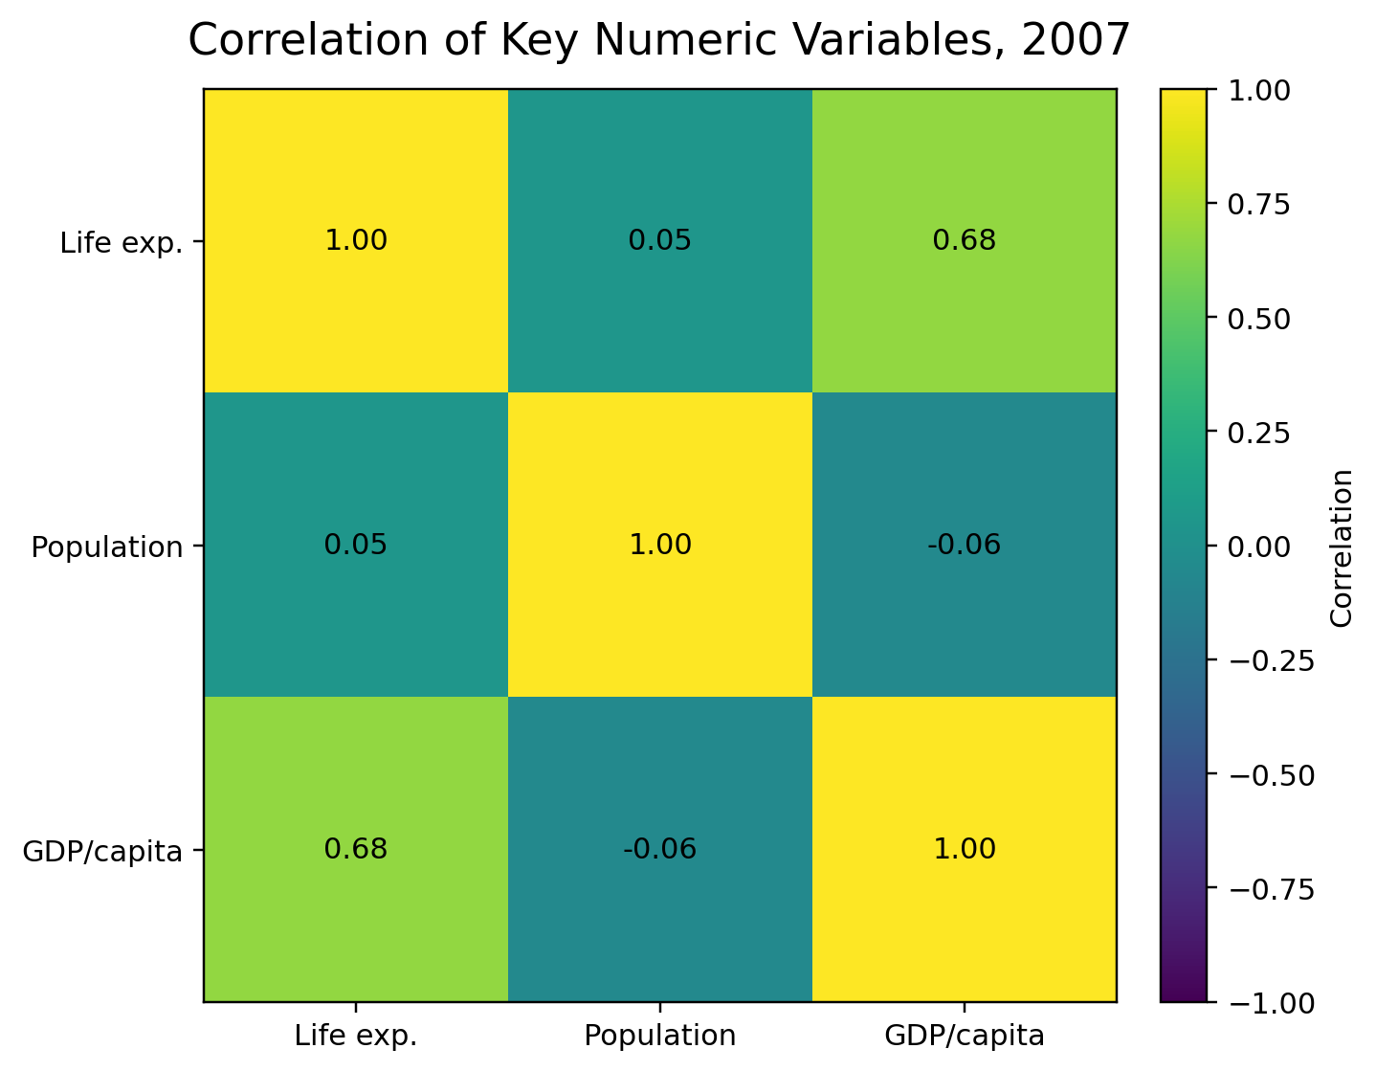
Figure 6. Correlation matrix for the three main numeric variables in 2007.

11. Numerical Summary Behind the Visuals
Continent | Countries | Mean life exp. | Median life exp. | Mean GDP/capita
Africa | 52 | 54.8 | 52.9 | 3,089
Americas | 25 | 73.6 | 72.9 | 11,003
Asia | 33 | 70.7 | 72.4 | 12,473
Europe | 30 | 77.6 | 78.6 | 25,054
Oceania | 2 | 80.7 | 80.7 | 29,810

The table is included as supporting evidence, not as the main communication method. The charts are easier to use when the goal is to see ranking, distribution, trend or relationship.

12. Key Insights Communicated by the Analysis
- Life expectancy differs noticeably across countries in the 2007 snapshot, so a single global average would hide important variation.
- The histogram shows that country values are concentrated in a broad middle-to-high range with a lower-life-expectancy tail.
- GDP per capita and life expectancy show a positive association in 2007. The relationship is easier to see on a logarithmic GDP axis.
- Average life expectancy rises over the 1952–2007 period across all five continent groups, although the starting levels and rates of change differ.
- The boxplot shows differences in both central tendency and spread, not just differences in means.
- The correlation heatmap gives a compact numerical view of the relationships among the main numeric variables.
- Using several chart types together gives a more complete story than relying on one chart.

13. Why Each Chart Type Was Chosen
Chart | Purpose | Why it fits
Bar chart | Ranking countries | Makes country names and relative positions easy to compare.
Histogram | Distribution | Shows concentration, spread and the shape of the data.
Scatter plot | Relationship | Shows how two continuous variables move together and exposes clusters.
Line chart | Time trend | Makes direction and change over time immediately visible.
Boxplot | Group comparison | Shows median, spread and possible unusual values.
Heatmap | Correlation overview | Lets the reader scan several pairwise relationships quickly.

14. Communicating the Results to a Non-Technical Reader
I kept the explanations beside the visuals instead of expecting the reader to understand the R code first. For each chart, I used a plain-language question followed by the reason for choosing that chart and the main observation. Technical details such as log scaling and correlation are explained briefly where they affect interpretation.
An important part of responsible visualization is not overstating what a chart proves. For example, the GDP and life-expectancy scatter plot shows an association in the data; it does not establish a causal relationship. Similarly, continent averages describe the countries included in this dataset and should not automatically be treated as universal estimates for every country or every year.

15. Limitations
- The dataset is a teaching/visualization dataset covering selected country-year observations, so it should not be treated as a current global statistical database.
- GDP per capita is a proxy for economic conditions and does not describe the full distribution of income within a country.
- The scatter plot shows association, not causation.
- Continent-level averages can hide substantial differences between individual countries.
- The 2007 snapshot is useful for comparison but should not be interpreted as a current 2026 snapshot.

16. Reproducibility and GitHub Project
The GitHub repository should contain the R script, the dataset used, the generated figures, the README and this report. Keeping the CSV in the repository makes the analysis reproducible even if the external dataset page changes.
File | Purpose
week2_visualization.R | Complete R code for all six visualizations and summary table.
gapminder.csv | Exact dataset used for the project.
continent_summary_2007.csv | Summary table generated by the R script.
figures/ | High-resolution visualization outputs.
README.md | Project explanation, source, setup and run instructions.
data_source.txt | Dataset and attribution information.
report.docx | Final Week 2 internship report.

17. Conclusion
This week’s work helped me understand that good data visualization is not just about creating attractive graphs. The important part is deciding what question each graph should answer and then choosing a chart that communicates that answer clearly. Using the same dataset, I was able to show rankings, distributions, relationships, changes over time and group differences. I also learned to be careful about interpretation: a visible pattern can be useful for exploration without automatically proving a cause-and-effect relationship.
The final R script keeps the process reproducible. Someone opening the project in RStudio can load the same CSV, run the code and regenerate the visualizations. This makes the report more than a collection of screenshots; it is a documented analysis that can be checked and extended.

Appendix A – Complete R Code
The same code is available as week2_visualization.R in the GitHub repository. It is included here so the report is self-contained.
# Yuva Intern – Week 2
# Data Visualization and Insight Communication using R
# Dataset: Gapminder-style country-year dataset
library(dplyr)
library(ggplot2)
library(scales)
# 1. Load the dataset -----------------------------------------------------
# Keep gapminder.csv in the same folder as this script.
gap <- read.csv("gapminder.csv", stringsAsFactors = FALSE)
gap$continent <- factor(
gap$continent,
levels = c("Africa", "Americas", "Asia", "Europe", "Oceania")
)
# 2. Basic overview ------------------------------------------------------
str(gap)
summary(gap)
cat("Rows:", nrow(gap), "\n")
cat("Countries:", n_distinct(gap$country), "\n")
cat("Years:", min(gap$year), "to", max(gap$year), "\n")
# 3. Focus year for country-level comparisons ----------------------------
d2007 <- gap %>% filter(year == 2007)
# 4. Bar chart: top 10 countries by life expectancy ----------------------
top10 <- d2007 %>%
arrange(desc(lifeExp)) %>%
slice_head(n = 10)
p1 <- ggplot(top10, aes(x = reorder(country, lifeExp), y = lifeExp)) +
geom_col() +
coord_flip() +
labs(
title = "Top 10 Countries by Life Expectancy, 2007",
x = NULL,
y = "Life expectancy (years)"
) +
theme_minimal(base_size = 12)
print(p1)
ggsave("figures/01_top10_life_expectancy.png", p1, width = 9, height = 5.2, dpi = 220)
# 5. Histogram: life expectancy distribution ------------------------------
p2 <- ggplot(d2007, aes(x = lifeExp)) +
geom_histogram(bins = 14, color = "white") +
labs(
title = "Distribution of Life Expectancy Across Countries, 2007",
x = "Life expectancy (years)",
y = "Number of countries"
) +
theme_minimal(base_size = 12)
print(p2)
ggsave("figures/02_life_expectancy_histogram.png", p2, width = 9, height = 5.2, dpi = 220)
# 6. Scatter plot: GDP per capita vs life expectancy ---------------------
p3 <- ggplot(
d2007,
aes(x = gdpPercap, y = lifeExp, size = pop, shape = continent)
) +
geom_point(alpha = 0.65) +
scale_x_log10(labels = comma) +
labs(
title = "GDP per Capita and Life Expectancy, 2007",
x = "GDP per capita (log scale)",
y = "Life expectancy (years)",
size = "Population",
shape = "Continent"
) +
theme_minimal(base_size = 12)
print(p3)
ggsave("figures/03_gdp_vs_life_expectancy.png", p3, width = 9, height = 5.5, dpi = 220)
# 7. Line chart: continent trend over time -------------------------------
trend <- gap %>%
group_by(year, continent) %>%
summarise(avg_lifeExp = mean(lifeExp, na.rm = TRUE), .groups = "drop")
p4 <- ggplot(trend, aes(x = year, y = avg_lifeExp, group = continent, shape = continent)) +
geom_line() +
geom_point() +
labs(
title = "Average Life Expectancy by Continent Over Time",
x = "Year",
y = "Average life expectancy (years)",
shape = "Continent"
) +
theme_minimal(base_size = 12)
print(p4)
ggsave("figures/04_life_expectancy_trend.png", p4, width = 9, height = 5.5, dpi = 220)
# 8. Boxplot: continent comparison --------------------------------------
p5 <- ggplot(d2007, aes(x = continent, y = lifeExp)) +
geom_boxplot() +
labs(
title = "Life Expectancy Distribution by Continent, 2007",
x = "Continent",
y = "Life expectancy (years)"
) +
theme_minimal(base_size = 12)
print(p5)
ggsave("figures/05_life_expectancy_boxplot.png", p5, width = 9, height = 5.2, dpi = 220)
# 9. Correlation heatmap --------------------------------------------------
cor_data <- d2007 %>%
select(lifeExp, pop, gdpPercap)
cor_matrix <- cor(cor_data, use = "complete.obs")
cor_long <- as.data.frame(as.table(cor_matrix))
names(cor_long) <- c("Variable1", "Variable2", "Correlation")
p6 <- ggplot(cor_long, aes(x = Variable1, y = Variable2, fill = Correlation)) +
geom_tile() +
geom_text(aes(label = sprintf("%.2f", Correlation))) +
scale_fill_gradient2(limits = c(-1, 1)) +
labs(
title = "Correlation of Key Numeric Variables, 2007",
x = NULL,
y = NULL,
fill = "Correlation"
) +
theme_minimal(base_size = 12)
print(p6)
ggsave("figures/06_correlation_heatmap.png", p6, width = 6.5, height = 5.2, dpi = 220)
# 10. A small summary table for the report -------------------------------
continent_summary <- d2007 %>%
group_by(continent) %>%
summarise(
countries = n(),
avg_lifeExp = mean(lifeExp),
median_lifeExp = median(lifeExp),
avg_gdpPercap = mean(gdpPercap),
.groups = "drop"
)
print(continent_summary)
write.csv(continent_summary, "continent_summary_2007.csv", row.names = FALSE)

Appendix B – Submission Checklist
- Replace [Your Name] on the cover page with your actual name.
- Upload the .docx report to the Yuva Intern Week 2 submission form.
- Create a public GitHub repository and upload the files listed in Section 16.
- Paste the repository URL into the GitHub project URL field.
- Use the prepared 200+ word submission description in the report-description field if the form asks for one.

