**Weather Forecasting**

*By*

Aman Jaiswal (CSE/16147/137) and

Yash Chandra Verma (CSE/16041/196)



*Bachelor Thesis submitted to*

Indian Institute of Information Technology Kalyani

*for the partial fulfilment of the degree of*

**Bachelor of Technology**

**in**

**Computer Science and Engineering**

Certificate

This is to certify that the thesis entitled “Weather Forecasting” being submitted by Aman Jaiswal and Yash Chandra Verma, an undergraduate student, Roll No. CSE/16147/137 and CSE/16041/196 respectively in Indian Institute of Information Technology Kalyani, West Bengal 741235, India, for the award of Bachelors of Technology in Computer Science and Engineering is an original research work carried by him under my supervision and guidance. The thesis has fulfilled all the requirements as par the regulation of Indian Institute of Information Technology Kalyani and in my opinion, has reached the standards needed for submission. The works, techniques and the results presented have not been submitted to any other university or institute for the award of any other degree or diploma.

-----------------------------

**Dr. Uma Das**

Assistant Professor

Indian Institute of Information Technology Kalyani

**Declaration**

I hereby declare that the work which is being presented in the thesis entitled “Weather Forecasting” is submitted to Indian Institute of Information Technology Kalyani in partial fulfilment for the award of the degree of **Bachelor of Technology** in Computer Science and Engineering does not contain any classified information during the period from **July to December, 2019** under the supervision of Uma Das, Indian Institute of Information Technology Kalyani, West Bengal 741235, India.

Yash Chandra Verma (CSE/16041/196)

Aman Jaiswal (CSE/16147/137)

Computer Science and Engineering

Indian Institute of Information and Technology Kalyani

This is to certify that the above statement made by the candidate is correct to best of my knowledge.

-----------------------------

**Dr. Uma Das**

Assistant Professor

Indian Institute of Information Technology Kalyani

Table of Contents

Abstract 3

Chapter 1: Introduction 4

Chapter 2: Different Approaches 6

Chapter 3: First Approach- Using Machine Learning 7

Chapter 4: Second Approach- Using Deep Learning 12

Chapter 5: Conclusion 16

References 17

**Abstract**

Weather forecasting has been playing an important factor due to it’s applications in the various sectors such as in agriculture, utility company and in day to day life. Weather prediction is a real-time challenging issue witnessed by the world in the last decade. The prediction is becoming more complex due to the ever-changing weather conditions. Weather forecasting entails predicting how the present state of the atmosphere will change. For effective analysis of the weather, it is necessary to understand various influencing factors that cause the weather changes. Weather forecasting is the process of recording the parameters of weather like wind direction, wind speed, humidity, rainfall, temperature etc. Since machine learning techniques are more robust to perturbations, in this project we applied linear regression and LSTM to predict the weather such as temperature, rainfall etc. and compare both approaches and analyzed it. We used two different datasets for the same. Coming to result that we got from each approaches was quite amazing. In the linear regression approach, we got mean absolute error about 96.32 mm and 2.69 celsius when performing rainfall and temperature prediction respectively whereas in the deep learning approach, the mean absolute error was 0.002268 degree celsius, 0.003266 km/h, and 0.003069 Pascal when performing temperature, wind speed and pressure prediction respectively. We could clearly see the difference between the outcomes.

**Chapter 1: Introduction**

Weather conditions changes rapidly, weather forecast is a vital process, weather forecasting is a process of collecting data on atmospheric conditions, which records the temperature, humidity, rainfall, wind speed and its direction etc. high-speed computers, wired and wireless sensors, meteorological satellites and weather radars are the tools used to collect the weather data for weather forecasting. Weather is so popular that there is now a television channel completely devoted to weather issues.

Weather can have a substantial impact on the economy, especially agriculture but other areas as well. The 2005 hurricanes Katrina and Rita caused an extensive shutdown of oil and gas rigs in the Gulf of Mexico resulting in a significant spike in energy prices while the 2006 freeze in California caused hundreds of millions of dollars in losses to citrus growers and widespread unemployment.

There are many applications that this system is used such as Air Traffic, Agriculture, Marine, Forestry, Navy, and Military etc.  The weather forecasting methods used in the ancient time usually implied pattern recognition i.e., they usually rely on observing patterns of events. For example, it is found that the following day has brought fair weather; if the preceding day sunset is particularly red. However, all of the predictions prove not to be reliable. Here in this system, we used parameters like average temperature, cloud cover to predict the rainfall. Two machine and deep learning algorithms were implemented: linear regression and artificial neural networks. A corpus of historical weather data for Denmark and India was obtained and used to train these algorithms.

The Linear Regression method is modified in order to obtain the most optimum error percentage by iterating and adding some percentage of the error to the input values. This method provides an estimate of rainfall using different atmospheric parameters like average temperature and cloud cover to predict the rainfall. The linear regression is applied to the set of data and the coefficients are used to predict the rainfall based on the corresponding values of the parameters. The main advantage of this model is that this model estimates the rainfall based on the previous correlation between the different atmospheric parameters.

Thus, an estimated value of what the rainfall could be at a given time period and place can be found easily.

There are four types of forecasting-

1. Climatology method - The climatology method offers a simple technique for generating a weather forecast. They predict the weather for a specific day and location based on the weather conditions for that same day for several years in the past.
2. Analog method - The analog method is a difficult method to use when predicting the weather because it requires finding a day in the past with weather similar to the current forecast, which is difficult to do. For example, suppose the current forecast indicates a warm day with a cold front imminent in the region of the forecast.
3. Persistence and trends method- The persistence and trends method requires little to no skill to predict the weather because it relies on past trends. In an ideal world, the atmosphere changes slowly, which equates to a forecast tomorrow that stays the same as today, with a hat tip to the climate's norm for the specific time of year.
4. Numerical weather prediction- Numerical weather prediction relies on computers to predict the weather. Massive supercomputers, complete with software forecasting models, help meteorologists make weather predictions based on multiple conditions in the atmosphere such as temperatures, wind speed, high- and low-pressure, rainfall and other conditions.

**Chapter 2: Different Approaches**

For the weather forecasting, we try to solve the problem using two methods and those were-

* Machine Learning
* Deep Learning

We divide the problem using two methods and we have done so because of the following reasons-

* Tackle the problem with different approaches
* Will know what are the strengths and weaknesses of each method.
* Will know what are the difficulties one could face while approaching the problem with these two methods.
* Will know what is the efficiency of each process.

Coming to the first approach that is Machine Learning, here we have solved the problem of weather forecasting with linear regression. In this approach, weather forecasting like rainfall prediction and temperature prediction is done separately. Also, the linear model which was trained for temperature predictions and rainfall predictions were trained using ordinary least square and regularization respectively.

Now coming to the second approach that is Deep learning, here we have solved the problem of weather forecasting in a single stroke. Mean, only in one solution, we have done the forecasting of the temperature, wind speed, and pressure. We have trained our model on LSTM (advanced version of the RNN).

**Chapter 3: First Approach- Using Machine Learning**

The first algorithm that we used was linear regression, which seeks to predict the high and low temperatures as a linear combination of the features. Since linear regression cannot be used with classification data, this algorithm did not use the weather classification of each day.

## 3.1 Linear Regression

Linear regression models are used to show or predict the relationship between two variables. The factor that is being predicted is called thedependent variable. The factors that are used to predict the value of the dependent variable are called the independent variables.

Single Variable Linear Regression is a technique used to model the relationship between a single input independent variable and an output dependent variable using a linear model. In Multi-Variable Linear Regression where a model is created for the relationship between multiple independent input variables and an output dependent variable. Linear regression is fast and easy to model and is particularly useful when the relationship to be modelled is not extremely complex and if you don’t have a lot of data.

## 

## Linear Regression Learning the Model

Learning a linear regression model means estimating the values of the coefficients used in the representation with the data that we have available.

Following are the four techniques to prepare a linear regression model-

1. Simple Linear Regression

2. Ordinary Least Squares

3. Gradient Descent

4. Regularization

## 3.2 Temperature Prediction

**1- Collecting Data Set, and Filter process**

We started to collect out the dataset and we look out to various websites and found a dataset on Open Government Data ([data.gov.in/](https://data.gov.in/)) which consist of various attributes.

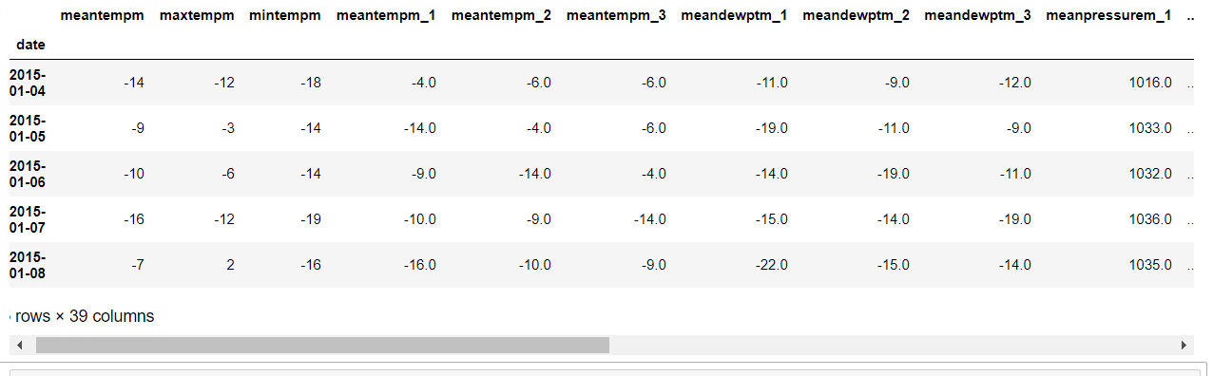

**2 -Training an LR model**

We need to perform temperature prediction, we went with linear regression. The Linear regression model used here was trained on Ordinary Least Squares technique, that is one of the above-mentioned technique. The model trained with OLS also known as Ordinary Least Squares Linear Regression. Following is the OLS Equation-

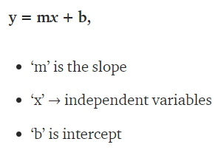

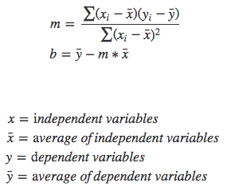

**3- Result**

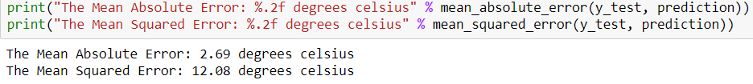

## 3.3 Rainfall Prediction

**1- Collecting Data Set, and Filter process**

We started to collect out the dataset and we look out to various websites and found a dataset on Open Government Data ([data.gov.in/](https://data.gov.in/)) which consist of various attributes. Dataset used in the project is month and year-wise.

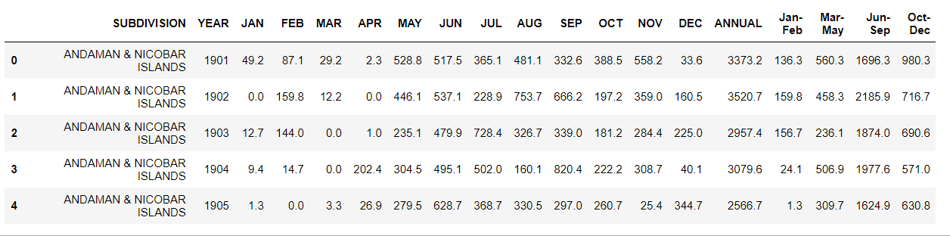

**2- Train an LR model**

We need to perform rainfall prediction, we went with the linear regression model using the regularization method. There are three types of the regularization method and those are Ridge, Lasso and Elastic Net.

Here we have used the Regularization of the Elastic Net version. Following is the Regularization of the Elastic Net version Equation-

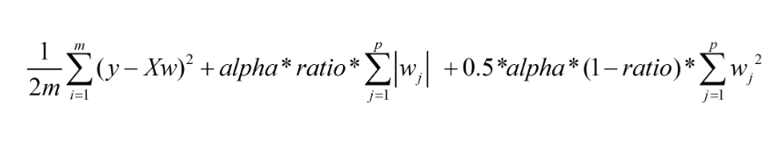

**3- Result**

## 

## Chapter 4: Second Approach- Using Deep Learning

* 1. **Dataset**

We will use weather-data from the period 1980-2018 for five cities in [Denmark](https://en.wikipedia.org/wiki/Denmark)**.**

The raw weather-data was originally obtained from the [National Climatic Data Center (NCDC), USA](https://www7.ncdc.noaa.gov/CDO/cdoselect.cmd).

We are trying to predict the weather for the Danish city "Odense" 24 hours into the future, given the current and past weather-data from 5 cities (although the flowchart below only shows 2 cities).

In the dataset, there are four features basically temp, pressure, wind speed and wind direction. A small snippet is given below of the dataset. Time varies for every 1 hour.

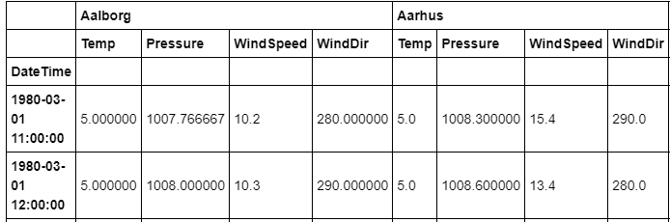

* 1. **LSTM**

Long Short-Term Memory (LSTM) is a specific recurrent neural network (RNN) architecture that was designed to model temporal sequences and their long-range dependencies more accurately than conventional RNNs. It processes data passing on information as it propagates forward. The differences are the operations within the LSTM’s cells. The core concept of LSTM’s are the cell state, and it’s various gates. LSTM introduces long-term memory into recurrent neural networks. It mitigates the vanishing gradient problem, which is where the neural network stops learning because the updates to the various weights within a given neural network become smaller and smaller. It does this by using a series of ‘gates’.

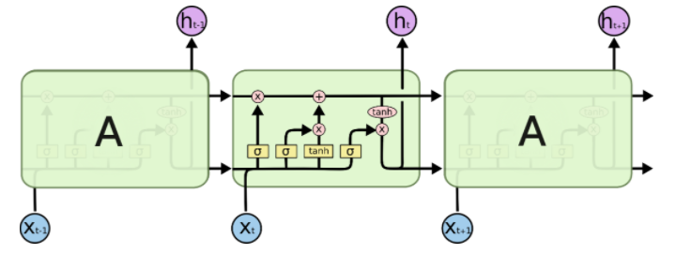

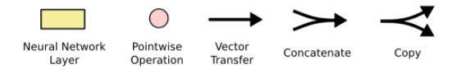

We have three different gates that regulate information flow in an LSTM cell. A forget gate, input gate, and output gate.

**Forget gate**

First, we have the forget gate. This gate decides what information should be thrown away or kept. Information from the previous hidden state and information from the current input is passed through the sigmoid function. Values come out between 0 and 1. The closer to 0 means to forget, and the closer to 1 means to keep.

**Input Gate**

To update the cell state, we have the input gate. First, we pass the previous hidden state and current input into a sigmoid function. That decides which values will be updated by transforming the values to be between 0 and 1 where 0 means not important, and 1 means important. You also pass the hidden state and current input into the tanh function to squish values between -1 and 1 to help regulate the network. Then you multiply the tanh output with the sigmoid output. The sigmoid output will decide which information is important to keep from the tanh output.

**Output Gate**

Last we have the output gate. The output gate decides what the next hidden state should be. Remember that the hidden state contains information on previous inputs. The hidden state is also used for predictions. First, we pass the previous hidden state and the current input into a sigmoid function. Then we pass the newly modified cell state to the tanh function. We multiply the tanh output with the sigmoid output to decide what information the hidden state should carry. The output is the hidden state. The new cell state and the new hidden is then carried over to the next time step.

**Cell State**

Now we should have enough information to calculate the cell state. First, the cell state gets pointwise multiplied by the forget vector. This has the possibility of dropping values in the cell state if it gets multiplied by values near 0. Then we take the output from the input gate and do a pointwise addition which updates the cell state to new values that the neural network finds relevant. That gives us our new cell state.

* 1. **Result**

Here is the Temperature prediction, with temp (in F) & days on y-axis and x-axis respectively.

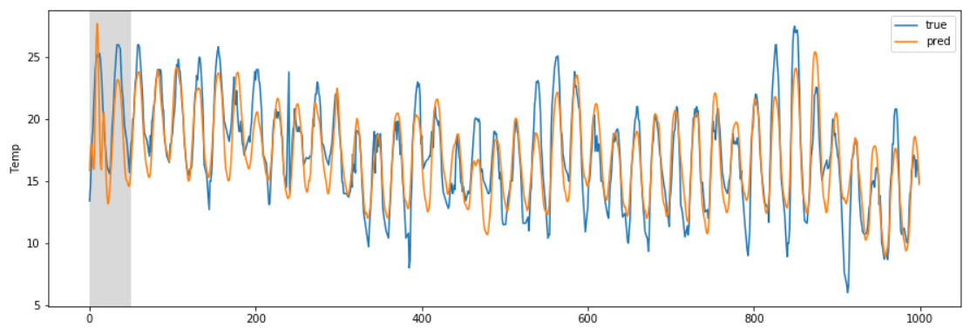

In the above graph, we could observe that there is not much variance in the predicted result and observed the result except for some points.

Here is the wind speed prediction, with wind speed (km/hr) & days on y-axis & x-axis respectively.

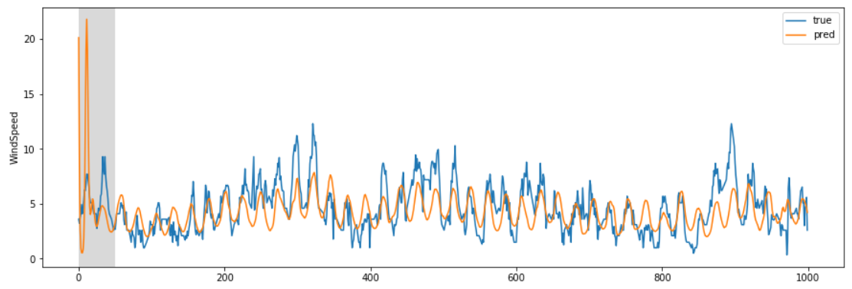

In the above graph, we could observe that there are is not much variance in the predicted result and observed the result except for some points.

Here is the pressure prediction, with pressure (in pascal) & days on y-axis and x-axis respectively.

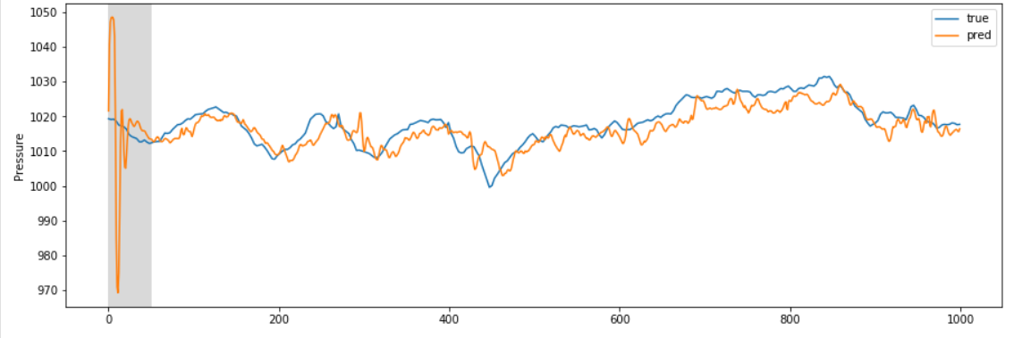

In the above graph, in starting you could see that variation is large but later on it is good. Also, we could observe that there are is not much variance in the predicted result and observed the result.

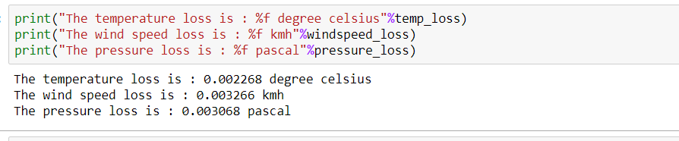

**Chapter 5: Conclusion**

In this project, linear regression and deep learning are used to predict the weather forecasting. We divided the whole weather forecasting project into two parts. Compared to the machine learning approach, deep learning approach which was the deep learning approach gives the better result.

Weather forecasts are increasingly accurate and useful, and their benefits extend widely across the economy. While much has been accomplished in improving weather forecasts, there remains much room for improvement.

For future improvements, following step we thought to took-

* Replacing model with a latest/different model
* Using other robust datasets
* Predicting result on more attributes
* Training model on higher-end GPU

Also, while performing weather forecasting, there was a lot of complexities involved. There are a lot of variables/attributes to consider for forecasting weather and if all or most of them are used, then we need a lot of computation power to get weather information. And, Real time weather forecasting is very difficult to forecast correctly.

**References**

* Parmar, Aakash & Mistree, Kinjal & Sompura, Mithila. (2017). Machine Learning Techniques for Rainfall Prediction: A Review.
* Mateo, Fernando & Carrasco, Juan José & Sellami, Abderrahim & Millán-Giraldo, Mónica & Domínguez, Manuel & Olivas, Emilio. (2013). Machine learning methods to forecast temperature in buildings. Expert Systems with Applications. 40. 1061–1068. 10.1016/j.eswa.2012.08.030.
* Pooja Malik, Prof. Saranjeet Singh, Binni Arora. An Effective Weather Forecasting Using Neural Network
* Abhishek, Kumar & Singh, M. & Ghosh, Saswata & Anand, Abhishek. (2012). Weather Forecasting Model using Artificial Neural Network. Procedia Technology. 4. 311–318. 10.1016/j.protcy.2012.05.047.
* Long Short-Term Memory Recurrent Neural Network Architectures for Large Scale Acoustic Modeling. Has¸im Sak, Andrew Senior, Franc¸oise Beaufays