A VOICE-BASED READING ASSESSMENT SYSTEM FOR ENHANCING THE ARAL READING PROGRAM

A Capstone Project Presented to the Faculty of the

COLLEGE OF INFORMATION TECHNOLOGY
CENTRAL BICOL STATE UNIVERSITY OF AGRICULTURE-SIPOCOT
Sipocot, Camarines Sur

In Partial Fulfillment of the Requirements For the Degree of

BACHELOR OF SCIENCE IN INFORMATION TECHNOLOGY

ANDREW JEFFERSON E. BUENA DIANA MARY ANN D. REJOTO FRANCINE P. TABILOG

May 25, 2026

CHAPTER I
THE PROBLEM AND ITS BACKGROUND
Introduction
Reading is the foundational pillar of all academic learning, cognitive development, and lifelong literacy. The ability to decode words accurately, read fluently with proper prosody, and construct meaning from text determines a student’s capacity to acquire knowledge across science, mathematics, literature, and social disciplines. Despite its critical importance, the global literacy landscape has suffered substantial disruptions in recent years. International assessments, such as the Programme for International Student Assessment (PISA), have consistently highlighted persistent reading difficulties among Filipino learners, revealing that a large percentage of secondary students perform below the minimum reading proficiency threshold (Department of Education [DepEd], 2024). In response to these alarming challenges, the Philippine government enacted Republic Act No. 12028, institutionalizing the Academic Recovery and Accessible Learning (ARAL) Program. The ARAL Program establishes a systematic national framework to accelerate foundational literacy, reading fluency, and comprehension through targeted, evidence-based academic interventions.
In the traditional classroom environment, reading assessment and remediation present overwhelming logistical burdens for educators. Teachers evaluate oral reading fluency individually by listening to each student read a passage aloud, manually marking miscues, calculating Words Per Minute (WPM), recording pronunciation errors, and conducting comprehension questionnaires. In standard class sizes consisting of 40 to 50 students, conducting individual diagnostic reading assessments consumes dozens of hours of instructional time, restricting the frequency of evaluations to once or twice per academic term. Furthermore, manual assessment is susceptible to evaluator subjectivity, fatigue, and inconsistent error tracking. Crucially, struggling readers and non-readers require immediate, frequent, and low-anxiety acoustic feedback to correct phonological miscues before bad reading habits solidify into chronic literacy deficits (Chen et al., 2024).
Recent breakthroughs in Artificial Intelligence (AI), Automatic Speech Recognition (ASR), and Neural Text-to-Speech (TTS) offer powerful opportunities to revolutionize reading pedagogy. Modern neural speech models, such as OpenAI Realtime WebRTC streaming architectures and Faster-Whisper, can transcribe children's spoken reading in real time, analyze phonemic accuracy, and calculate oral reading metrics with high precision (Systran, 2023). Simultaneously, steerable Text-to-Speech synthesis allows the system to act as a warm, patient, and highly articulate reading coach capable of modeling pure speech sounds, guiding echo reading, and scaffolding emergent readers through multi-sensory blending activities (E. et al., 2025). Integrating these advanced speech AI capabilities into a modern Learning Management System (LMS) like Moodle provides an accessible, structured, and scalable environment where reading interventions can be administered continuously, objectively, and adaptively.
Background of the Study
Barcelonita Fisheries School, established on February 8, 1982, is a public secondary educational institution located in Barcelonita, Cabusao, Camarines Sur. Operating under the Department of Education, the school implements the national K–12 curriculum and serves a vibrant community of Junior High School and Senior High School learners, with an approximate student population of 200. As a coastal community institution, Barcelonita Fisheries School is dedicated to delivering inclusive and high-quality education that prepares students for higher learning, technical vocations, and meaningful community participation.
In alignment with national literacy mandates, Barcelonita Fisheries School actively implements reading remediation and the ARAL Reading Program. However, teachers face significant operational hurdles when assessing and coaching struggling students. Initial assessments reveal a wide spectrum of reading abilities within the student body, categorized into three distinct tiers: (1) Independent Readers who require regular fluency and comprehension benchmarking; (2) Instructional Readers who exhibit hesitations, slow reading speed, and mispronunciations requiring line-by-line guided assistance; and (3) Non-Readers / Emergent Decoders who struggle with fundamental phoneme-grapheme correspondences and cannot independently blend multi-letter words.
The current remediation process at Barcelonita Fisheries School relies primarily on printed reading passages, manual stopwatches, and individual teacher evaluation sessions. Because teachers handle multiple subject preparations and heavy teaching loads, they cannot provide daily one-on-one guided oral reading practice to every struggling student. Non-readers, in particular, are often left overwhelmed when presented with dense paragraph texts, while instructional readers lack an interactive audio guide to model correct pronunciation during independent study. To bridge this gap, there is an urgent necessity for an automated, voice-enabled reading assessment and instructional platform tailored specifically to the needs of Barcelonita Fisheries School. This capstone project introduces the Voice-Based Reading Assessment and Instructional Guided System, engineered as an interactive Moodle plugin that integrates real-time speech recognition, steerable teacher audio coaching, and Science of Reading successive phoneme blending to empower both educators and learners in the ARAL Reading Program.
Statement of the Problem
The general problem of this study is: How can a Voice-Based Reading Assessment and Instructional Guided System be designed, developed, and evaluated as a Moodle plugin to enhance the implementation of the ARAL Reading Program at Barcelonita Fisheries School?
Specifically, this study seeks to answer the following research questions:
1. What are the existing reading assessment and remediation practices, challenges, and instructional requirements of teachers and students at Barcelonita Fisheries School under the ARAL Reading Program?
2. What are the functional, architectural, and pedagogical requirements needed to design and develop the Voice-Based Reading Assessment System supporting three tailored learning modes:
a. Independent Reading Assessment Mode (measuring Oral Reading Fluency, Words Per Minute [WPM], and Reading Comprehension);
b. Guided Instructional Reader Mode (providing line-by-line audio modeling, echo reading, word-level sound-out coaching, and configurable 1x to 5x mastery repetition loops); and
c. Non-Reader & Early Phonics Studio Mode (implementing pure synthetic phonics without schwas and Science of Reading Successive Progressive Blending: /f/ → /f/ + /i/ = /fi/ → /fi/ + /sh/ = /fish/ → "fish")?
3. What technical mechanisms and protocols are required to eliminate acoustic loopback and prevent the speech recognition engine from falsely matching its own Text-to-Speech (TTS) audio output during voice-guided reading tasks?
4. How effective is the automated speech processing and phonetic alignment engine in evaluating student pronunciation accuracy, calculating reading fluency metrics, and recording student comprehension in the Moodle Gradebook?
5. What is the level of software quality and usability of the developed system as evaluated by teachers, reading coordinators, and students based on the ISO/IEC 25010 Software Quality Standards?
Objectives of the Study
The primary objective of this study is to design, develop, and evaluate a Voice-Based Reading Assessment and Instructional Guided System integrated with Moodle to enhance the ARAL Reading Program at Barcelonita Fisheries School.
Specifically, the study aims to achieve the following objectives:
1. To identify and analyze the reading difficulties, assessment workflows, and instructional pain points of teachers and learners at Barcelonita Fisheries School.
2. To design, develop, and implement the Moodle reading assessment plugin (mod_readingassessment) featuring three specialized pedagogical modules:
a. Independent Oral Reading Assessment module with real-time speech streaming, dynamic word tracking, Levenshtein miscue analysis, and a 17-type comprehension questionnaire builder;
b. Guided Instructional Reader module featuring line-by-line audio coaching, student echo reading, interactive miscue word assistance, and configurable mastery repetition targets (1x to 5x); and
c. Non-Reader & Early Phonics Studio module utilizing Science of Reading successive progressive blending, pure synthetic phonemes, and picture-word cards.
3. To engineer an ironclad Two-Phase Teacher-Student Handshake protocol incorporating hardware microphone muting (track.enabled = false), Web Speech API suspension (speechRecognizer.abort()), and a 700ms acoustic silence cooldown to ensure zero acoustic loopback during audio playback.
4. To construct an administrative ARAL Reading Progress Dashboard providing real-time class KPIs (Average WPM, Accuracy %, Comprehension %, Duration), student drilldown modals, and 1-click CSV reporting.
5. To evaluate the acceptability, functionality, reliability, usability, and educational efficacy of the developed system in accordance with the ISO/IEC 25010 Software Quality Model.
Significance of the Study
The findings and outputs of this capstone project will significantly benefit the following stakeholders:
To Students and Struggling Readers: The system provides a private, judgment-free, and interactive reading environment where learners can practice oral reading, receive instantaneous pronunciation guidance, and build decoding confidence at their own pace. Non-readers gain structured, step-by-step phoneme blending support, while developing readers benefit from guided audio modeling without fear of peer embarrassment.
To English Teachers and Reading Coordinators: The platform automates the time-consuming tasks of timing passages, calculating Words Per Minute, tracking miscues, and grading comprehension questionnaires. This empowers educators to redirect valuable classroom hours toward high-impact pedagogical interventions while accessing objective, continuous diagnostic reading data.
To School Administrators of Barcelonita Fisheries School: The study equips school leadership with a centralized, data-driven reading dashboard to monitor school-wide literacy progress, evaluate the efficacy of the ARAL Program, and allocate instructional resources strategically.
To the Department of Education (DepEd) & ARAL Program Implementers: The project offers an open-source, standards-compliant technological model demonstrating how artificial intelligence and Learning Management Systems can be practically deployed to accelerate national learning recovery in public secondary schools.
To Future Researchers: The research contributes valuable empirical data, algorithmic methodologies, and architectural blueprints for integrating real-time speech recognition, successive phoneme blending, and acoustic echo mitigation within educational software.
Scope and Delimitation
This capstone study focuses on the design, development, and evaluation of a Voice-Based Reading Assessment and Instructional Guided System implemented as a custom activity module (mod_readingassessment) for Moodle LMS. The primary beneficiaries of the system are the Junior High School and Senior High School students enrolled in reading remediation and the ARAL Reading Program at Barcelonita Fisheries School, located in Barcelonita, Cabusao, Camarines Sur, during the Academic Year 2025–2026.
The system's functional scope is divided into three pedagogical tiers: (1) Independent Reading Assessment, featuring real-time fluency tracking, automated WPM computation, Levenshtein distance miscue classification, and an interactive 17-type comprehension quiz builder; (2) Guided Instructional Reader, featuring line-by-line audio modeling, echo reading, interactive word sound-out coaching, and configurable 1x–5x mastery repetition loops; and (3) Non-Reader & Early Phonics Studio, encompassing four learning stages (Letter Sounds, Random Sound Challenge, Continuous Successive Blending with picture-word cards, and Completion Certification). The technical architecture incorporates an asynchronous Python microservice (Aiohttp) hosting OpenAI Realtime WebRTC session endpoints, Faster-Whisper local ASR fallback, steerable OpenAI Text-to-Speech (with personality instructions and 0.88x speed pacing), and Moodle Gradebook synchronization.
The study is delimited to English oral reading fluency, phoneme blending, and reading comprehension. The system is designed to run on modern web browsers (Google Chrome, Microsoft Edge, Mozilla Firefox) equipped with microphone hardware and requires network connectivity to communicate with the local/cloud speech microservice. The system is not designed to diagnose clinical speech pathologies or cognitive neurological disorders, but rather to serve as an academic assessment and instructional acceleration tool.
Conceptual Framework
The conceptual framework of this study is structured around the Input-Process-Output (IPO) model, illustrating the systematic flow of data, algorithmic processing, and resulting instructional outputs, accompanied by a continuous feedback loop for pedagogical improvement.
Figure 1.1
Conceptual Framework of the Voice-Based Reading Assessment and Instructional Guided System
1. Input Phase: The input domain encompasses: (a) Student oral voice streams captured via microphone; (b) Reading curriculum assets, including graded reading passages, comprehension questionnaires (17 supported question types), phonetic letter sound sets, and picture-word blending cards; (c) Teacher configuration parameters, including activity mode selection, teacher voice selection (13 OpenAI voices), voice personality style prompts, and mastery repetition targets (1x to 5x); and (d) User profile and enrollment credentials from the Moodle database.
2. Process Phase: The core computational and pedagogical engine executes: (a) Dual-engine streaming speech recognition via OpenAI Realtime WebRTC and Continuous Browser Web Speech API; (b) Phonetic alignment and miscue analysis using the Levenshtein minimum edit distance algorithm; (c) Science of Reading Successive Progressive Blending state machine; (d) OpenAI steerable Text-to-Speech synthesis with personality instructions and deliberate speed control; (e) Two-Phase Teacher-Student Handshake executing hardware microphone muting (track.enabled = false), speech recognizer suspension (speechRecognizer.abort()), and 700ms acoustic silence cooldown; (f) Real-time oral reading metrics computation (WPM, Accuracy %, Hesitations, Duration); and (g) Automated Moodle Gradebook synchronization and progress analytics aggregation.
3. Output Phase: The output domain generates: (a) The interactive Voice-Based Reading Assessment and Instructional Guided Moodle Activity Plugin (mod_readingassessment); (b) Real-time visual reading feedback (color-coded word tracking, progressive blend badges, mastery confetti celebration); (c) Comprehensive student attempt diagnostics (transcripts, miscue breakdowns, quiz responses); (d) ARAL Reading Progress Dashboard providing class-wide analytics; and (e) 1-click exportable CSV reports for institutional literacy monitoring.
4. Feedback Loop: The continuous feedback mechanism enables assessment results and diagnostic miscue data to inform teachers in refining passage difficulty, assigning targeted phonics remediation, and tailoring individualized instructional support, fostering progressive literacy advancement.
Definition of Terms
For clarity and consistent understanding, the following terms are defined conceptually and operationally within the context of this study:
ARAL Reading Program. Conceptually, refers to the Academic Recovery and Accessible Learning Program enacted under Republic Act No. 12028 by the Department of Education to accelerate national foundational literacy and numeracy. Operationally, refers to the targeted reading remediation intervention implemented at Barcelonita Fisheries School, Cabusao, Camarines Sur, supported by the proposed voice-based system.
Automatic Speech Recognition (ASR). Conceptually, refers to the computational technology that converts human spoken acoustic signals into written textual form. Operationally, refers to the dual-tier engine (OpenAI Realtime WebRTC and Web Speech API) used to transcribe and evaluate students' spoken reading in real time.
Artificial Intelligence (AI). Conceptually, refers to machine-based systems capable of performing cognitive tasks such as reasoning, speech analysis, and natural language understanding. Operationally, refers to the neural speech processing, miscue alignment, and synthetic voice modeling utilized throughout the Moodle plugin.
Comprehension. Conceptually, refers to the cognitive process of extracting, constructing, and interpreting meaning from written text. Operationally, refers to the student's performance score on the 17 supported interactive questionnaire types completed after reading a passage.
Dual-Engine Speech Recognition. Conceptually, refers to an architecture integrating multiple speech processing technologies to ensure high accuracy and zero system downtime. Operationally, refers to the combination of cloud-based OpenAI Realtime streaming and client-side Continuous Web Speech API fallback.
Guided Instructional Reader. Conceptually, refers to a pedagogical framework where reading is scaffolded through teacher modeling and echo reading. Operationally, refers to the plugin's Mode 2, where passages are broken into single lines, audio-modeled by AI teacher voices, and paired with word-level coaching loops.
Levenshtein Distance Algorithm. Conceptually, refers to a mathematical string metric measuring the minimum number of single-character or single-word edits (insertions, deletions, substitutions) required to transform one string into another. Operationally, refers to the algorithm used to compare the student's spoken transcript against reference passages to classify reading miscues.
Mastery Repetition Target. Conceptually, refers to deliberate over-learning where a learner repeats a skill multiple times to build automaticity and long-term retention. Operationally, refers to the teacher-configurable counter (1x to 5x) requiring students to correctly vocalize coached words multiple times before advancing.
Non-Reader & Early Phonics Studio. Conceptually, refers to an instructional environment dedicated to emergent literacy and synthetic phonics. Operationally, refers to Mode 3 of the plugin, guiding non-readers through Pure Letter Sounds, Random Sound Challenges, Successive Progressive Blending, and Picture-Word Cards.
OpenAI Realtime API. Conceptually, refers to an ultra-low-latency multimodal API providing bi-directional speech and audio streaming over WebRTC protocols. Operationally, refers to the primary streaming speech recognition engine powering real-time oral reading evaluation.
OpenAI Text-to-Speech (TTS). Conceptually, refers to a neural speech synthesis model that converts text into natural-sounding human audio. Operationally, refers to the speech engine supporting 13 official voices, personality instructions, and 0.88x speed pacing to model teacher audio.
Pronunciation Accuracy. Conceptually, refers to the degree of precision with which a speaker articulates standard phonemic sounds and words. Operationally, refers to the percentage of correctly vocalized words and phonemes evaluated against reference phonetic dictionaries.
Pure Synthetic Phonics. Conceptually, refers to a method of reading instruction where individual letter sounds are taught in isolation without appending extra vowel sounds (schwas). Operationally, refers to the system's phoneme modeling that articulates pure continuous sounds (e.g., /ffff/ rather than "fuh").
Reading Fluency. Conceptually, refers to the ability to read text accurately, rapidly, and with appropriate prosodic expression. Operationally, refers to the composite score derived from Words Per Minute (WPM), accuracy percentage, and hesitation metrics.
Real-Time Acoustic Feedback. Conceptually, refers to instantaneous sensory information returned to a learner immediately following vocalization. Operationally, refers to the dynamic visual highlighting, sound badges, and audio corrections provided during reading.
Successive Progressive Blending. Conceptually, refers to a Science of Reading decoding technique where phonemes are accumulated continuously (/f/ -> /fi/ -> /fish/) to prevent working memory decay. Operationally, refers to Stage 3 of the Non-Reader Studio.
Two-Phase Handshake & Loopback Muting. Conceptually, refers to an acoustic control protocol that prevents audio output from leaking into audio input channels. Operationally, refers to the system's hardware track disabling (track.enabled = false), Web Speech API aborting, and 700ms acoustic silence cooldown enforced during TTS playback.
Words Per Minute (WPM). Conceptually, refers to the standard international metric quantifying oral reading rate. Operationally, refers to the calculated value: (Total Correct Words Read / Reading Duration in Seconds) * 60.
References
Chen, Y. C., Chen, N. S., & Lin, Y. T. (2024). Integrating artificial intelligence and extended reality in language education: A systematic literature review (2017–2024). Education Sciences, 15(8), 1066. https://doi.org/10.3390/educsci15081066
Department of Education. (2024). Academic Recovery and Accessible Learning (ARAL) Program (Republic Act No. 12028). Department of Education, Republic of the Philippines. https://www.deped.gov.ph
E., Johnson, J., & William, B. (2025). Real-Time Feedback Systems in Assistive E-Learning: A Step Toward Inclusive Education. ResearchGate. https://doi.org/10.13140/RG.2.2.38989.1863
Hayati, H. A., & Puspitaloka, N. (2022). An analysis of students' reading comprehension difficulties during the COVID-19 pandemic. Journal of English Teaching, 8(2), 123–134.
Kuhfeld, M., Lewis, K., & Peltier, T. (2023). Reading achievement declines during the COVID-19 pandemic: Evidence from 5 million U.S. students. Educational Researcher, 52(4), 215–224. https://doi.org/10.3102/0013189X231153112
Ludewig, U., Kleinkorres, R., Schaufelberger, R., & McElvany, N. (2022). The COVID-19 pandemic and student achievement in reading: A longitudinal analysis. Frontiers in Psychology, 13, 876485. https://doi.org/10.3389/fpsyg.2022.876485
OpenAI. (2024). Text-to-speech guide and developer documentation. OpenAI Platform. https://platform.openai.com/docs/guides/text-to-speech
Stanford Graduate School of Education. (2021). New Stanford study sheds light on how much learning young students have lost during stages of the pandemic. Stanford University. https://ed.stanford.edu/news
Systran. (2023). Faster-Whisper: Reimplementation of OpenAI's Whisper model using CTranslate2. GitHub. https://github.com/SYSTRAN/faster-whisper

CHAPTER II

REVIEW OF RELATED LITERATURE AND STUDIES

This chapter reviews the related literature and studies gathered from the internet, journals, and books. All serve as supporting evidence to this research study.

Questionnaire Module for Pre-Assessment and Post-Assessment

Assessment systems are important tools in evaluating students’ learning progress and determining the effectiveness of instructional strategies. According to Heydarnejad, Tagavipour, and Patra (2022), assessment systems help educators monitor learners’ comprehension, motivation, and academic performance through continuous evaluation. Their study explained that performance-based assessments improve the reliability of educational evaluation and support data-driven instruction. The researchers further emphasized that assessment activities provide meaningful feedback that can guide teachers in identifying learners who require additional academic support and intervention.
Similarly, Cooksey and Jonsson (2022) stated that pre-test and post-test questionnaires are essential in curriculum development because they determine students’ baseline knowledge and measure learning gains after instruction. Their findings highlighted that structured quizzes and assessment forms enable educators to evaluate teaching effectiveness and learner improvement systematically. The researchers also emphasized that assessment results can support educational planning and improve the implementation of instructional programs.

In another study, Ritonga, Tazik, and Omar (2022) explained that assessment activities positively influence reading comprehension, vocabulary learning, and learner motivation. Their research revealed that consistent evaluation practices encourage active participation in learning activities and improve students’ academic confidence. The study highlighted that educational assessments help teachers understand students’ learning behaviors and provide opportunities for continuous learner development.
Furthermore, Abdulaal, Alenazi, Tajuddin, and Hamidi (2022) found that diagnostic assessments positively influence students’ speaking fluency and accuracy. Their findings showed that educational assessment systems provide important feedback that assists teachers in identifying learners’ weaknesses and creating appropriate interventions to improve academic performance. The researchers emphasized that diagnostic assessments are effective tools for monitoring students’ progress before and after instruction. The importance of digital educational systems was also discussed by Kwon, Kim, Bae, Cho, Lee, and Dreamson (2021), who explained that learning management systems and educational technologies improve the monitoring of student performance and the management of learner information. Their study highlighted that digital educational systems support efficient student assessment, facilitate data organization, and improve accessibility to academic records. These technologies also assist educators in making informed decisions regarding instructional strategies and learner development.

These studies highlight the significance of utilizing assessment systems in evaluating students’ baseline performance and learning progress. The reviewed literature suggests that pre-assessment and post-assessment tools provide reliable data that can support instructional improvement, learner monitoring, and intervention planning. In relation to the present study, the use of a questionnaire module for pre-assessment and post-assessment will help evaluate students’ academic performance before and after participation in the ARAL Program, enabling educators to measure learning progress and determine the effectiveness of reading interventions.

Student Selection and Profiling System

Student profiling systems play an important role in organizing learner information and improving educational management. According to Kwon, Kim, Bae, Cho, Lee, and Dreamson (2021), learning management systems help educational institutions collect, organize, and manage student data effectively. Their study emphasized that digital systems support personalized learning and improve communication between teachers and learners through organized learner records and performance monitoring. The researchers further explained that technology-based systems improve the efficiency of educational processes by making student information more accessible and manageable.
Recent educational technologies have also integrated profiling systems to classify learners according to their academic needs and performance. Kwon et al. (2021) explained that digital systems improve learner management and help educators monitor students’ educational progress using organized databases.

Through these systems, educators can easily identify learners who require academic support and implement suitable interventions according to students’ needs. Similarly, Cooksey and Jonsson (2022) stated that learner data gathered through assessments can be used to identify academic strengths and weaknesses. Their study emphasized that systematic student profiling supports educational planning and targeted intervention programs because educators are provided with reliable information regarding students’ academic conditions. The researchers also highlighted that organized learner data contributes to more effective instructional planning and student monitoring.
Heydarnejad, Tagavipour, and Patra (2022) further explained that assessment-based learner classification helps teachers develop appropriate instructional strategies according to students’ needs and abilities. Their findings showed that educational technologies improve the accessibility of academic records and learner evaluations, making it easier for teachers to monitor students’ performance and identify areas requiring improvement. The study emphasized that learner classification is important in ensuring that instructional interventions are aligned with students’ learning capacities.
In another study, Ritonga, Tazik, and Omar (2022) found that digital assessment systems improve learners’ engagement and academic monitoring. The researchers explained that technology-based educational systems provide accurate learner information that assists educators in making informed decisions regarding student development and intervention planning. These systems also

support efficient monitoring of students’ academic progress and participation in learning activities.
These studies highlight the importance of implementing student profiling systems in educational programs and assessment systems. Understanding learners’ academic profiles, strengths, and weaknesses allows educators to design appropriate instructional strategies and interventions that respond to students’ needs. In relation to the present study, the implementation of a student selection and profiling system for the ARAL Program will support efficient learner classification, organized data management, and effective monitoring of students’ academic progress.

Voice-Based Assessment Using OpenAI Whisper

Voice-based assessment systems have become widely used in evaluating reading fluency and pronunciation accuracy. According to Molenaar, Tejedor-Garcia, Strik, and Cucchiarini (2023), automatic speech recognition systems such as Whisper can effectively assess oral reading accuracy and support reading diagnostics. Their findings showed that AI-based speech recognition technologies achieved results comparable to human evaluation in assessing students’ oral reading performance. The researchers emphasized that automated systems provide reliable and efficient tools for evaluating learners’ reading abilities and identifying reading difficulties.
Similarly, Wang et al. (2022) explained that automatic assessment systems for oral reading can evaluate reading fluency, pronunciation, and expressiveness

through speech-based analysis. Their study revealed that speech recognition technologies support educators in monitoring reading development more efficiently by providing objective and accurate assessment results. The researchers also noted that automated oral reading systems help reduce the time and effort required in traditional reading evaluations.
In another study, Inceoglu, Chen, and Lim (2022) examined the use of automatic speech recognition in pronunciation assessment. Their findings showed that ASR systems support pronunciation learning by providing feedback regarding learners’ intelligibility and speaking performance. The study emphasized that speech recognition technologies improve pronunciation evaluation because they can analyze speech patterns consistently and accurately. Kim, Jeon, Seo, and Kim (2022) also introduced an automatic pronunciation assessment system using self-supervised speech representation learning. Their research demonstrated that AI-based pronunciation evaluation systems improve the accuracy of assessing learners’ pronunciation skills and speaking performance. The researchers explained that advanced speech recognition models contribute to more reliable language assessment systems that can support educational applications.
Furthermore, Saito, Macmillan, Kachlicka, Kunihara, and Minematsu (2022) discussed automated assessment systems for second-language comprehensibility. Their study emphasized that AI-driven speech assessment tools are effective in evaluating fluency, pronunciation, and oral communication skills in educational environments. The researchers further explained that automated

speech assessment systems provide consistent feedback that can support learners in improving their oral reading and speaking abilities.
These studies highlight the importance of utilizing voice-based assessment technologies in evaluating reading fluency and pronunciation accuracy. The reviewed literature suggests that automatic speech recognition systems provide reliable, efficient, and objective assessment results that can support reading diagnostics and intervention planning. In relation to the present study, the implementation of a voice-based assessment using the OpenAI Whisper model will help evaluate students’ oral reading performance and support the development of appropriate literacy interventions for struggling readers.

Recommendation System Based on Phil-IRI Results

Recommendation systems are important tools in providing targeted interventions and reading development strategies for struggling readers. According to Heydarnejad, Tagavipour, and Patra (2022), assessment-based educational interventions improve students’ reading comprehension and academic performance by identifying learners’ needs through diagnostic evaluations. Their findings emphasized that intervention strategies based on assessment results help educators address students’ specific learning difficulties and improve overall academic achievement.
Similarly, Ritonga, Tazik, and Omar (2022) explained that learner-centered interventions improve reading motivation and vocabulary development by addressing students’ individual learning needs. Their study highlighted that

educational recommendation systems can support individualized learning strategies for students with different reading abilities. The researchers further explained that targeted instructional interventions contribute to better learner engagement and academic improvement.
Molenaar, Tejedor-Garcia, Strik, and Cucchiarini (2023) also emphasized that automated reading assessments provide reliable information that can be used to design targeted reading interventions and support systems for learners experiencing reading difficulties. Their study revealed that assessment-based intervention planning improves the efficiency of literacy programs because educators can identify students’ reading challenges more accurately. In another study, Wang et al. (2022) found that oral reading assessment systems can identify students’ fluency and pronunciation difficulties, allowing educators to provide suitable reading development strategies and intervention programs. Their findings showed that speech-based assessment technologies help educators monitor learners’ reading performance and implement appropriate literacy support according to students’ needs.
Furthermore, Cooksey and Jonsson (2022) stated that assessment results should be used to improve curriculum planning and provide evidence-based recommendations for learner development. Their study emphasized that educational recommendation systems support continuous student improvement through data-driven instructional strategies and intervention planning. The researchers highlighted that assessment-based recommendations help educators provide more effective learning experiences for students.

These studies highlight the importance of implementing recommendation systems in literacy programs and educational assessment systems. The reviewed literature suggests that assessment-based interventions and recommendation systems support individualized learning, improve reading development, and assist educators in addressing learners’ specific academic needs. In relation to the present study, the development of a recommendation system based on Phil-IRI results will help provide targeted interventions and reading development strategies according to students’ reading performance and academic progress.

Synthesis of Related Literature and Studies

The reviewed literature highlights the importance of assessment systems, student profiling, voice-based reading evaluation, and recommendation systems in improving literacy programs and educational interventions. Studies by Heydarnejad et al. (2022), Cooksey and Jonsson (2022), Ritonga et al. (2022), Abdulaal et al. (2022), and Kwon et al. (2021) emphasized that pre-assessment and post-assessment tools are essential in monitoring students’ learning progress, identifying academic strengths and weaknesses, and evaluating the effectiveness of instructional strategies. These studies revealed that continuous assessment practices support data-driven instruction, improve learner engagement, and provide educators with reliable information necessary for intervention planning and academic monitoring.
The literature also emphasized the significance of student selection and profiling systems in educational management. Kwon et al. (2021) explained that digital educational technologies and learning management systems improve the

organization, accessibility, and management of learner information. Similarly, Cooksey and Jonsson (2022), Heydarnejad et al. (2022), and Ritonga et al. (2022) highlighted that systematic learner profiling supports effective instructional planning, targeted interventions, and efficient academic monitoring. These studies suggest that profiling learners according to their academic needs and performance allows educators to develop more personalized and appropriate instructional strategies for students.
Advancements in artificial intelligence and speech recognition technologies further support the development of voice-based assessment systems for literacy evaluation. Molenaar et al. (2023), Wang et al. (2022), Inceoglu et al. (2022), Kim et al. (2022), and Saito et al. (2022) emphasized that automatic speech recognition systems such as OpenAI Whisper can effectively assess oral reading fluency, pronunciation accuracy, and oral communication skills. Their studies demonstrated that AI-driven speech assessment tools provide objective, reliable, and efficient evaluation results comparable to human assessment. These technologies also improve reading diagnostics and support educators in identifying students’ reading difficulties more efficiently.
The reviewed studies also highlighted the importance of recommendation systems and targeted interventions in supporting struggling readers. Heydarnejad et al. (2022) and Ritonga et al. (2022) emphasized that assessment-based educational interventions improve reading comprehension, vocabulary development, and learner motivation by addressing students’ specific academic needs. Similarly, Molenaar et al. (2023) and Wang et al. (2022) explained that

automated reading assessments provide reliable information that can be used to design suitable literacy interventions and reading development strategies. Cooksey and Jonsson (2022) further emphasized that assessment results should be utilized in developing evidence-based instructional recommendations that support continuous learner improvement and curriculum planning.
Overall, the reviewed literature converges on the importance of integrating assessment systems, student profiling, speech recognition technologies, and recommendation systems in literacy programs and educational interventions. The studies collectively suggest that combining pre-assessment and post-assessment tools, learner profiling, AI-based oral reading evaluation, and intervention recommendation systems provides a comprehensive framework for monitoring students’ progress and supporting struggling readers. In relation to the present study, these findings support the development of a voice-based reading assessment and recommendation system for the ARAL Program that aims to improve learner assessment, academic monitoring, and literacy intervention planning through the use of educational technologies and artificial intelligence.

NOTES

Heydarnejad, T., Tagavipour, F., & Patra, I. (2022). The impacts of performance-based assessment on reading comprehension achievement, academic motivation, foreign language anxiety, and students’ self-efficacy. Language Testing in Asia, 12(51). Retrieved from https://link.springer. com/article/10.1186/s40468-022-00202-4

Cooksey, K. L., & Jonsson, P. (2022). Using pre-/post-quizzes intentionally in curriculum development and evaluation. Retrieved from https://arxiv
.org/abs/2210.01823

Ritonga, M., Tazik, K., & Omar, A. (2022). Assessment and language improvement: The effect of peer assessment on reading comprehension, reading motivation, and vocabulary learning among EFL learners. Language Testing in Asia, 12(36). Retrieved from https://link.springer.com/article
/10.1186/s40468-022-00188-z

Abdulaal, M. A. A., Alenazi, M. H., Tajuddin, A. J. A., & Hamidi, B. (2022). Dynamic vs. diagnostic assessment: Impacts on EFL learners’ speaking fluency and accuracy, learning anxiety, and cognitive load. Language Testing in Asia,
12(32). Retrieved from https://link.springer.com/article/10.1186/s40468-022-00179-0

Kwon, S., Kim, W., Bae, C., Cho, M., Lee, S., & Dreamson, N. (2021). The identity changes in online learning and teaching: Instructors, learners, and learning management systems. International Journal of Educational Technology in Higher Education, 18(67). Retrieved from https://link.springer.com/article
/10.1186/s41239-021-00304-8
Molenaar, B., Tejedor-Garcia, C., Strik, H., & Cucchiarini, C. (2023). Automatic assessment of oral reading accuracy for reading diagnostics. Retrieved from https://arxiv.org/abs/2306.03444

Wang, F., et al. (2022). Automatic assessment of oral readings of young pupils. Speech Communication, 138, 67–79. Retrieved from https://www. sciencedirect.com/science/article/pii/S0167639322000164

Inceoglu, S., Chen, W.-H., & Lim, H. (2022). Assessment of L2 intelligibility: Comparing L1 listeners and automatic speech recognition. ReCALL. Retrieved from https://www.cambridge.org/core/ journals/recall/article
/abs/assessment-of-l2-intelligibility-comparing-l1-listeners-and-automatic-speech-recognition/7E499AD990383AC65A9688BB5BE17887

Kim, E., Jeon, J.-J., Seo, H., & Kim, H. (2022). Automatic pronunciation assessment using self-supervised speech representation learning. Retrieved from https://arxiv.org/abs/2204.03863

Saito, K., Macmillan, K., Kachlicka, M., Kunihara, T., & Minematsu, N. (2022). Automated assessment of second language comprehensibility: Review, training, validation, and generalization studies. Studies in Second Language Acquisition. Retrieved from https://www.cambridge.org/core
/journals/studies-in-second-language-acquisition/article /automat ed-assessment-of-second-language-comprehensibility-review-training-vali dation-and-generalization-studies/ED850D916818C7ABA23EA1CA8CF 8A590

CHAPTER III
RESEARCH DESIGN AND METHODOLOGY

This chapter presents the research design, methodology, system architecture, requirements, and diagrams for the system “a voice-based reading assessment system for enhancing the aral reading program”.

Research Design

This study adopted both developmental and descriptive methods of research to achieve its objectives. The descriptive method was employed to gather information by observing and documenting the reading behaviors of students enrolled in the ARAL Program. Through this approach, data on reading fluency, pronunciation accuracy, and comprehension levels were collected, providing insights into the current challenges faced by learners and guiding the formulation of appropriate solutions. Meanwhile, the developmental method was applied in the design and creation of a voice-based reading assessment system. This process involved establishing a business case that led to the development of a software product capable of monitoring and evaluating students’ oral reading performance. The system allowed teachers to record and analyze reading outputs, generate reports, and provide timely feedback, while also enabling users to access information about reading progress and areas needing improvement.
By combining descriptive observations with developmental processes, and grounding the study in relevant literature, the researchers ensured that the project was both researchable and responsive to the needs of the ARAL Reading Program.

Research Methodology

The Iterative SDLC model was used in developing the system. It explains and illustrates the processes and procedures of the project plan and establishment phase. It refers to a development life cycle designed to deliver high-quality systems through repeated cycles of planning, design, implementation, and testing (Larman & Basili, 2003).
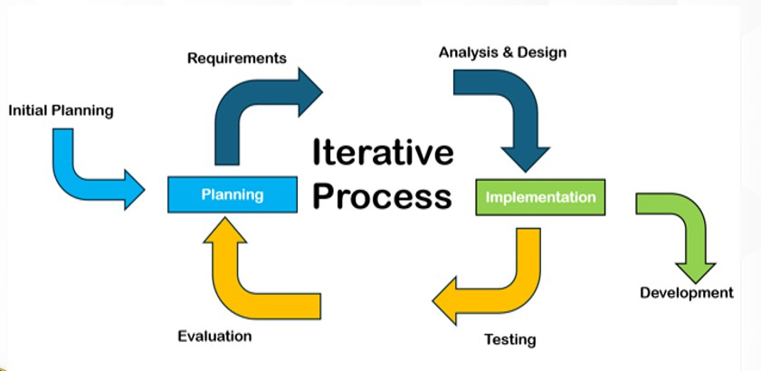
Literature about the Iterative model centers on incremental development and user involvement, where analysis, design, build, and test phases are repeated in short cycles until the system evolves into its final form. Each iteration produces a working prototype that incorporates feedback from stakeholders, allowing requirements to be refined and risks to be reduced. This set of methods was developed to overcome the weaknesses of traditional system development methods by emphasizing adaptability, continuous improvement, and early delivery of functional components. Compared to traditional approaches, the Iterative model provides flexibility and better alignment with user needs (Kumar & Bhatia, 2014).
Figure 3.1

Iterative Model

Phase 1: Initial Planning/Planning

In this phase, the researchers worked together with stakeholders to set the goals and expectations of the project based on the challenges observed in students’ reading performance. They conducted informal consultations and observations with teachers involved in the ARAL Reading Program to better understand common difficulties in fluency, pronunciation, and comprehension. At the same time, the researchers planned the tasks, timeline, and resources needed for the system’s development, including the tools and methods to be used. This phase aimed to ensure that the project was well-organized and could be carried out smoothly and efficiently.

Phase 2: System Requirements

In this phase, the developers and program coordinators collaborated in determining the goals and expectations of the project given the current and potential issues in the ARAL Reading Program. For this purpose, the researchers conducted both structured and unstructured interviews with teachers and reading coordinators at Barcelonita Fisheries School. Its aim was to gather information and identify all encountered problems in assessing students’ oral reading fluency and comprehension.
Based on the data gathered, it was found that teachers experienced difficulties in conducting manual reading assessments, particularly in terms of consistency, time consumption, and subjectivity of scoring.

Furthermore, teachers had limited tools to analyze pronunciation errors, pacing, and comprehension levels in real time. Experience and informal strategies, such as relying on classroom observations usually used in determining reading performance. These led to issues on credibility and reliability of the assessment results. After assessing the problems of the client (teachers and students), the researchers decided to develop a voice-based reading assessment system that is able to record, analyze, and provide feedback on students’ oral reading performance.
Table 3.1

Software Requirements

 | Minimum | Recommended
Operating System | Windows 7 | Ubuntu
Browser | Any browser | Google Chrome
Programming Language | Php, Python,
Database | MySQL, SQL Server

Table 3.1 shows the software requirements for the system to properly and efficiently work. These requirements are based on the studies and developers who used the same algorithm.
Table 3.2

Hardware Requirements
 | Minimum | Recommended
Processor | Intel Core i3 | Intel Core i7
Memory | 500 GB | 1 TB
RAM | 8 GB | 16 GB

Hardware requirements are important to utilize the system. Hardware was defined as the physical components that a computer system is required for the system to function. Table 3.2 shows the hardware requirements. The system

requires Intel Core i3 or a higher version of processor, the storage should have at least 500 GB as the minimum, but 1 TB is the recommended capacity. The RAM should be at least 8 GB but 16 GB is the recommended capacity.
Moreover, the researchers developed a Gantt chart (Figure 3.2) to serve as a guide in monitoring the progress of the project. This chart functioned as an essential project management tool that helped organize and present the entire project timeline in a clear and structured manner. It showed the different tasks and milestones, along with their corresponding schedules for each phase of the study.
Through this visual guide, the researchers were able to manage resources more effectively, anticipate possible delays, and maintain a steady flow of activities. As the project progressed, the Gantt chart also acted as a reference for comparing actual accomplishments with the planned timeline, making it an important tool in ensuring the successful completion of the study.

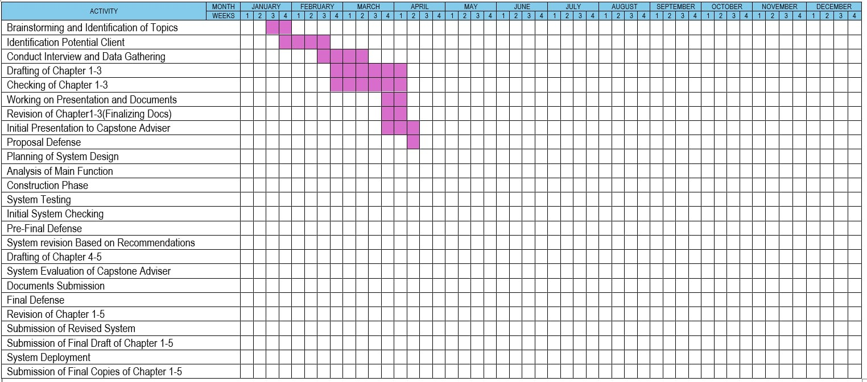
Figure 3.2

Gantt chart of a Voice-based reading assessment system for enhancing the Aral reading program

Phase 3: Analysis and Design


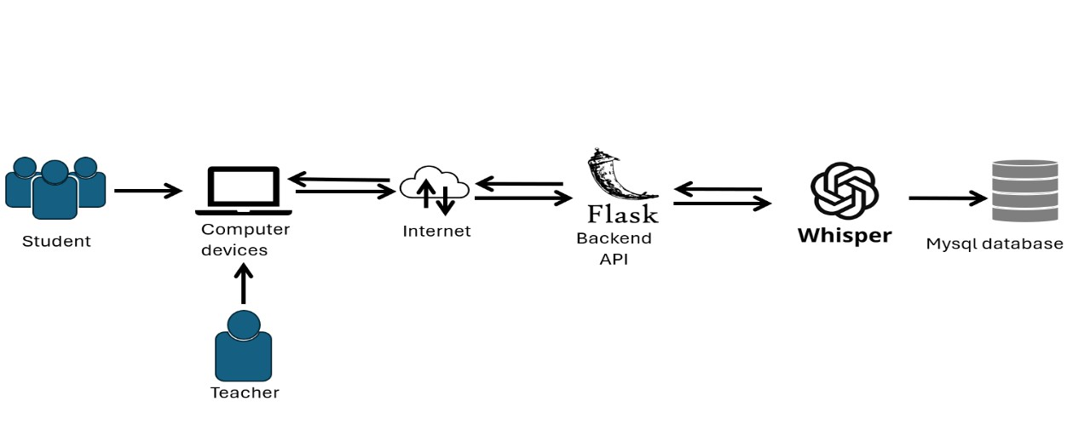
During this phase, the systems architecture determines the component’s interfaces and behavior. Requirements or data were transformed into designs, which are then used to develop the system interface. This phase contains the flow's main diagram and acts as a blueprint and basis for creating the system structure.
Figure 3.3

System Architecture of a Voice-based reading assessment system for enhancing the Aral reading program
Figure 3.3 illustrates how the different components of the system interact with each other. The system involves two main users: the student and the teacher, who both access the platform using computer devices. These devices are connected to the internet, which serves as the communication link between the users and the system. Through the internet, requests are sent to the backend API developed using Flask, which processes the data and handles the system’s logic. The backend then communicates with the OpenAi-Whisper to process speech-related tasks, such as recognizing and analyzing the student’s reading input. After

processing, the data is stored in the MySQL database, where it can be saved and retrieved when needed.
After creating the system architecture diagram, the researchers crafted the Data Flow Diagram (DFD) of the project. This diagram is important as it helps clearly identify and explain the different processes involved in the system, particularly how data moves from input to storage and eventually to report generation. In this phase, the researchers initially developed the Level 0 (Context Diagram) followed by the Level 1 DFDs to provide a more detailed representation
of the system’s processes.
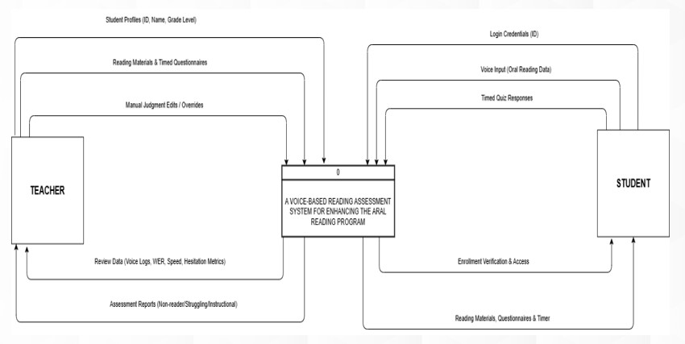

Figure 3.4

Context Diagram of a Voice-based reading assessment system for enhancing the Aral reading program

Figure 3.4 shows the context diagram of the Voice-Based Reading Assessment System for Enhancing the ARAL Reading Program, highlighting the interaction between two main external entities: the teacher and the student.

The student first provides their login credentials (ID) to access the system. Once authenticated, the system allows the student to participate in reading activities by accessing reading materials, questionnaires, and a timer. During the assessment, the student submits voice input (oral reading data) and answers timed quiz responses. These inputs are processed by the system to evaluate the student’s reading performance. In return, the system provides enrollment verification and access, ensuring that only authorized students can use the platform.
On the other hand, the teacher interacts with the system primarily for monitoring and management purposes. The teacher inputs and manages student profiles (ID, name, grade level), prepares reading materials and timed questionnaires, and can perform manual judgment edits or overrides when necessary. After the student completes the assessments, the system generates data such as voice logs, word error rate (WER), reading speed, and hesitation metrics, which the teacher can review. Additionally, the system produces assessment reports (e.g., non-reader, struggling, instructional levels) to help the teacher evaluate student progress.
Overall, the diagram illustrates how the system serves as a central platform that processes student inputs and provides meaningful outputs, while also allowing the teacher to manage content and monitor students’ reading performance efficiently.

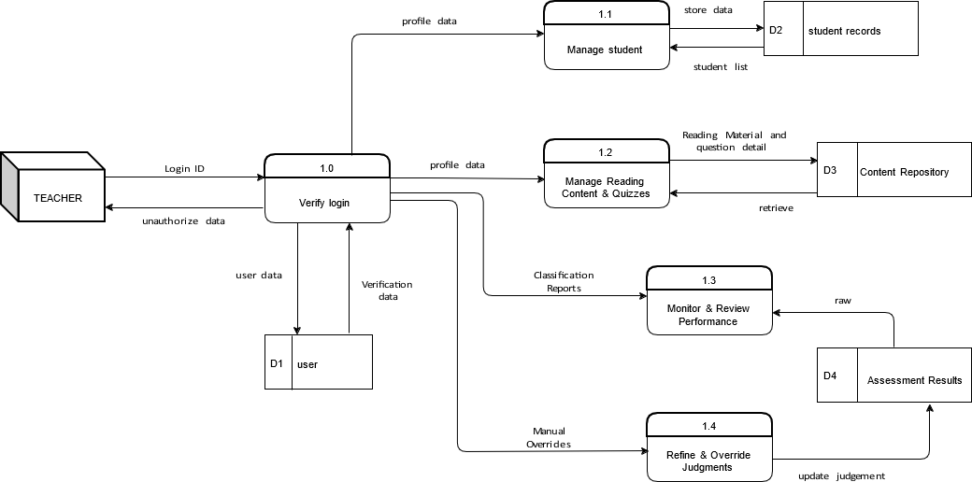
Figure 3.5.1

Part 1 of Data Flow Diagram of a Voice-based reading assessment system for enhancing the Aral reading program
Figure 3.5.1 shows the teacher-side administrative functions of the system into five specific sub-processes. This segment focuses on how data is managed and stored to facilitate the Aral Reading Program. The process begins with Process 1.0 (Verify Login), where the teacher's credentials are authenticated against the D1 (Users) data store. Once authorized, the teacher can engage in Process 1.1 (Manage Student Records), which involves adding or updating student information in D2 (Student Records). To populate the system with curriculum, Process 1.2 (Manage Content Repository) allows the teacher to upload and organize reading sets and questionnaires, which are then saved in D3 (Content Repository). The output phase is handled by Process 1.3 (Generate Performance Reports), which retrieves data from D4 (Assessment Results) to provide the teacher with detailed analytics on student progress.

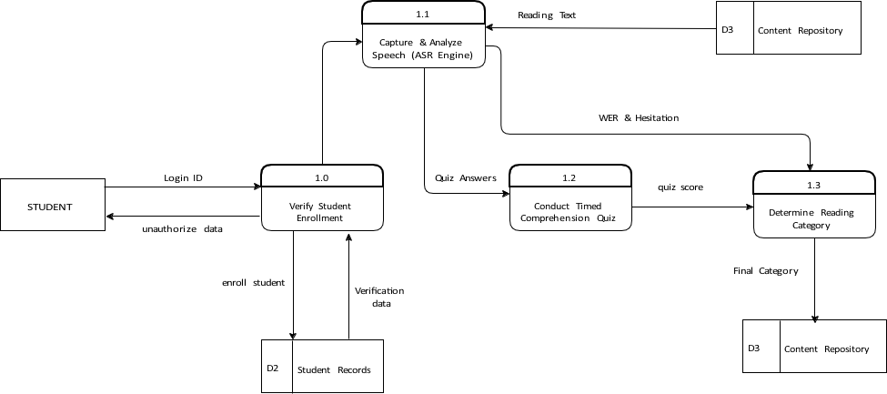

Finally, Process 1.4 (Refine Assessment Judgments) allows the teacher to review the automated ASR classifications and apply manual overrides if necessary, ensuring the accuracy of the final data stored in D4.
Figure 3.5.2

Part 2 of Data Flow Diagram of a Voice-based reading assessment system for enhancing the Aral reading program
For student-side illustrates the operational flow of the assessment from the perspective of the learner, The cycle starts with Process 1.0 (Verify Student Enrollment), where the system checks the student's ID against D2 (Student Records) to ensure they are registered in the program. Upon successful verification, Process 1.1 (Load Reading Material & Timer) retrieves the specific set assigned to the student from D3 (Content Repository) and initiates the assessment clock. The core technical function is performed by Process 1.2 (Analyze Speech), where the system utilizes an ASR engine (Whisper) to process the student's voice input. This process compares the audio against the reference text from D3 to calculate the Word Error Rate (WER), hesitation, and reading speed. Following the

reading phase, Process 1.3 (Manage Timed Questionnaire) presents the comprehension quiz and records student answers.
The final logical step is Process 1.3 (Calculate Reading Classification), which aggregates the fluency metrics from Process 1.2 and the quiz score from Process 1.3 to determine if the student is a Non-reader, Struggling, or Instructional reader. This final judgment is then recorded in D4 (Assessment Results).

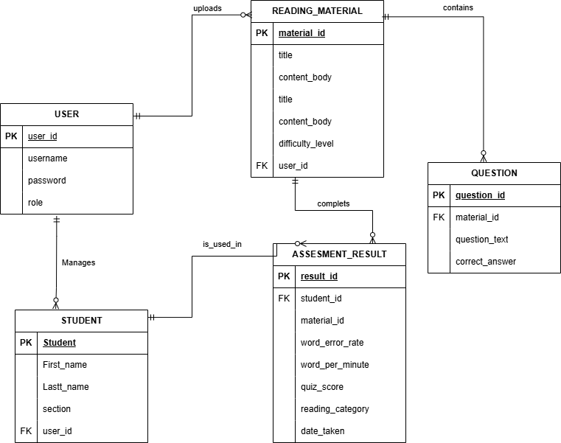
Figure 3.6

Entity Relationship Diagram of a Voice-based reading assessment system for enhancing the Aral reading program
The Entity Relationship Diagram (ERD) outlines the logical structure of the system's database, ensuring that data is stored in a normalized and relational format. The primary entity is the User, which represents the administrative or teaching staff and maintains a one-to-many relationship with the Student entity, as one teacher may manage multiple students. The User entity also manages the Reading Material entity, which serves as the parent for the Question entity. Each reading set contains multiple comprehension questions, establishing a one-to-

many relationship between the material and its associated quiz items. At the center of the system is the Assessment Result entity, which serves as an associative record linking a Student to a specific piece of Reading Material. This entity stores the critical metrics generated during a session, including the Word Error Rate (WER), Words Per Minute (WPM), and the final reading category. Because one student can take multiple assessments over time and one reading material can be assigned to many students, the relationships surrounding the Assessment Result ensure that every session is unique and traceable. This database design provides the necessary architecture to support the data flows described in the DFDs.

Phase 4: Testing

In this phase, the system was tested by selected students and teachers from Barcelonita Fishers School. The researchers scheduled testing sessions to evaluate the system’s performance in real scenarios. Students used the system to complete reading tasks using their computers, while teachers monitored the outputs. If an error occurred the researchers will fix the system and will schedule another test. Multiple testing cycles were conducted to ensure that the system is reliable, accurate, and user-friendly.

Phase 5: Evaluation

In this phase, the researchers evaluated the system’s overall performance and effectiveness. Feedback from teachers and students was gathered to assess its usability, accuracy, and functionality in supporting students’ reading skills, particularly in fluency, pronunciation, and comprehension. The results served as the basis for conclusions and recommendations for further system improvement.

NOTES

Larman, C., & Basili, V. R. (2003). Iterative and incremental development: A brief history. Computer, 36(6), 47–56. Retrieved from https://ieeexplore.ieee.org/document/1204375

Kumar, A., & Bhatia, P. (2014). Comparative analysis of SDLC models. International Journal of Advanced Research in Computer Science and Software Engineering, 4(6), 372–376. Retrieved from https://www.researchgate.net/publication/273885661_Comparative_Analy sis_of_SDLC_Models

