
EXT: Ajado Facebook
Extension Key: ajado_facebook
Language: en
Version: 0.1.0
Keywords: forAdmins, forIntermediates
Copyright 2006-2011, ajado , <info@ajado.com>

This document is published under the Open Content License
available from http://www.opencontent.org/opl.shtml

The content of this document is related to TYPO3
- a GNU/GPL CMS/Framework available from www.typo3.org
Table of Contents
EXT: Name of your Extension 1
Introduction 3
What does it do? 3
Screenshots 3
Users manual 4
Subheading 4
FAQ 4
Administration 5
FAQ 5
Configuration 6
FAQ 6
Reference 6
Tutorial 8
Known problems 9
To-Do list 10
ChangeLog 11
Important guidelines 12
Inserting images 12
Fonts 12
Paragraph styles 12
Linking 13
Meta data and updates 13
HowTo: Update a manual to the new layout 13
HowTo: Alternative updating possibility: Import the styles from another document 14
HowTo: Fix the Table Of Contents when it is empty 14
HowTo: Fix the Table Of Contents when a chapter is missing 15
Help from documentation.openoffice.org 15

Introduction

What does it do?
This extension provides a Facebook Connect-Module for TYPO3, that focuses on comaptibility with sr_feuser_register (so that both a registration via e-mail and Facebook can be users), OAuth2 and takes care of all the Facebook-changes after 1st of October 2011.
A general introduction and the reasons why we developed the extension can be found here:
http://www.ajado.com/blog/presentation-facebook-connect/
If you're interested in the development, you can participate here: https://github.com/ajado/ajado_facebook

Screenshots

Facebook login in the Backend:
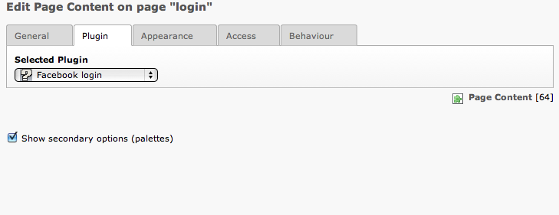
Facebook-login with customized button in the Frontend:


Users manual
In order to use this extension you need to create an App on Facebook. You'll find detailled information in this tutorial:
http://developers.facebook.com/docs/appsonfacebook/tutorial/
Be aware that you need to integrate the app on Facebook just as “Website”, not as “App on Facebook”.
The information you need in the extension configuration is the “App ID” and the “App Secret”

FAQ
Coming soon...

Administration
The user records can be found in the fe_user. Be aware that because of the requirement to work with sr_feuser_register the mail we get from Facebook is not stored in the fe_user e-mail field but in the tx_ajadofacebook_email column.

FAQ
Coming soon...

Configuration
The configuration can mostly be done via the Constants editor, the list here shows all parameters that can be set in Setup.

Reference
Property: | Data type: | Description: | Default:
appId | string | Facebook app id:The app id of your Facebook application
secret | wrap | Facebook secret:The application secret of your Facebook application
usersPid | Int | User storage page:uid of the page where Frontend user records are stored
userGroup | Int | Redirect after login page:uid of the page where the user will get redirected after login
askForEmail | boolean | Save Facebook-Email in fe_users | 0
redirectAfterLoginPid | Int | Redirect to Pid after succesfull Login. If 0 the current page will be used. | 0
redirectAfterLogoutPid | Int | Redirect to Pid after successful Logout. If 0 the current page will be used. | 0
facebookLanguage | string | Set facebook language | en_EN
makeSessionPermament | boolean | Make fe_user-session permament.
loginButton | HTML | Change login button
logoutButton | HTML | Change logout button
copyFacebookImageToImageDir | boolean | Set to 1 if you want the extension to save the Facebook profile image locally | 0
imageDir | string | Specifies directory where profile image should be set. Attention: the default value requires the extension sr_feuser_register! | uploads/tx_srfeuserregister/

Example
Coming soon...

Tutorial
Coming soon...

Known problems
None at the moment.

To-Do list
- Change loginButton and logoutButton into a IMAGE-Object
- Expand documentation
- Think about rewriting it in extBase?

ChangeLog
Version: | Changes:
0.3.0 | Major upgrade:  * Bugfix when running the extension without sr_feuser_register  * Added possiblity to locally save the Facebook profile image - installed sr_feuser_register recommended  * Added possibility to stay on same site when logging in  * Cleaned up files and code
0.2.2 | Security fix
0.2.1 | Manual extended
0.2.0 | Manual extended, Constants and setup cleaned up
0.1.0 | Initial upload

Important guidelines
Coming soon...

