HDFC Bank – Customer & Branch Analytics Report (2022–2025)
Author: Ajai Arumugam — Data Analyst

1. Project Overview
This project analyzes customer behavior, branch performance, and investment trends for HDFC Bank from 2022 to 2025. It demonstrates a complete end-to-end analytics workflow, including data cleaning, SQL business analysis, Power BI visualization, and actionable insights. The objective is to transform raw operational datasets into meaningful, decision-ready intelligence.

2. Dataset Summary
• Customer Records: ~10,000
• Transaction Records: ~10,000
• Branch Records: 40
• Combined Features include customer demographics, transaction characteristics, branch financials, and investment types.
You may insert dataset preview screenshots below:
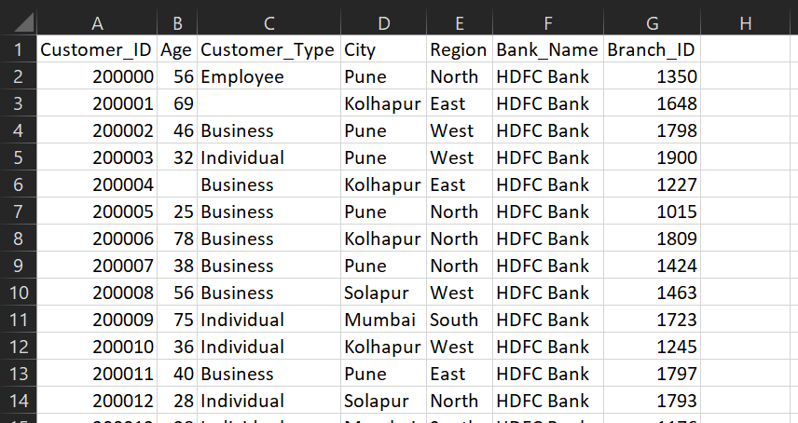
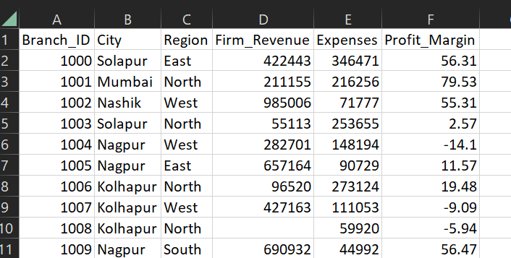
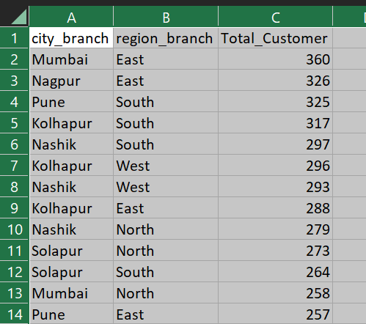

3. Exploratory Data Analysis using Python
Python was used to clean, transform, and merge datasets. Key steps included:
• Handling missing values and correcting datatypes
• Removing duplicates and standardizing formats
• Creating derived fields such as Age Group and Total Balance
• Merging all three datasets into cleaned.csv
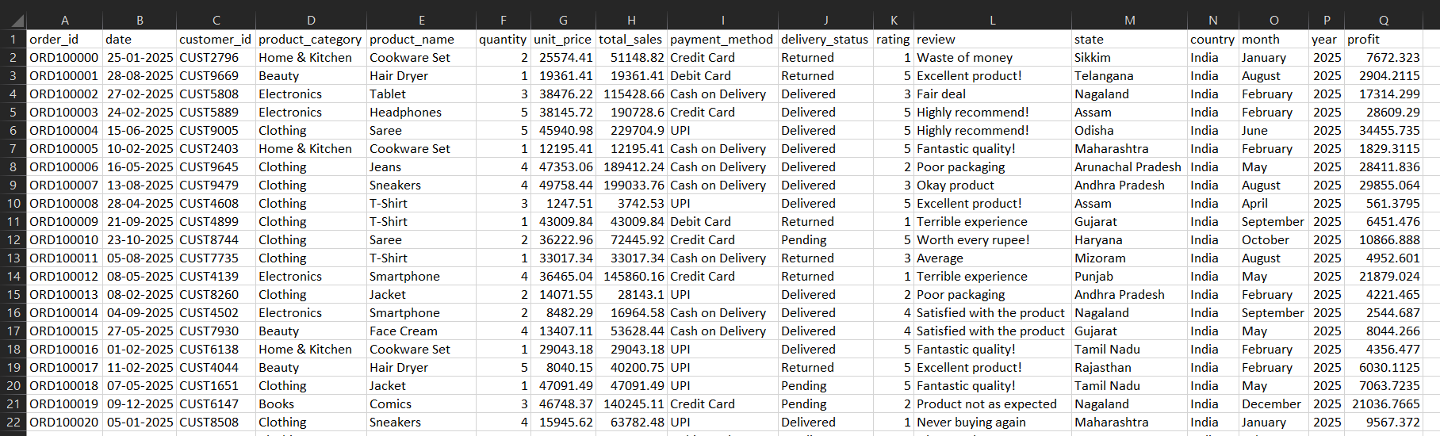

4. Data Analysis Using SQL (Business Questions)
SQL queries answered 10 core business questions including:
1. Monthly Transaction Amount Trends
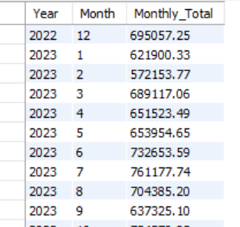
2. Monthly Transaction Volume Trends
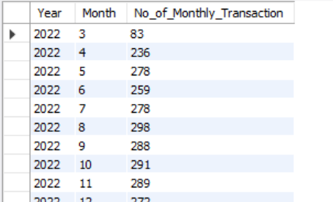

3. Customer Type Average Transaction Value
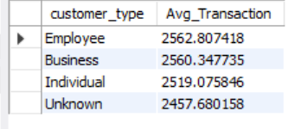
4. Branch-Wise Customer Count
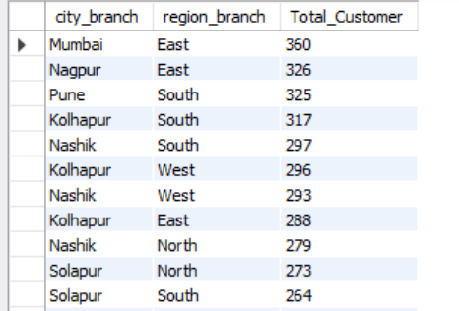

5. Top 10 Customers by spending
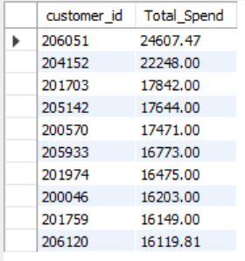

6. Investment Spend Comparison
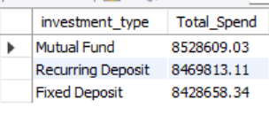

7. Investment Type Contribution
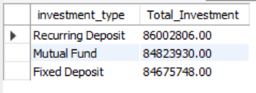

8. Total Transaction Value by City
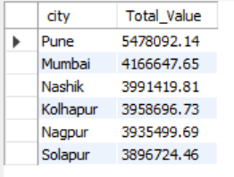

9. Top High-Value Customers

10. Customers by Age Group
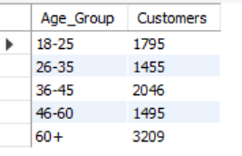

5. Power BI Dashboard
A comprehensive Power BI dashboard was created containing:
• KPI Cards
• Monthly Trends
• Investment Distribution
• Branch Performance Scatter Plot
• Customer Segmentation Charts
Insert Dashboard Screenshot below:
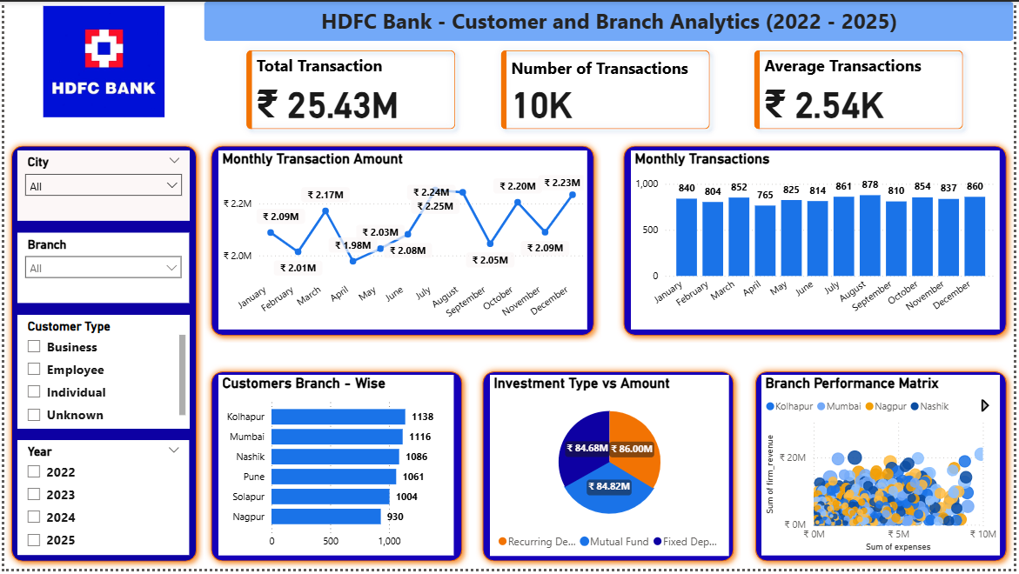

6. Business Recommendations
• Strengthen engagement with high-value customers
• Allocate resources to high-revenue cities such as Pune and Mumbai
• Optimize operational efficiency for branches with high expenses
• Promote high-demand investment products (MF, RD, FD)
• Tailor services for age groups 36–45 and 60+
• Enhance segmentation strategies for Business, Individual, and Employee categories

