Database System Engineering and Distributed Backend Development(25CS1302E)
Practical Week-2

Name : Ajai Manikanta
Roll No. : 2520030320
SEC : 7
Step 1 : Create Database
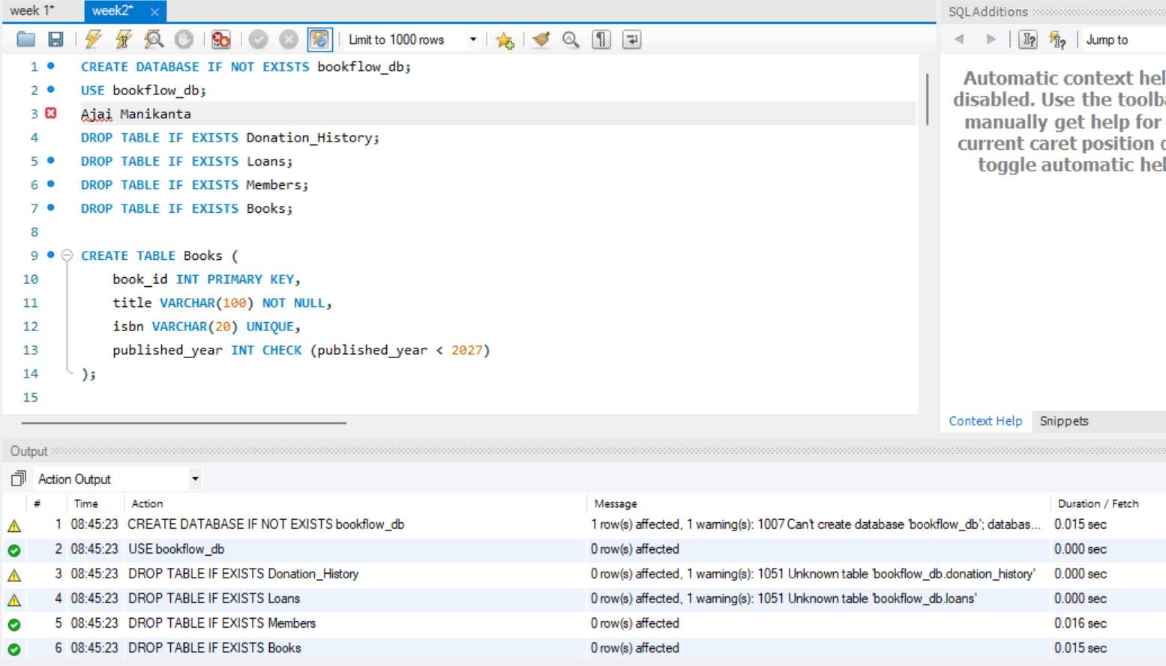

Step 2 : Create Books Table
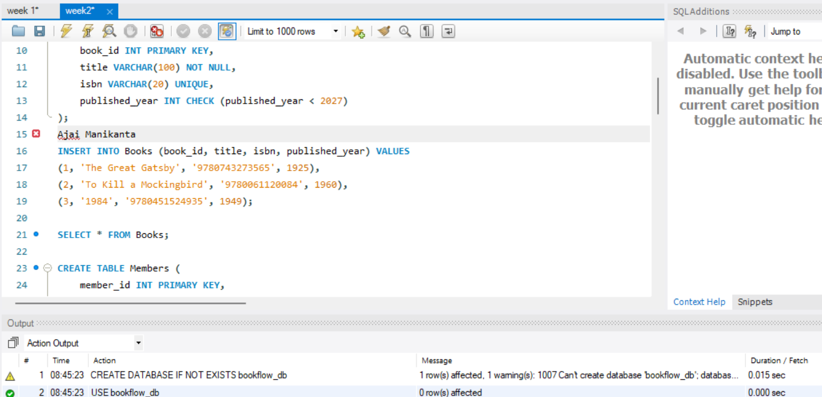

Step 3 & 4 : Insert Books and Display
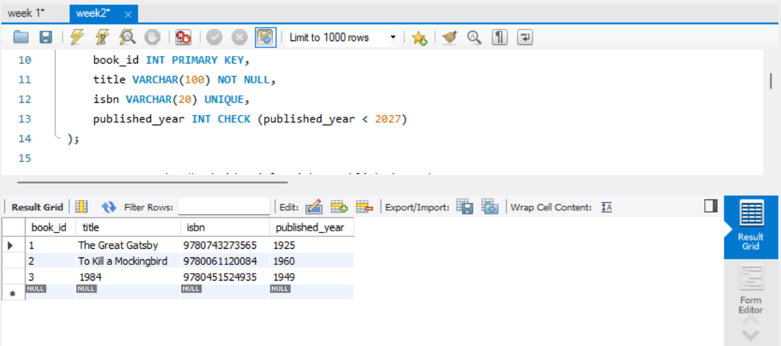

Step 5 : Members Table: Create
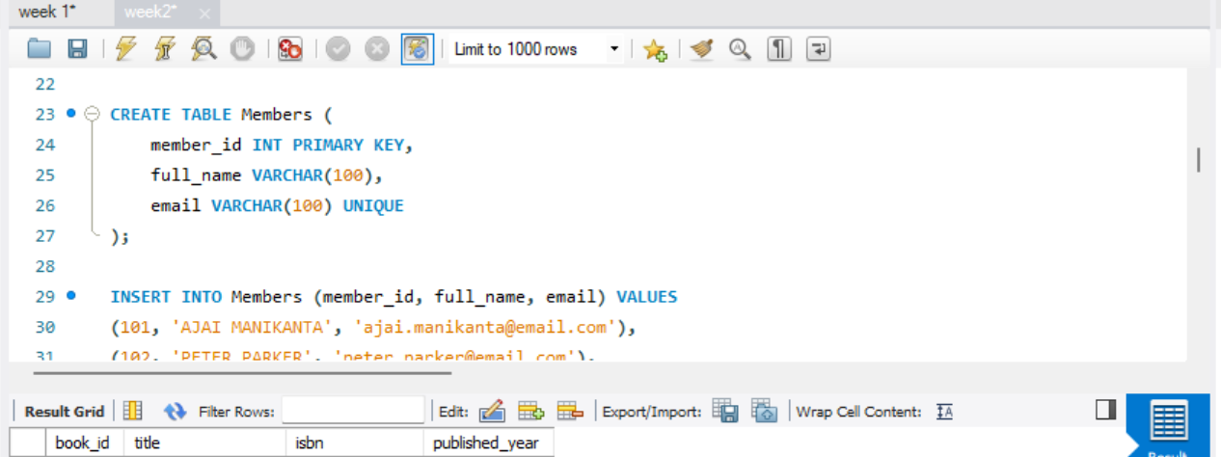

Step 6 & 7 : Members Table: Insert, Display
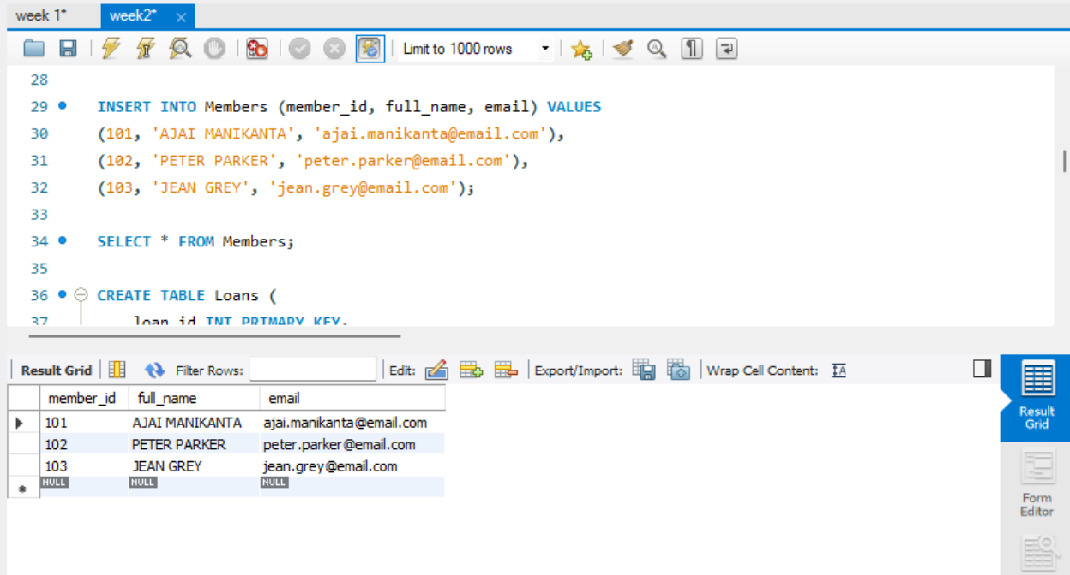

Step 8 : Create Loans Table
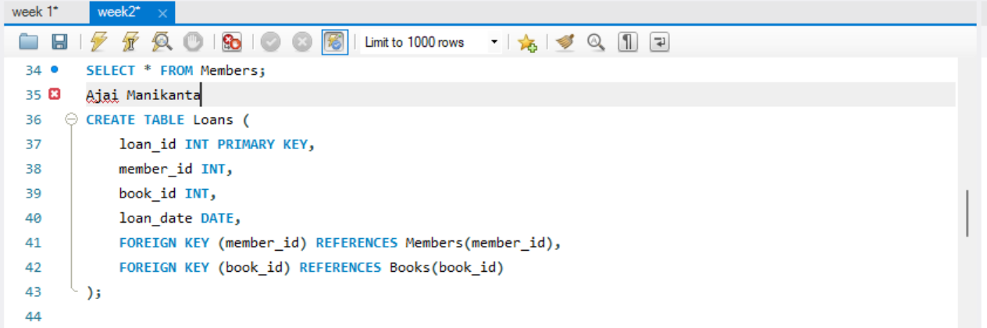

Step 9 & 10 : Insert 10 Loans and Display
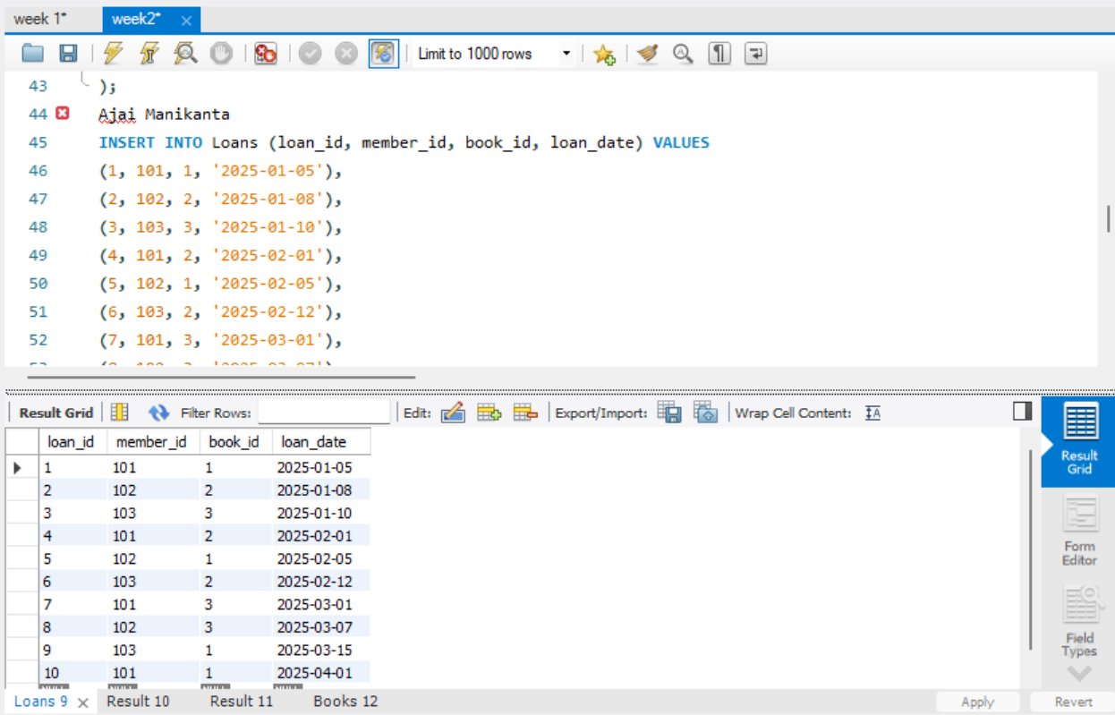

Step 11 : JOIN Query
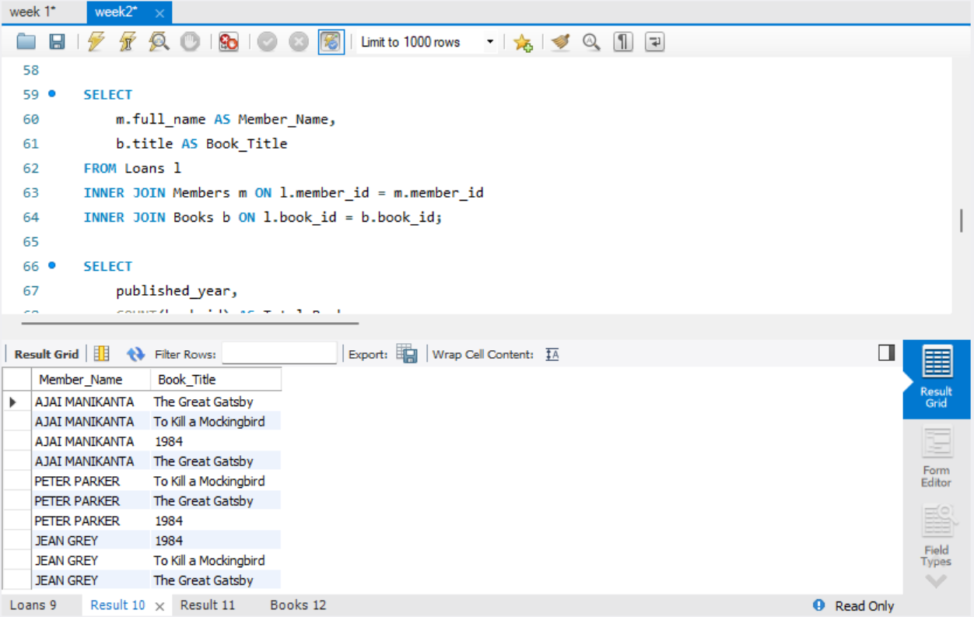

Step 12 : GROUP BY Query
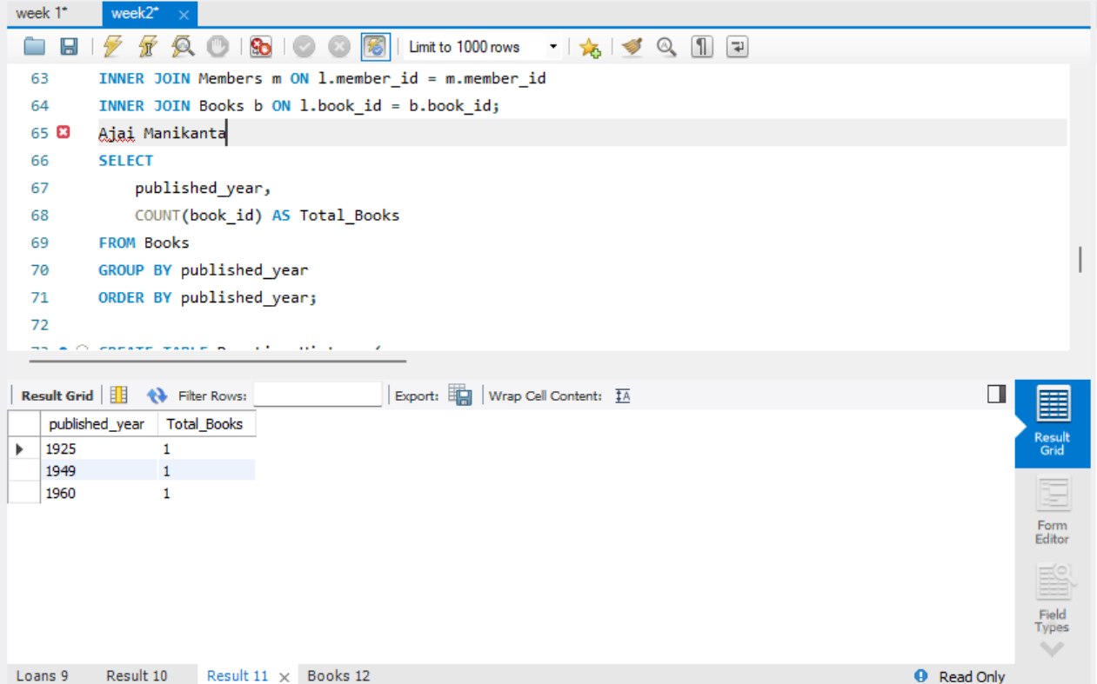

Step 13–16 : Donation via TRANSACTION
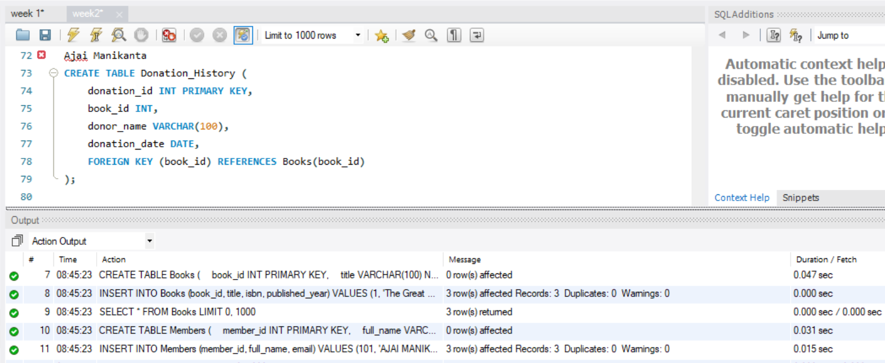
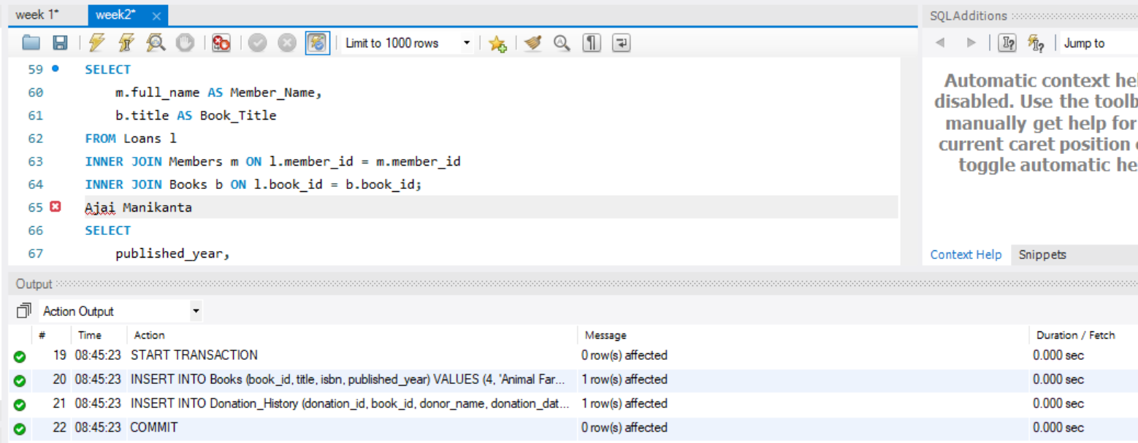

Step 17 & 18: Index on ISBN + Fast Search
