QA AI Agent — Handover Document
Playwright Agentic Test Automation for SunTeck TMS
Mode Global · Proof of Concept
Prepared by: R Systems International
Prepared for: Mode Global QA Team
Date: July 07, 2026
Classification: Confidential

1. Purpose of This Document
This document is the complete handover guide for the QA AI Agent developed during the Mode Global proof of concept (POC). It explains how the agentic system was built, how each component works, what was delivered, and how Mode Global and partner QA teams can install, configure, and use the agent to generate Playwright test specification (.spec.ts) files from detailed test cases going forward.
POC outcomes: 28 executable test scripts successfully generated — 24 billing toggle and 4 DFB — using the hybrid rule-based + LLM multi-agent pipeline described in this document.

2. Prerequisites & Environment Setup

2.1 Required Software
- Node.js 18+ and npm (project uses TypeScript + Playwright)
- Google Chrome (Playwright runs via channel: 'chrome')
- Git
- Claude CLI (claude command) — primary LLM engine for script generation
- Optional: Anthropic API key (ANTHROPIC_API_KEY) — secondary fallback if CLI unavailable
- Optional: Cursor IDE — governance rules in .cursor/rules/ guide agent behaviour

2.2 Clone Repository & Install Dependencies
git clone <repository-url>
cd Playwright_Agent
npm install
npx playwright install chrome

2.3 Git Configuration (One-Time per Clone)
git config core.ignorecase false
git update-index --skip-worktree src/testmo/testmo-reporter.ts

2.4 Environment Variables (.env)
Create a .env file in the project root (this file is gitignored). Required variables for test execution:
Variable | Purpose
GLOBAL_PASSWORD | BTMS global user password
BTMS_SSO_PASSWORD | BTMS SSO login password
TNX_PASSWORD | Tender Exchange password
TNX_REP_PASSWORD | TNX rep password
DME_PASSWORD | DME application password
TRITAN_CUSTOMER_PASSWORD | Tritan customer password
ANTHROPIC_API_KEY | Optional — Anthropic API fallback for LLM generation

User credentials (usernames, non-sensitive config) are in src/loginHelpers/userConfig.json (gitignored). Contact your team lead for the credential files.

2.5 Claude CLI Installation
The AI Script Writer uses Claude for four strategic generation calls. At startup, the agent runs claude --version to verify the CLI is available. If not found, generation falls back to rule-based mode only.
- Install Claude Code / Claude CLI from Anthropic (https://docs.anthropic.com/en/docs/claude-code)
- Sign in with your Anthropic account (Max plan or API access)
- Verify installation:
claude --version
- The agent invokes Claude as: claude -p --output-format text --tools "" --model claude-sonnet-4-6
- If Claude CLI is unavailable, set ANTHROPIC_API_KEY in .env — the agent tries the Anthropic Messages API first, then falls back to CLI

2.6 Verify Agent Setup
npm run agent:cli
At startup you should see either:
- LLM Service initialized via Claude CLI (version …) — LLM tiers enabled
- LLM Service disabled — rule-based generation only (install Claude CLI or set ANTHROPIC_API_KEY)

3. What Was Built in the POC
R Systems developed a hybrid agentic test automation pipeline inside the existing SunTeck TMS Playwright framework. Written test cases (from Testmo, CSV, Excel, JSON, or plain text) flow through a multi-agent pipeline and emerge as validated, runnable Playwright .spec.ts scripts.
- Four specialised validation/mapping agents + AI Script Writer (LLMService)
- 130+ declarative step-to-code automation patterns (StepMappings)
- 5,900+ real UI element IDs indexed from BTMS + DME application source repos
- 25+ auto-fix quality rules (SpecValidator sanitizer + guardrails)
- Cursor governance rules enforcing architecture standards on every generation
- 12 product test categories configured (DFB, billing toggle, EDI, commission, etc.)
- 28 POC scripts delivered: 24 billing toggle + 4 DFB in src/tests/AIAgent/
- Per-category runtime test data CSVs in src/data/<category>/
- Canonical testcase catalog: src/agent/examples/sample-testcases.csv

4. Agentic Architecture
Generation is orchestrated by PlaywrightAgent (src/agent/PlaywrightAgent.ts). The pipeline combines deterministic rule-based generation with Claude LLM calls at strategic points. All output is validated before saving.
End-to-end pipeline diagram:
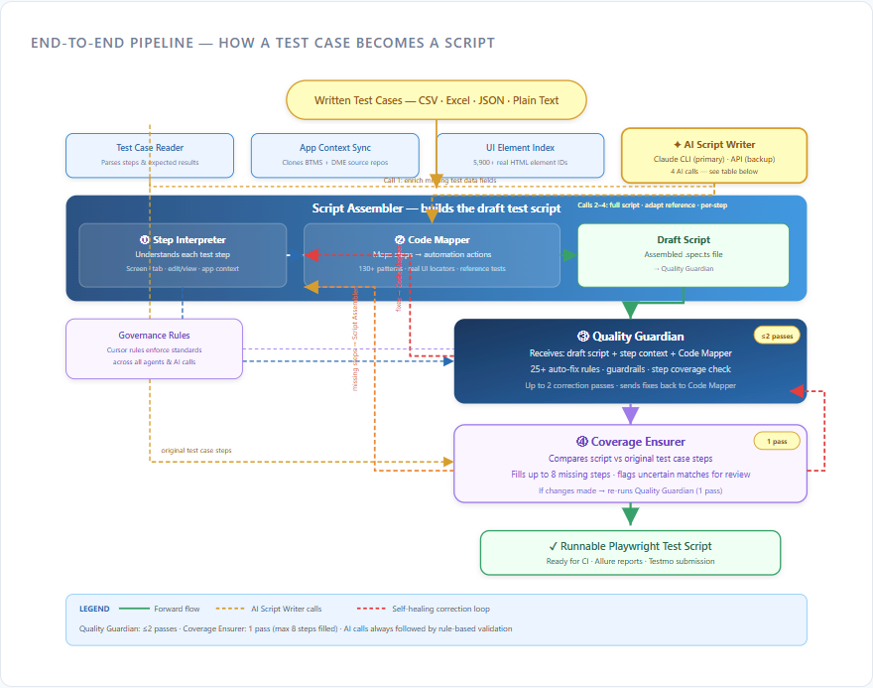

4.1 High-Level Flow
- Test Case Reader (TestCaseParser) — parses input, detects category, extracts fields
- App Context Sync (RepoCloneManager) — clones/updates BTMS (mono.git) + DME (dme.git) repos
- UI Element Index (AppSourceIndexer) — scans PHP/Twig for real HTML element IDs
- CSV Data Service — ensures runtime test data row exists in category CSV
- Script Assembler (CodeGenerator) — builds draft .spec.ts via tiers below
- ③ Quality Guardian (SpecValidator) — validates, auto-fixes, up to 2 correction passes
- ④ Coverage Ensurer (SpecFeedbackLoop) — compares script vs testcase, fills up to 8 missing steps
- Output — src/tests/AIAgent/<category>/<TEST_ID>.spec.ts

4.2 Generation Tiers (CodeGenerator)
Tier | Method | When Used
Tier 1 | Full-spec LLM (Call 2) | First attempt when ≤40 steps and reference spec exists
Tier 2 | Clone + adapt reference (Call 3) | When new case ≥70% similar to existing automated test
Tier 2b | Rule-based step-by-step | Step Interpreter + Code Mapper + 130+ patterns
Tier 3 | Per-step LLM (Call 4) | Last resort when no pattern matches a step

4.3 What Each Agent Does

✦ AI Script Writer (LLMService · LLMPrompts)
Invokes Claude at four strategic points. Uses governed prompts with framework schema, quality rules, and reference test patterns. Claude CLI or Anthropic API. If a call fails, the pipeline falls back automatically.
Call | Business Name | What It Does | When It Runs
Call 1 | Data Enricher | Fills missing test data fields not parsed from testcase | Before generation when data incomplete
Call 2 | Full Script Writer | Writes entire script using reference as template | First attempt (≤40 steps, reference exists)
Call 3 | Smart Adapter | Clones reference; rewrites only differing steps | When ≥70% similar to existing test
Call 4 | Step Writer | Writes code for individual unmatched steps | Last resort after rules fail

Generation order: Call 2 → Call 3 → Rule-based (Step Interpreter + Code Mapper) → Call 4. Safety net: All AI output passes Quality Guardian and Coverage Ensurer before saving.

① Step Interpreter (Agent 1 · StepProcessor)
Reads each raw test step and classifies intent. Tracks immutable context snapshots (contextBefore / contextAfter): current page, edit vs view mode, current tab, current application (BTMS/DME/TNX). Output: structured ProcessedStep[] consumed by Code Mapper and Quality Guardian.

② Code Mapper (Agent 2 · POMMethodMatcher)
Maps understood steps to proven Page Object Model methods using StepMappings (130+ patterns), AppSourceIndexer data (5,900+ UI elements), and reference specs. Proposes new POM methods with real locators from application source when needed. Receives correction requests from Quality Guardian and Coverage Ensurer (≤2 iterations via correctBatch()).

③ Quality Guardian (Agent 3 · SpecValidator)
Validates generated script against guardrails. Runs 13 sanitizer rules (SAN-001–SAN-013) then structural validation. Auto-fixes violations (navigation, hardcoded values, locator-in-spec issues, billing toggle user switch, etc.). Inputs: draft script + ProcessedStep[] + POMMethodMatcher. Up to 2 correction passes. Loops back to Code Mapper on violations.

④ Coverage Ensurer (Agent 4 · SpecFeedbackLoop)
Compares finished script against original testcase steps. Injects code for missed steps (max 8 injections, 1 pass). Flags uncertain matches for human review. If changes applied, re-runs Quality Guardian (1 pass). Ensures every explicit expected result from the testcase has an assertion.

4.4 Self-Healing & Governance
- SpecValidator SAN-001–SAN-013: sanitizer pre-pass (quotes, imports, navigation patterns, etc.)
- 25+ guardrail rules: no locators in specs, no hardcoded assertion values, POM JSDoc required, etc.
- Cursor rules (.cursor/rules/agent-architecture.mdc, CLAUDE.md): architecture standards always applied
- Human-authored POM methods are protected — agent may only add new @author AI Agent methods

5. Repository Structure (Key Paths)
Path | Purpose
src/agent/ | Agent pipeline — parsers, generators, validators, CLI
src/agent/run-agent.ts | CLI entry point for all agent modes
src/agent/PlaywrightAgent.ts | Main orchestration class
src/agent/config/StepMappings.ts | 130+ step-to-code patterns
src/agent/config/FieldRegistry.ts | Unified field name mappings
src/agent/examples/sample-testcases.csv | Canonical testcase step catalog
src/tests/AIAgent/ | Generated Playwright specs (28 POC scripts)
src/data/<category>/ | Runtime test data CSVs per module
src/pages/ | Page Object Model classes
src/utils/globalConstants.ts | Assertion constants (never hardcode in specs)
src/agent/.cache/ | Cloned app repos + UI element index JSON
.cursor/rules/ | Cursor governance for generation quality
docs/presentations/ | Technical deck and POC closure PPT

6. POC Deliverables
- Complete Playwright Agent repository (framework + agent pipeline)
- 28 generated, runnable .spec.ts scripts (24 billing toggle · 4 DFB)
- Category CSV test data files with parsed runtime values
- Agent CLI for interactive and batch generation
- Reference spec catalog per category for clone-and-adapt generation
- App source indexer cache workflow for real UI locators
- Technical presentation: docs/presentations/agentic-system-slides.html
- This handover document

7. How to Use the Agent for Spec File Generation

7.1 Testcase Input Requirements
The agent requires detailed test cases — not high-level summaries. This is the largest upstream effort.
- Testmo cases must include full step-by-step actions and explicit expected outcomes per step
- Manual QA typically spends 3–5 hours per test case reaching agent-ready detail
- Without sufficient detail, generated specs are inaccurate and require heavy manual correction
- JIRA scenarios may document the what — agent-ready step detail (the how) must be present

7.2 Supported Input Formats
- CSV — src/agent/examples/sample-testcases.csv format (Case ID, Test Steps, Expected, Tags)
- Excel (.xlsx, .xls)
- JSON
- Plain text (.txt)

7.3 Agent CLI Commands
Command | Description
npm run agent:cli | Interactive CLI — guided generation
npm run agent:file -- <path> | Generate from a single CSV/Excel/JSON/TXT file
npm run agent:batch -- <folder> | Batch process all supported files in a folder
npm run agent:generate -- "description" | Generate from plain-text description
npm run agent:preview | Preview generated code without writing files
npm run agent:analyze | Analyze test cases only (no generation)
npm run agent -- --no-llm | Rule-based generation only (skip all LLM calls)
npm run agent -- --help | Show all CLI options

7.4 Step-by-Step: Generate a New Spec from CSV
- Prepare a detailed testcase row in CSV (or add to sample-testcases.csv)
- Ensure runtime test data exists in src/data/<category>/ or let Call 1 (Data Enricher) fill gaps
- Run: npm run agent:file -- src/agent/examples/sample-testcases.csv
- Agent parses testcase → syncs app source → indexes UI elements → generates draft
- Quality Guardian validates and auto-fixes (≤2 passes)
- Coverage Ensurer checks step coverage (1 pass, up to 8 missing steps filled)
- Output written to: src/tests/AIAgent/<category>/<TEST_ID>.spec.ts
- Review generated spec; run: npx playwright test src/tests/AIAgent/<category>/<TEST_ID>.spec.ts

7.5 Step-by-Step: Interactive CLI
- Run: npm run agent:cli
- Follow prompts to select input source, testcase, and category
- Review generation log for LLM tier used and any warnings
- Open generated spec and verify step traceability (test.step titles reference CSV step numbers)

7.6 Running Generated Tests
# Run all AI Agent tests
npx playwright test src/tests/AIAgent/
# Run single spec
npx playwright test src/tests/AIAgent/billingtoggle/BT-74454.spec.ts
# Allure report
npm run test:allure
# Submit to Testmo
npm run submit:testmo

7.7 Adding Test Data for a New Case
Runtime values (customer names, rates, office codes, etc.) live in src/data/<category>/*.csv. The CsvDataService maps CSV column headers to canonical testData keys via FieldRegistry. Generated specs load data via: dataConfig.getTestDataFromCsv(dataConfig.<category>Data, testcaseID)

8. Known Limitations & Upstream Gaps
The pipeline is built and working — effectiveness depends on input quality.

① Test Cases Lack Sufficient Detail
- Testmo cases must include full step-by-step actions and expected outcomes
- Manual QA spends 3–5 hours per test case — largest upstream effort
- Without sufficient detail, spec generation is inaccurate

② Tribal Knowledge — Scenarios Without Executable Steps
- Scenarios exist in JIRA — the what is often documented
- Agent-ready step detail is frequently missing — the how is not
- Precondition paths and business rules cannot be automated without executable steps

③ Limited Application Source Access
- UI Element Index syncs BTMS and DME repos only
- Broader repo sync needed for full product coverage

④ Execution Time — Monolithic Scripts
- Large cases become single long-running scripts
- Consider phased specs or shared fixtures for very large test cases

9. Reference & Support
- Architecture rules: CLAUDE.md and .cursor/rules/agent-architecture.mdc

9.1 Command Quick Reference
Task | Command
Install dependencies | npm install
Verify Claude CLI | claude --version
Interactive agent | npm run agent:cli
Generate from file | npm run agent:file -- <path>
Batch generate | npm run agent:batch -- <folder>
Preview only | npm run agent:preview
Run AI Agent tests | npx playwright test src/tests/AIAgent/
Allure report | npm run test:allure
Submit Testmo | npm run submit:testmo

— End of Handover Document —

