**Ashish Jain (MT18052)**

**Assignment 2**

**Q4.a**

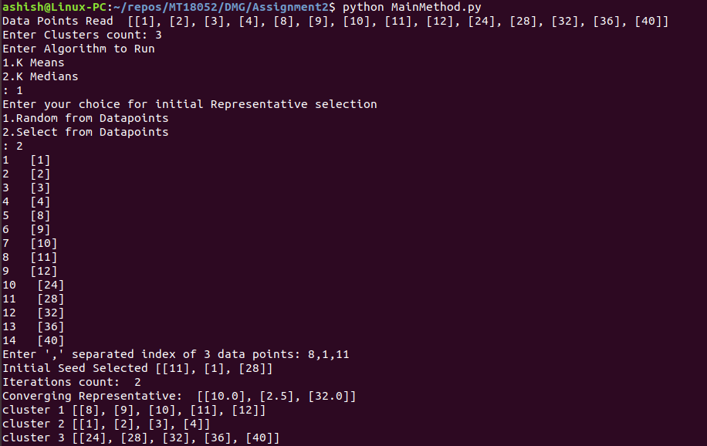

**Q4.b**

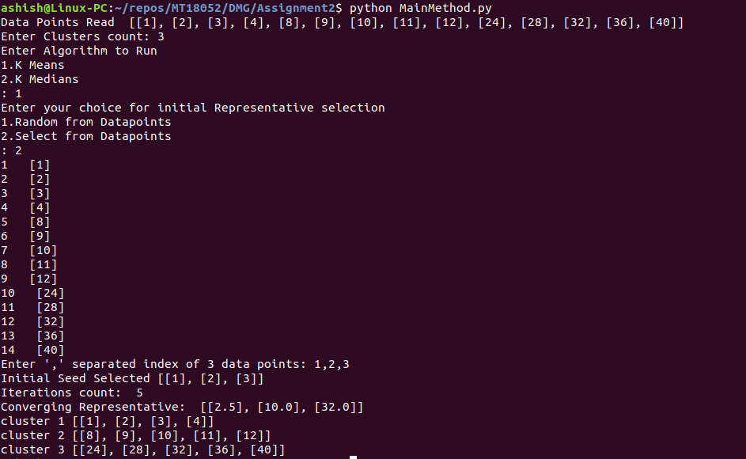

**Q4.c**

It depends on the initial seed Representative set how soon the convergence will reach and which element’s will belong to which cluster and it is not always true that every time with different seed same clusters will form different seed may results in different clusters with different datapoints.