CS 114 HW1

**Problem 1:**

public class Problem1 {  
 public static void main(String[] args) {  
 /* red = 0  
 white = 1  
 blue = 2  
 */  
 int red = 0;  
 int blue = 0;  
 int white = 0;  
 int[] balls = {0,0,0,1,2,1,0,2,1};  
 Arrays.*sort*(balls);  
 System.*out*.println(Arrays.*toString*(balls));  
  
 for(int i = 0; i<balls.length; i++){  
 switch(balls[i]){  
 case 0:  
 red++;  
 break;  
 case 1:  
 white++;  
 break;  
 case 2:  
 blue++;  
 break;  
 }  
 }  
 System.*out*.println("The number of Red balls: " + red);  
 System.*out*.println("The number of white balls: " + white);  
 System.*out*.println("The number of blue balls: " + blue);  
 }  
}

**Output: Red balls:** 4**, white balls:** 3**, blue balls:** 2

**Problem 2:**

public class Problem2 {  
 /*  
 Number is student is m  
  
 */  
 static String array(int[] arr){  
 int diff = 0;  
 int min = 0;  
 int max = 0;  
 Arrays.*sort*(arr);  
 min = arr[0];  
 max = arr[2];  
 diff = max-min;  
 return "Minimum Difference is " + diff ;  
  
 }  
 public static void main(String[] args) {  
 int[] arr = {57,13,12,14,69,26,56};  
 System.*out*.println(Problem2.*array*(arr));  
 }  
}

**Output**:

**Minimum difference is 2**

**Problem 3:**

public class Problem3 {  
 public static void main(String[] args) {  
 int n = 5;  
  
 for (int i = 1; i <= n; i++) {  
 for (int j = 1; j <= n - i; j++) {  
 System.*out*.print(" ");  
 }  
  
 for (int j = 1; j <= i; j++) {  
 System.*out*.print(j + " ");  
 }  
  
 for (int j = i - 1; j >= 1; j--) {  
 System.*out*.print(j + " ");  
 }  
  
 System.*out*.println();  
 }  
 }  
}

**Output:**

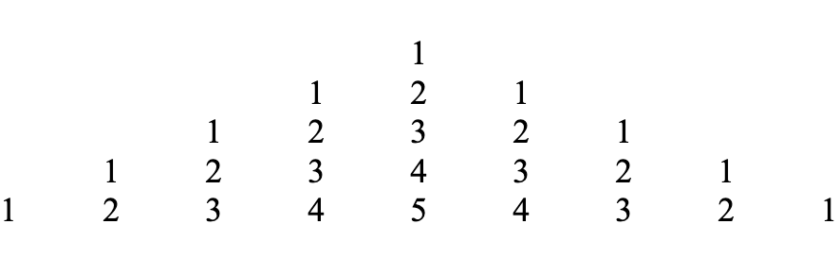

**Problem 4:**   
Student Performance Records: Within an educational setting, instructors frequently utilize arrays to maintain records of student performance. Each student's assessment or examination results are stored as distinct entries within the array. This approach enables educators to compute average scores, pinpoint the highest and lowest achievements, and monitor individual student advancements over an extended period.

Library Book Inventory: In libraries, the inventory of books is commonly structured using arrays or analogous data organization methods. Each book within the library constitutes an individual component in the catalog, and they are usually categorized by a variety of attributes like book title, author, genre, or ISBN. Consequently, when you're searching for a particular book, you're effectively sifting through an array of books to locate the one you intend to borrow.

**Problem 5:**

An ‘ArrayIndexOutOfBoundsException’ is thrown when we try to access an element in an array using an index that is outside of the range of the array. The correct way to have an array range is n-1 if the array has n number of elements. We also get an index error if we put a negative array index.

**Example**:

1. int[] numbers = {1,2,3,4,5};

int index = 10;

int value = numbers[index];

System.out.println(value);

1. int[] scores = {85,92,78,89,94};

for(int i = 0; i <= scores.length; i++){

System.out.println(scores[i]);

}

**Problem 6:**

|  |  |  |
| --- | --- | --- |
| **Operation** | **Time-Complexity** | **Actual Run Time** |
| Traverse | O(n) | 0.20MS |
| Insert | O(n) | 0.50MS |
| Delete | O(n) | 0.65MS |

**Problem 7:**

public class Problem7 {  
 public static void main(String[] args) {  
 int[] arr1 = {7,5,2004,5,326,8};  
 int[] arr2 = {7,5,200,5,326,8};  
  
 boolean length = false;  
 if(arr1.length == arr2.length)  
 length = true;  
  
 boolean value = true;  
 for(int i = 0; i < arr1.length; i++) {  
 if(arr1[i] != arr2[i])  
 value = false;  
  
 }  
 if(length && value)  
 System.*out*.println("The two arrays are equal.");  
 else  
 System.*out*.println("The two arrays are not equal.");  
  
  
 }  
}

**Output: The two are not equal**

**Problem 8:**

public class Problem8 {  
 public static void main(String[] args) {  
 int n = 100;  
 int sumOfArr = 0;  
 int[] arr = {1, 2, 3, 4, 6, 7, 8, 9, 10, 11, 12, 13, 14, 15, 16, 17, 18, 19, 20,  
 21, 22, 23, 24, 25, 26, 27, 28, 29, 30,  
 31, 32, 33, 34, 35, 36, 37, 38, 39, 40,  
 41, 42, 43, 44, 45, 46, 47, 48, 49, 50,  
 51, 52, 53, 54, 55, 56, 57, 58, 59, 60,  
 61, 62, 63, 64, 65, 66, 67, 68, 69, 70,  
 71, 72, 73, 74, 75, 76, 77, 78, 79, 80,  
 81, 82, 83, 84, 85, 86, 87, 88, 89, 90,  
 91, 92, 93, 94, 95, 96, 97, 98, 99, 100};  
 int sumOfNaturalNums = n*(n+1)/2;  
 for(int i:arr){  
 sumOfArr += i;  
 }  
 int missNum = sumOfNaturalNums - sumOfArr;  
 System.*out*.println("The missing number is " + missNum);  
 }  
}

**Output: Missing the number 5**

**Problem 9:**

public class Problem9 {  
 public static void main(String[] args) {  
 int n = 5;  
  
 for (int i = 1; i <= n; i++) {  
  
 for (int j = 1; j <= n - i; j++) {  
 System.*out*.print(" ");  
 }  
 for (int j = 1; j <= i; j++) {  
 System.*out*.print((char)('A' + j - 1));  
 if (j < i) {  
 System.*out*.print(" ");  
 }  
 }  
 for (int j = i - 1; j >= 1; j--) {  
 System.*out*.print(" " + (char)('A' + j - 1));  
 }  
 System.*out*.println();  
 }  
 }  
}

**Output:**

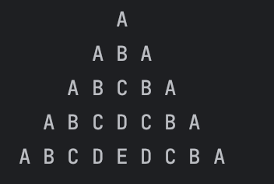

**Problem 10:**

public class Problem10 {  
 public static void main(String[] args) {  
 int n = 5;  
  
 for (int i = 1; i <= n; i++) {  
 for (int j = 1; j <= n - i; j++) {  
 System.*out*.print(" ");  
 }  
 for (int j = 1; j <= 2 * i - 1; j++) {  
 if (j == 1 || j == 2 * i - 1) {  
 System.*out*.print("*");  
 } else {  
 System.*out*.print(" ");  
 }  
 }  
 System.*out*.println();  
 }  
  
 for (int i = n - 1; i >= 1; i--) {  
 for (int j = 1; j <= n - i; j++) {  
 System.*out*.print(" ");  
 }  
 for (int j = 1; j <= 2 * i - 1; j++) {  
 if (j == 1 || j == 2 * i - 1) {  
 System.*out*.print("*");  
 } else {  
 System.*out*.print(" ");  
 }  
 }  
 System.*out*.println();  
 }  
 }  
}

Output:

