**CENTENNIAL COLLEGE**

**COMP 212: PROGRAMMING 3**

**LAB ASSIGNEMT MULTITHREADING**

**NAME: _Aakash Jain_________________________________________________**

**STUDENT ID: _____300795874 ________________________________________**

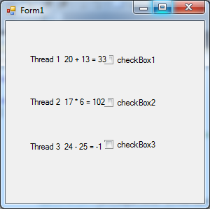 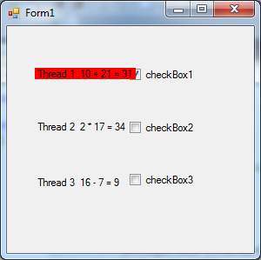

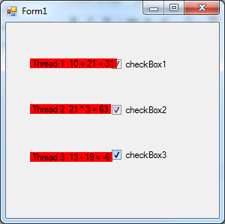 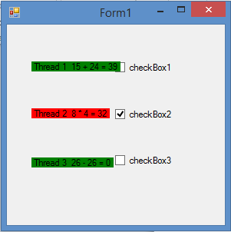

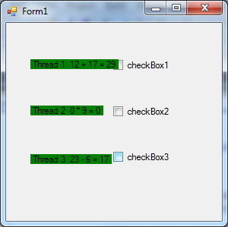

**Class1.cs**

using System.Text;

using System.Threading;

using System.Windows.Forms;

using System.Drawing;

namespace multithreadingGUI

{

public class ThreadNumber

{

private static Random generator = new Random();

private bool suspend = false;

private Label output;

private string threadName;

public ThreadNumber(Label label)

{

output = label;

}

private delegate void DisplayDelegate(int [] a);

private void DisplayCharacter(int [] a)

{int sum=0;

if (threadName == "Thread 1 ")

{

sum = a[0] + a[1];

output.Text = threadName + " " + a[0] + " + " + a[1] + " = " + sum;

}

if (threadName == "Thread 2 ")

{

sum = a[0] * a[1];

output.Text = threadName + " " + a[0] + " * " + a[1] + " = " + sum;

}

if (threadName == "Thread 3 ")

{

sum = a[0] - a[1];

output.Text = threadName + " " + a[0] + " - " + a[1] + " = " + sum;

}

}

public void GeneratorRandomCharacter()

{

threadName = Thread.CurrentThread.Name;

while (true)

{

Thread.Sleep(generator.Next(1000));

lock (this)

{

while (suspend)

{

Monitor.Wait(this);

}

}

int []num=new int[2] ;

num[0]= generator.Next(28);

num[1] = generator.Next(28);

output.Invoke(new DisplayDelegate(DisplayCharacter), new object[] { num });

}

}

public void Toggle()

{

suspend = !suspend;

output.BackColor = suspend ? Color.Red : Color.Green;

lock (this)

if (!suspend)

Monitor.Pulse(this);

}

}

}

**Form1.cs**

using System;

using System.Collections.Generic;

using System.ComponentModel;

using System.Data;

using System.Drawing;

using System.Linq;

using System.Text;

using System.Windows.Forms;

using System.Threading;

namespace multithreadingGUI

{

public partial class Form1 : Form

{

public Form1()

{

InitializeComponent();

}

private ThreadNumber Num1, Num2, Num3;

private void Form1_Load(object sender, EventArgs e)

{

Num1 = new ThreadNumber(thread1label);

Num2 = new ThreadNumber(thread2label);

Num3 = new ThreadNumber(thread3label);

Thread firstThread = new Thread(new ThreadStart(Num1.GeneratorRandomCharacter));

firstThread.Name = "Thread 1 ";

firstThread.Start();

Thread secondthread = new Thread(new ThreadStart(Num2.GeneratorRandomCharacter));

secondthread.Name = "Thread 2 ";

secondthread.Start();

Thread thirdThread = new Thread(new ThreadStart(Num3.GeneratorRandomCharacter));

thirdThread.Name = "Thread 3 ";

thirdThread.Start();

}

private void thread1checkbox_CheckedChanged(object sender, EventArgs e)

{

Num1.Toggle();

}

private void thread2checkbox_CheckedChanged(object sender, EventArgs e)

{

Num2.Toggle();

}

private void thread3checkbox_CheckedChanged(object sender, EventArgs e)

{

Num3.Toggle();

}

}

}