CWATM and FUSE: Simulating the Upper Bhima basin

Mikhail Smilovic, IIASA

# General

The Community Water Model (CWATM) is an open-source process-based hydrological model designed to assess water availability, water demand, and environmental needs. The following infographic illustrates a general overview of the different processes in the model. 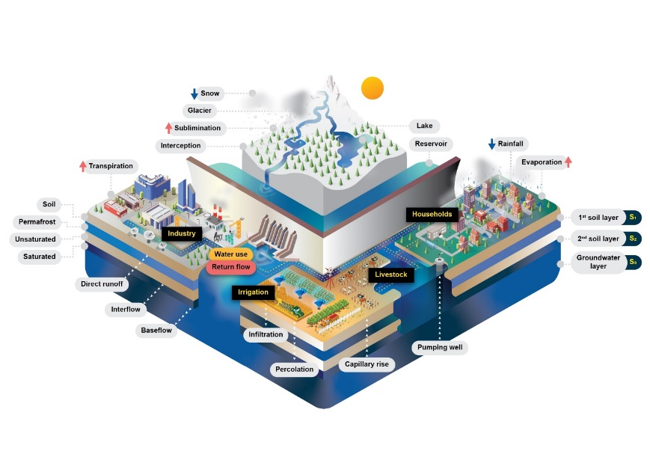

Figure Schematic of the processes within CWATM

The inputs include information on meteorological parameters like temperature and precipitation, topography and river flow parameters, and land and water use. The model simulates the region as a connected grid of cells where each cell calculates the amount of water entering and leaving at a daily timestep, in relationship to the surrounding cells and its own water demand.

The specific data requirements are detailed here on the CWATM webpage: <https://cwatm.iiasa.ac.at/data.html>.

The outputs can relate to any of the processes that are simulated in CWATM. These include processes such as river discharge, evapotranspiration, as well as water demand, water availability, and environmental needs. The following figure illustrates an example of estimated river discharge along the rivers in the Upper Bhima basin for a snapshot in time, where the amount of flow is represented relatively with deeper blue colours.

Figure Example output of CWATM showing a snapshot in time of river discharges across the Upper Bhima basin.

Some model outputs in the form of animations simulating over several years are available here: [**https://cwatm.iiasa.ac.at/results.html#rst-demo**](https://cwatm.iiasa.ac.at/results.html#rst-demo).

Outputs generally of interest are:

* River discharge over the entire region or at specific points, from daily to monthly to yearly
* Reservoir water availability,
* Evapotranspiration,
* Soil moisture,
* Groundwater recharge and abstraction,
* Groundwater levels and depth to groundwater (beta)
* Crop-specific transpiration and relative yield (to be developed)

# CWATM development:

CWATM is being further developed for the FUSE project is several ways:

* Higher resolution,
* Improved groundwater processes, and
* Crop-specific agricultural water use and relative yield.

Higher resolution:   
CWATM has previously been applied at ~10 kilometre resolution (5 arc minute), namely, where each cell represents an area of ~100 km2. This is being increased significantly by an order of 144 where each cell represents <1km2 (30 arc second). The following figure shows the previous resolution over the entire Krishna basin with the Upper Bhima basin at the higher resolution nested inside.

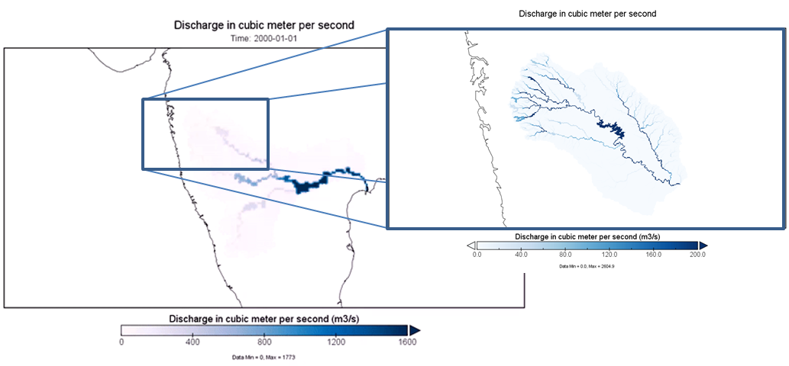

Figure 3 The figure on the left illustrates the Krishna basin at ~10km resolution, and the figure on the right illustrates the Upper Bhima basin at ~1km resolution nested inside. Both figures illustrate CWATM simulated discharge.

This increase in resolution requires that some of the previous procedures be revisited. Additionally, the basin is significantly managed with reservoirs and allocations diverting water away from rivers for agricultural, domestic, and industrial demands. This requires that the model be treated with careful attention for processes such as water demand and availability, and the spatial relationship between both.

The model is currently running in beta mode at the higher 30 arc second resolution, although some of the procedures are still being revisited. The following figures show a comparison between observed and simulated river discharge at a location downstream from Pune. The graph from which these figures are derived is available interactively online here: <https://plot.ly/~mikhail.smilovic/432/>.

The following figure illustrates both the timeseries of observed and simulated flows, as well as the total simulated and observed flow over the wet (Kharif) season of 1985.

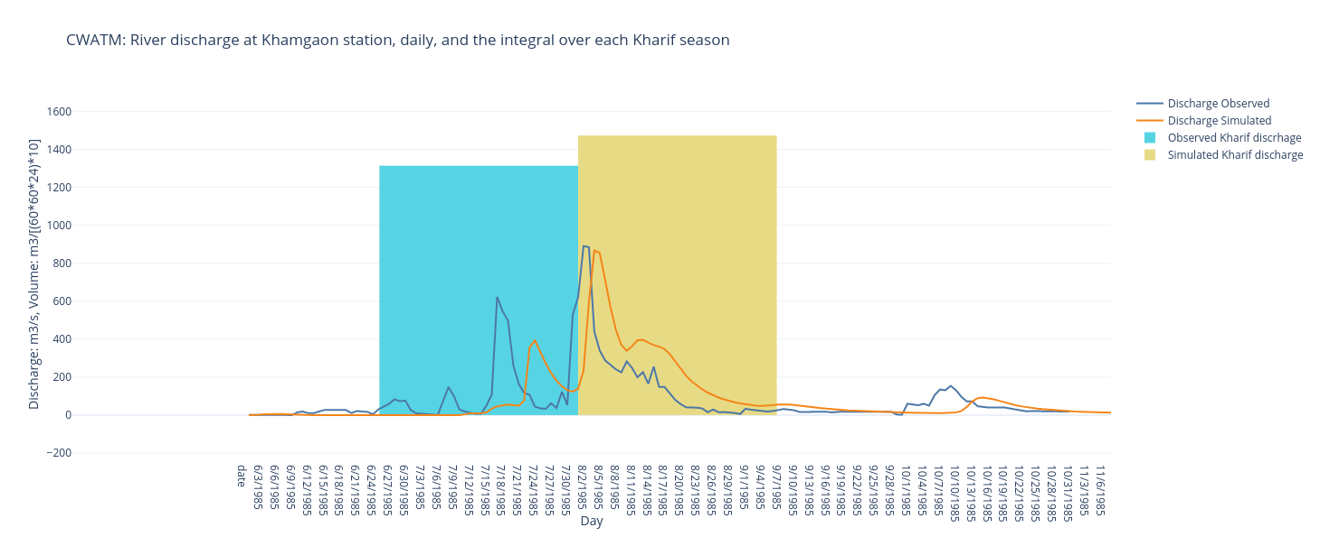

Figure Observed and simulated river discharge at Khamgaon station for the wet season (Kharif) of 1985. Note that the total observed and simulated flows have been adjusted to fit on the same graph as the daily discharge.

The current processes being redeveloped relate to supplying water demand. In its current state, CWATM under-allocates river discharge to Pune city and the surrounding agriculture. This can be observed similarly in the following figure showing a comparison across five years.

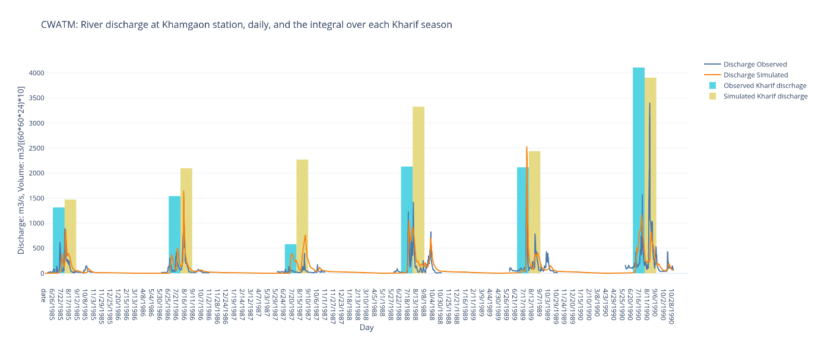

Figure 5 Observed and simulated river discharge at Khamgaon station for the wet season (Kharif) from 1985-90.

#### Improved groundwater processes

#### CWATM has been recently coupled with the finite-difference flow model MODFLOW developed by the U.S. Geological Survey. This allows for the model to simulate groundwater flow, groundwater levels, and depth to groundwater. To better simulate the interactions of surface water and groundwater, MODFLOW has been set up at 500 metre resolution and includes even finer resolution data on the presence of rivers within each cell. The following figure illustrates an example output of the depth to groundwater over the Upper Bhima basin.

#### E:\ScaleWAYS\gw1.png

#### The model currently represents the hydrogeology of the Upper Bhima basin as a single layer of uniform thickness. Further development will include evaluating the addition of more layers to better represent the layered aquifer system of the basin, as well as calibrating the model with groundwater level data.

#### Crop-specific agricultural water use and relative yield:

CWATM currently determines agricultural crop water use by grouping crops into three categories: paddy rice, non-paddy irrigated crops, and non-irrigated agriculture. The development of the model will disaggregate the water use from separate crops important for the region and allow for estimating the effect on yields from not meeting crop water demand. The approach will be using the FAO methodology of crop coefficients and sensitivity indices to determine such water use and crop yield functions. The relationship between crop production and crop water use depends on the timing and amount of water use. CWATM calculates water demand daily and depending on the water availability will similarly calculate daily water deficit. The timing of these deficits/stress affect the crop yield in a non-linear fashion. The estimated delivery of this development is Autumn, 2019. For further information, you can find an overview of these function and the methodology of Crop Kites on the AGU/EGU blog here: <https://blogs.egu.eu/network/water-underground/2017/01/09/crop-kites/>.