Bias and variance

Bias: Is the training error

Variance: Is the testing error.

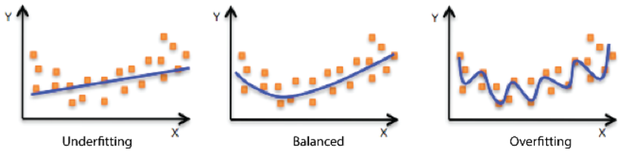

Overfitting:

A model performs well on the training data but not the testing data is called an overfitted model or overfitting

Underfitting:

A model performs bad on both the training and testing data is called as underfitted model or underfitting.

Ideal model (balanced):

An ideal model should perform well on training as well as the test data. In other words, an ideal model should have less training error (SSR) as well as less testing error (SSR).

Takeaways:

* Even a model performs ok with training data but generalizes well to the unseen training data can be considered. This way of sacrificing some accuracy in training and getting good results in test data is called as bias-variance trade-off.
* There are many ways to overcome overfitting using techniques like,
  + Regularization
  + Bagging
  + Boosting