Neural network:

A neural network consists of nodes and connection between the nodes.

Below given an image of simple neural network.

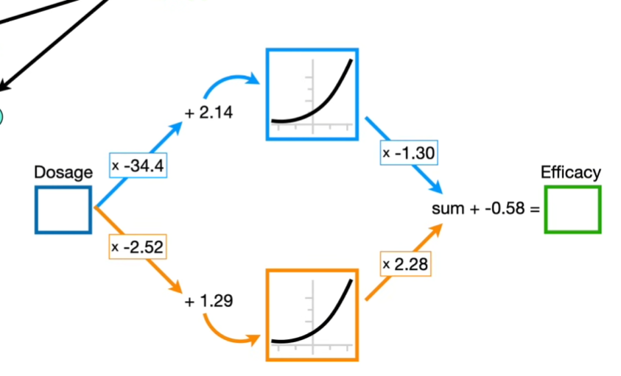

Nodes:

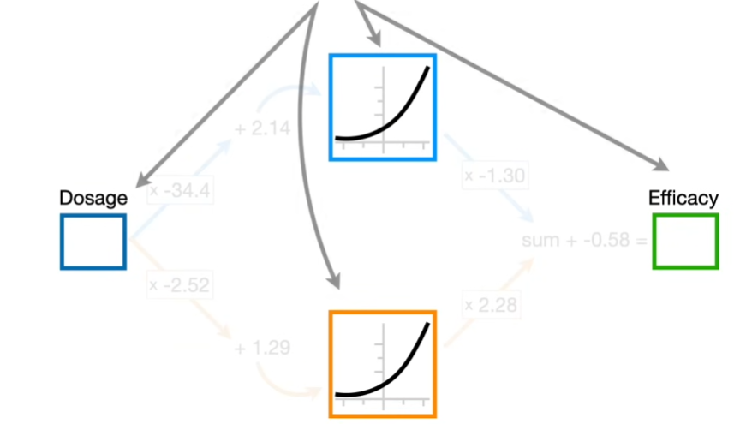

Connections:

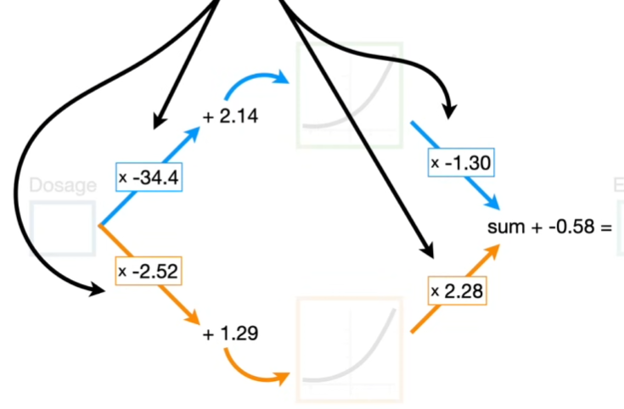

A neural network starts with unknown parameter values and that are estimated when we fit a neural network to our data using a technique called back propagation.

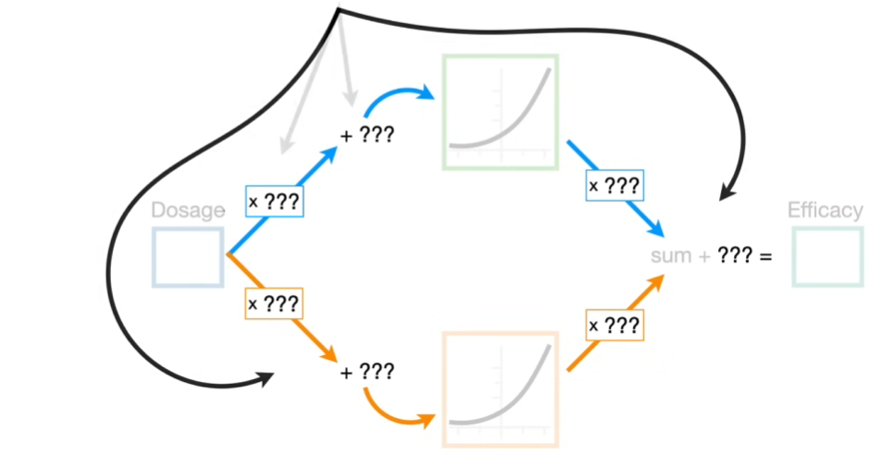

Activation functions:

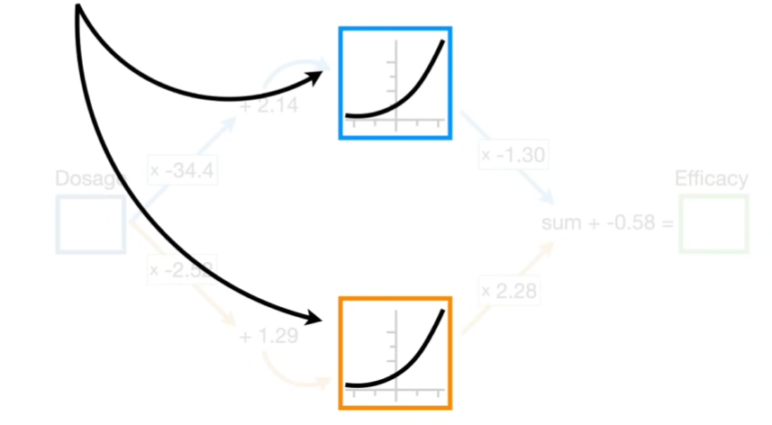

* The curved or bend lines are called as activation functions. These transforms input values to fit the training data. Commonly use activation functions are
  + ReLU
  + Softmax
  + Softplus
  + Sigmoid

Hidden layers:

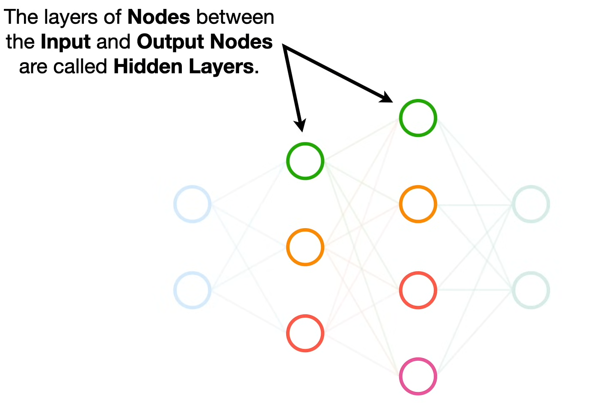

The layers of nodes in between input and output layers are called as Hidden layers.

Weights:

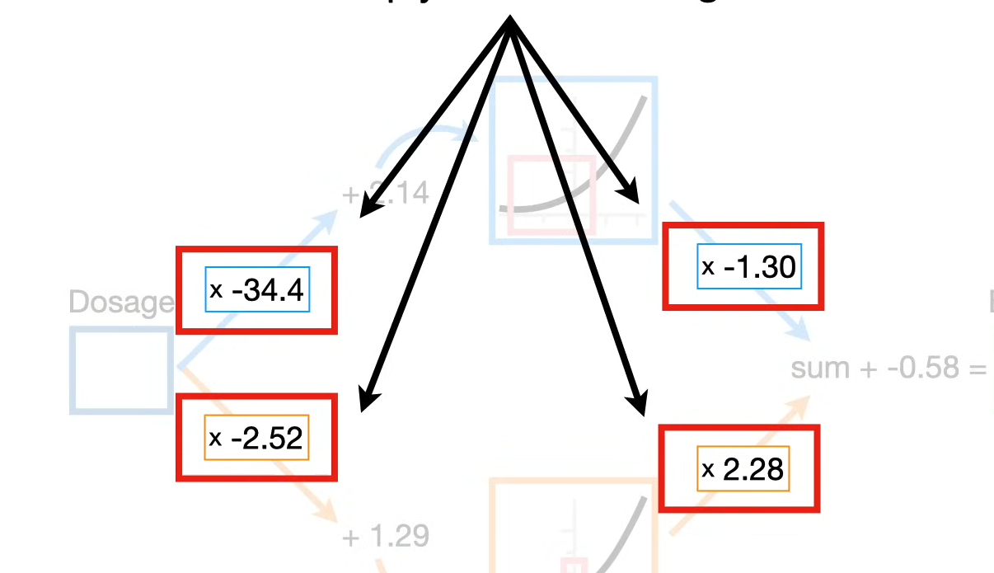

Biases:

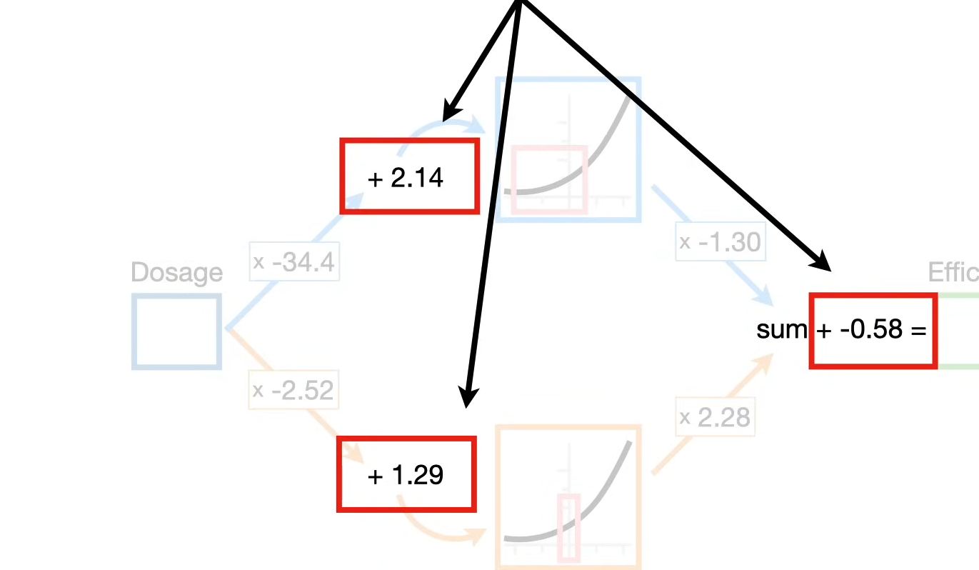

The Chain