Decision Tree

* In general decision tree makes a statement and then makes a decision based on whether the statement is true or false.
* When a decision tree classifies things into categories then it’s a classification tree.
* When a decision tree predicts numeric values then it’s a regression tree.

Classification Tree

* The very top of the tree is called a root node or the root.

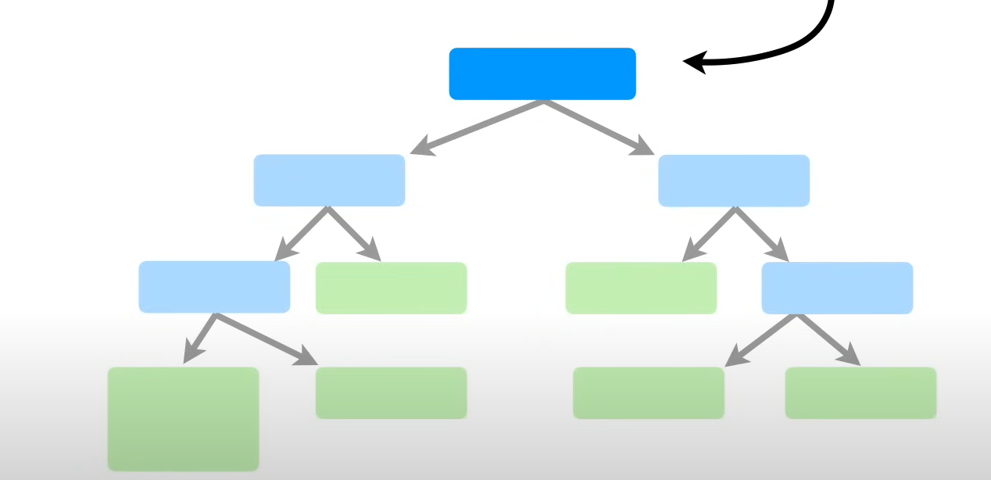

* The internal nodes are called as branches. Branches have arrows pointing towards them and arrows pointing away from them.

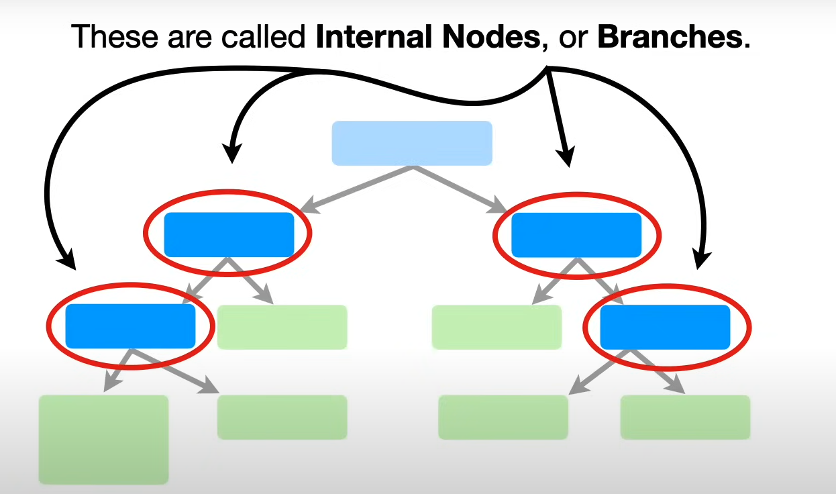

* Lastly, we have leaf nodes or just leaves. Leaves have arrow pointing towards them not away from them.

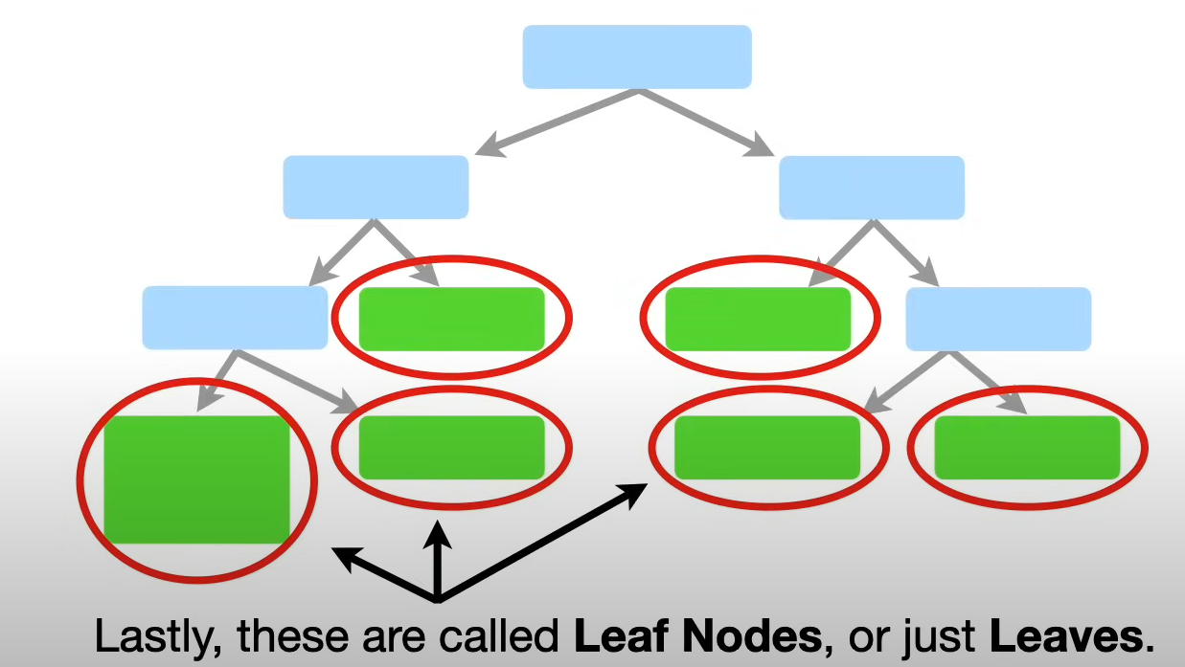

Example:

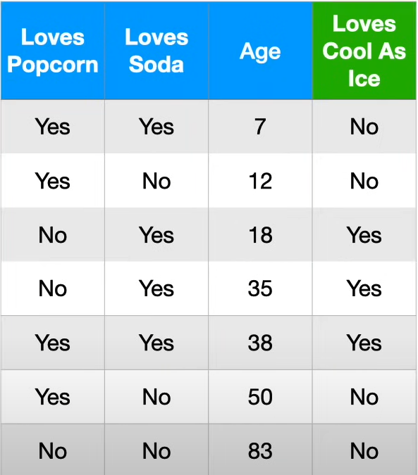

We have a data like this an we have to make a decision tree. So, what can we do here.

* First, we have to find the root note. For that build sub trees with X and Y. Here first we use loves popcorn (X) and loves cool as Ice (Y).

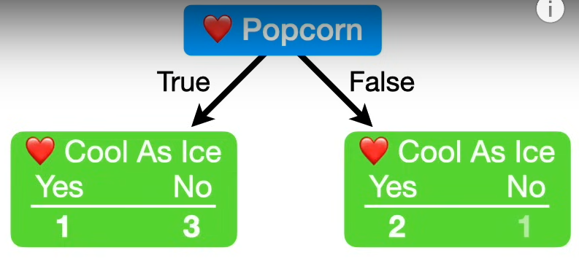

* Now repeat the same for next independent and dependent variable

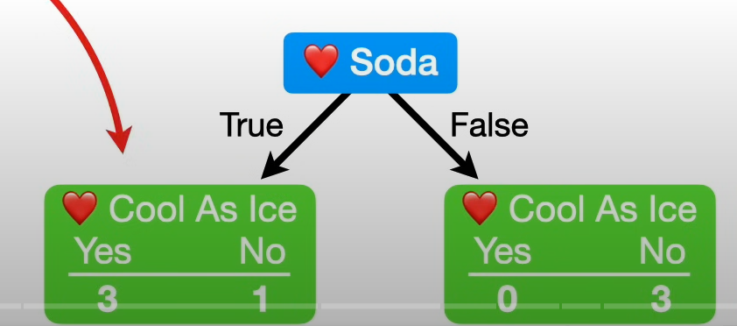

* Now seeing these three tree leaves (Out of 4 leaves) all contain a mixture of people who do and who do not love cool as ice. So, they are called impure.
* To quantify the impurity, we use impurity measures such as
  + Gini impurity
  + Entropy
  + Information gain
* Gini impurity of leaf is given by

Gini impurity of a leaf = 1 – (the probability of “Yes”)2-(the probability of “No”)2

So, for popcorn in left leaf we have

=1 – (1/1+3)2-(3/1+3)2

=0.375

For right leaf,

=1-(2/2+1)2-(1/2+1)2

=0.444

Since the data points on both the leaves are not same, we should take weighted average of the impurities

Total Gini impurity = weighted average of Gini impurities for the leaves

= (total data points on left leaf/ Total data points in both leaves) \*Gini impurity of left leaf +

(total data points on right leaf/ Total data points in both leaves) \*Gini impurity of right leaf

= (4/4+3) \*0.375 + (3/4+3) \*0.444

= 0.405

Therefore, the Gini impurity for loves popcorn is 0.405.

Likewise, for loves soda the Gini impurity is 0.214

Then we go for Age, but this a numerical feature. So, we can split like we did for loves soda and popcorn

So, now we arrange the data in ascending order. Then we calculate the average age for all adjacent people.

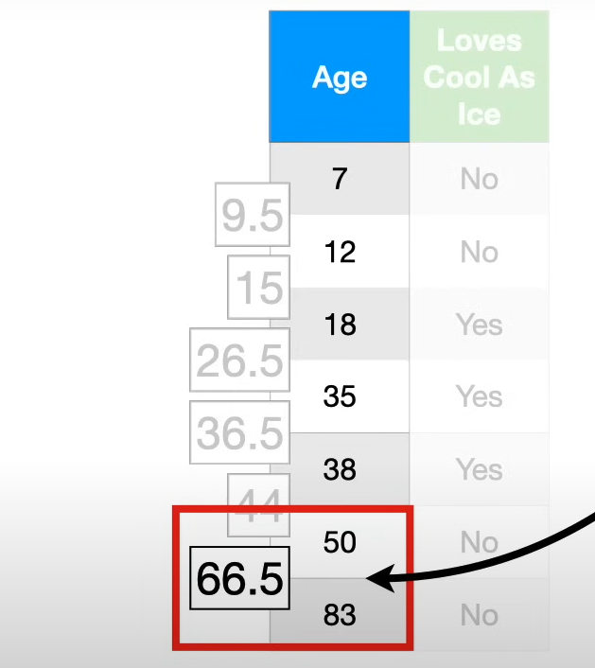

Now we calculate gini impurity for each values

For eg, lets take first average data point 9.5,

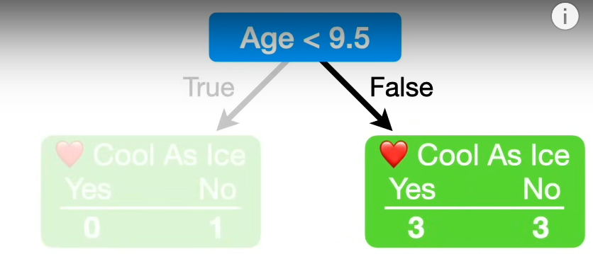

Again, like before we calculate the Gini impurity for left and right leaf and then calculate total Gini impurity.

Likewise, calculate the Gini impurity for the all the other candidate values

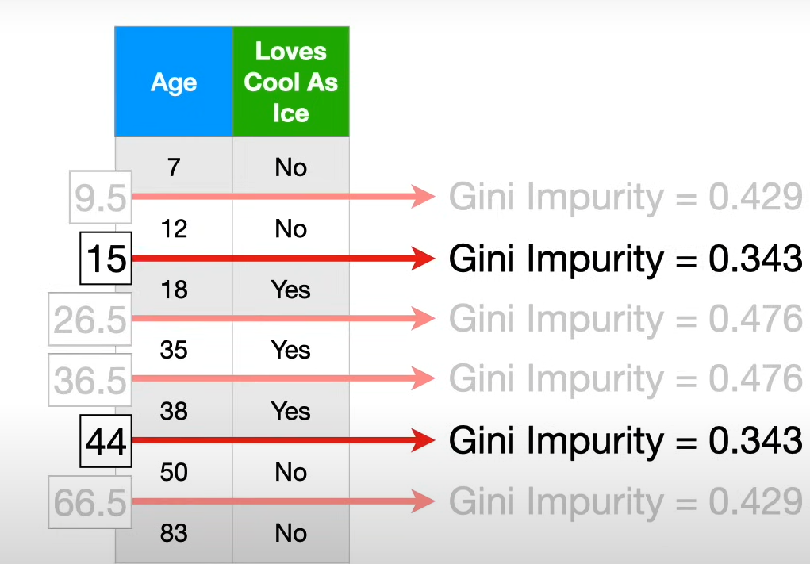

Here these two-candidate threshold have lower Gini impurity, So, consider once amongst those.

Now comparing three variables we have lowest Gini impurity for loves soda. So, we consider that as the root node.

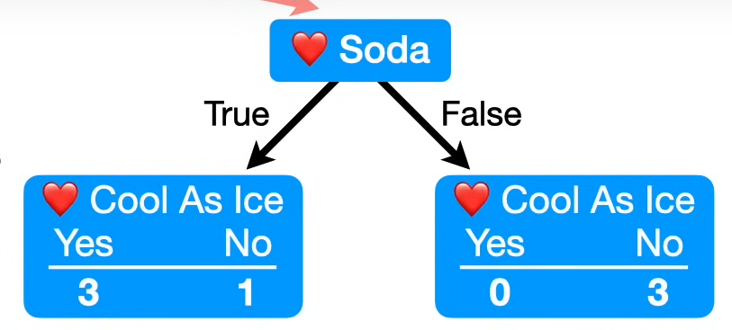

* Now we have repeated the same that mentioned above process for the branches until a purity is reached. Purity means we there is no chance to split a node further and this is called as a leaf node. One last thing we have to do is to assign values to each leaf. This is done by using majority of the votes in the leaf.

Final tree will look something like this,

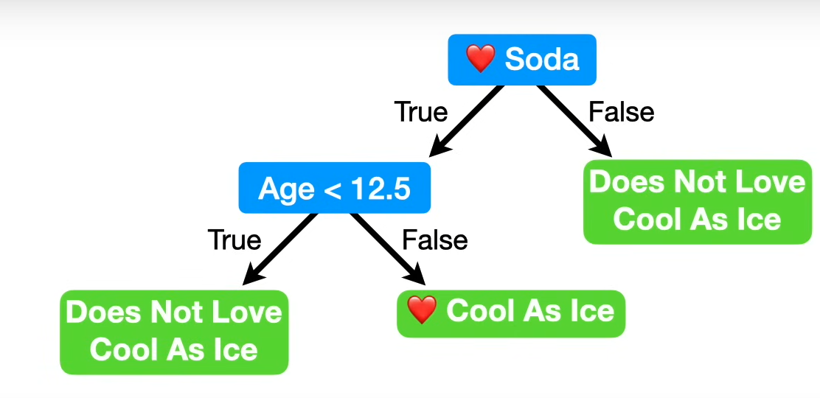

Important takeaway:

* By implementing this algorithm, the data well adapts to the data. As it learns complex patterns and doesn’t perform well with the test data leading to overfitting condition. To avoid this, we use pruning by setting parameters to some extent.
  + Split feature (what feature should go next to the root node to split on)
  + Split point (for numerical features which point do we have to split)
  + When do we have to stop splitting (when to stop before overfitting)
* So, while building a decision tree we don’t know how many data points to put per leaf. These can be found out by cross validation technique and pick the one that works best.

Feature selection and missing data.

Feature selection:

* Suppose we have a node we cannot further split into and the impurity also is so less. But we have data to split on. In this case the tree acts as a automatic feature selector. By setting threshold and making simpler trees with less feature (important one) we can avoid overfitting.

Missing data:

* For categorical missing data
  + Use median imputation.
  + Or find a feature which is highly correlated with the missing feature column and then impute with that.
* For numerical data
  + Use mean or median
  + Or make a linear regression with other highly correlated variable and with available data points make predictions on missing data points.

Regression Trees

Regression tree is a type of decision tree which helps to predict numeric value. Also, the leaves of a regression tree are numeric value.

Example:

Let’s take an example about effectiveness of drugs and dosages and we have an independent variable (dosage) and dependent variable effectiveness.

So, here we have only one independent variable so this goes to the root node.

For the best split we calculate the sum of square residuals per each threshold of dosage and then find the threshold in which gives the less sum of squared residuals and split based on that.

Now the branches can be also further split into more nodes by the same process with available data points per split and then we cannot further split we name it as a leaf node. But may result in overfitting condition also. So, to avoid we allow min samples per split criteria to avoid extending the trees more. Now the output will be given in the basis after doing min samples per node, the samples whatsoever in the leaf node, we will take average of them give as an output.

Now let’s take a complex example

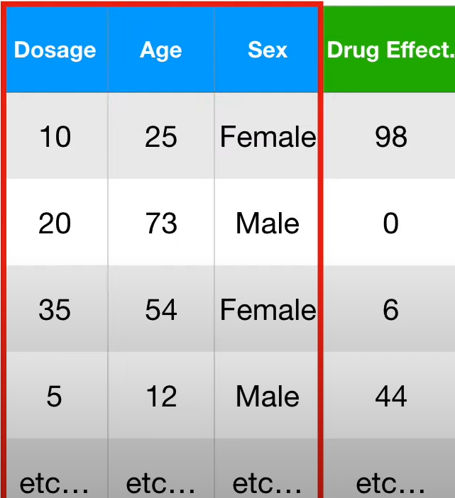

Here we have bunch of predictors. So, in this case we will try to find the sum of squared residuals per predictor against the dependent variable

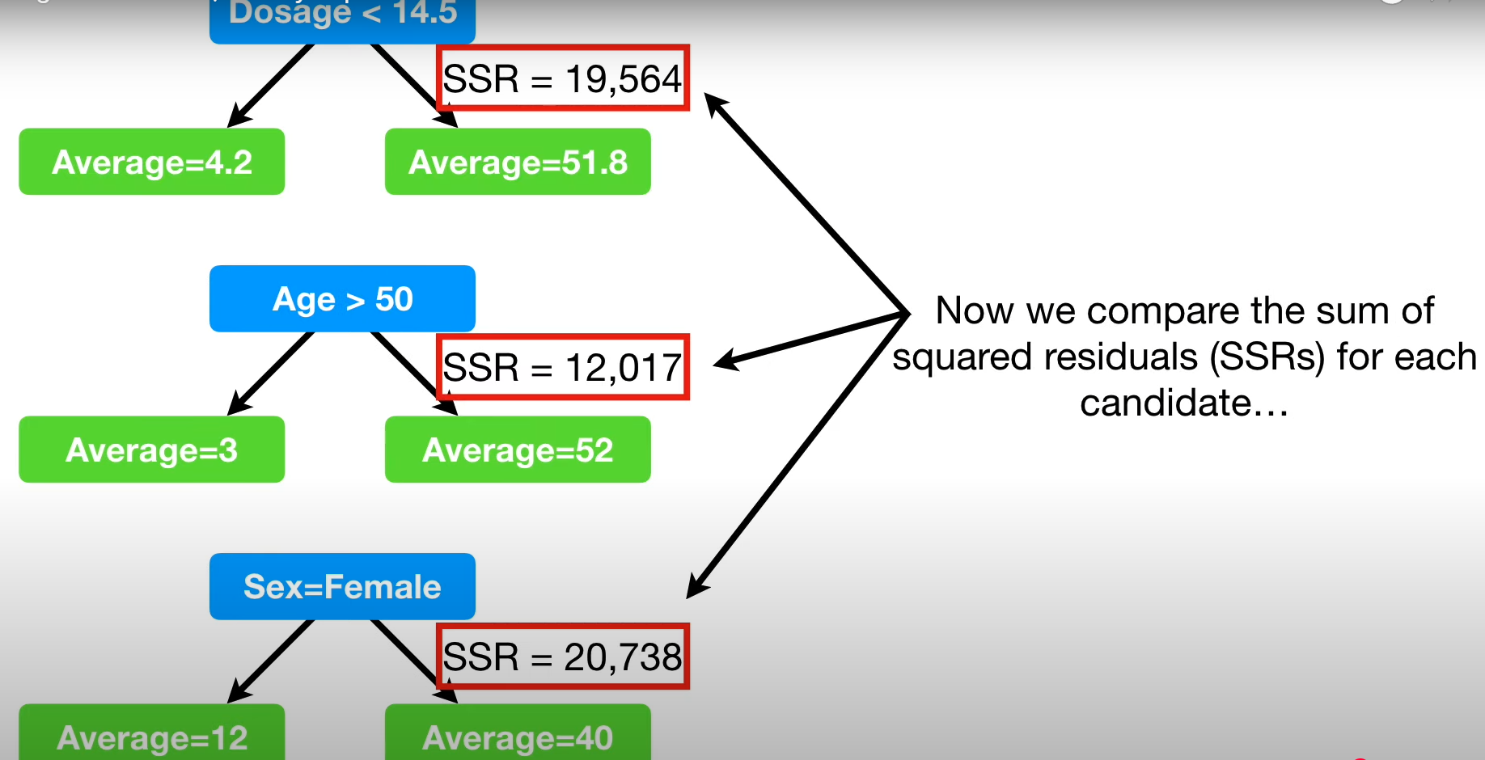

Now we pick the candidate with the lowest value here as the root node. Likewise we will the some for rest of the nodes until the min samples per node criteria met and then we will end up in leaf node.

In summary,

* A regression tree is a type of decision tree which has numeric values in the leaf
* We determine how to divide the observations by trying different thresholds and calculating the sum of squared residuals at each step.

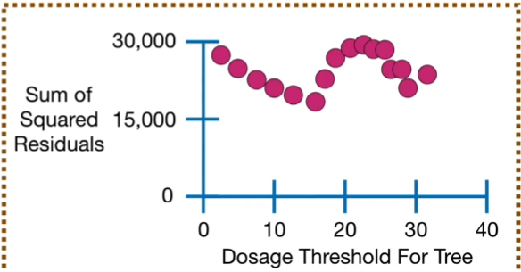

* If we have more than one predictor then the optimal threshold for each one and pick the candidate with smallest SSR to be the root.
* When we have fewer than some observations (min samples per node). Then the node becomes a leaf node.

Pruning regression tree:

The main idea behind pruning a regression tree is to prevent overfitting to the training data, so that it performs well on the test data. So, we limit the depth of tree by pruning to avoid overfitting. But how to do pruning? For this we will use cost complexity pruning.

Cost complexity pruning (weakest link pruning)

1. Calculate the sum of squared residuals of each tree. Start with full size tree and then decrease the depth and calculate SSR for rest of the trees.

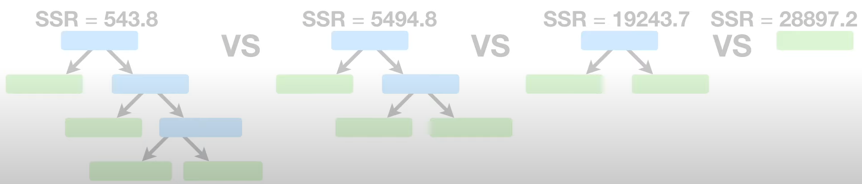

1. Note that when we remove leaf from each tree the SSR gets larger and larger. So how can we determine the best tree. For that we add a tree complexity penalty to the SSR

Tree score = SSR + αT

Here α is determined by hyperparameter found using cross validation.

T: Tree complexity penalty that is a function of leaves, or terminal nodes in a tree or subtree (Total number of leaves). This actually compensates for the difference in number of leaves.

After solving we get, and here α = 10000 (for example)

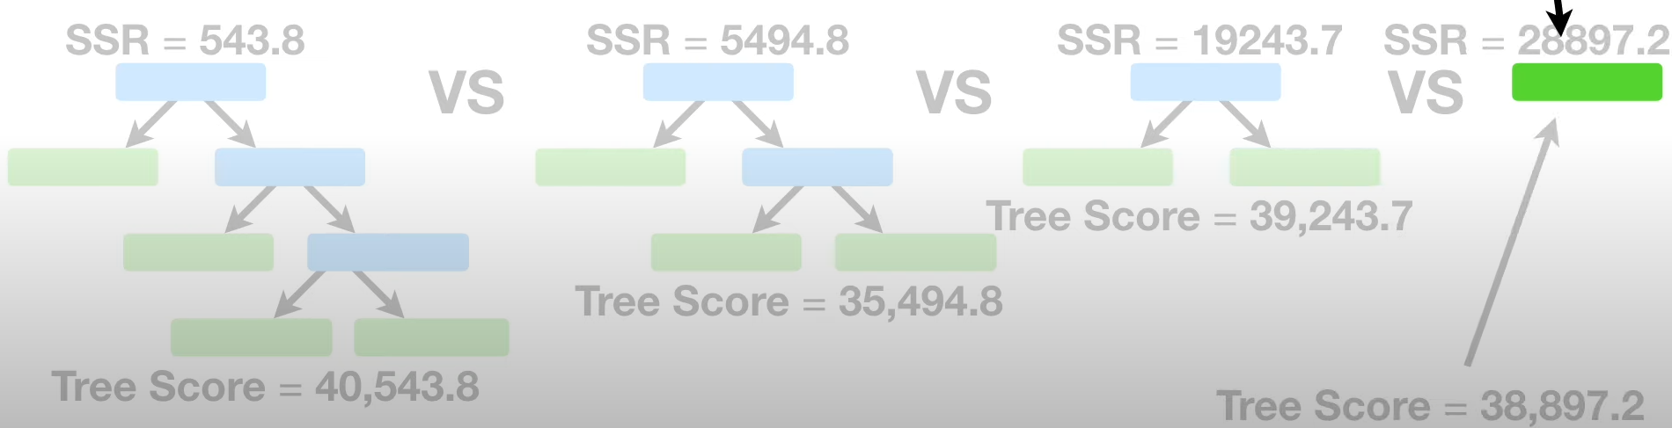

For different values of α we get different tree score in different trees.

So, when we do k fold cross validation and testing on testing data. On an average which α gives less SSR will be taken as the final tree.

