Logistic Regression

* Logistic regression is same as linear regression except, logistic regression predicts something is whether True or False, instead of predicting something continuous. Instead of fitting a line to the data, logistic regression fits a “S” shaped logistic function.

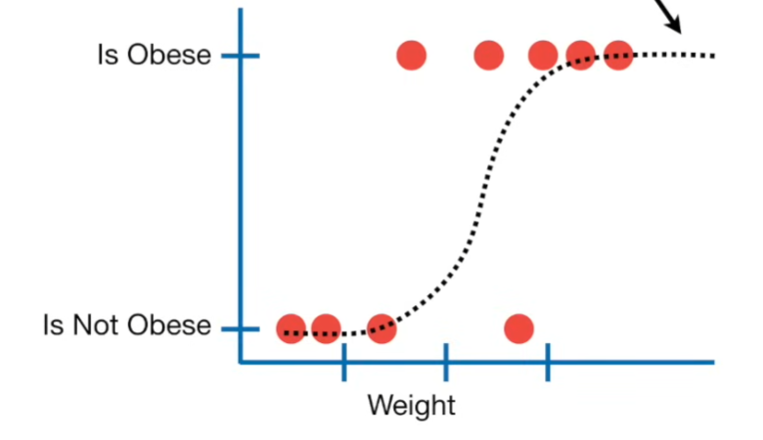

* In logistic regression we will have lots of predictor variable. But some may not be contributing to the dependent variable. This can be found using **Walt’s test**.
* Logistic regression doesn’t have the concept of least squares. So, it can’t calculate R2. Instead of this we use something called as **maximum likelihood** (product of likelihood of all data points). Different “S” shaped logistic function was fitted and product of likelihood is calculated. Then the “S” logistic function with maximum likelihood is selected as the curve.

