Name – Aniket Jalasakare

PRN – 1132210192

Roll No – 24

Create S3 Bucket & host a static website code into it.

Open AWS Console and create a bucket by naming it ani7600745960

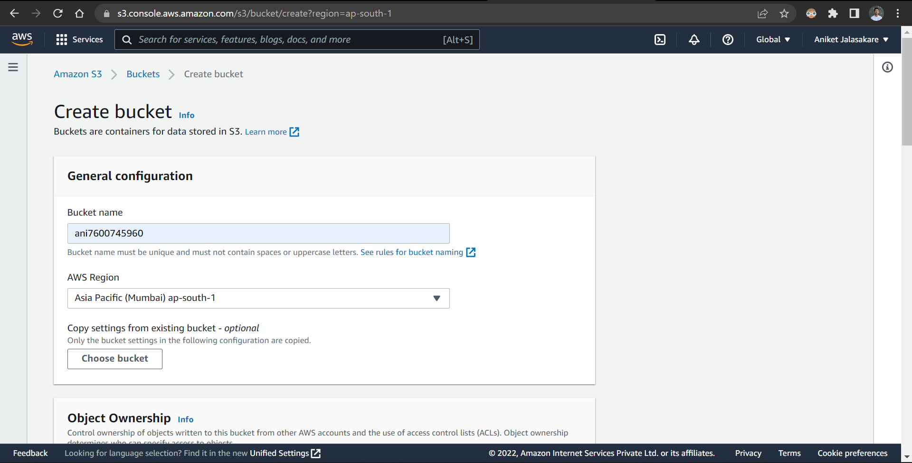

Unblock all public access

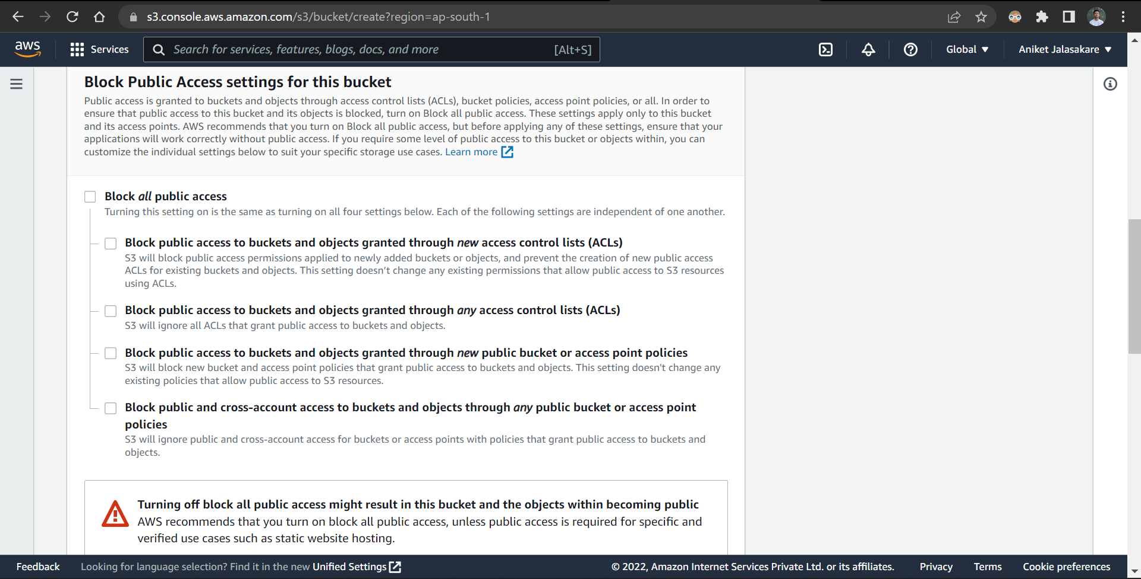

Add tag to the bucket while creating it

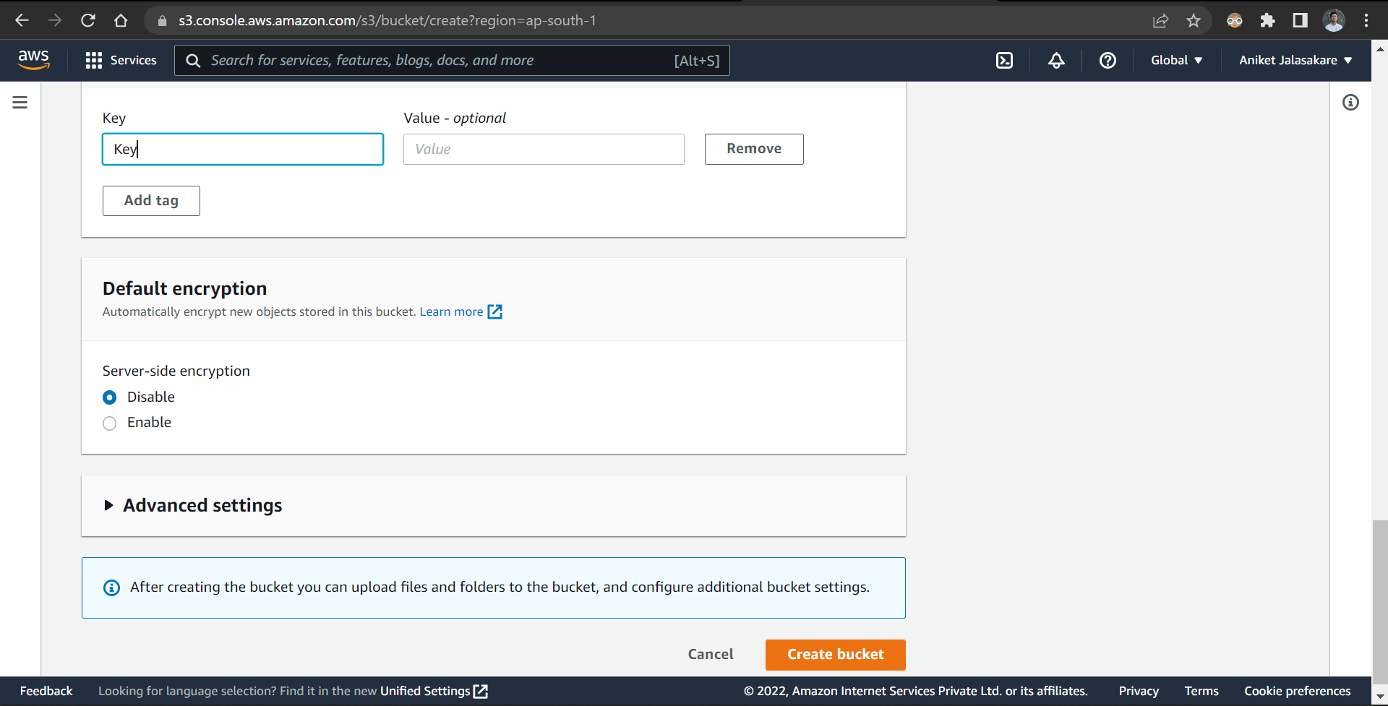

The bucket is created successfully

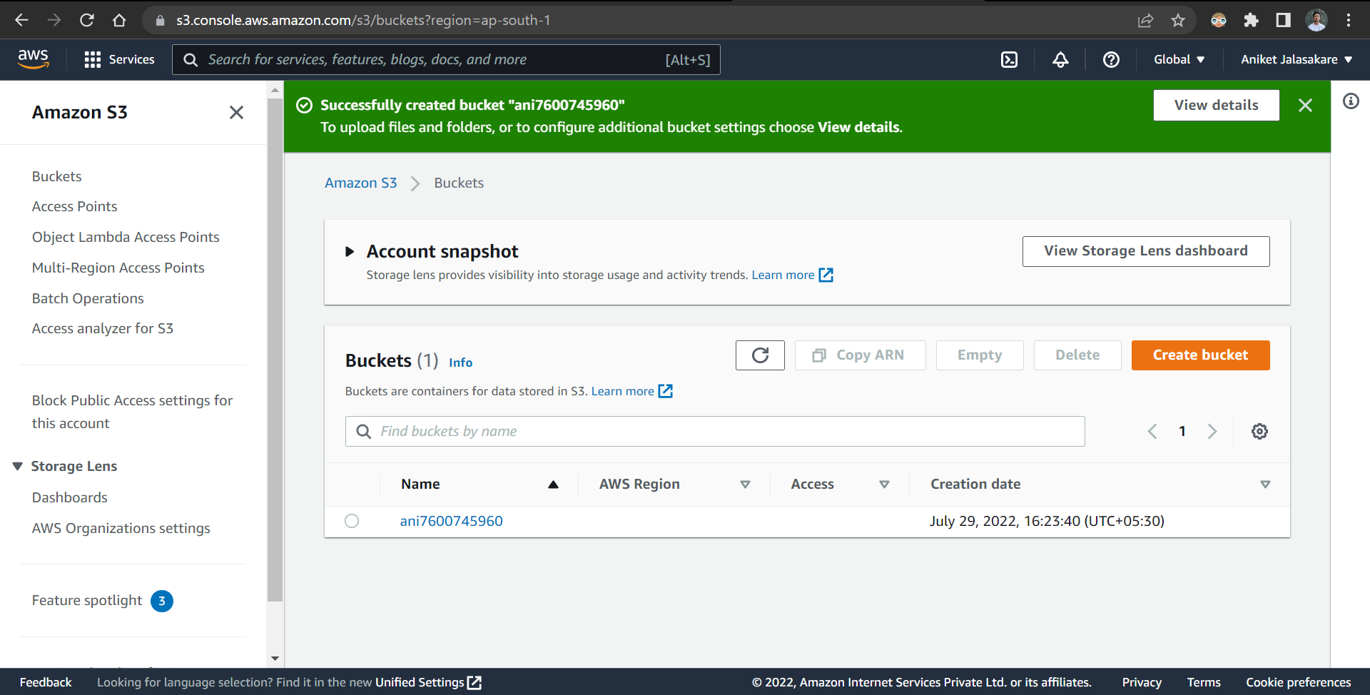

Go to the bucket and upload index.html file.

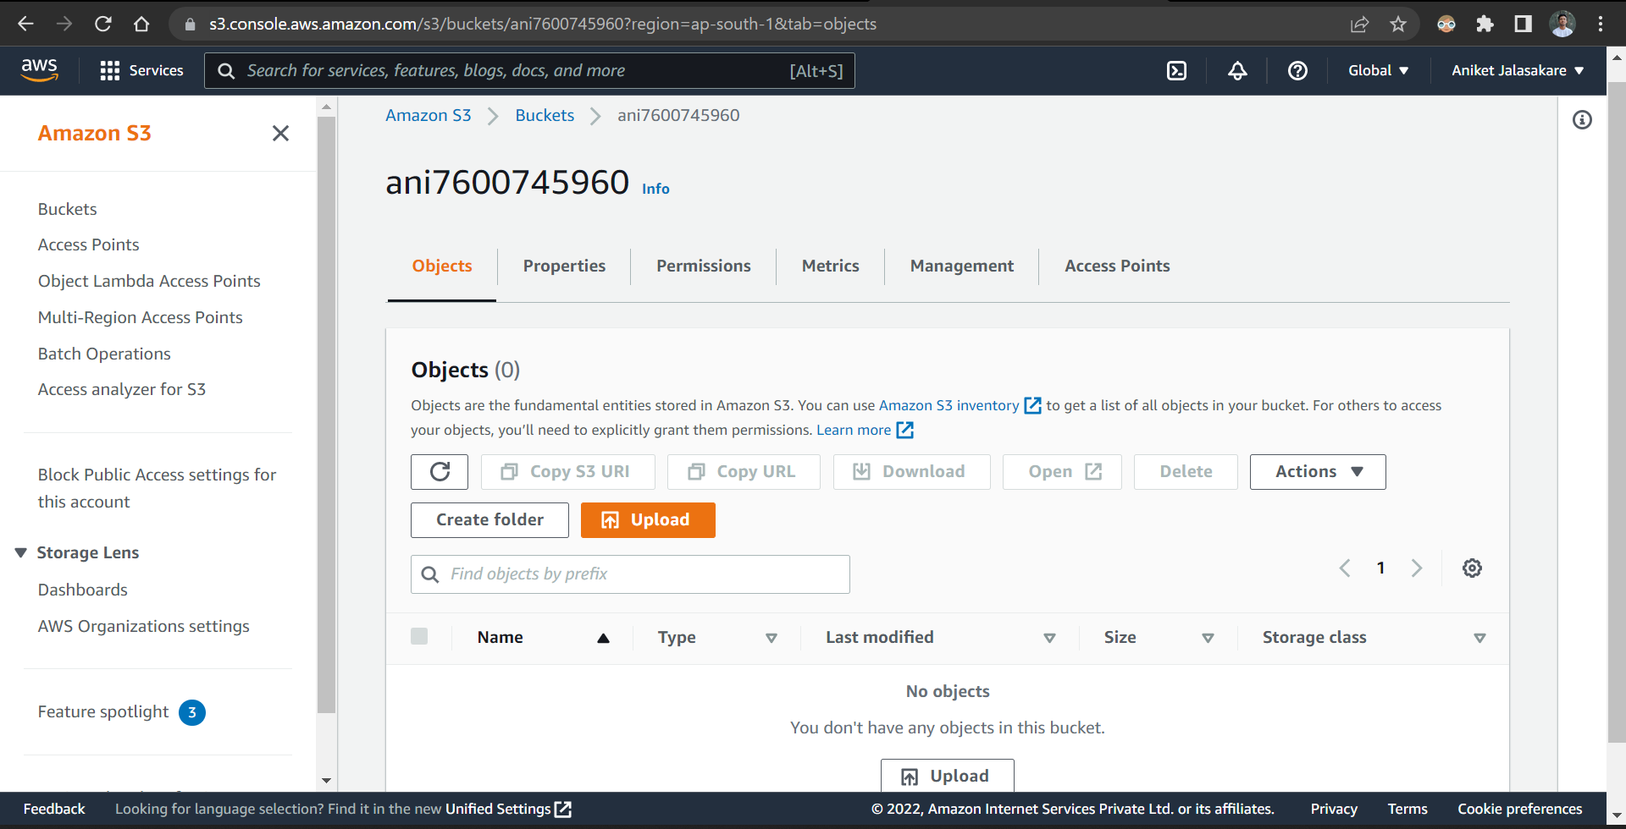

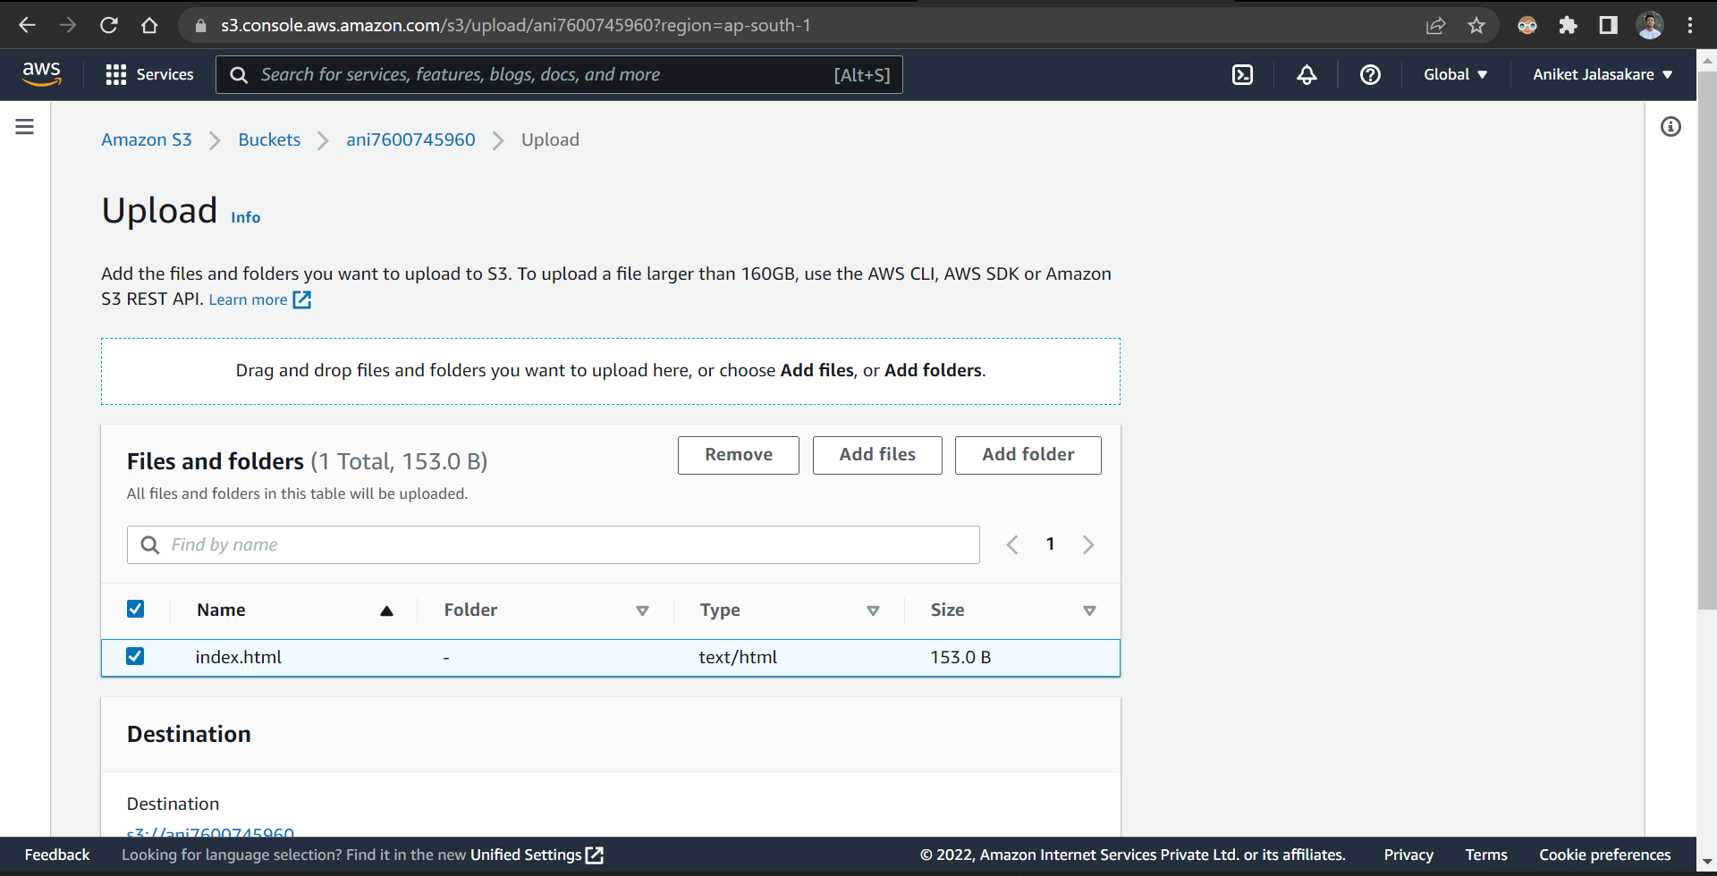

The file is uploaded successfully

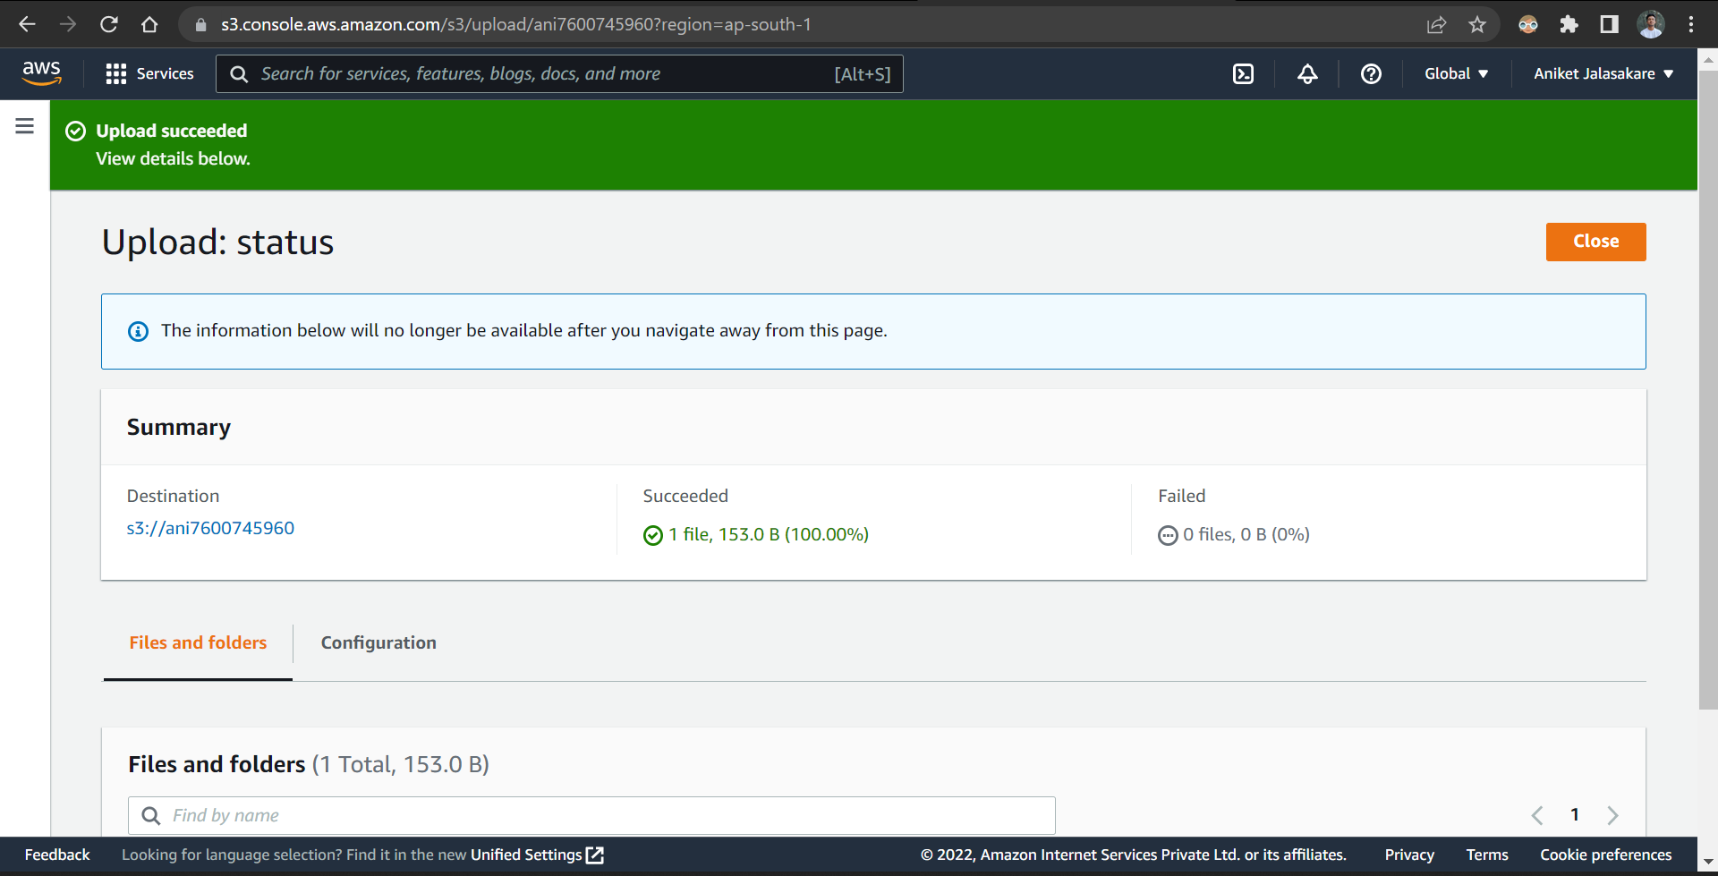

Go to bucket properties and select static website hosting option

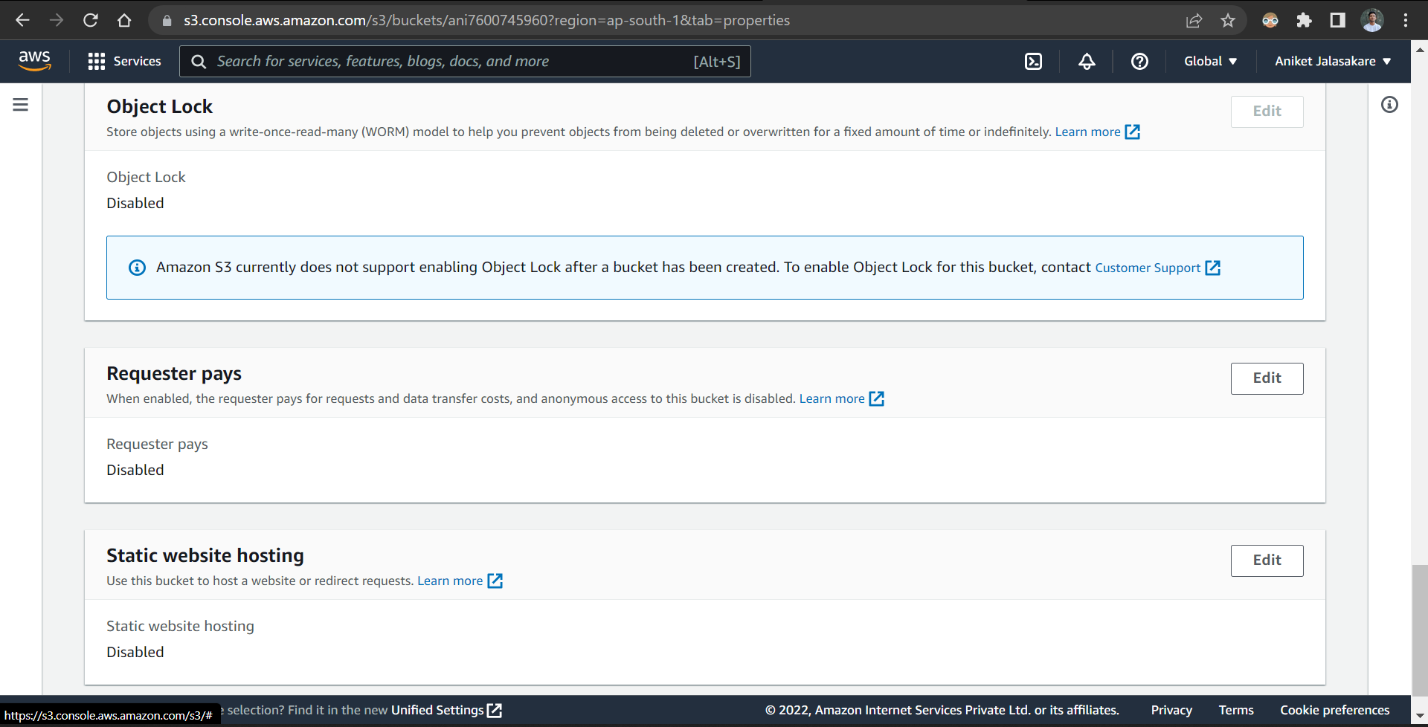

Enable the static website hosting option and enter index.html name in the document , save the changes

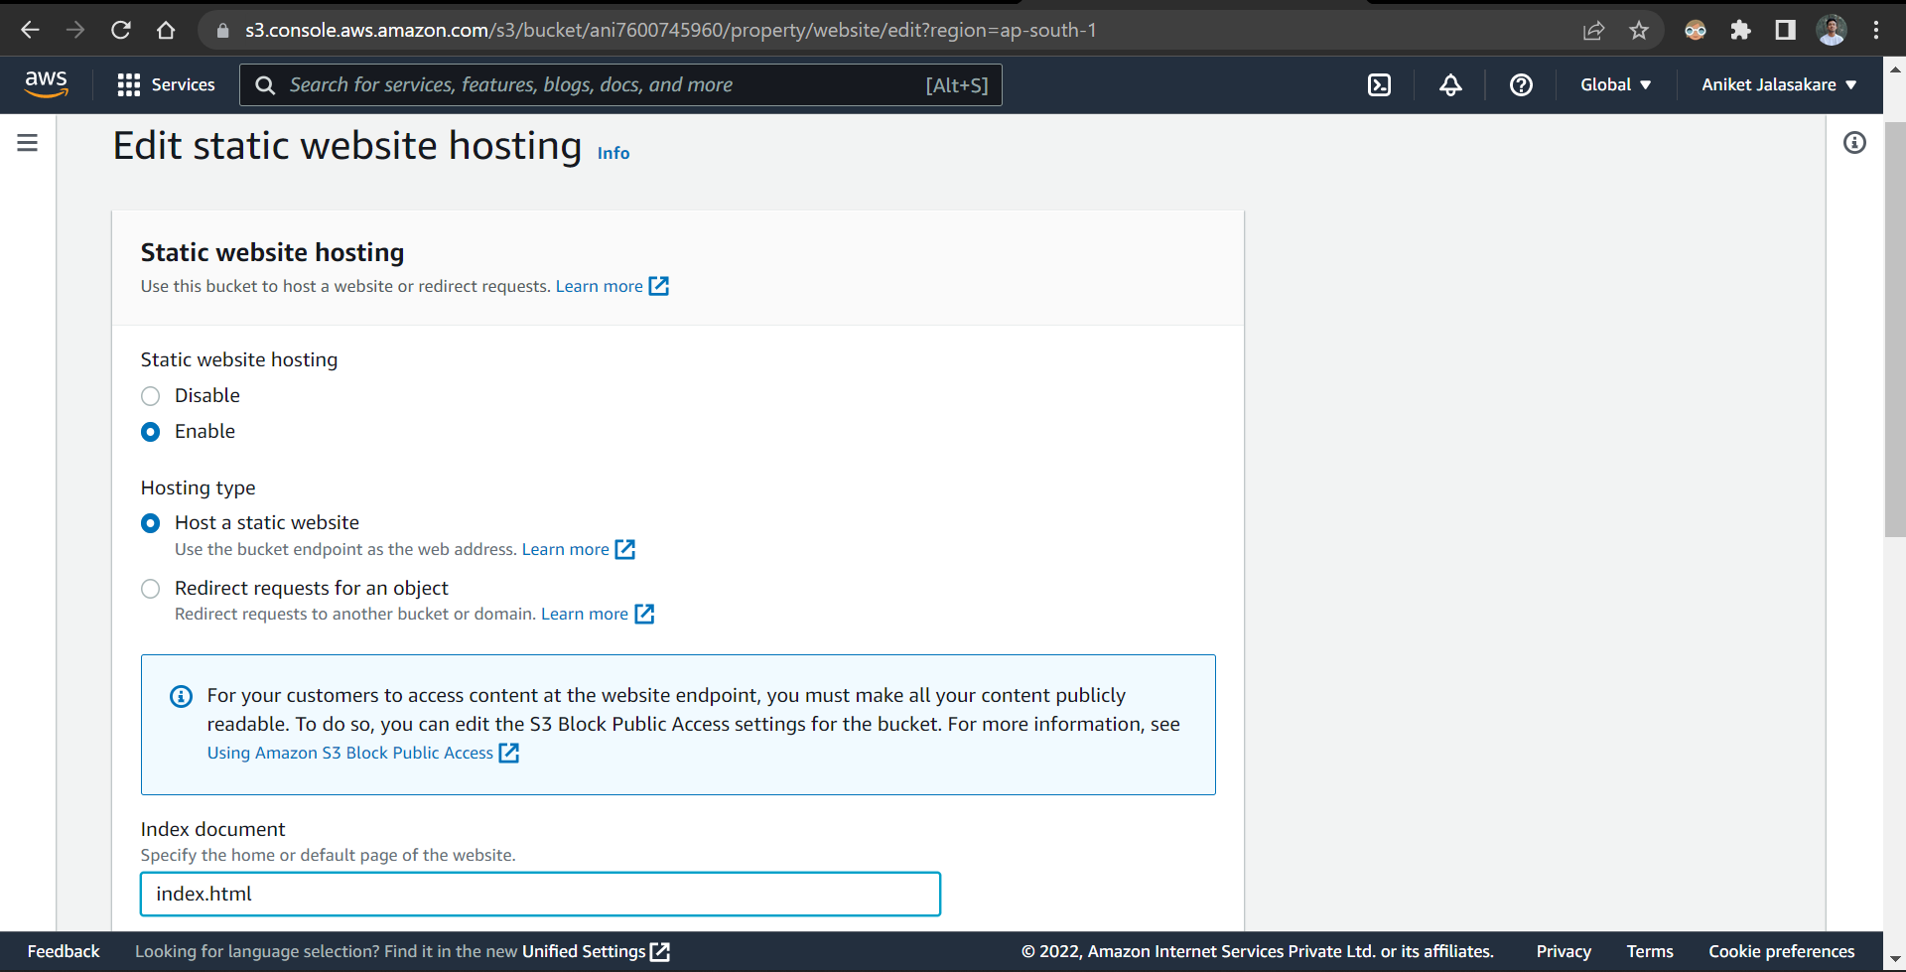

Open the index.html file from the bucket in another tab

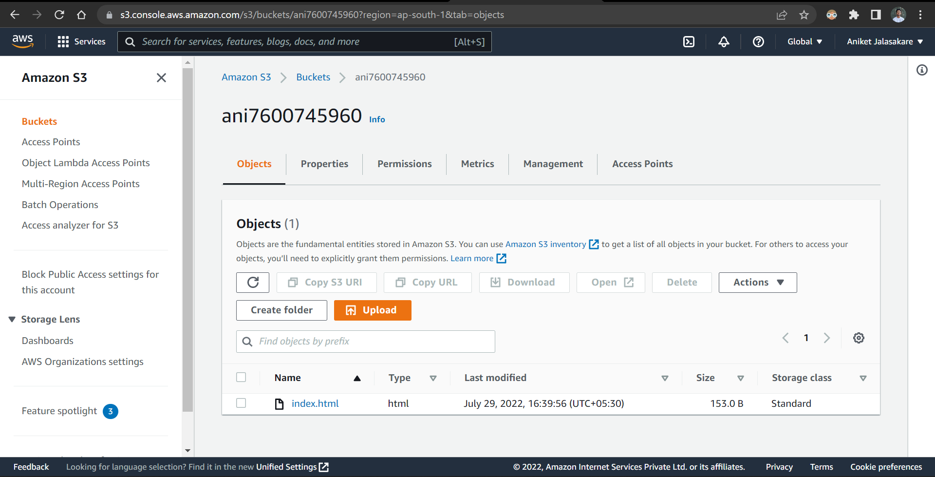

Hence, the website is opened successfully

