**Name – Aniket Jalasakare**

**Roll No – 24**

**PRN – 1132210192**

Connect EC2 Linux | T2 micro with Putty |

Windows or Linux Terminal >>> Practice

Basic Linux Commands

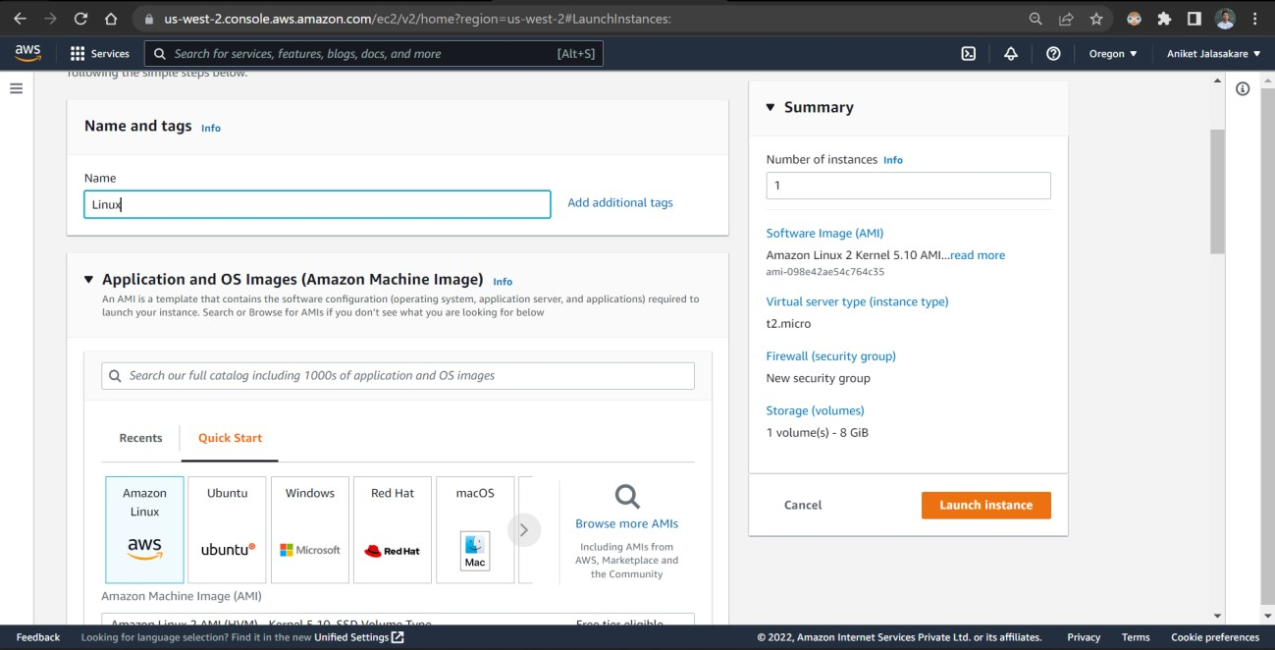

Create key-value pair

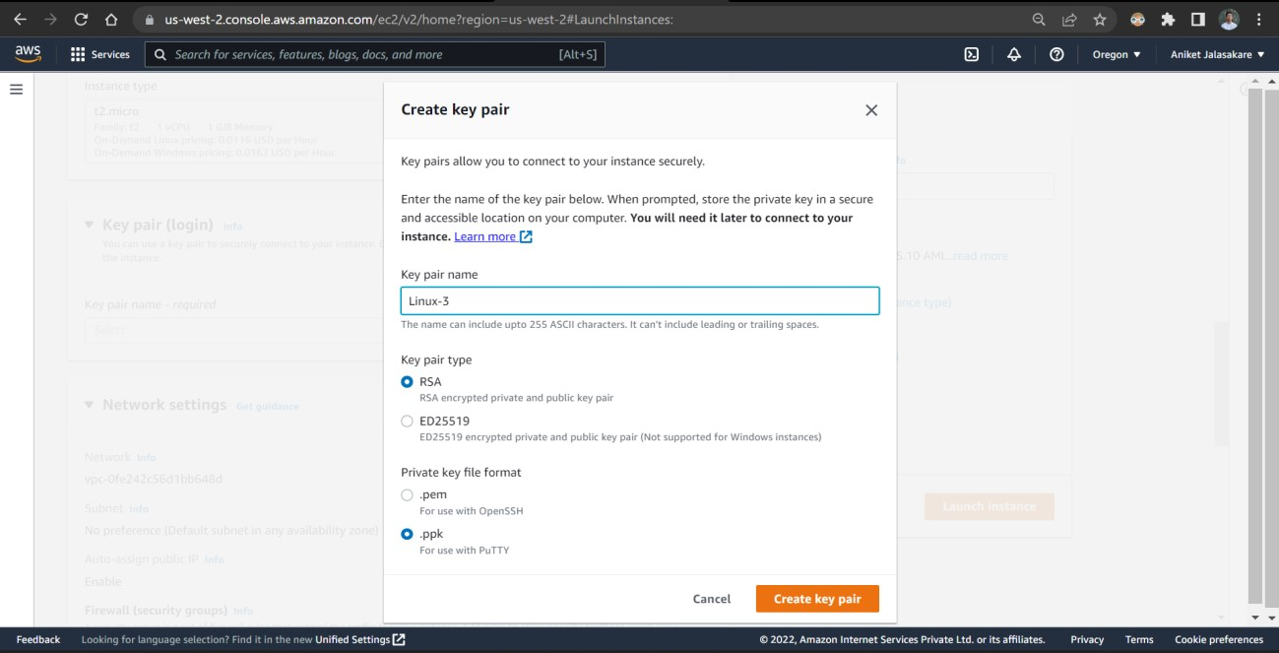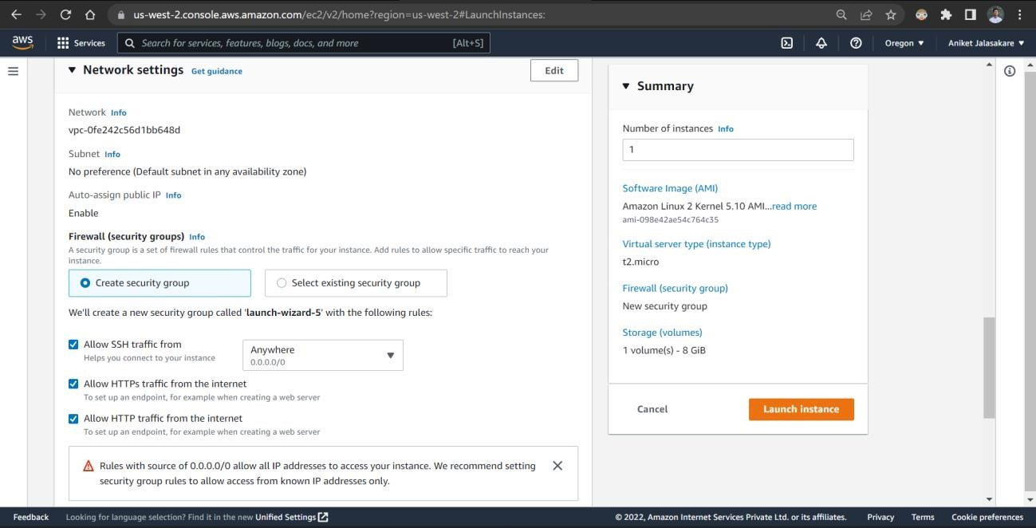

Launch Instance

Launch and view all running

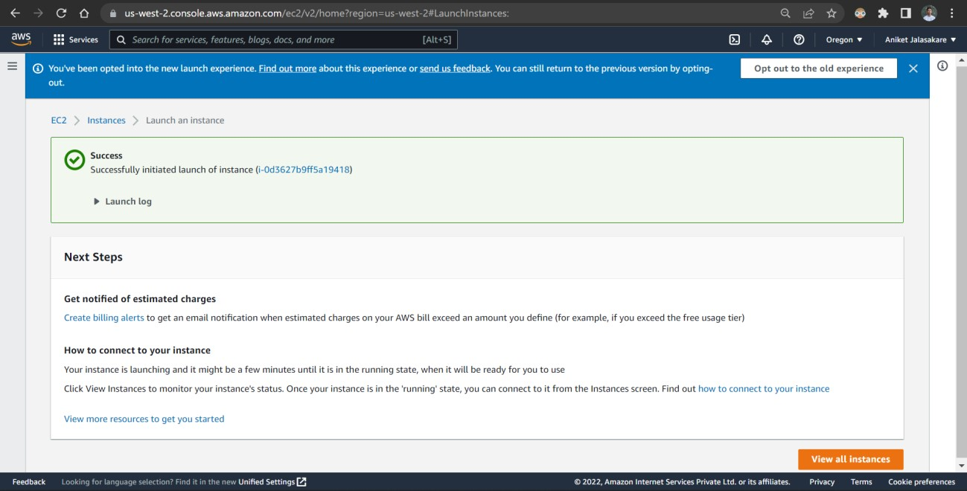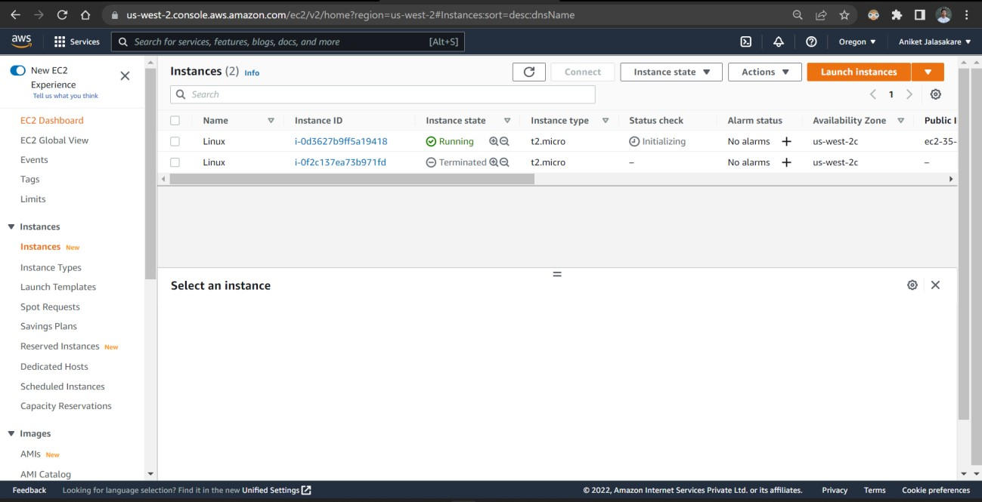

instances

Connect to the Instance

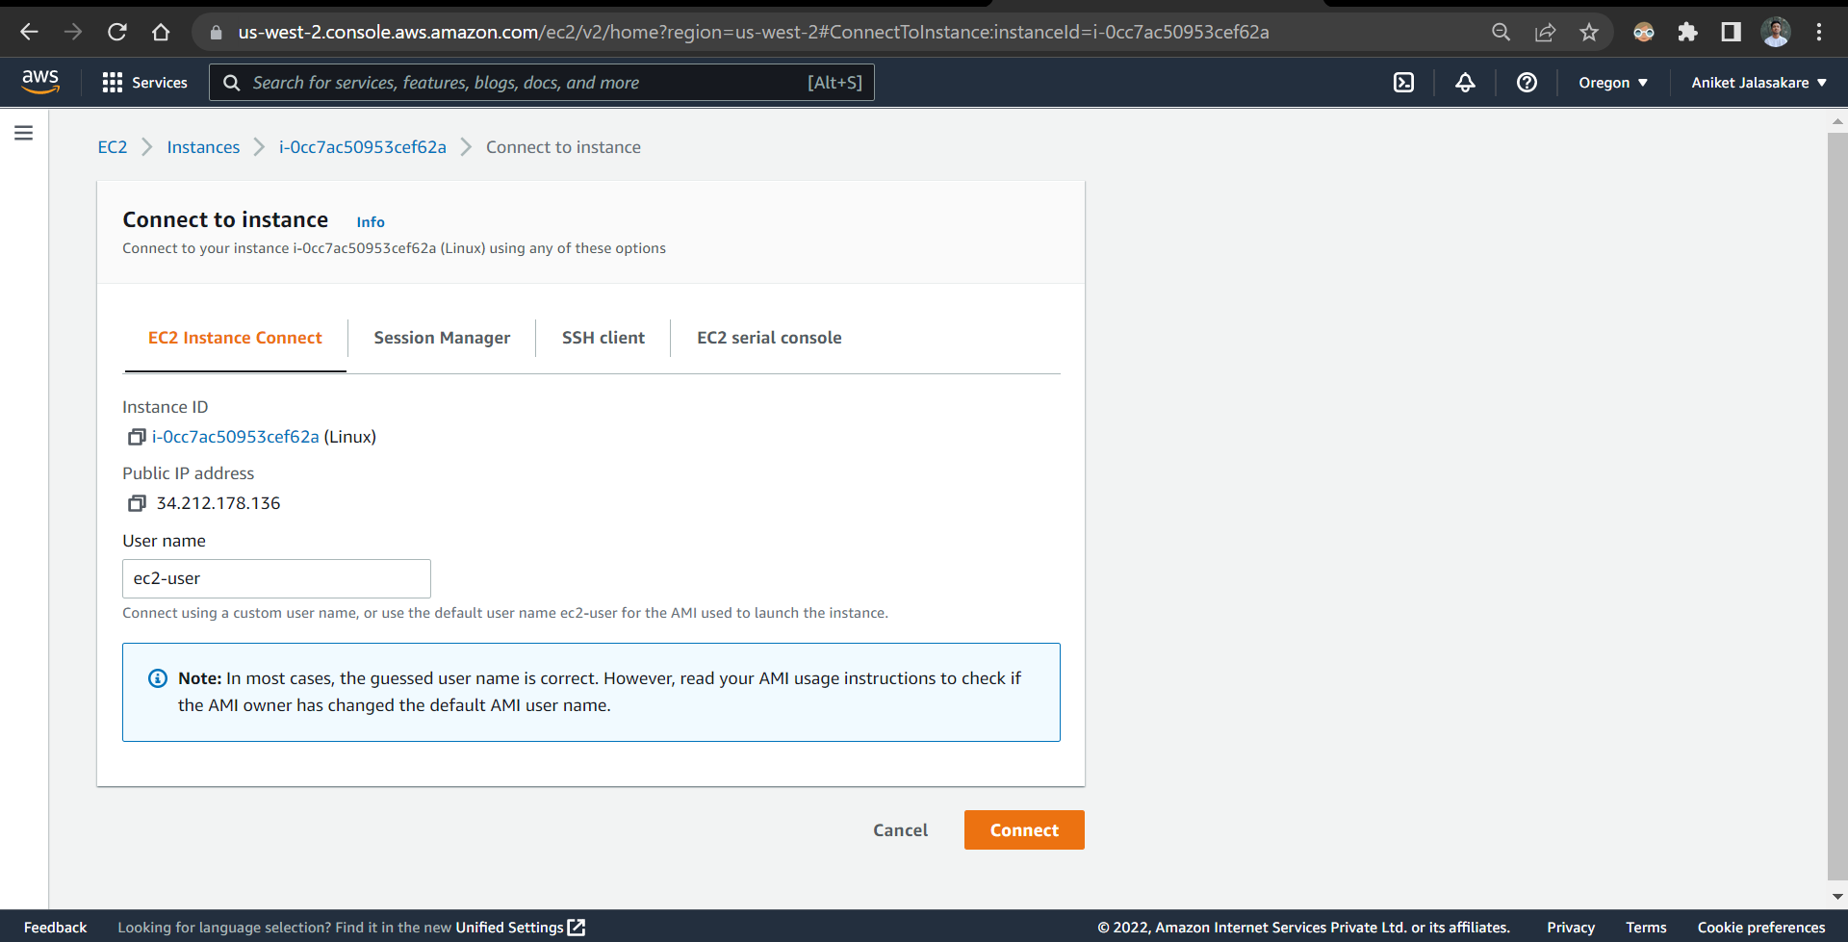

Open Terminal in new window

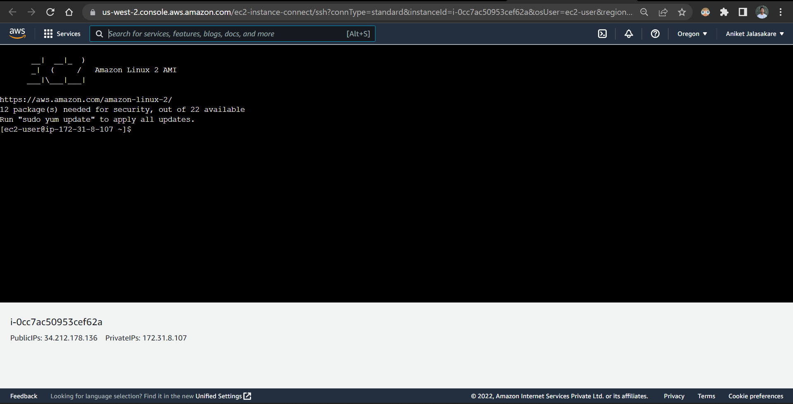

Run command – pwd, whoami

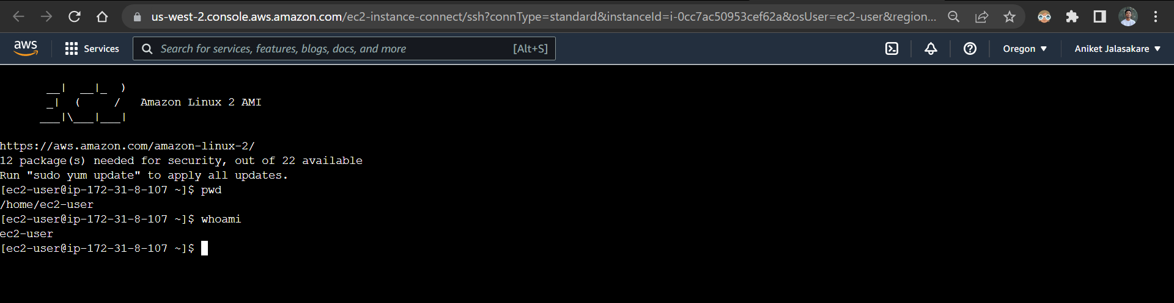

Run man cd

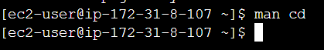

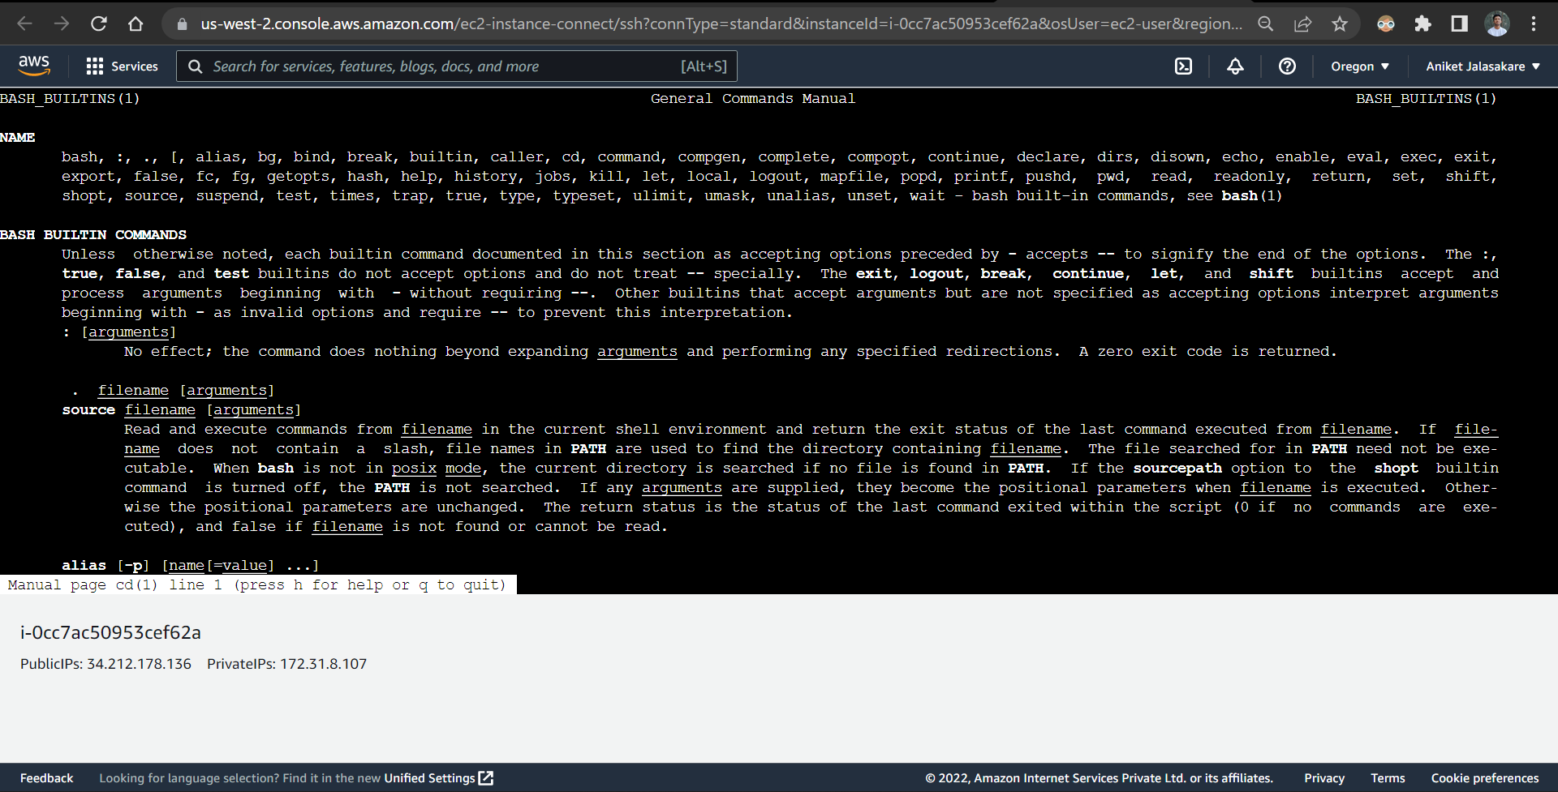

Create a directory using mkdir

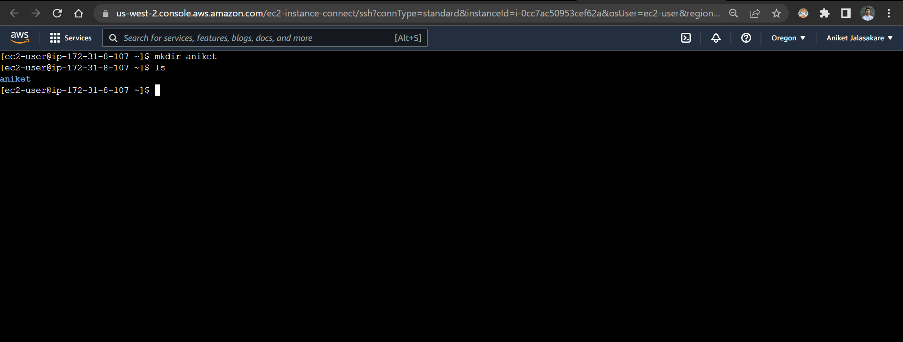

Run ls -l, ls -la

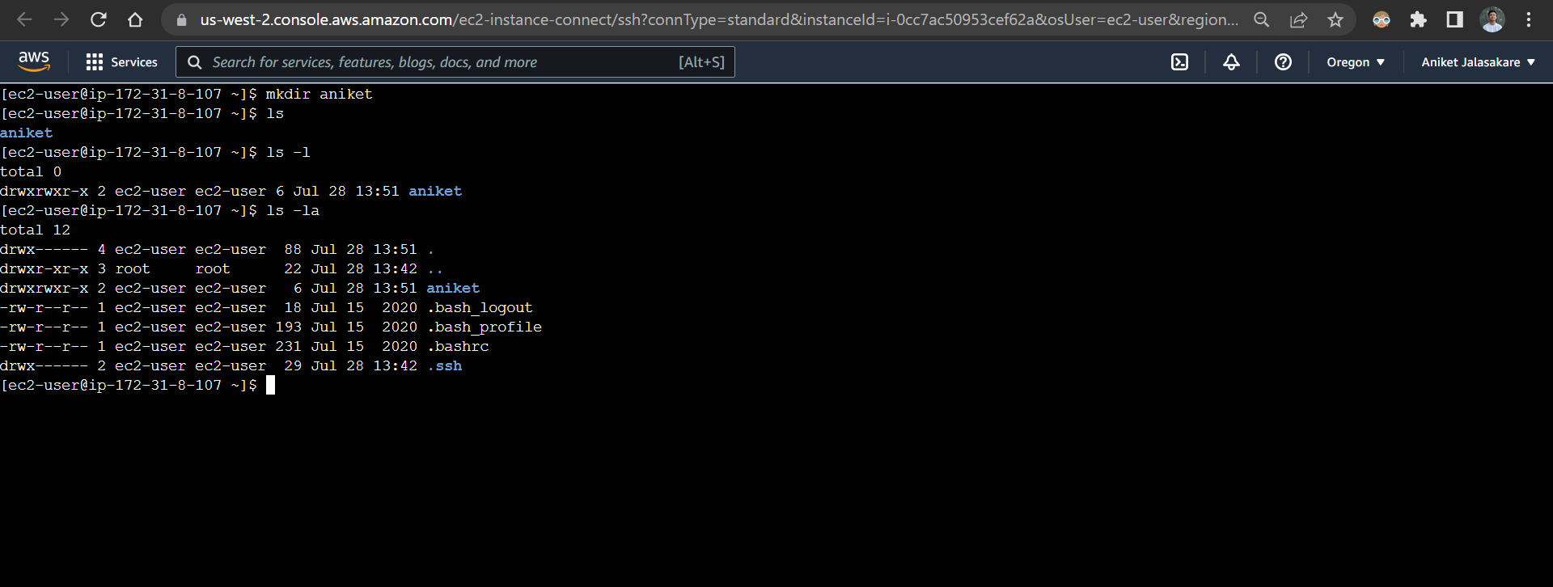

Move to newly created directory and create a text file

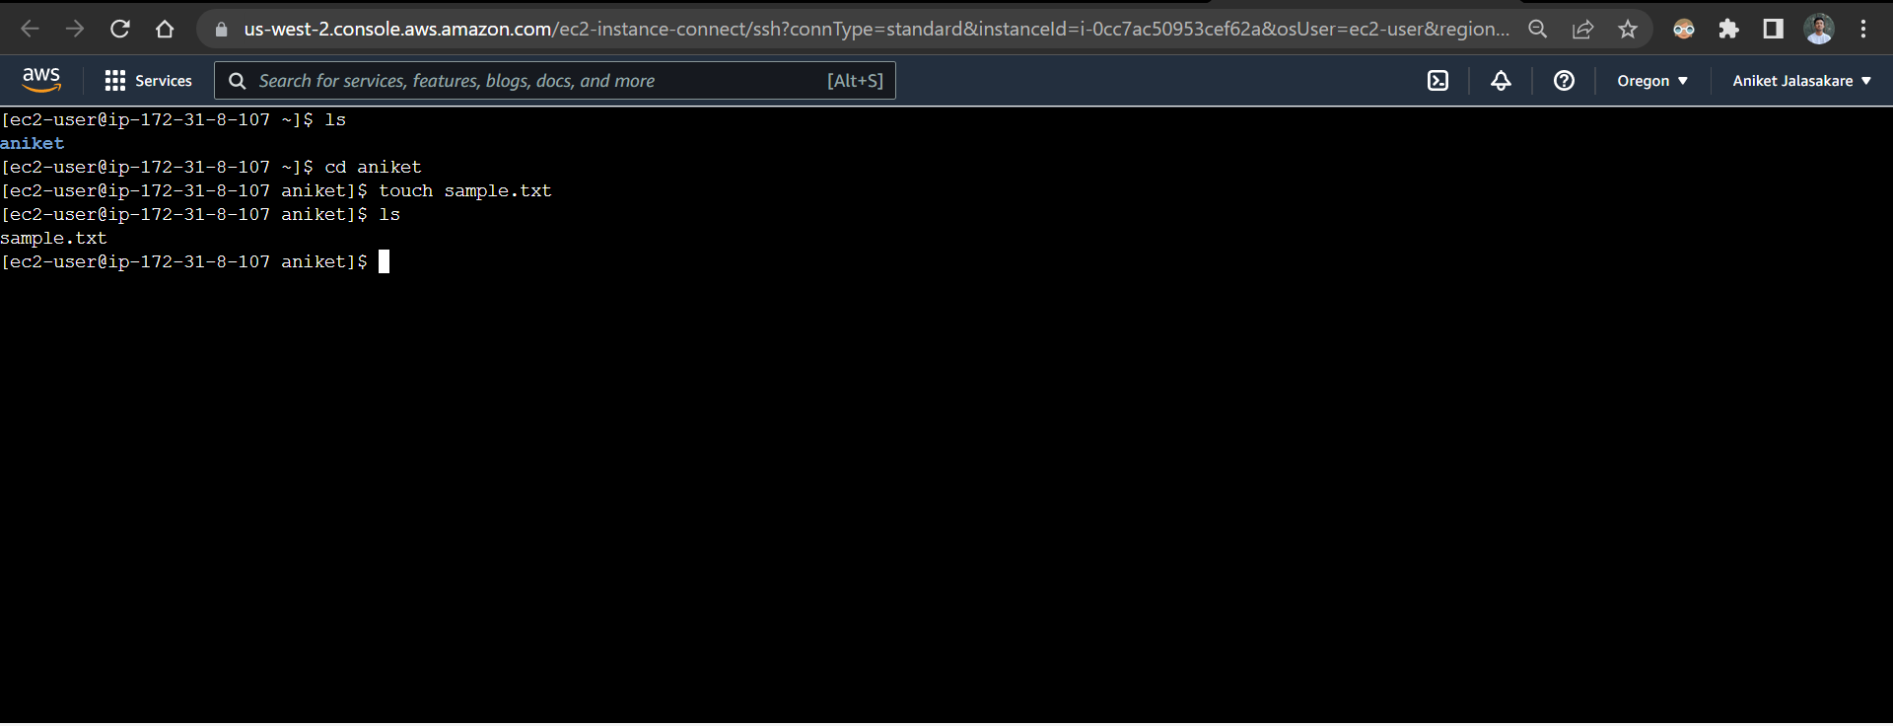

Edit the text file and add some content

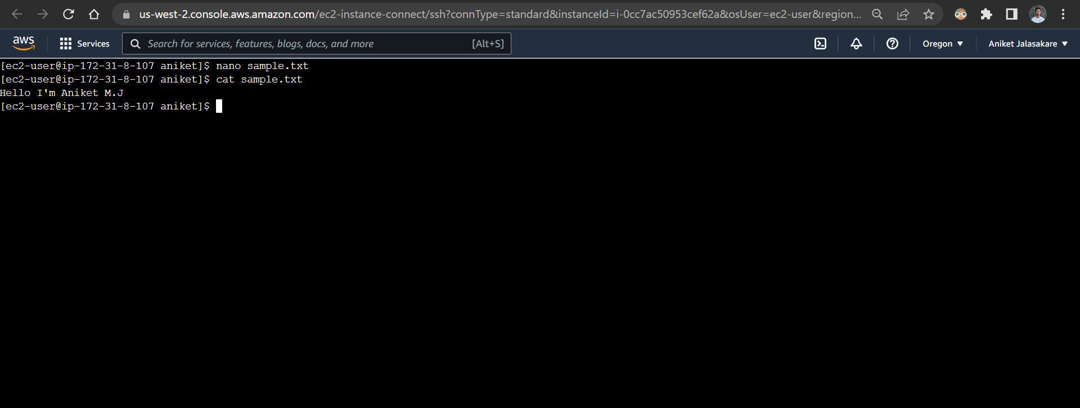

Copy the text file and view contents from it

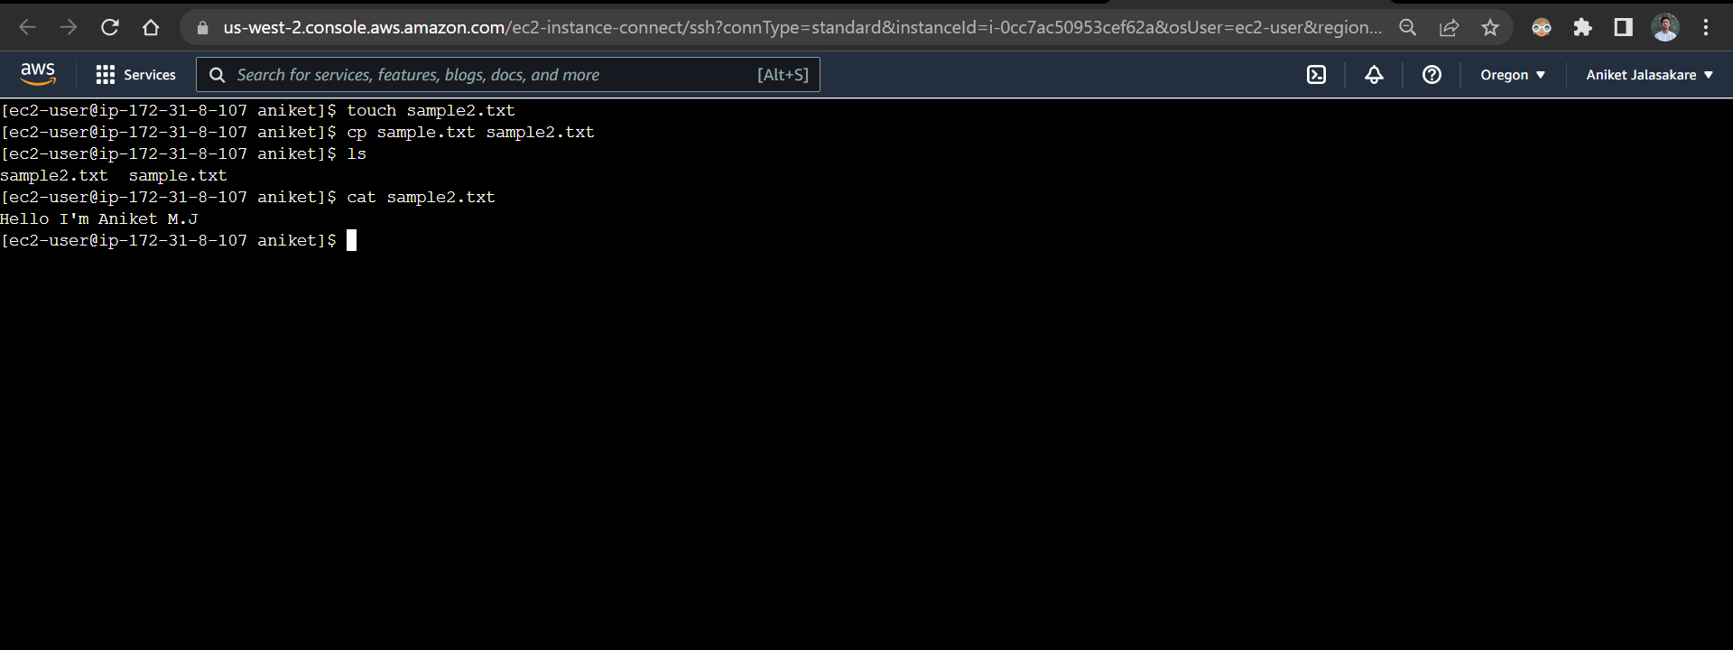

Rename sample2.txt to aniket.txt

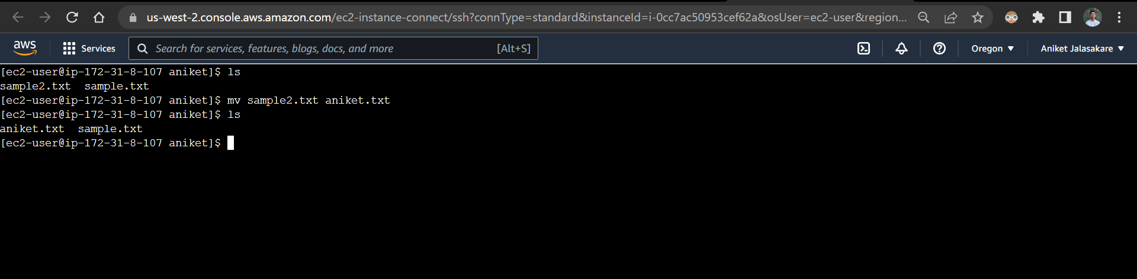

Add new lines using echo command and view the contents

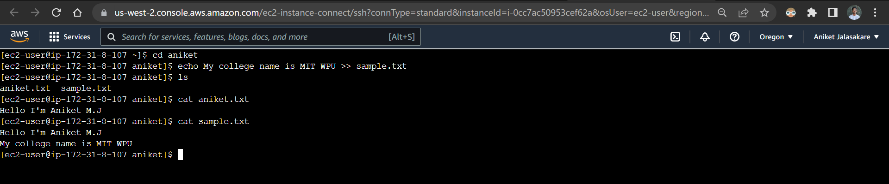

Run df -m

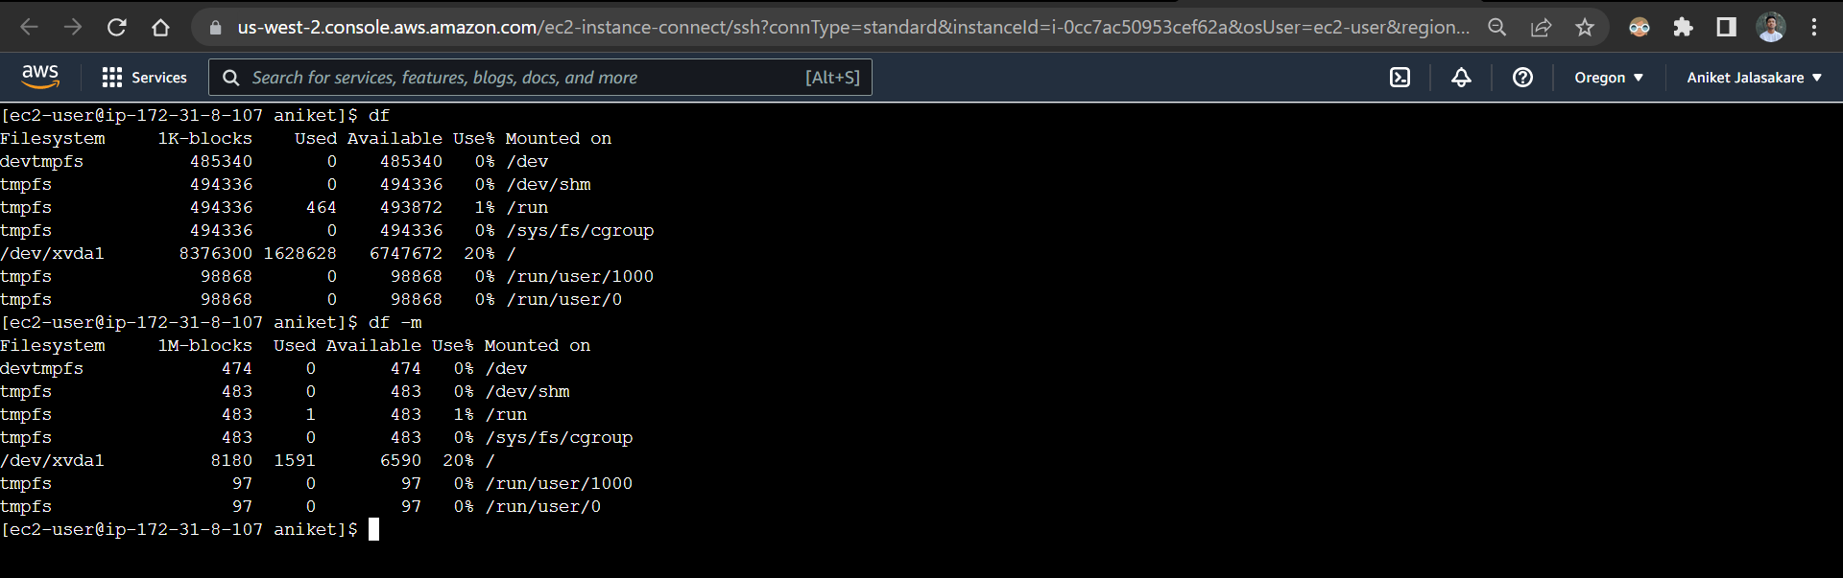

Run uname -a

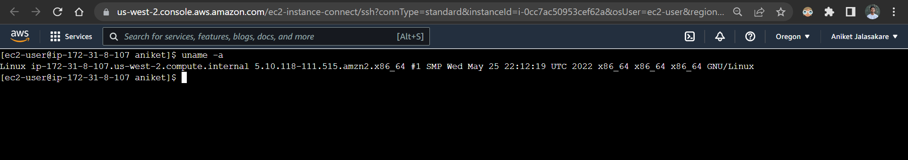

Run hostname

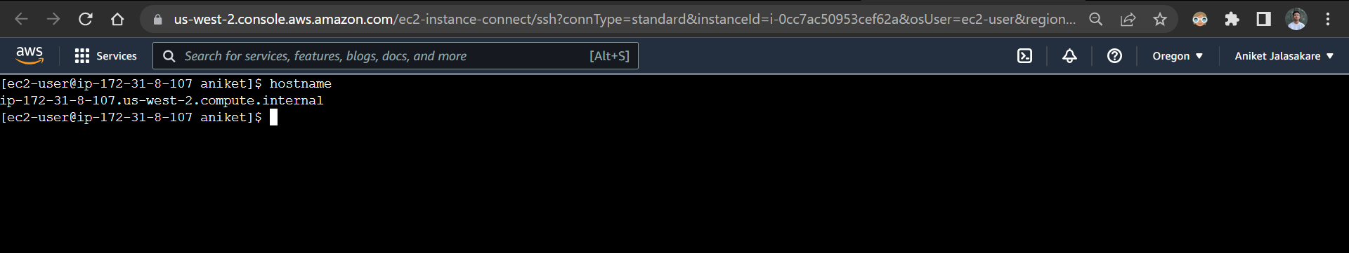

Run ping command

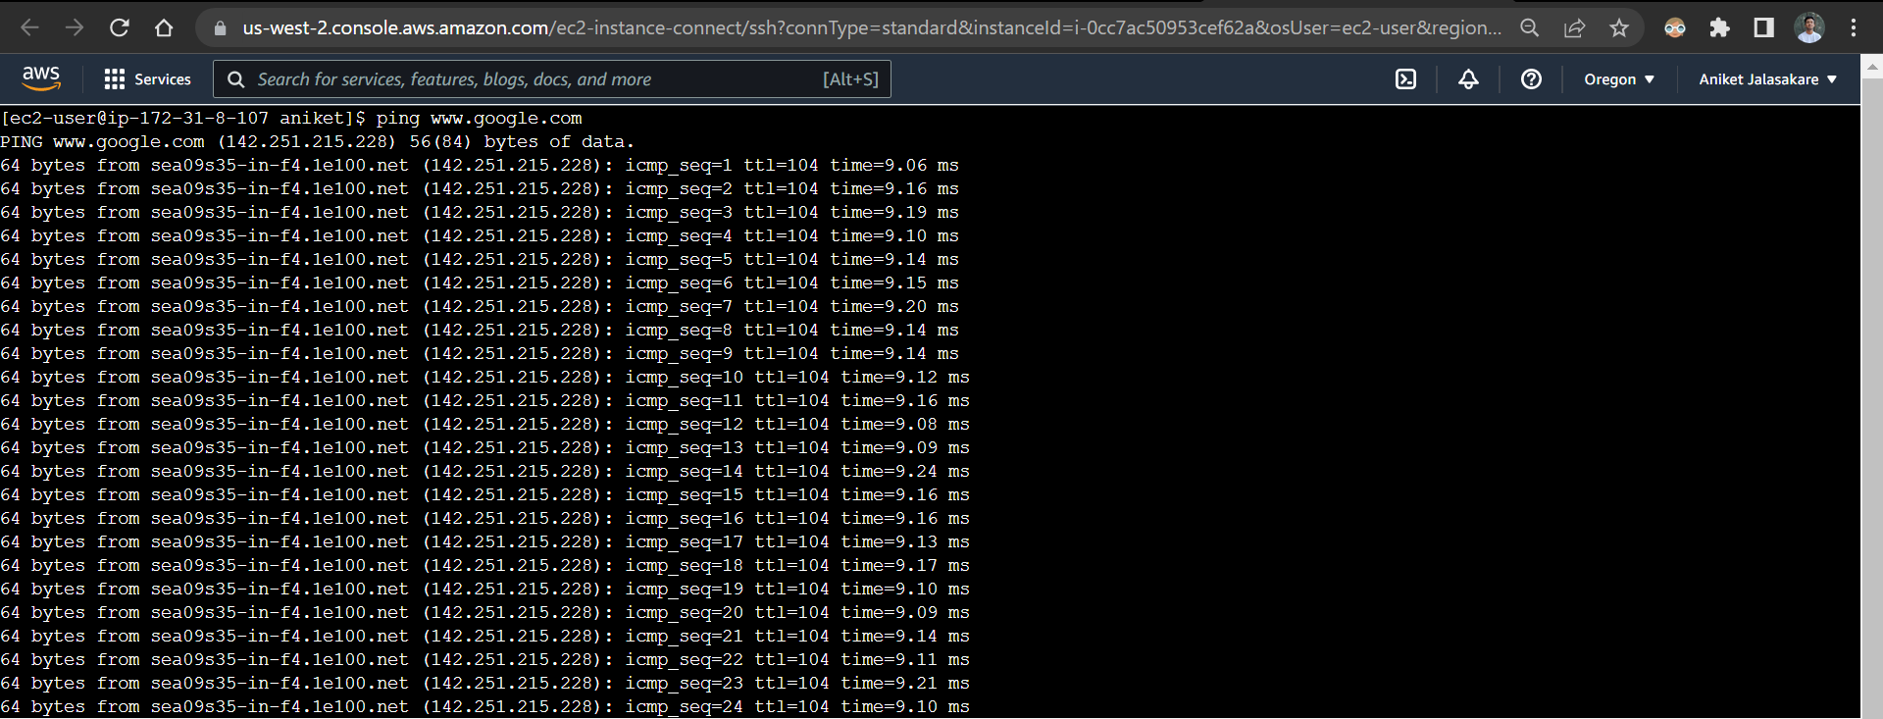

Install net-tools

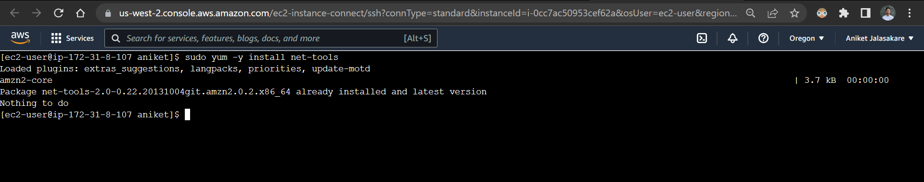

Check netstat

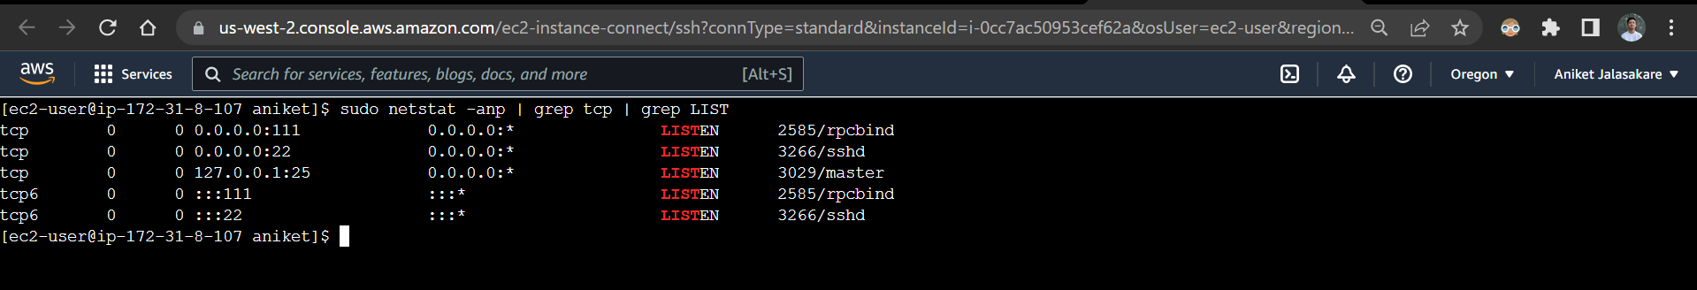

Remove aniket.txt

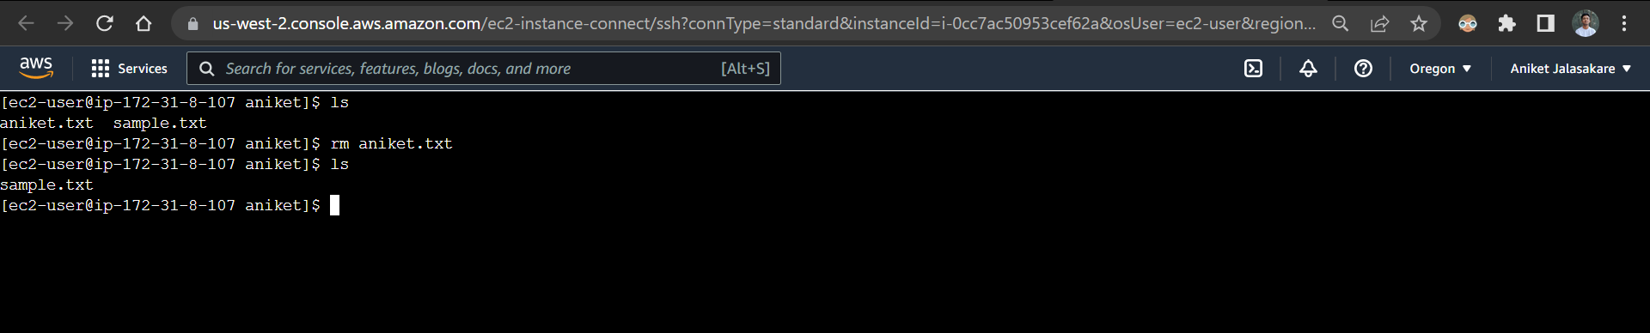

Remove directory named aniket

