**Name – Aniket Jalasakare**

**PRN – 1132210192**

**Roll No – 24**

5) Associate Elastic IP to EC2 instance. | Release Elastic ip after practice.

Launch instance named Linux

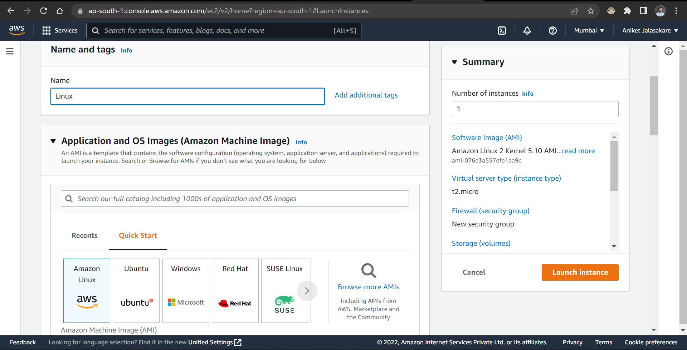

Create new key pair named linux_1 with ppk file

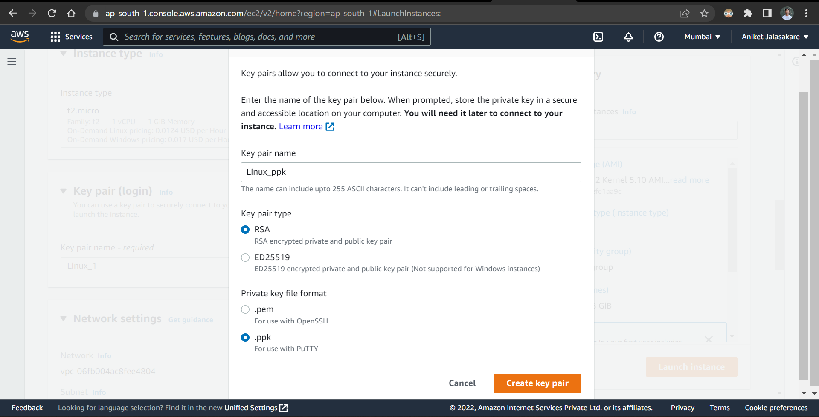

Network Settings of the instance

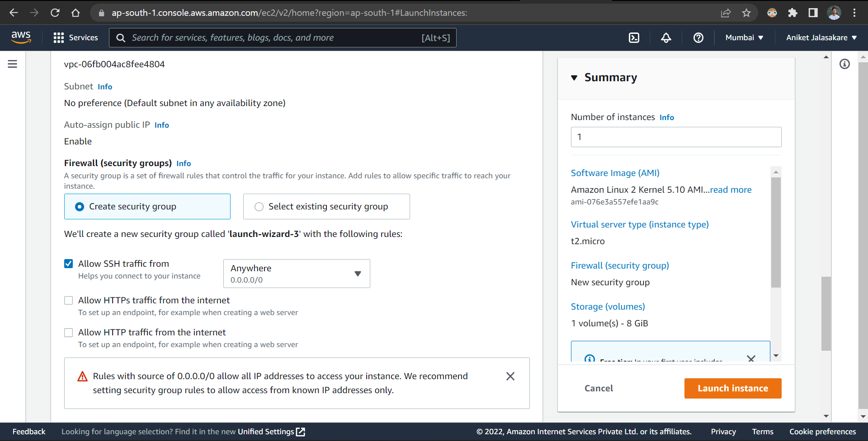

Instance launched successfully

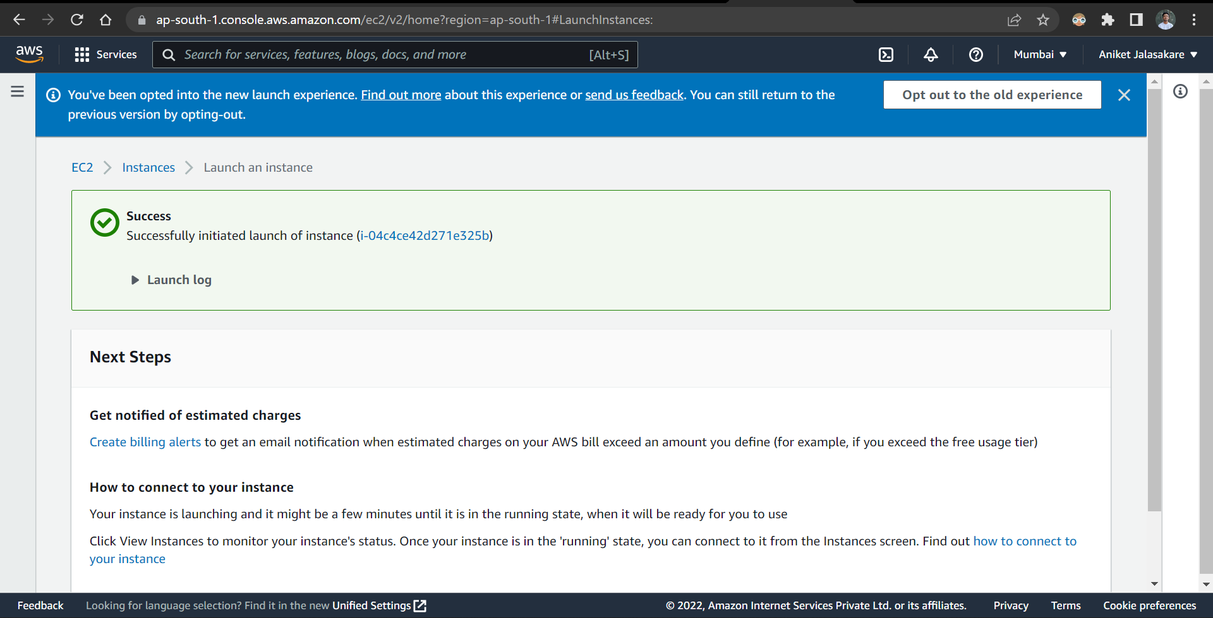

Details of the instance and if we observe ipv4 address it is 13.233.196.123

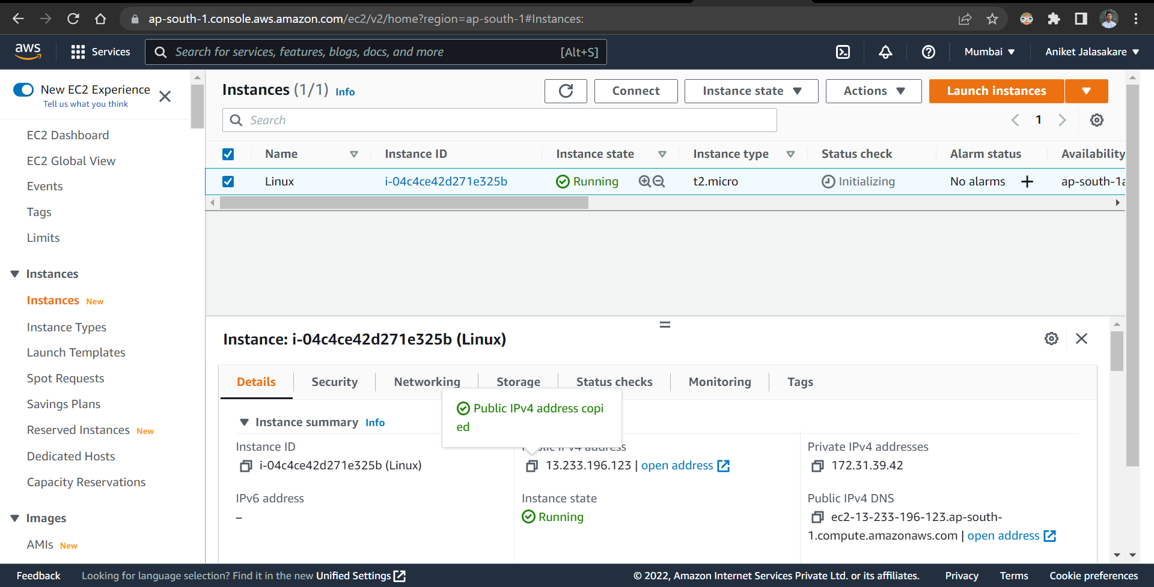

Let’s allocate elastic ipv4 address

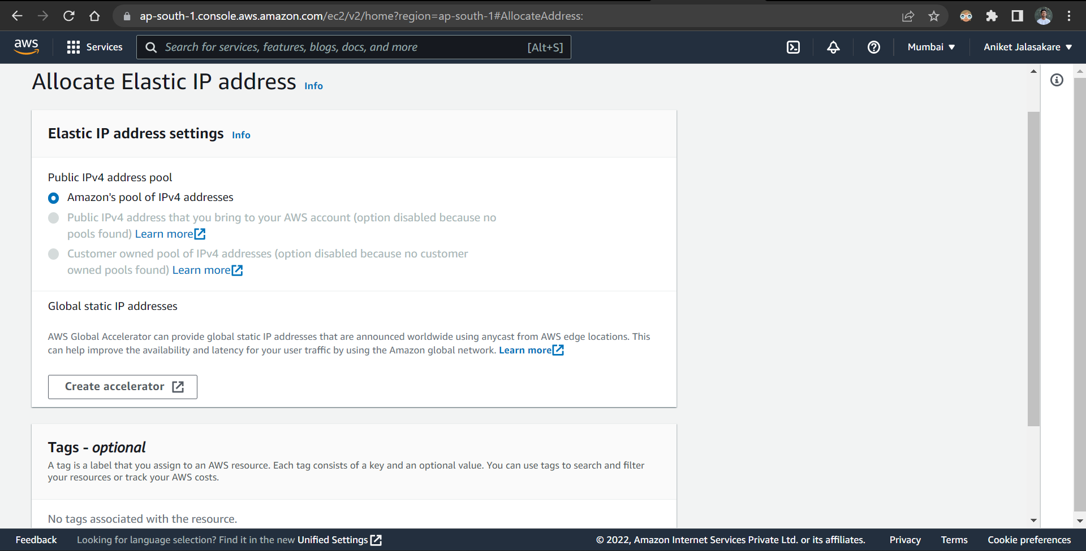

Elastic ip address is allocated successfully

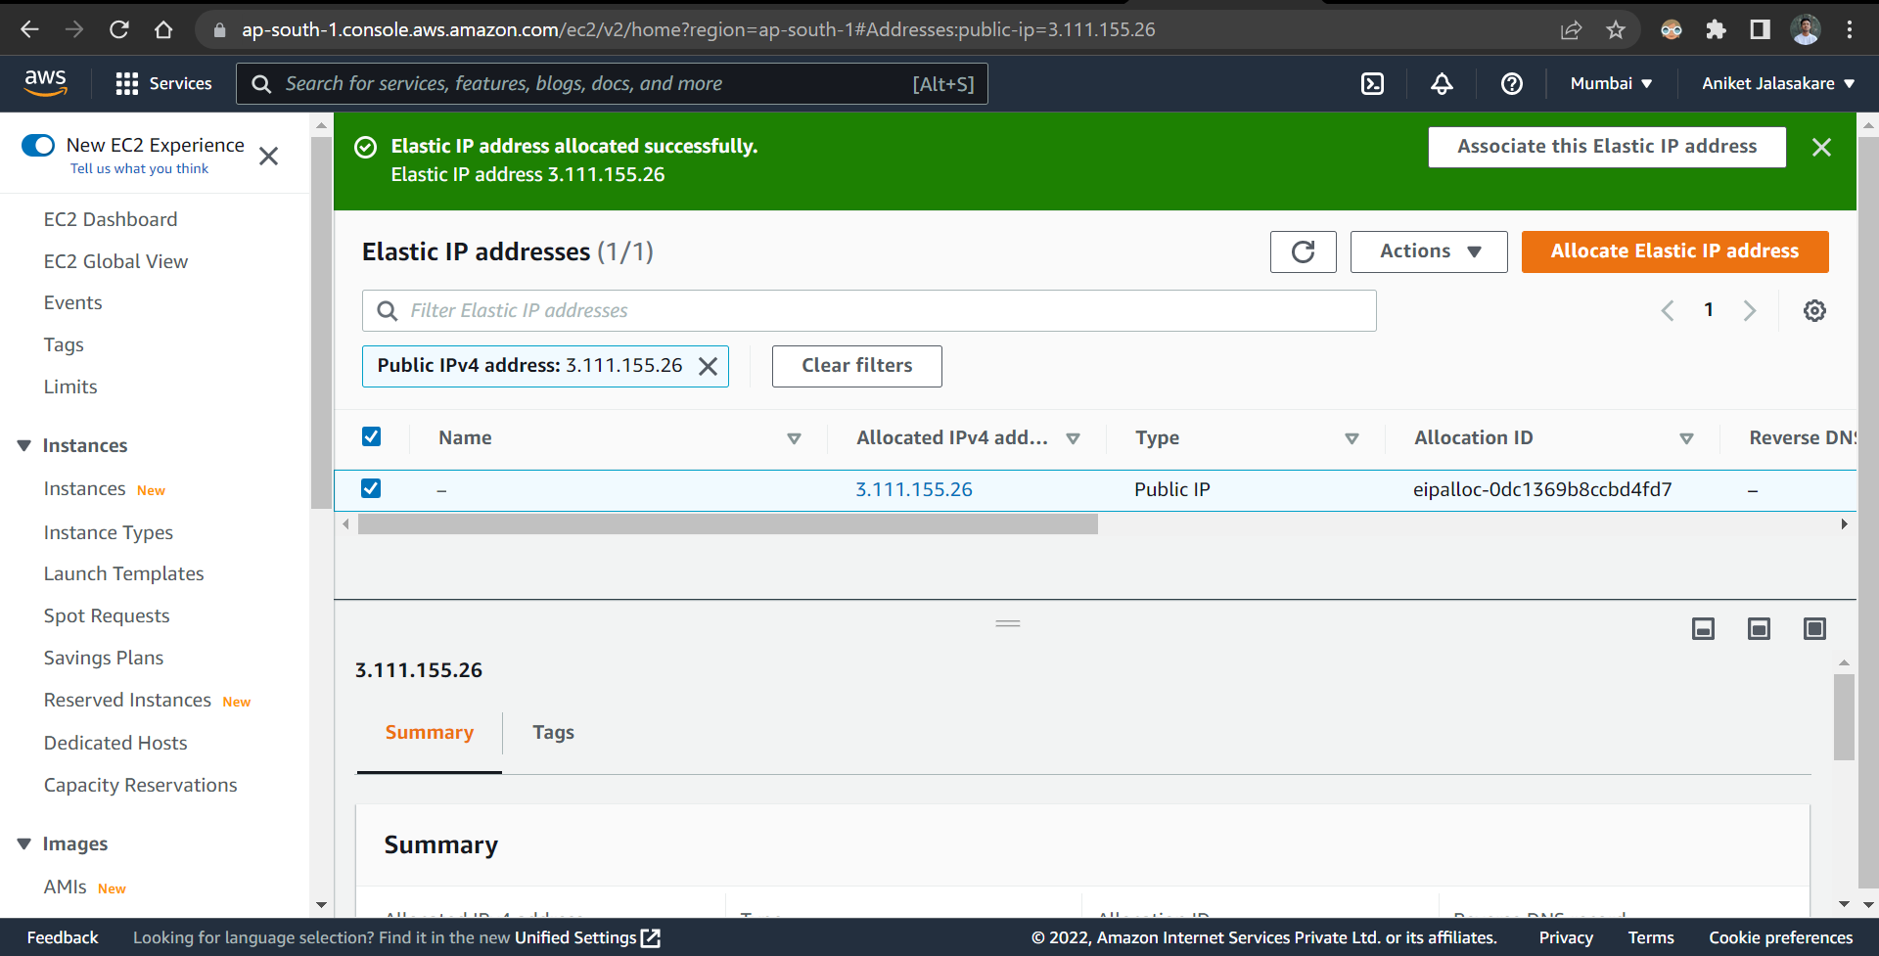

Associate ipv4 address

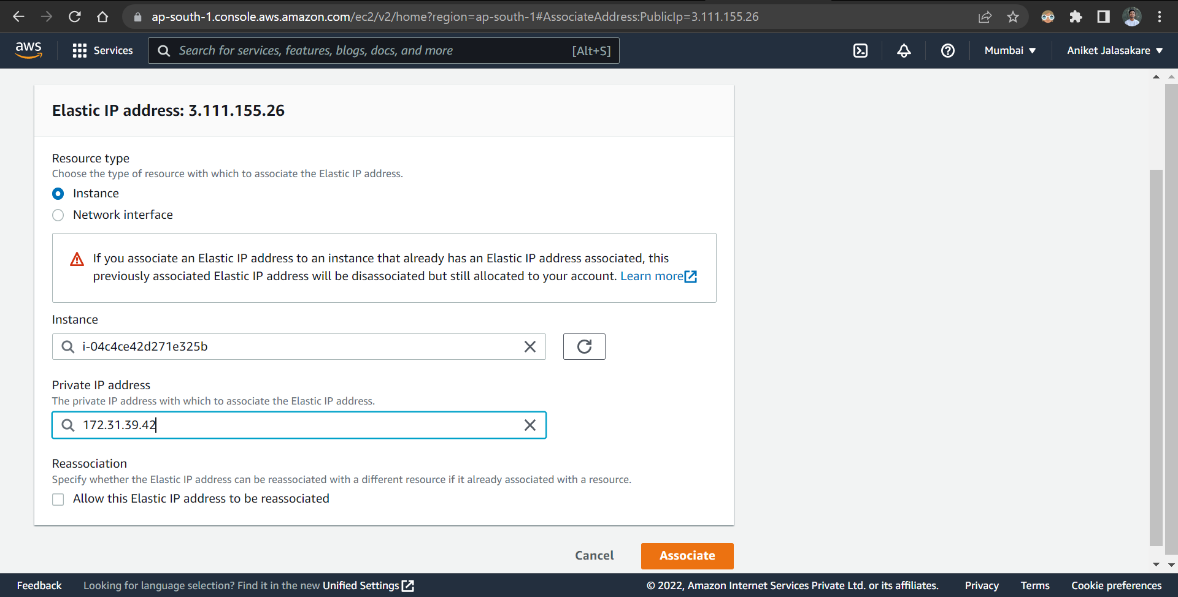

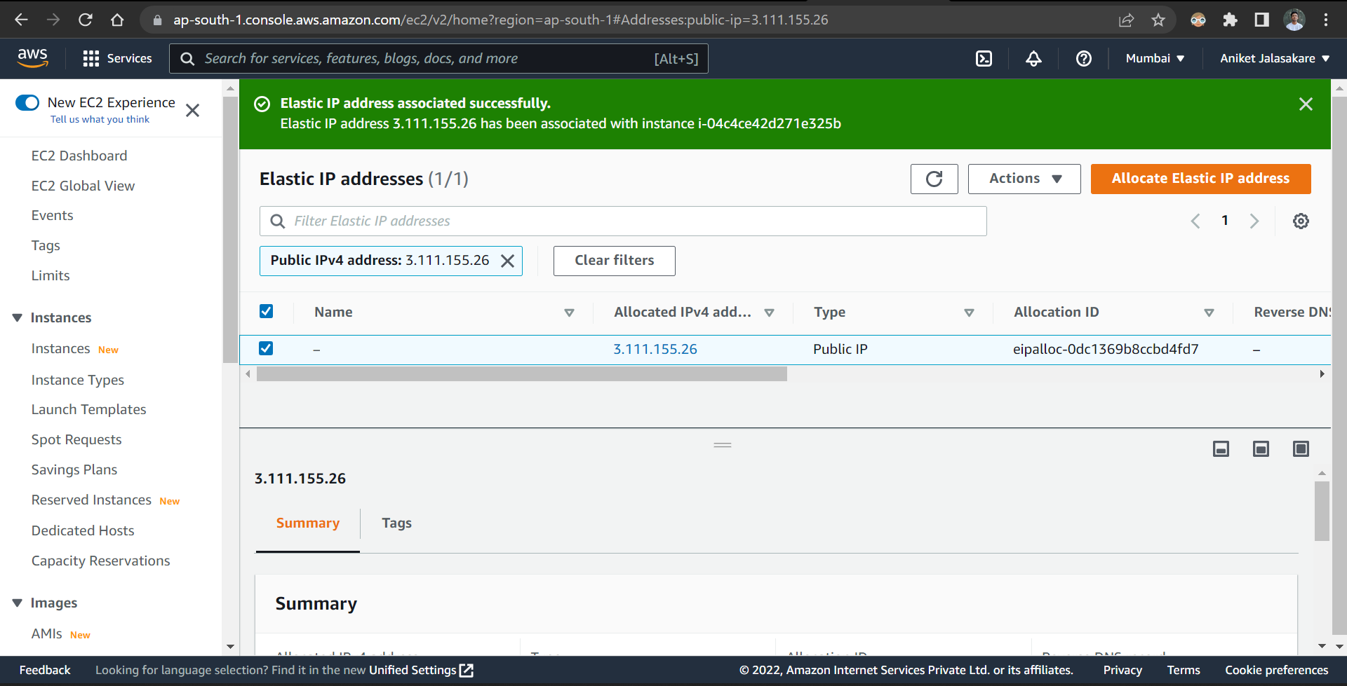

If we observe ipv4 address of the instance it is changed 3.111.155.26

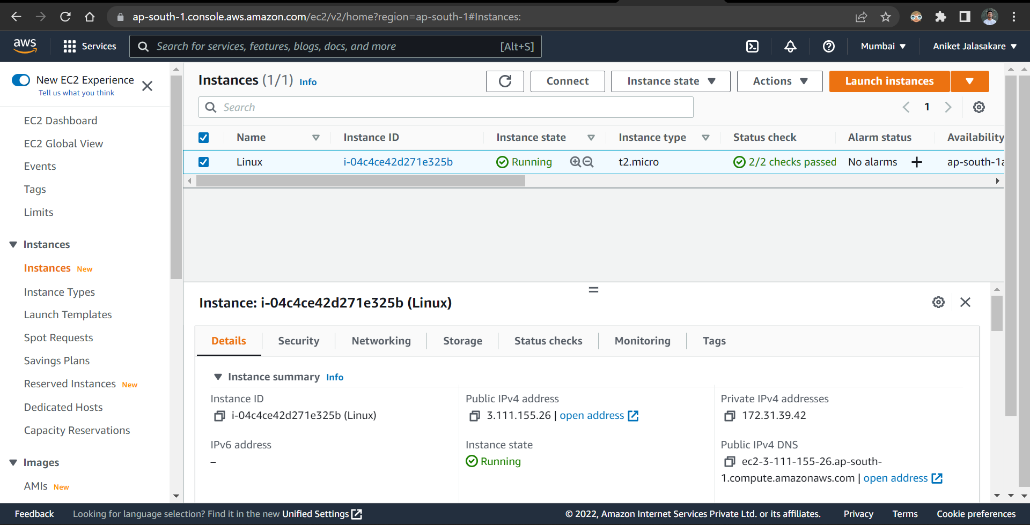

Disassociate the elastic address

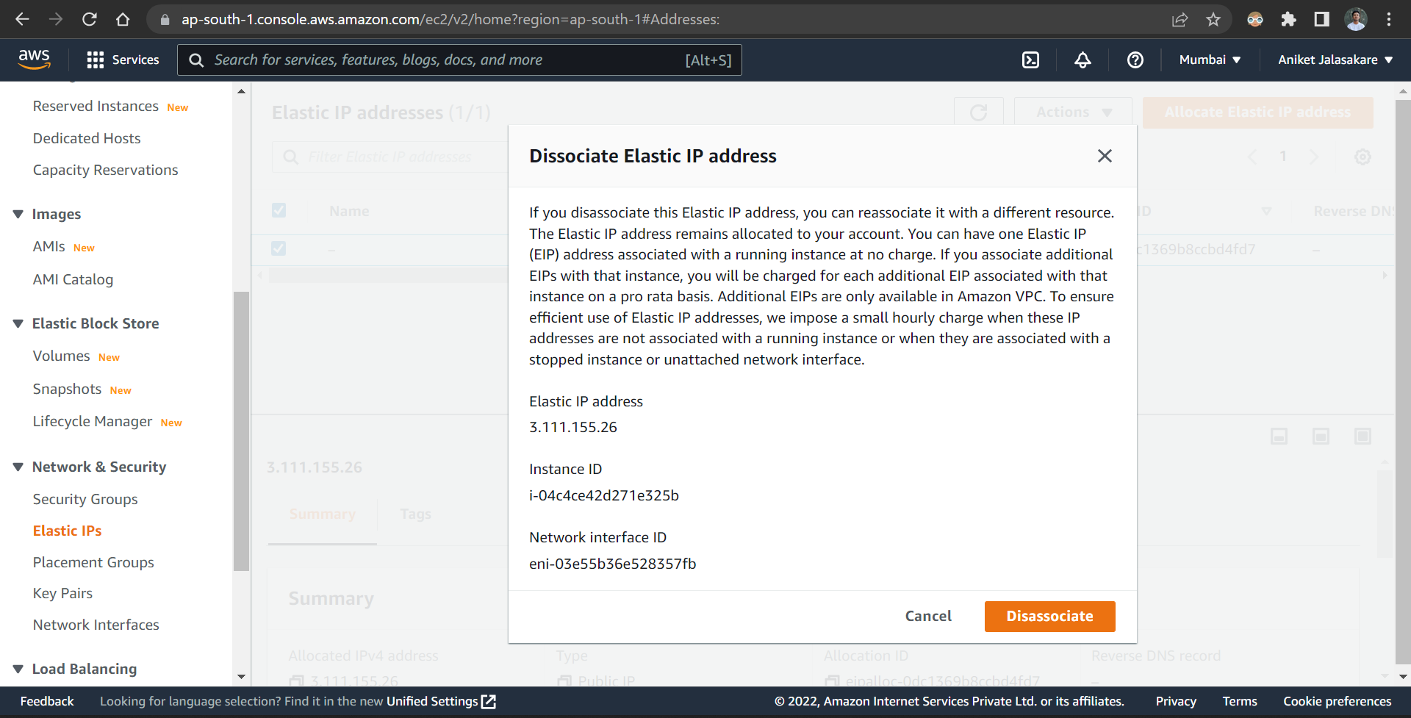

Disassociated successfully

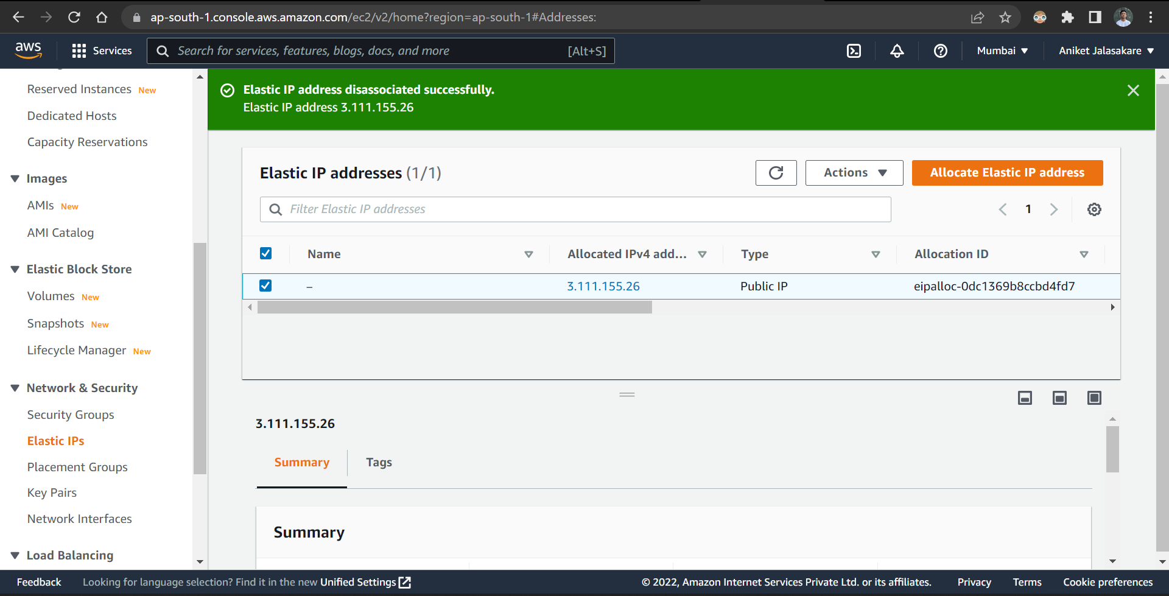

Release elastic ipv4 address

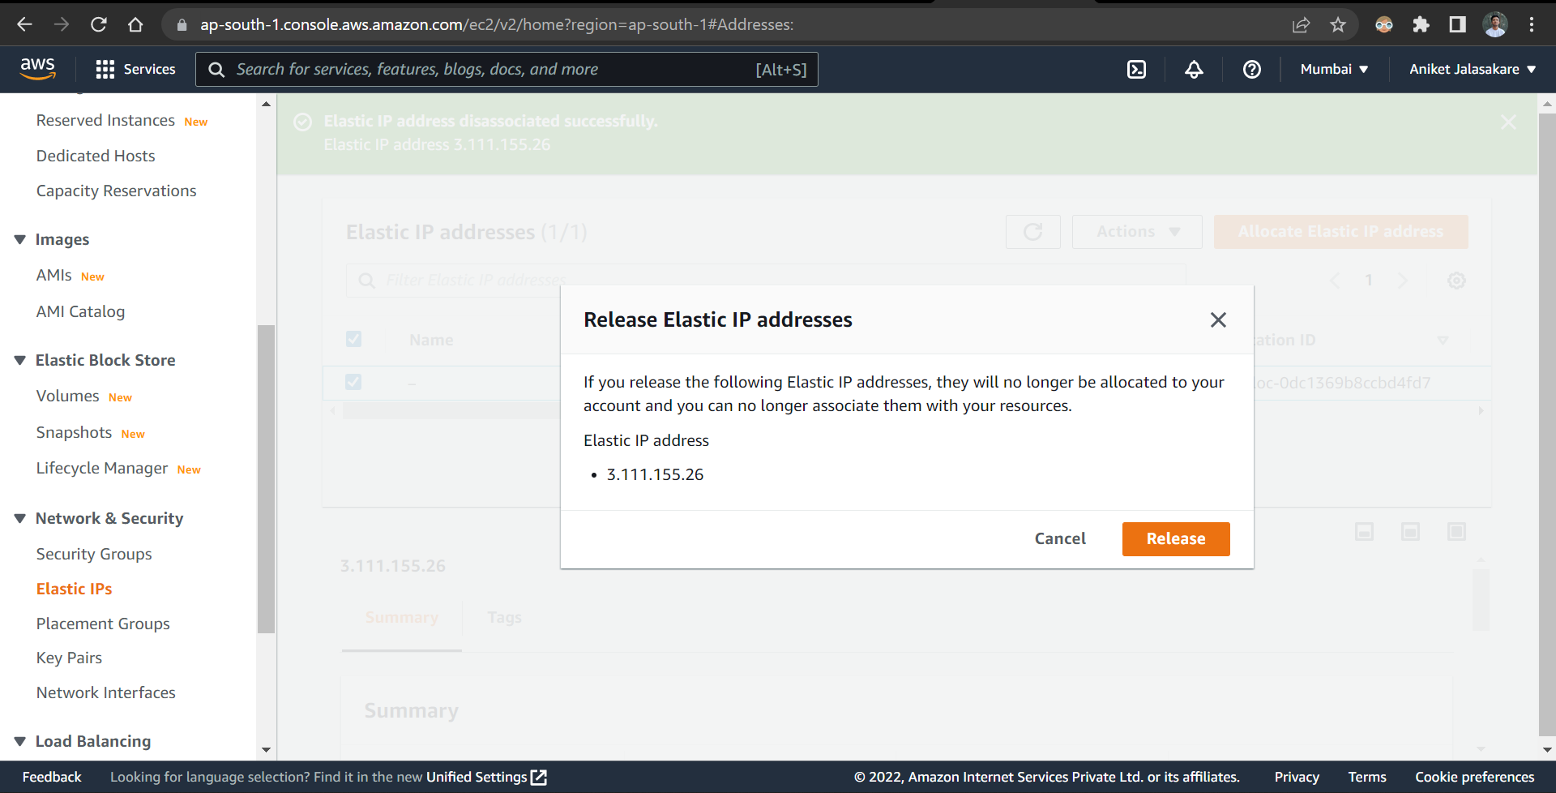

Elastic ipv4 address released successfully

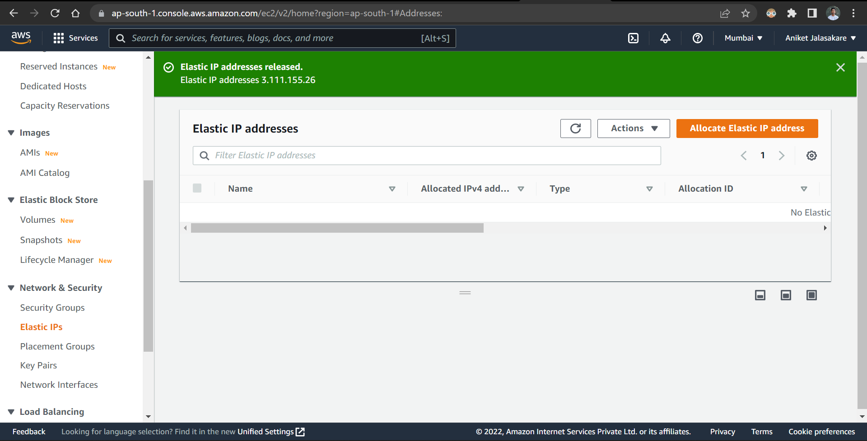

Terminate the instance

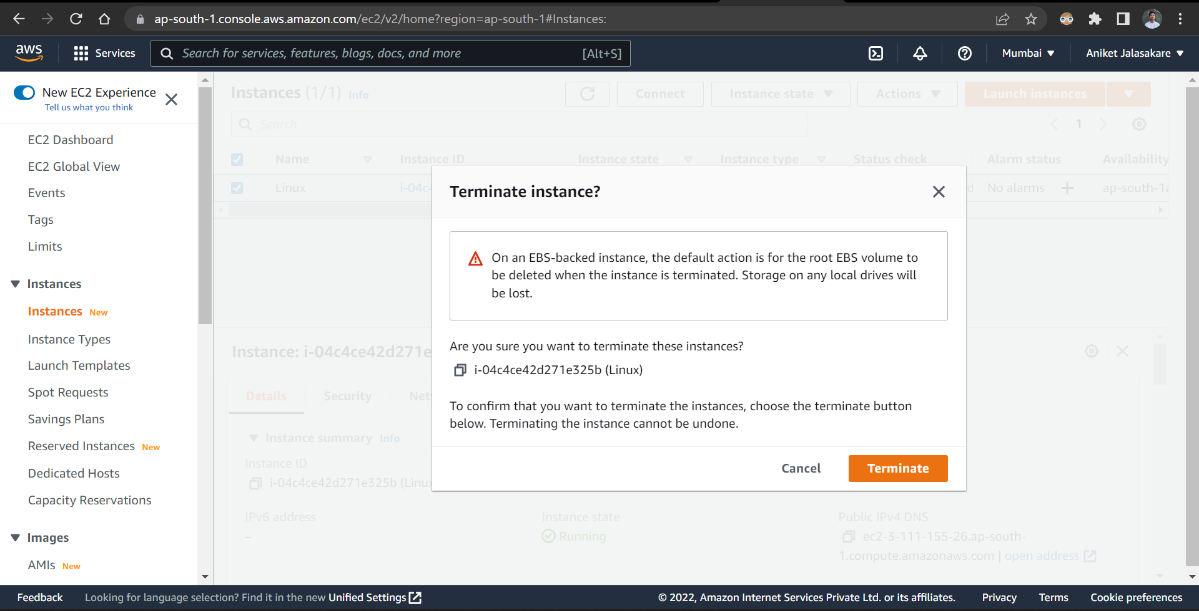

Terminated the instance successfully

