**Name – Aniket Jalasakare**

**PRN – 1132210192**

**Roll No – 24**

Assignment 7

Practice Cloud Shell, Run Python Program from Cloud Shell & Create S3 Bucket from Cloud Shell.

Login into AWS console

Open cloudshell

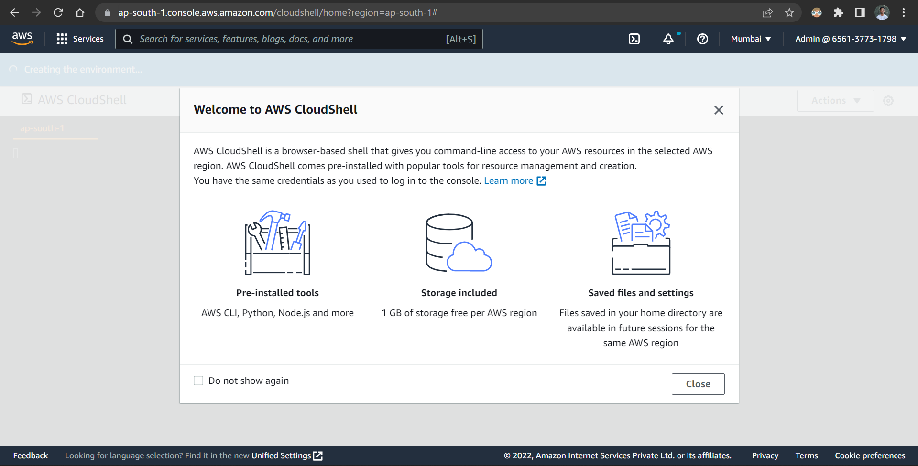

Enter basic bash commands

Create directory project

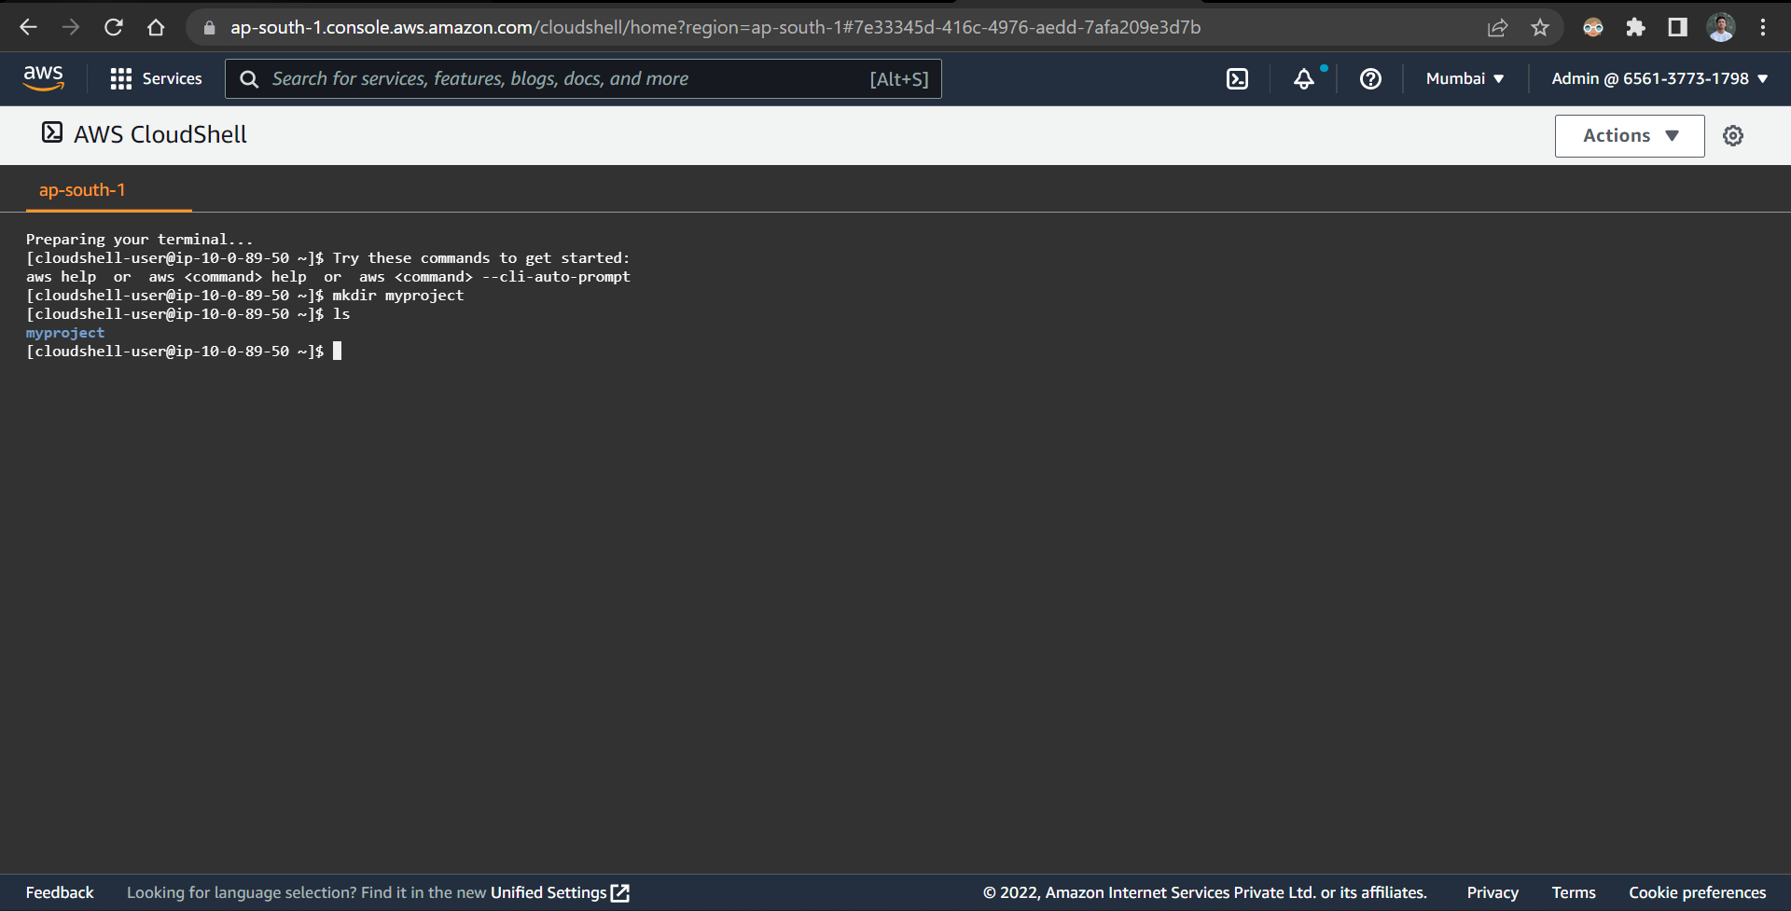

Create a file using touch command

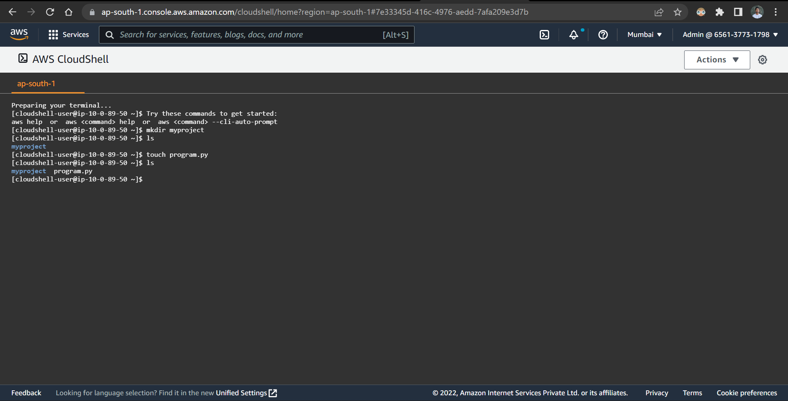

Edit the file using nano editor

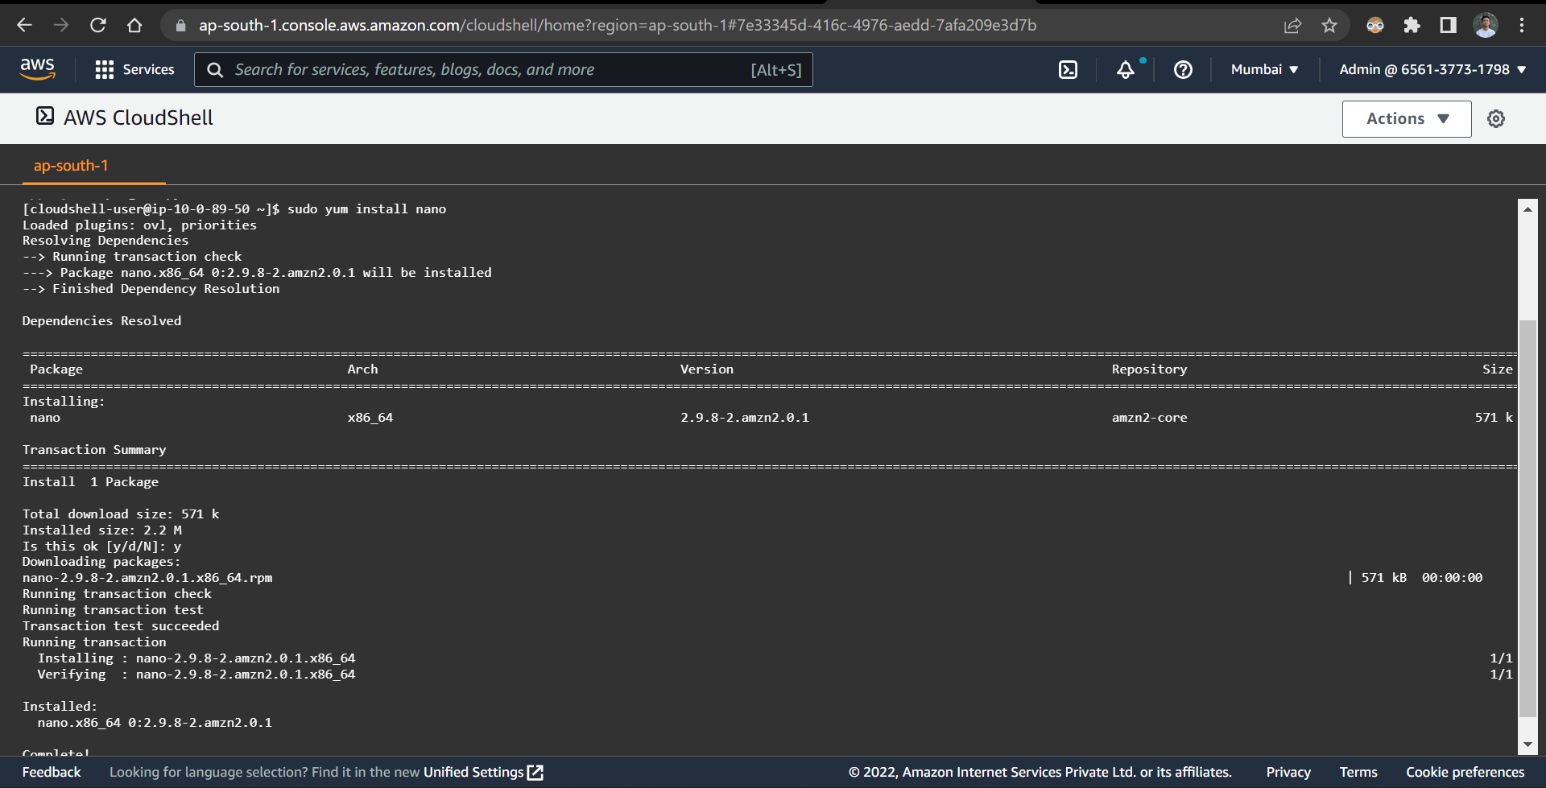

Write a python program

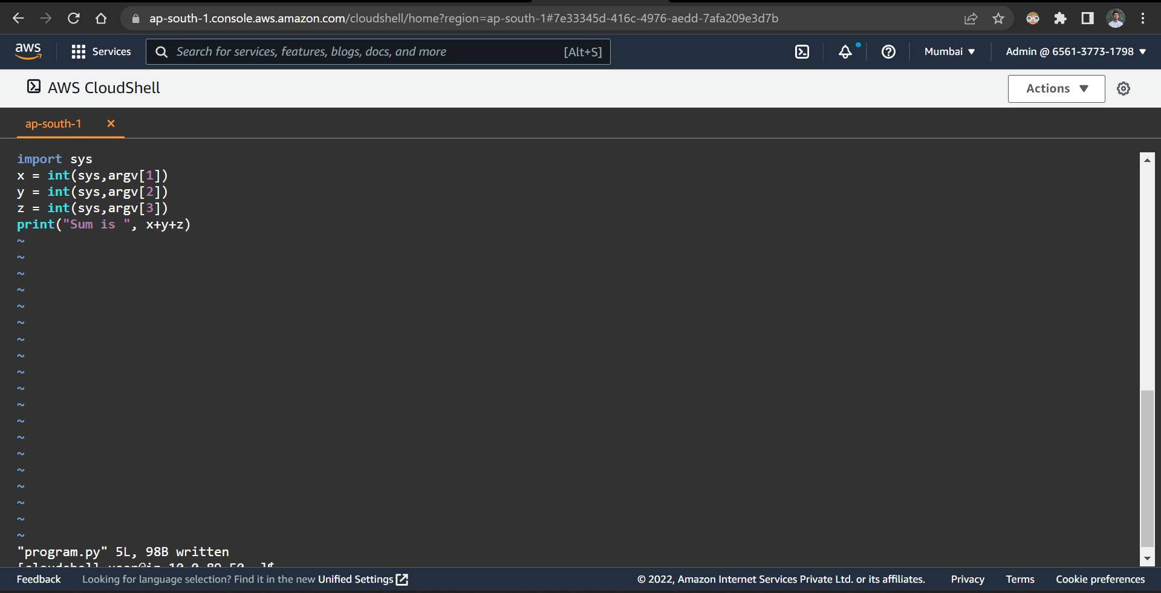

Move the program file into project folder using mv command

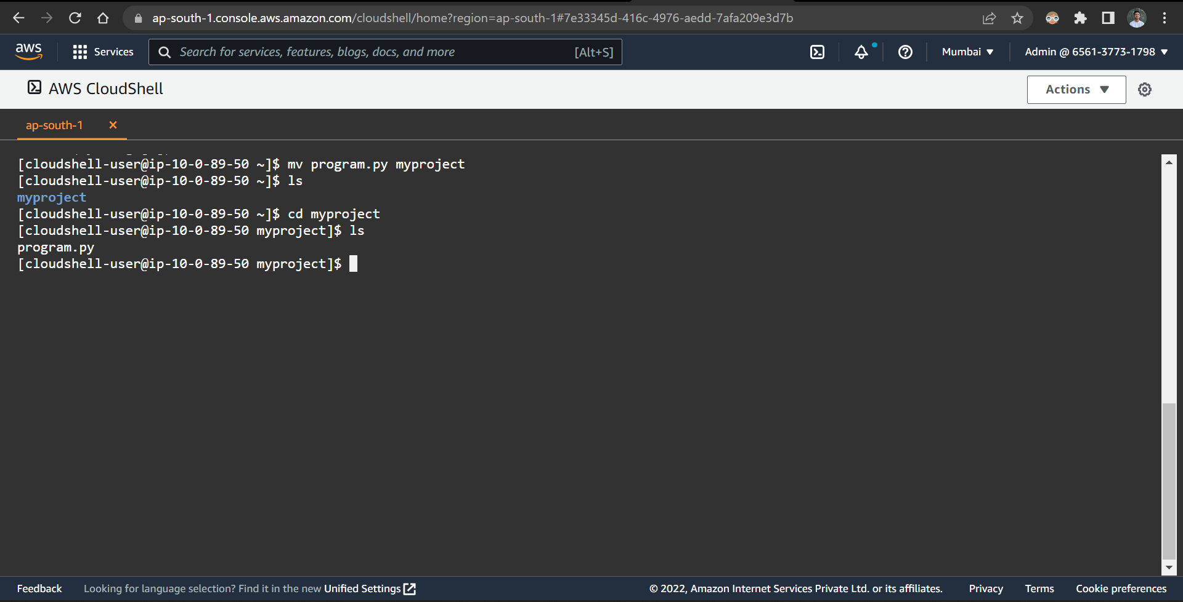

Upload the program file from local desktop into cloudshell and run python program

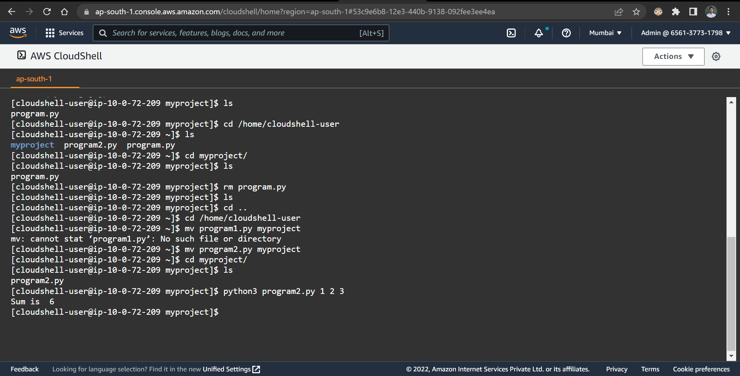

Download the program file from cloudshell into local desktop

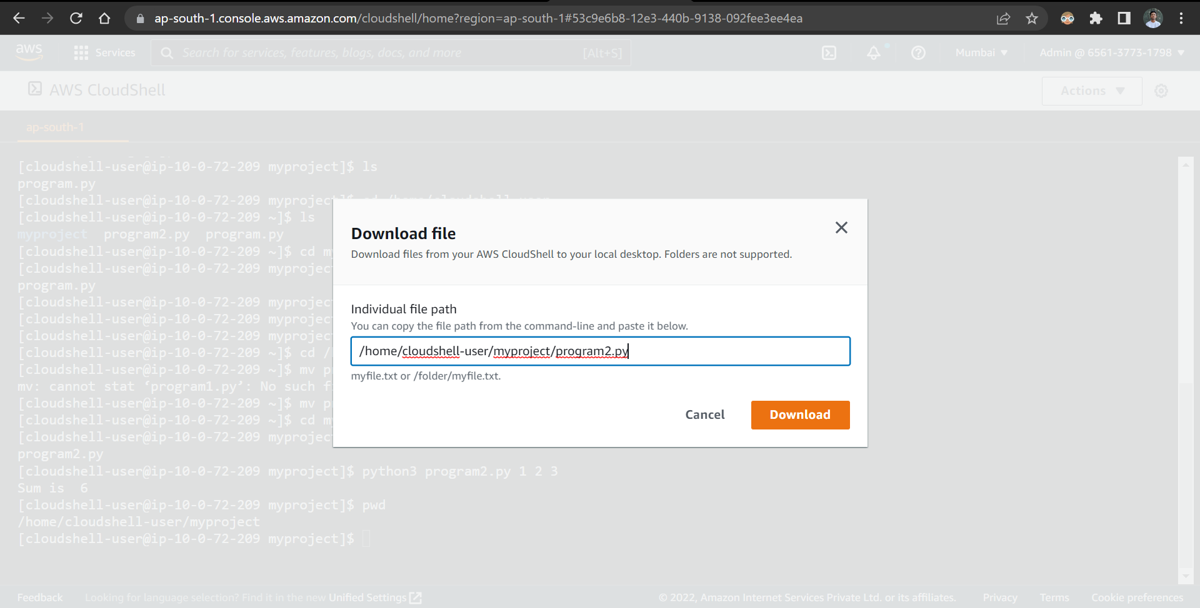

Create a bucket prat9110542272 in cloudshell

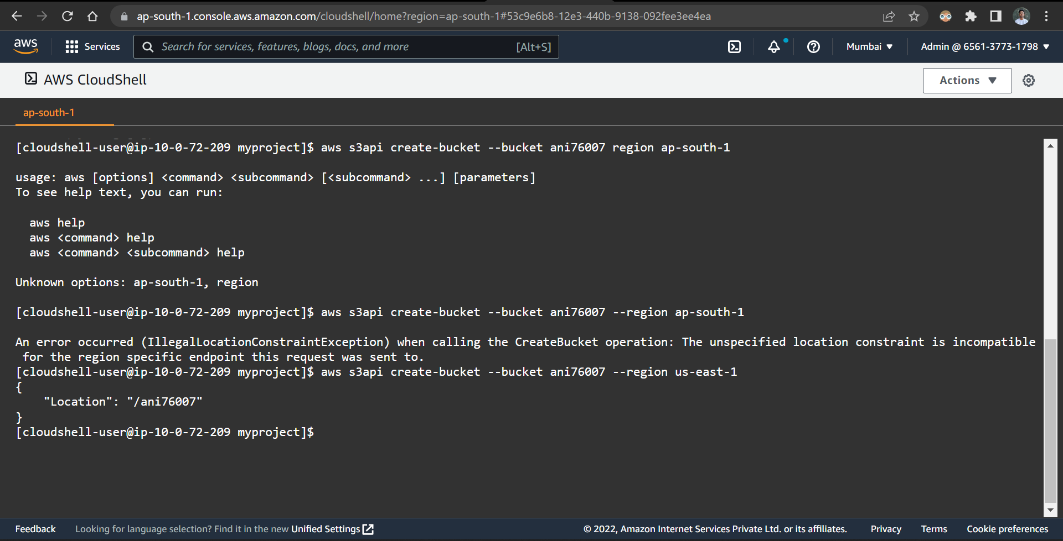

Bucket created successfully

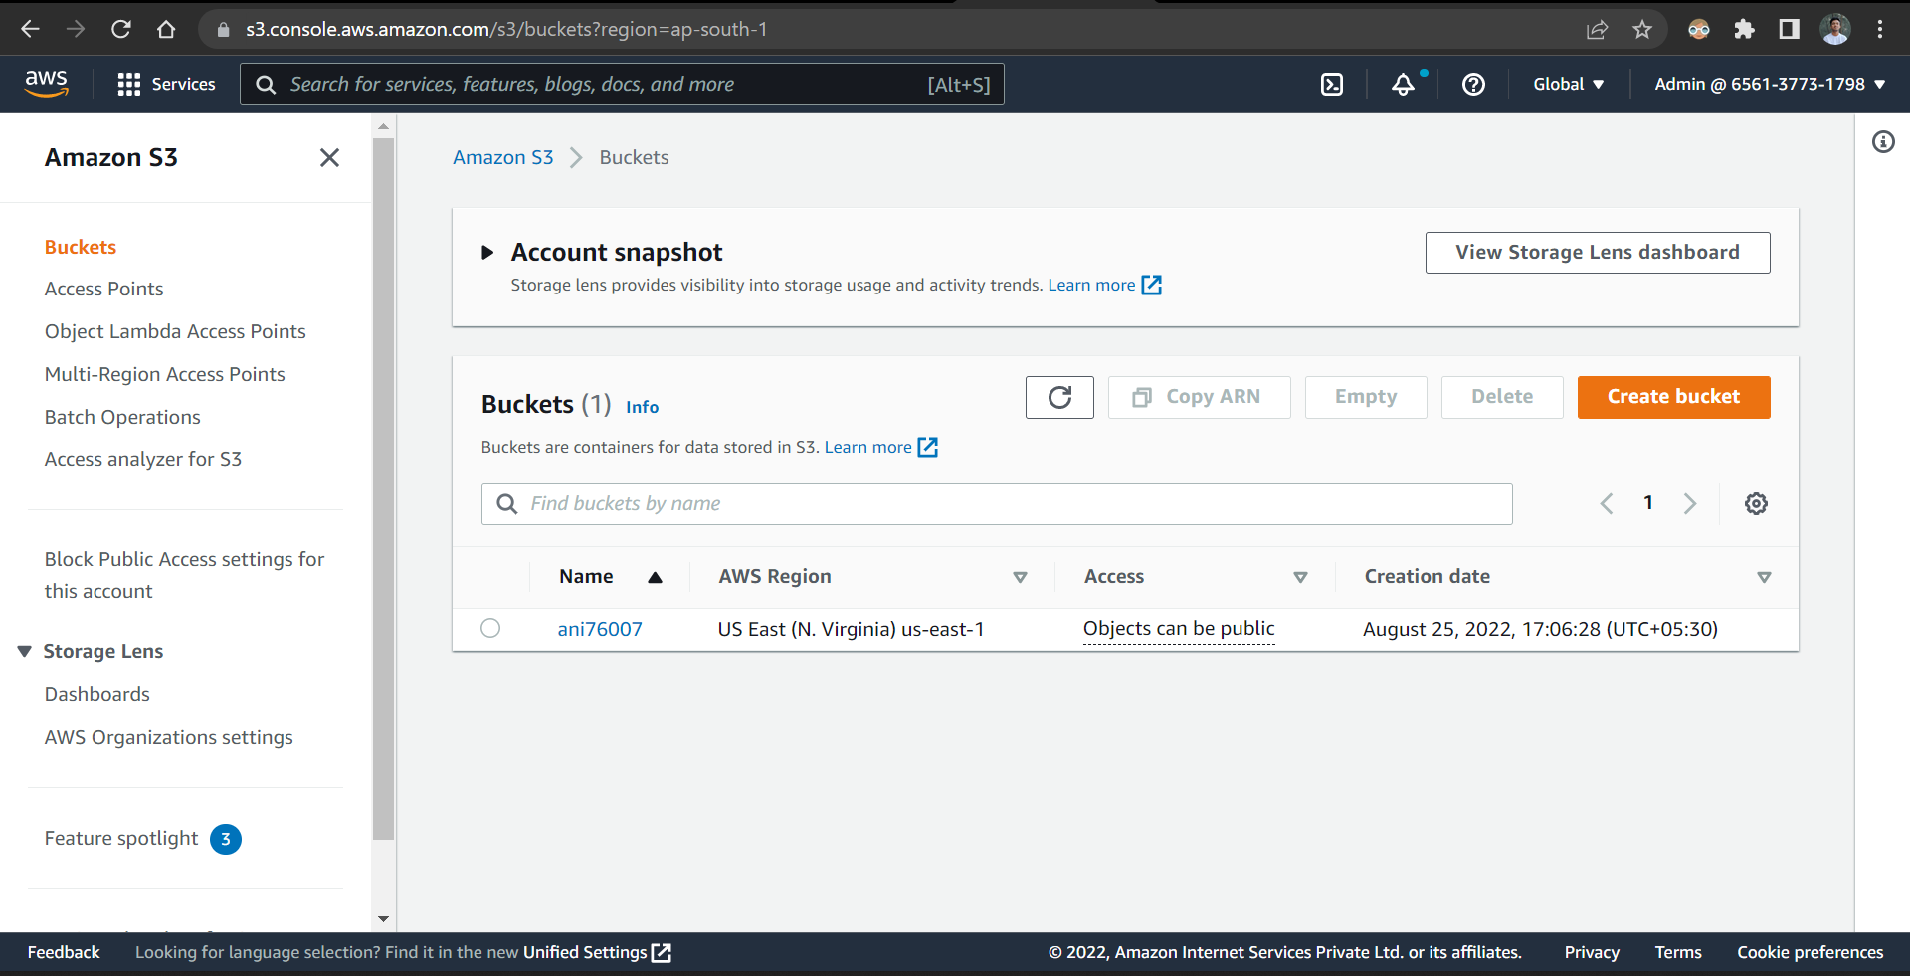

Deleted bucket successfully

