**Name – Aniket Jalasakare**

**PRN – 1132210192**

**Roll No – 24**

Create Virtual Machine from Azure Portal | SSH Connect to it | (Subscription - Azure For Students*)

Sign in to Azure Portal | CLICK on Create a resource.

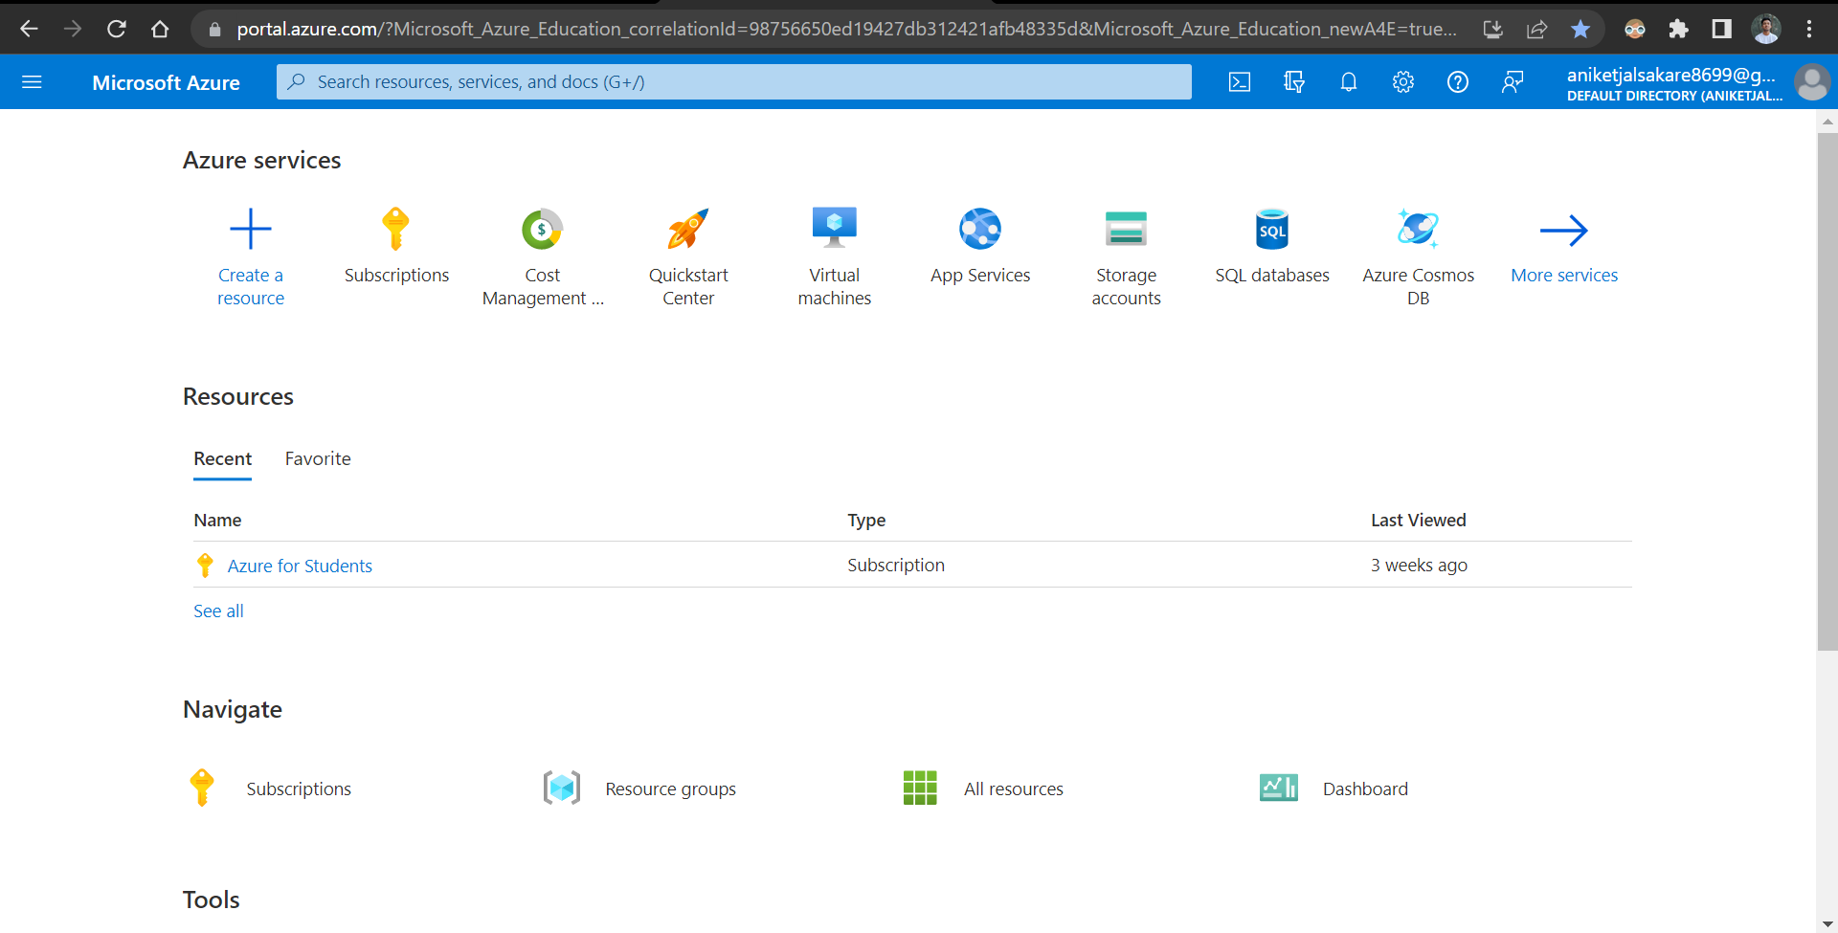

SELECT Virtual Machine. | Click on Create.

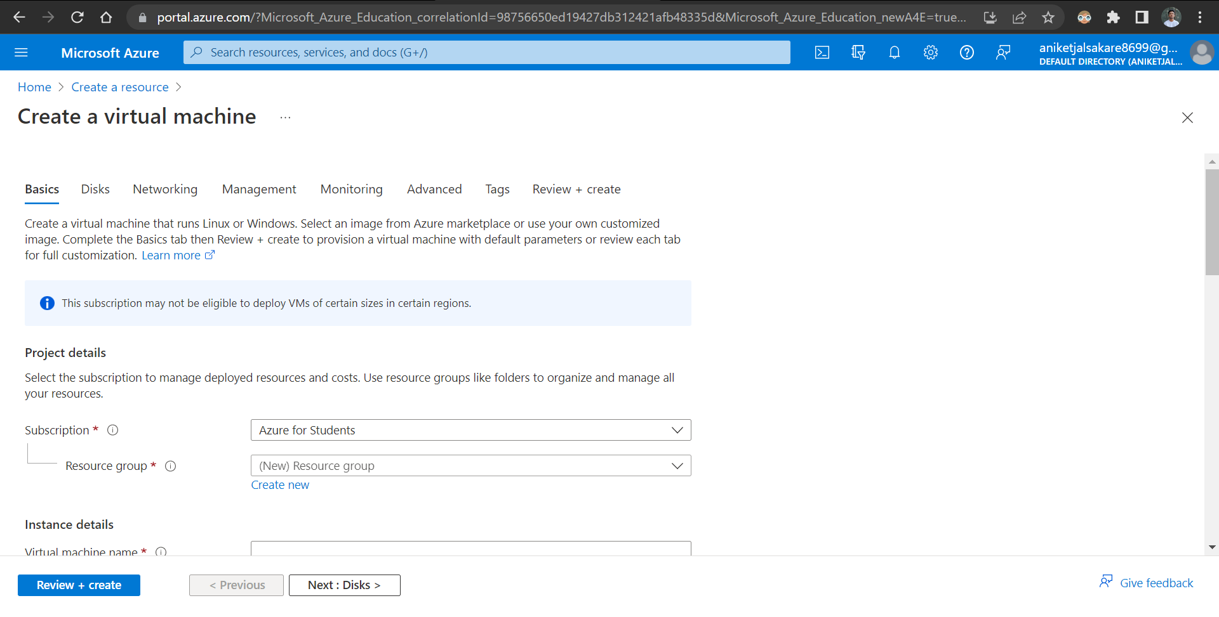

SELECT Subscription | Azure for Students.

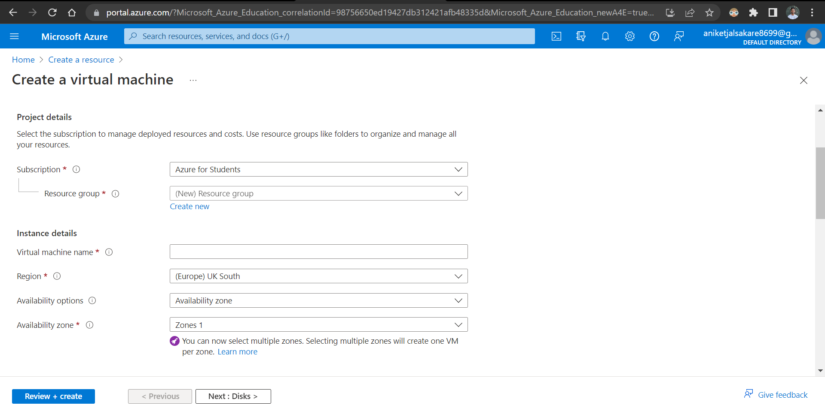

SELECT Resource Group.

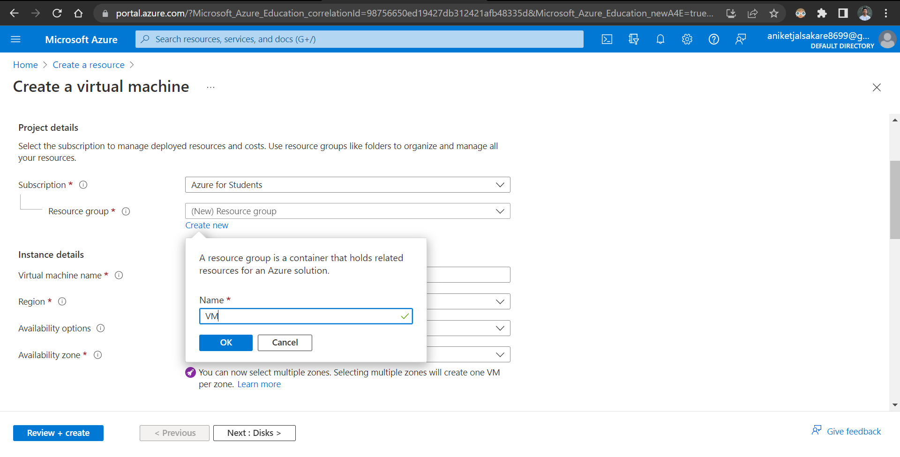

Edit Instance Details | Add Instance Name | Select Region | Select Ubuntu Image | Select Instance Size Standard_B1ls ( Instance with least pricing)

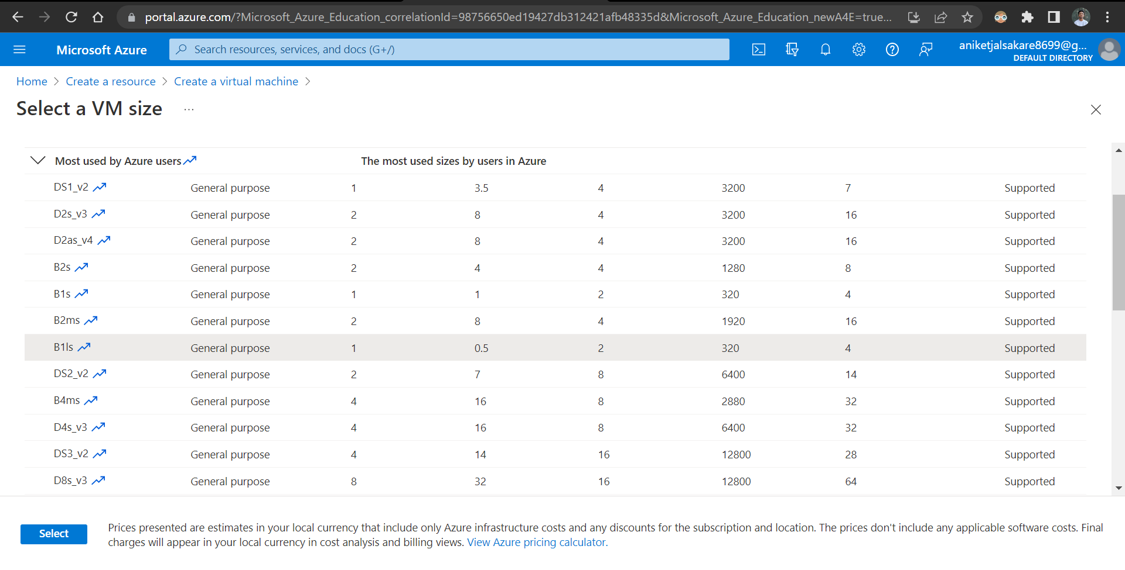

Add Username | Create New KeyPair

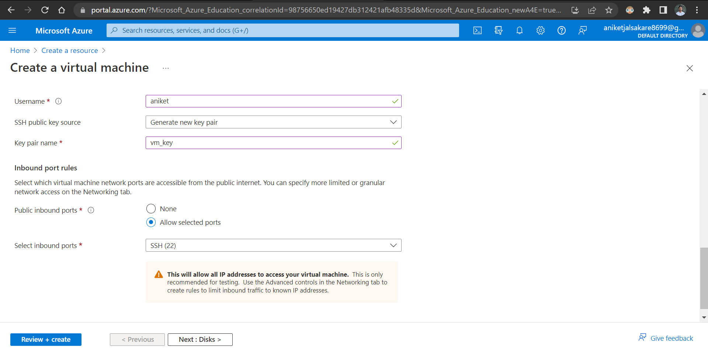

Inbound Port 22 should be SELECTED.

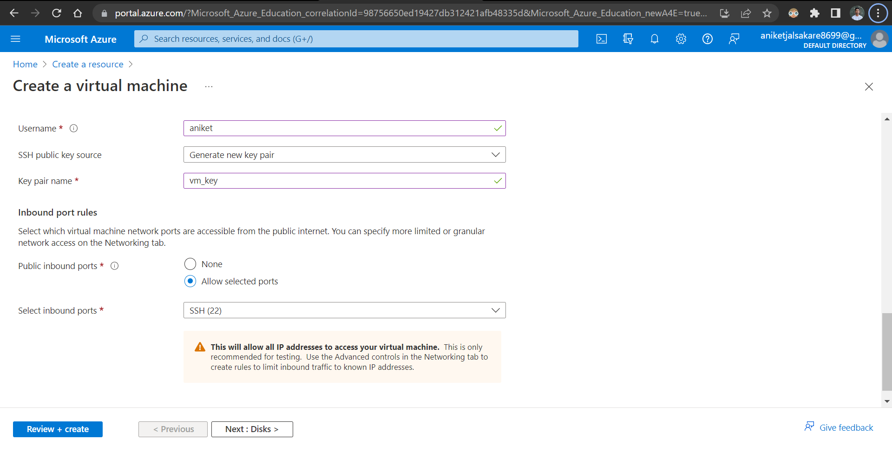

In Networking TAB | Select VNET Or Create manually.

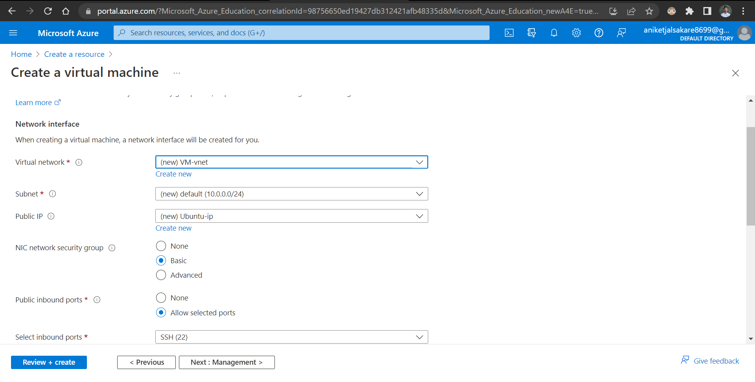

Add TAG

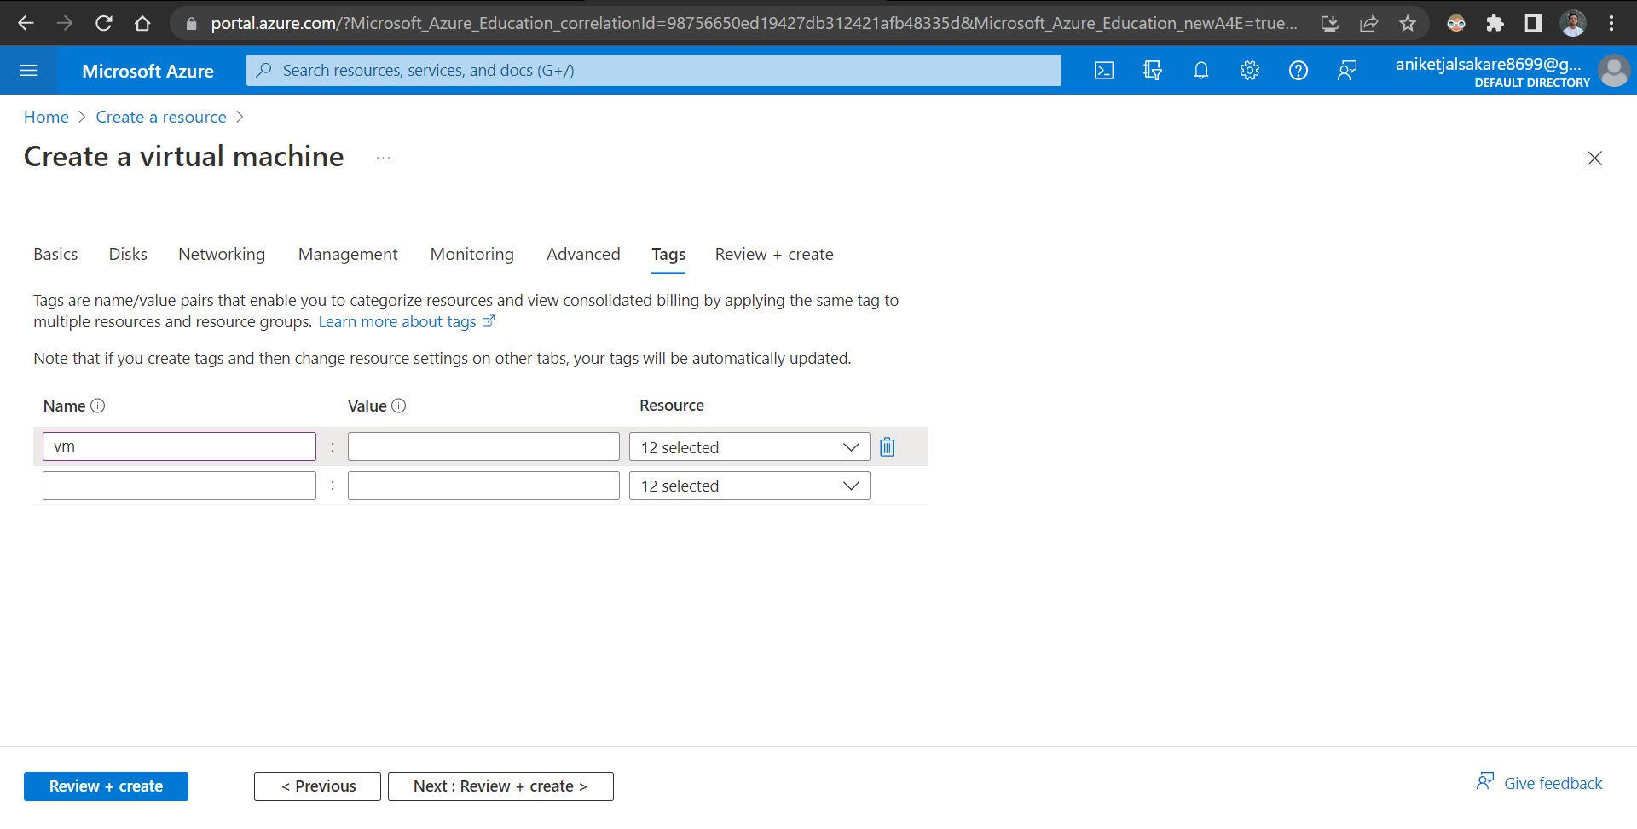

(Vaildation should passed) At Last Click REVIEW + CREATE.

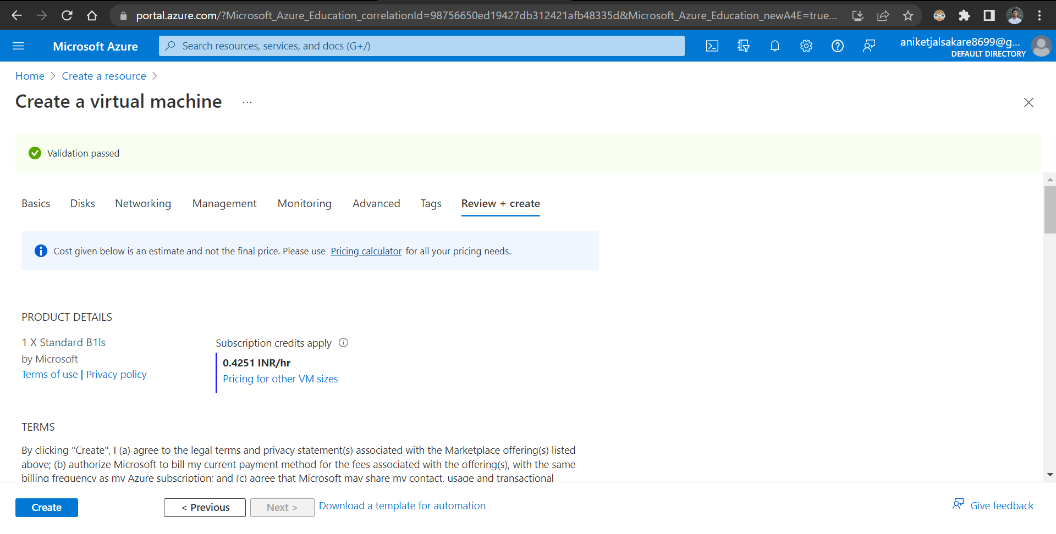

Download KeyPair to your Local Machine

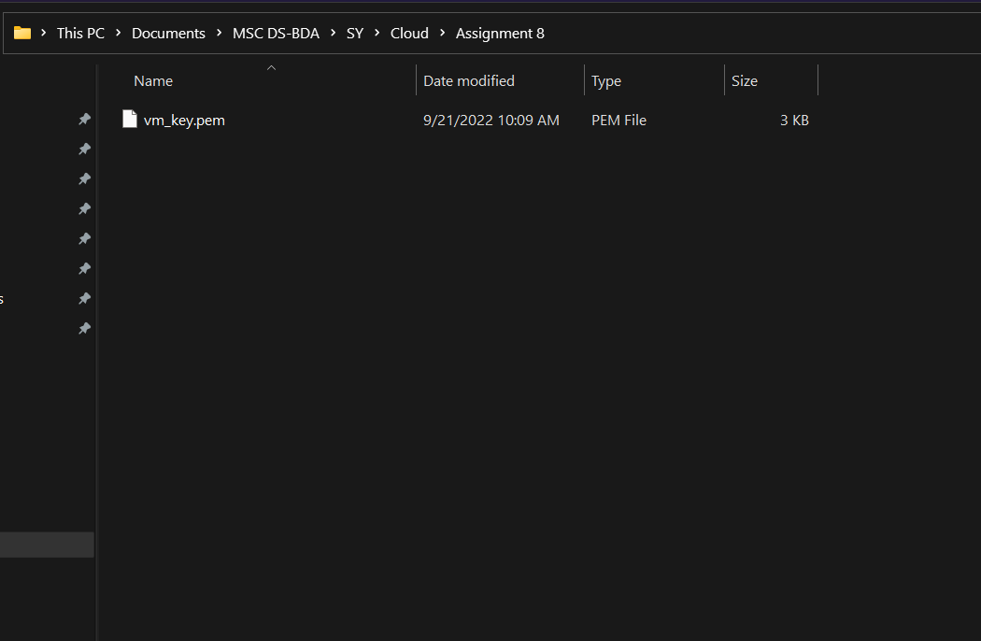

Deployment is successful

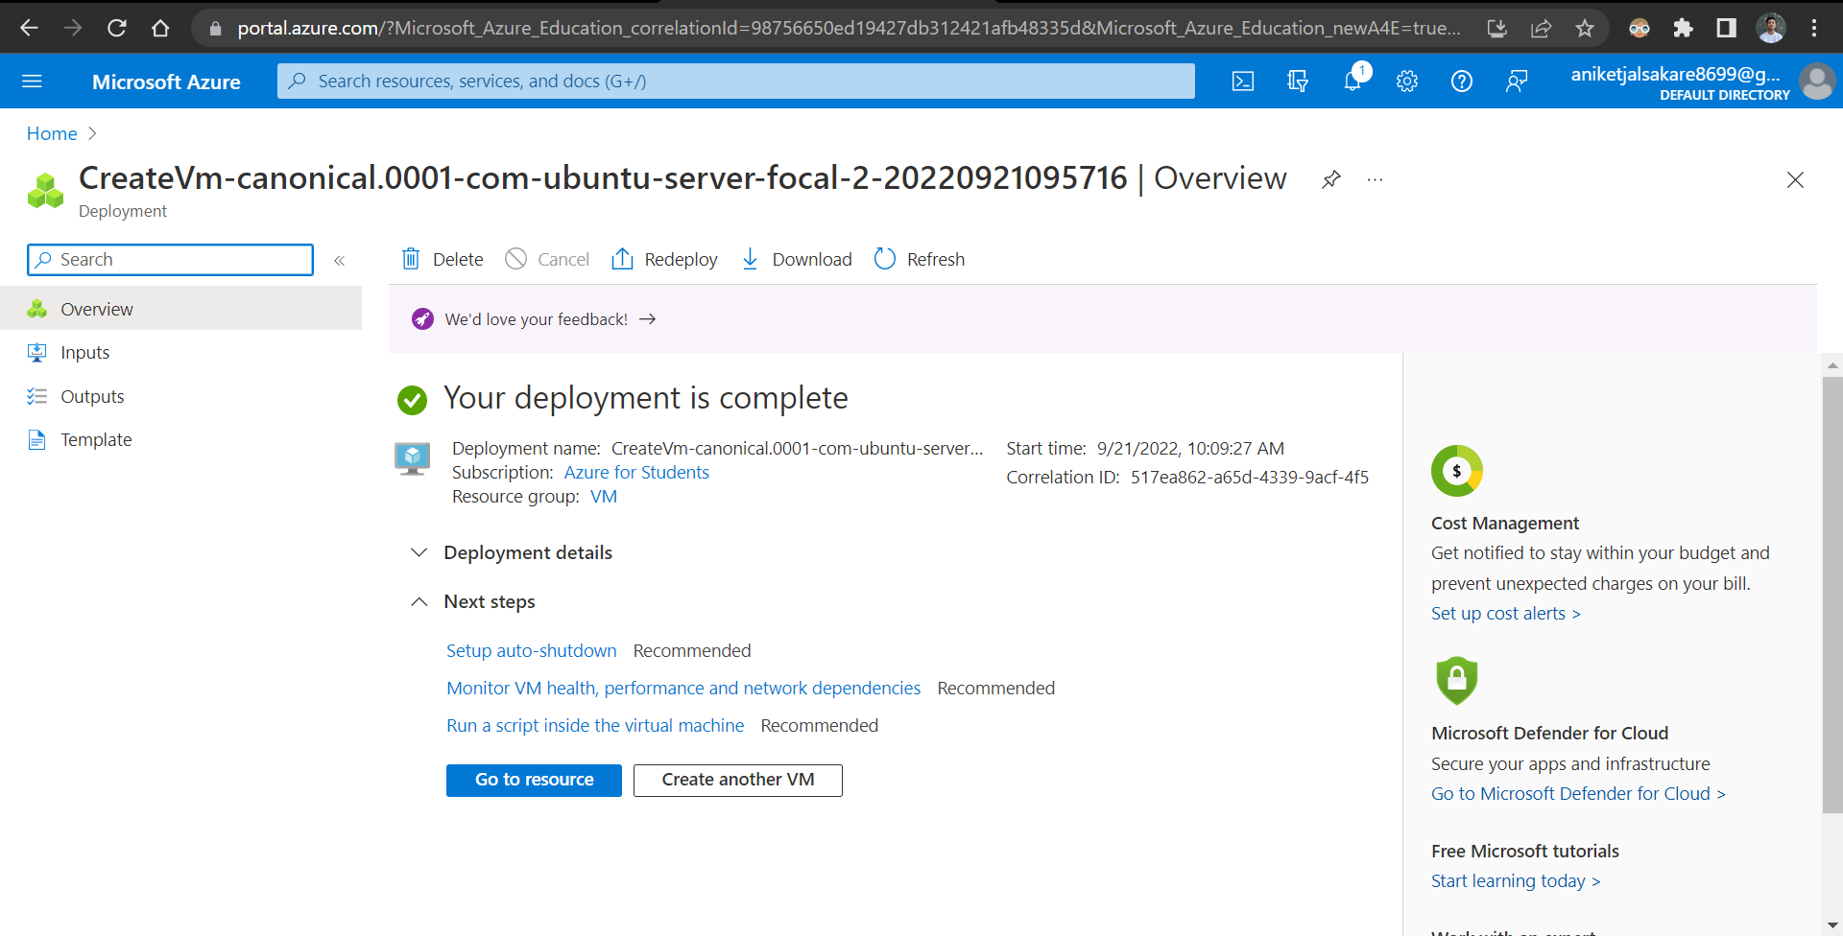

Connect Virtual Machine for SSH Connection. (Putty from Windows or Terminal from Linux)

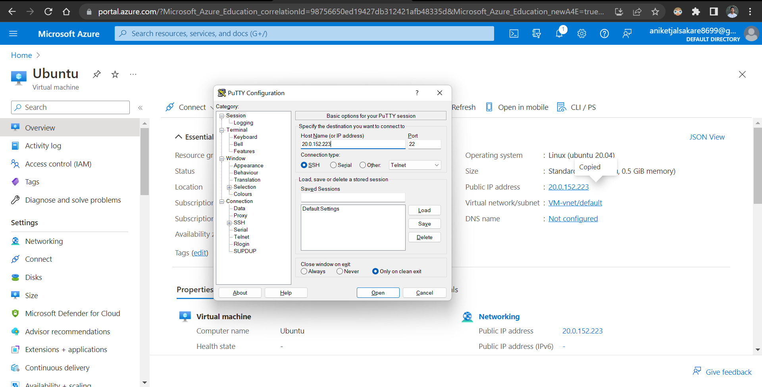

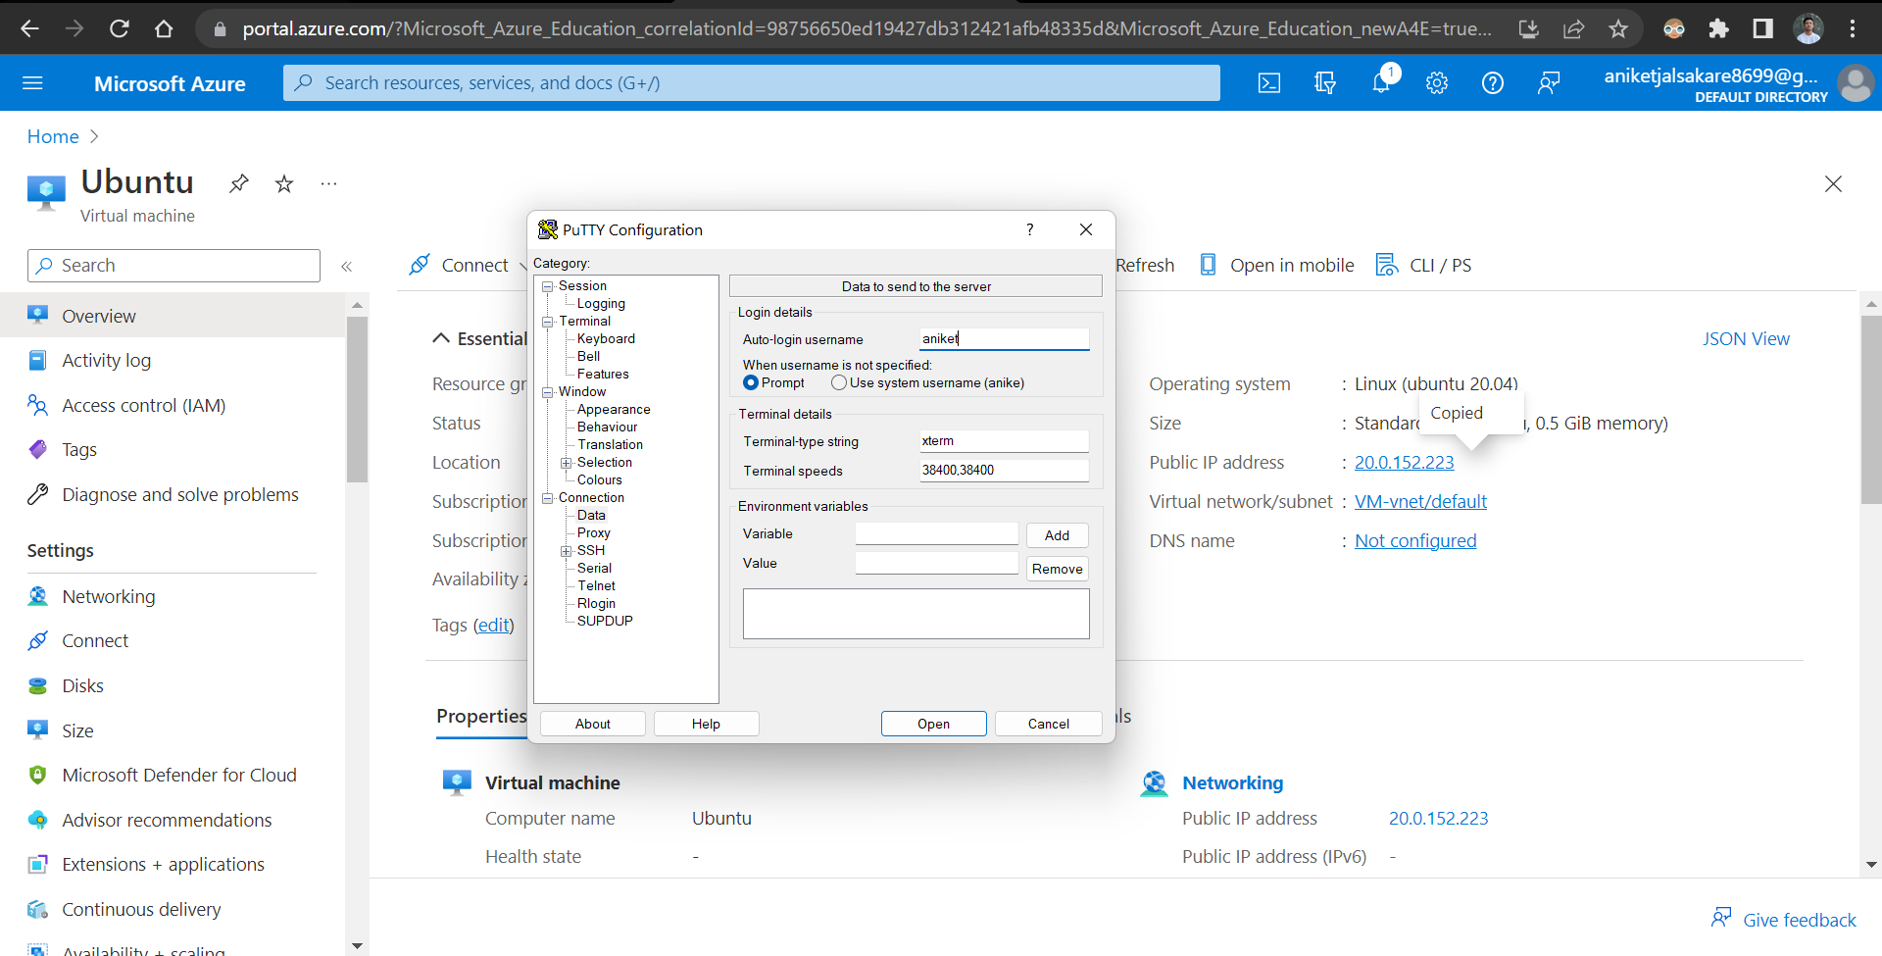

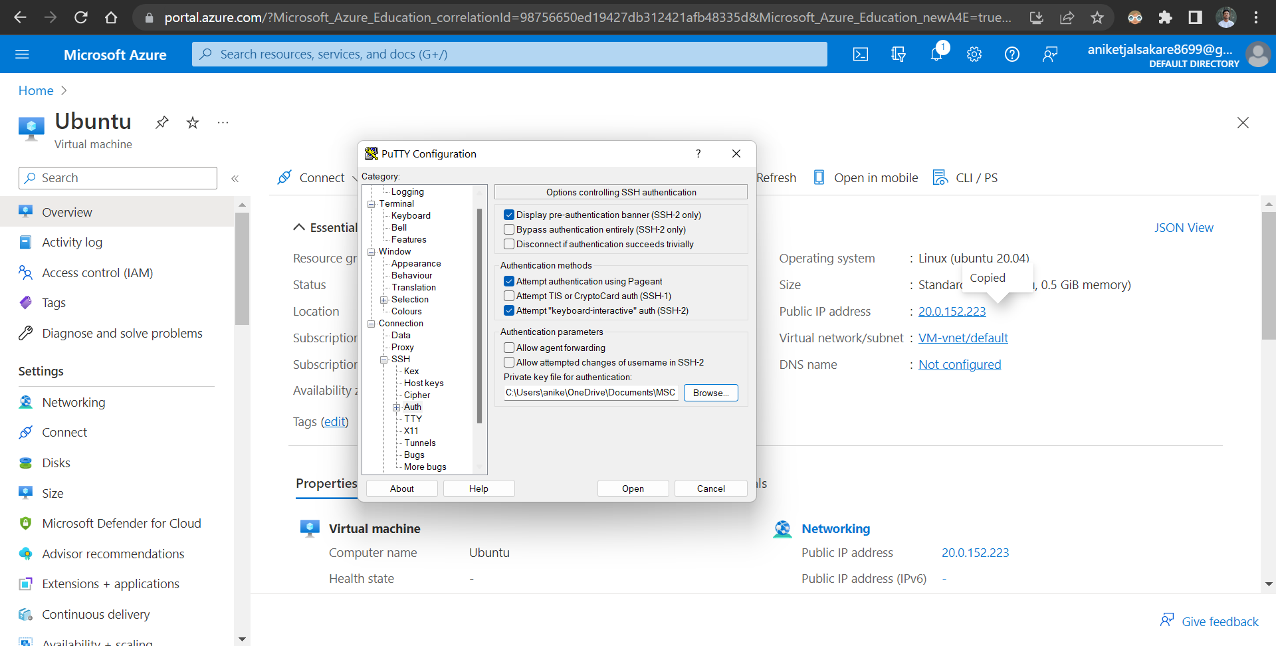

Connected virtual machine

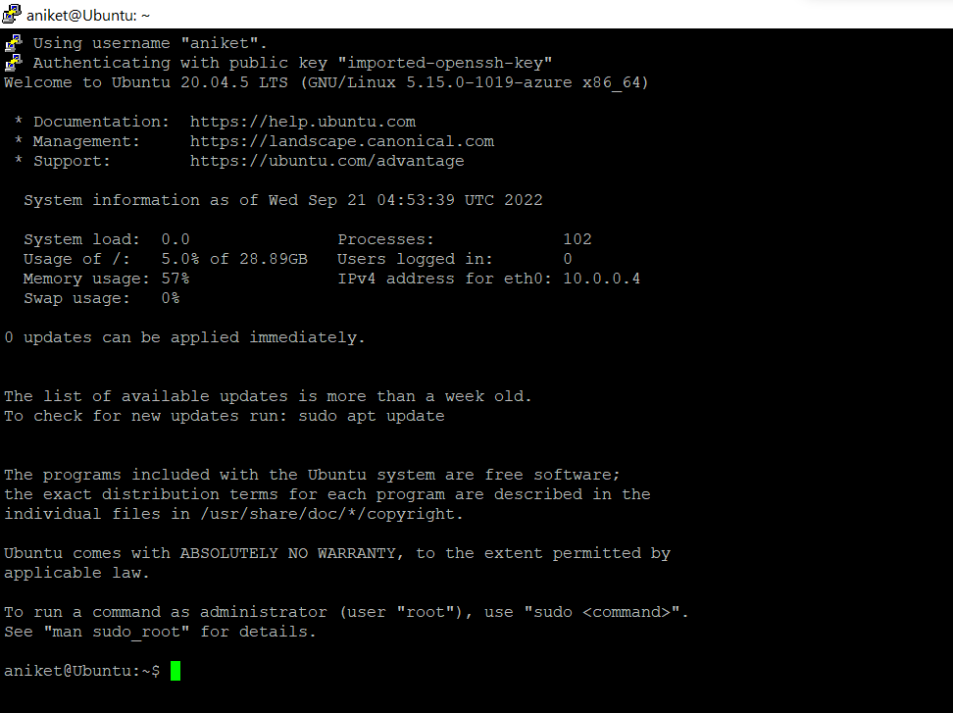

Practice Basic Linux Commands over there.

1. Creating directory mit

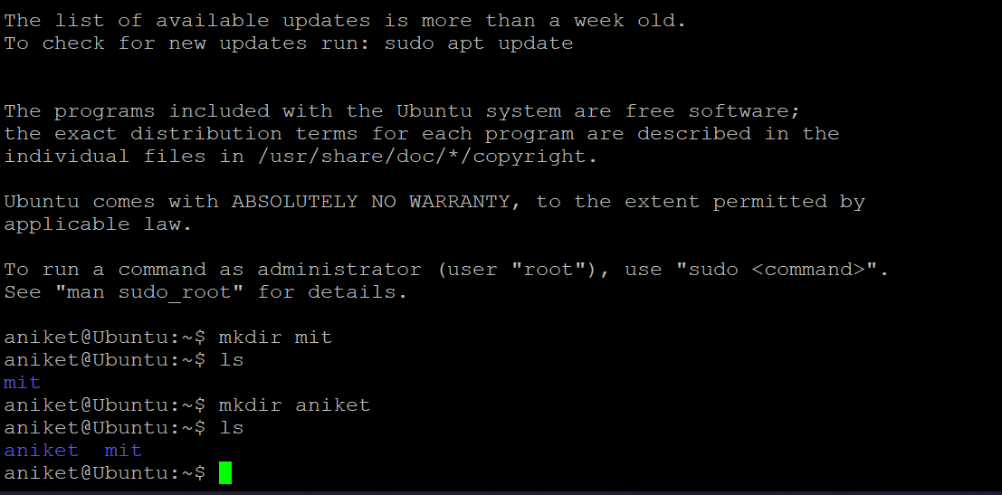

1. Listing the directories



1. Creating file using touch command

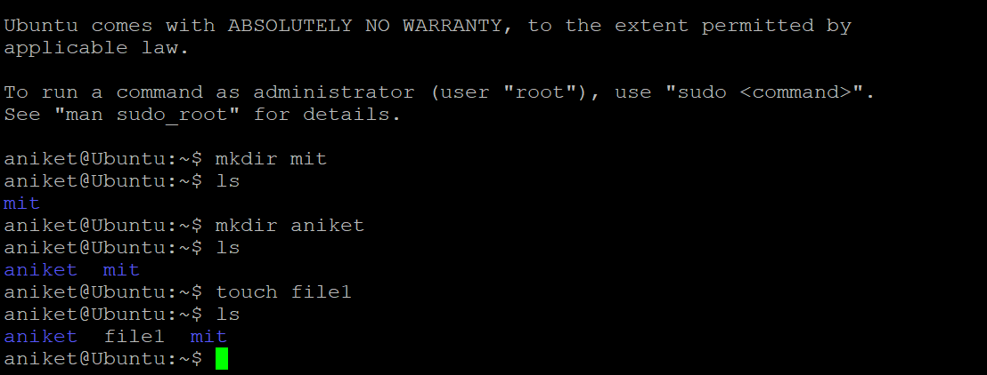

1. Editing the file using nano editor

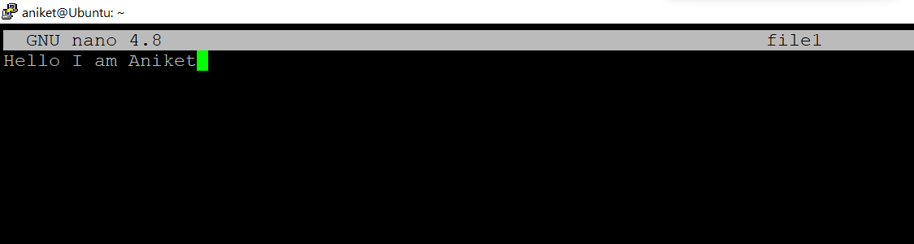

1. View content of file1 using cat command

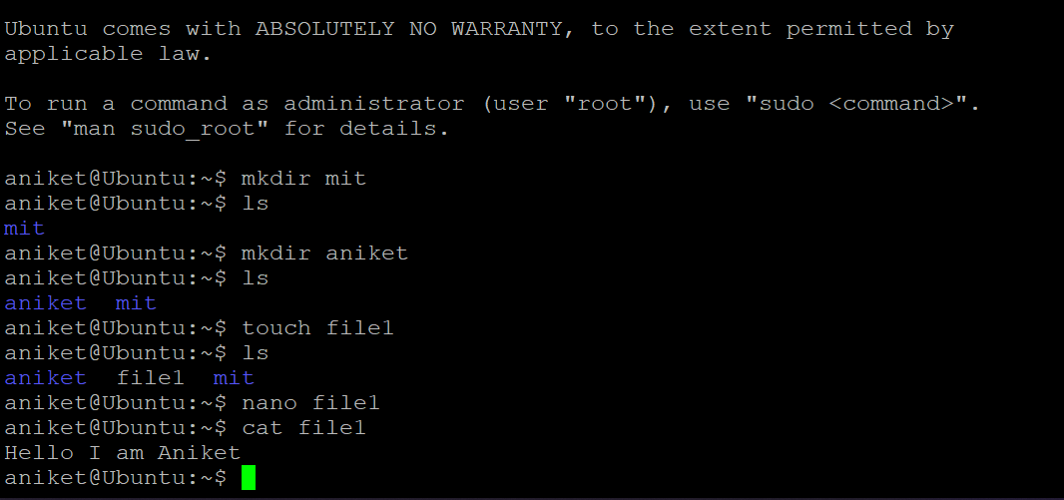

1. Move file1 content to file2 using mv command

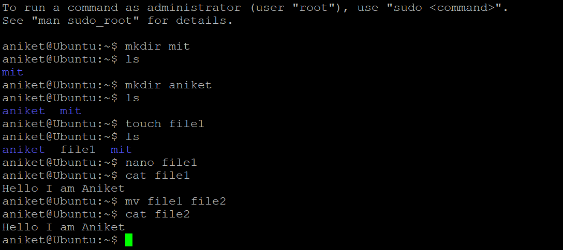

1. Remove files using rm command

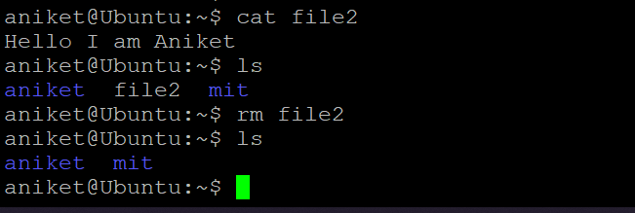

1. Delete directory using rmdir command

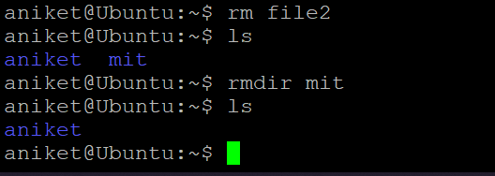

At Last, Go to ALL Resources TAB | SELECT & DELETE the resources.

