**Name – Aniket Jalasakare**

**PRN – 1132210192**

**Roll No – 24**

Tutorial 8 B) Create Virtual Machine from Azure Portal | Do RDP Connection to it

Sign in to Azure Portal | CLICK on Create a resource.

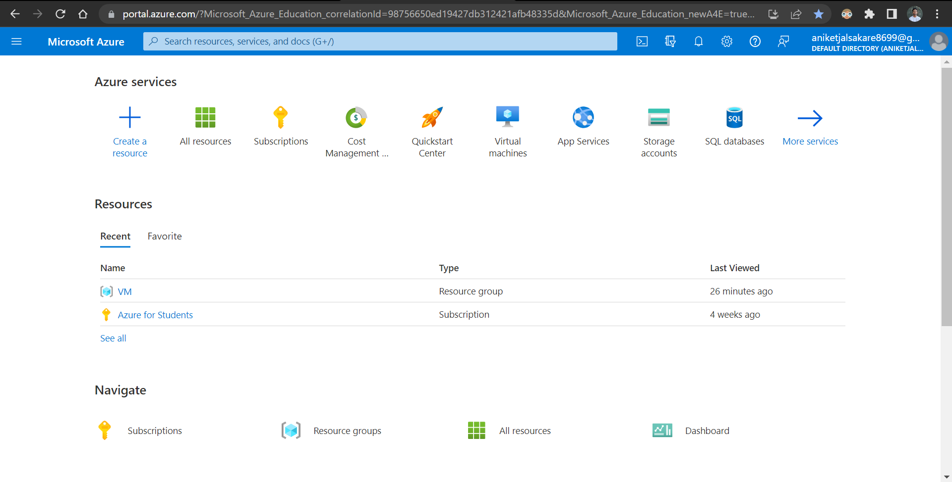

SELECT Virtual Machine. | Click on Create, SELECT Subscription | Azure for Students.

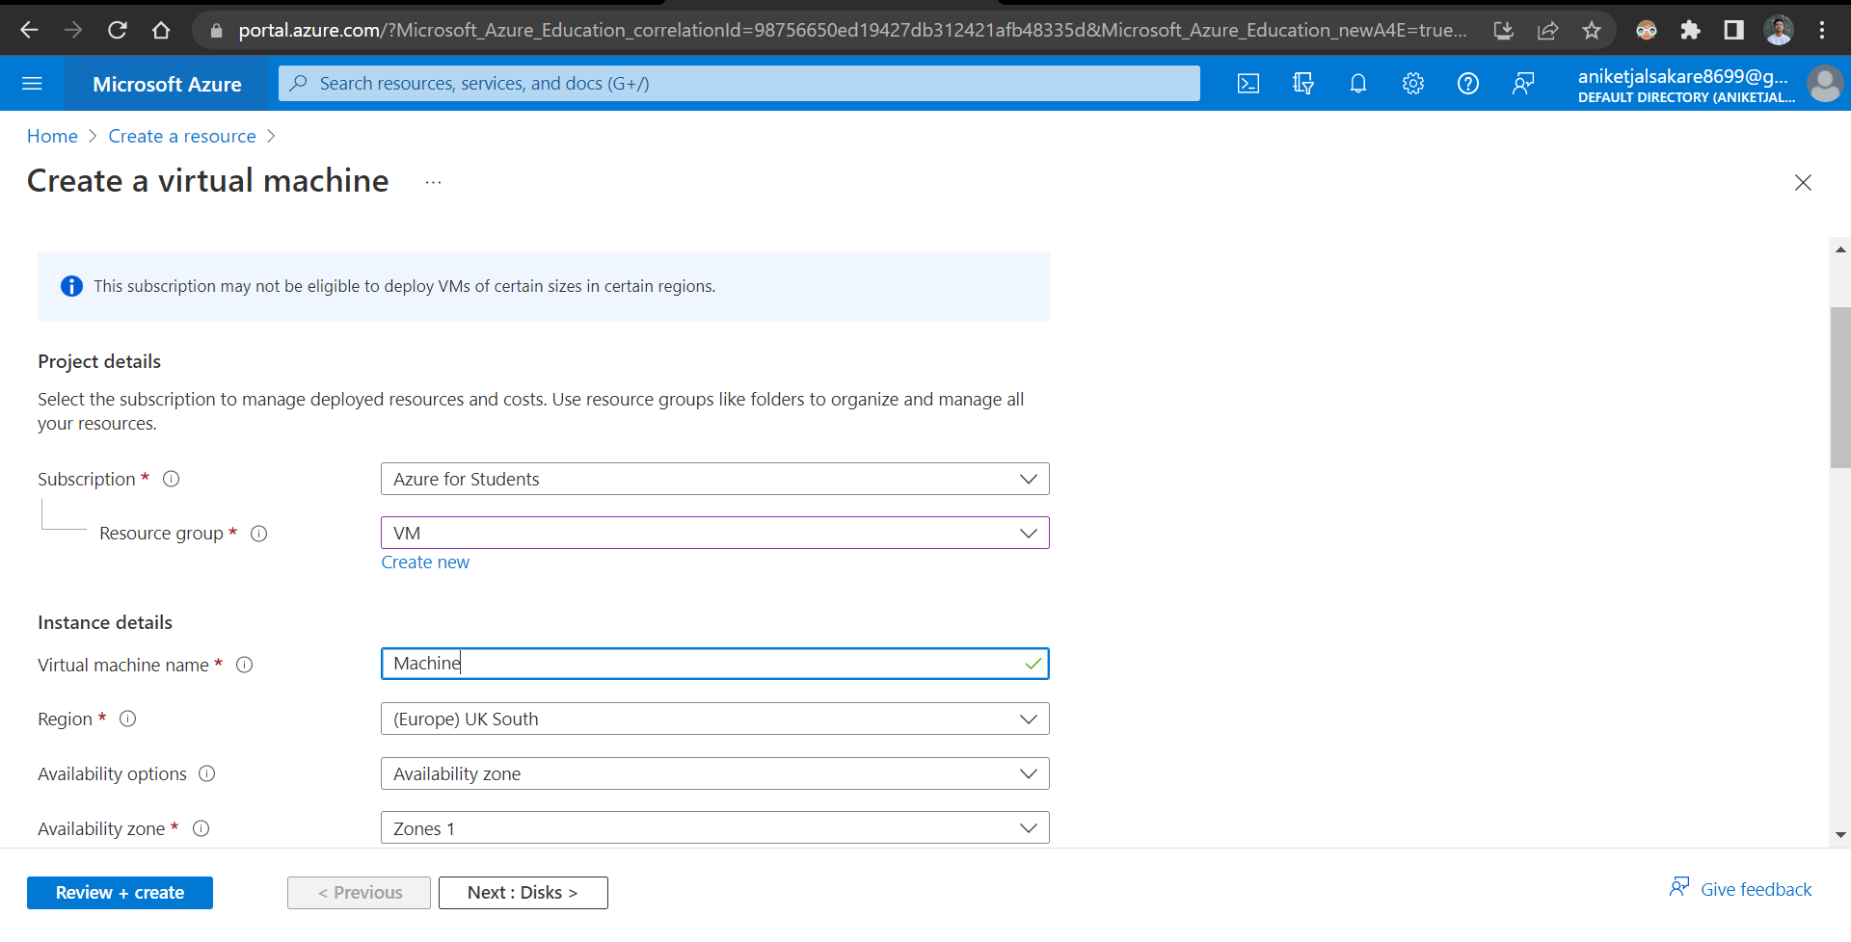

SELECT Resource Group.

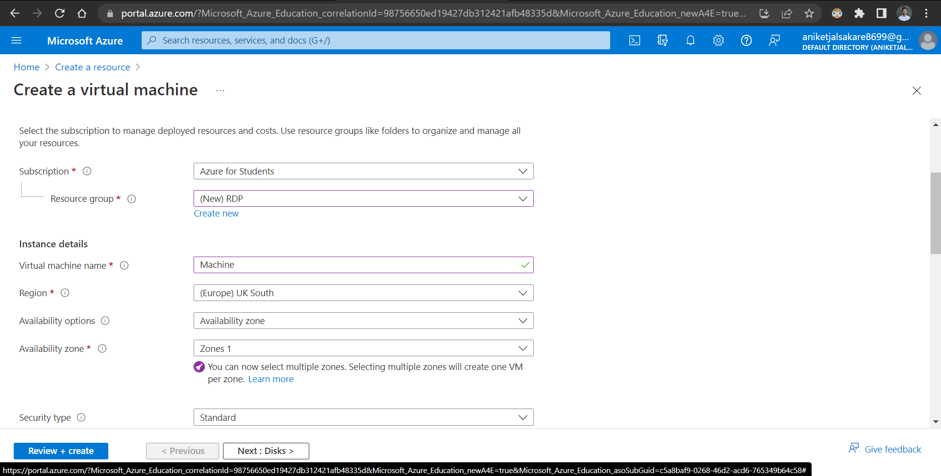

Edit Instance Details | Add Virtual Machine details Name | Select Region | Select Windows Server Image

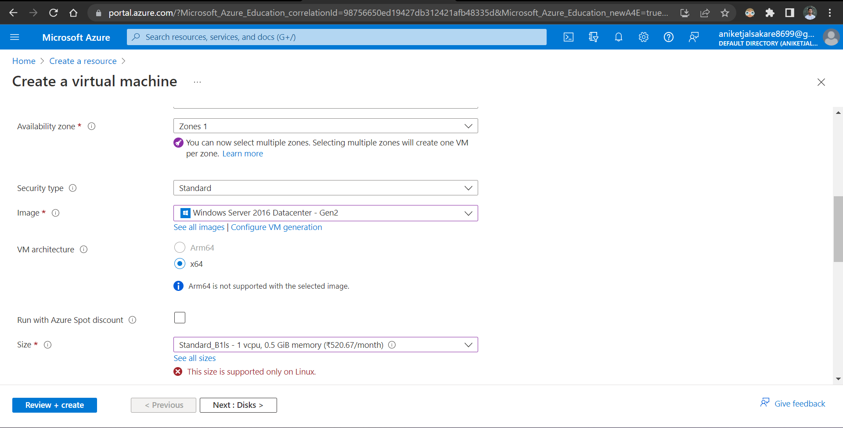

Select Instance Size Standard_B2s ( Instance with least pricing)

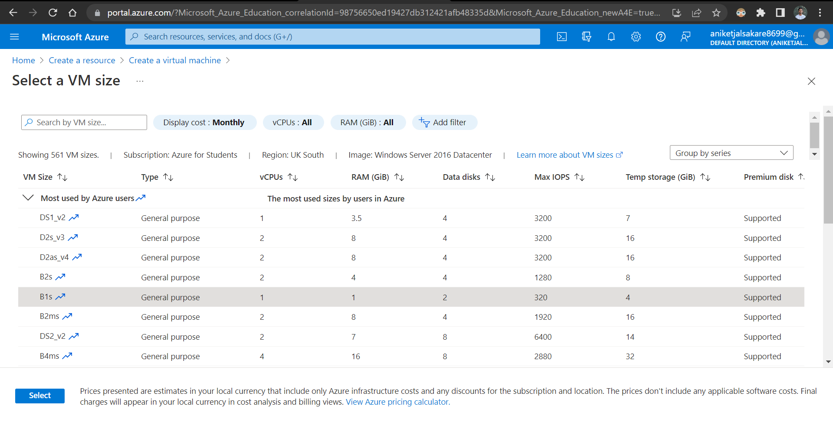

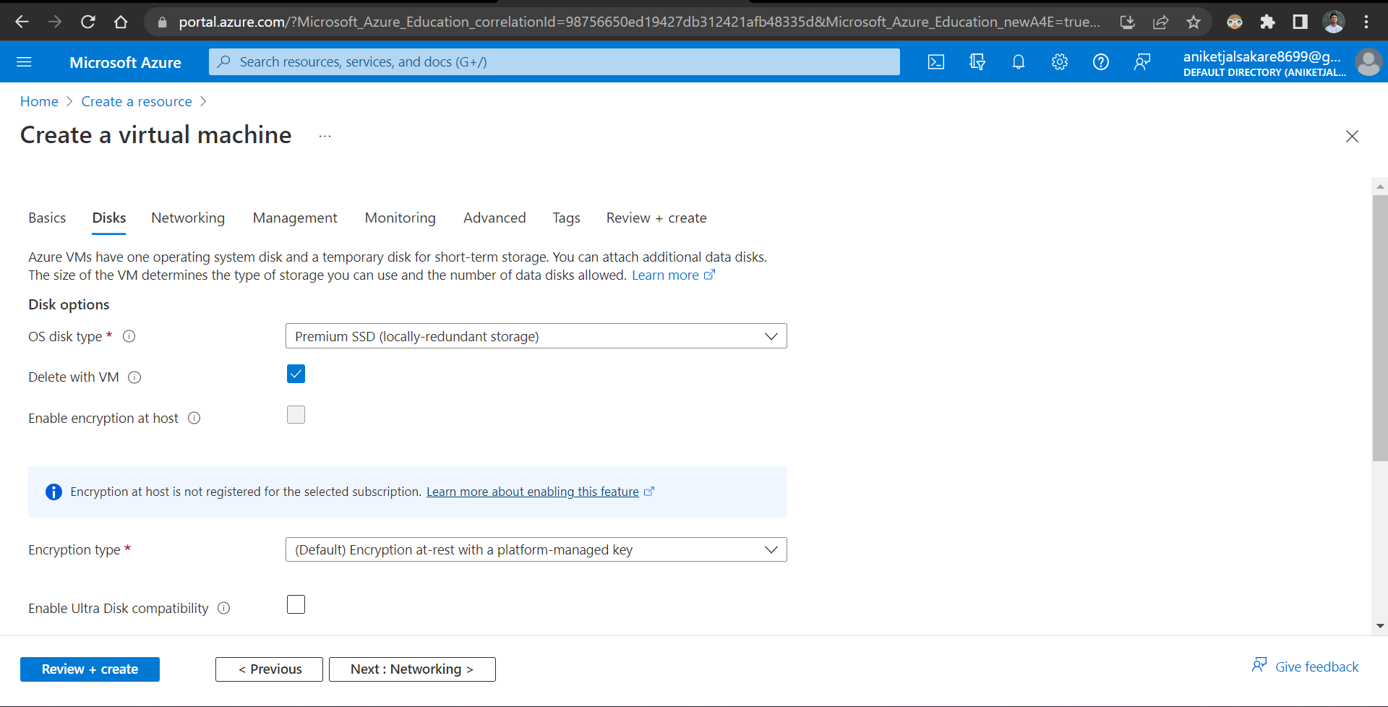

In Networking TAB | Select VNET Or Create manually.

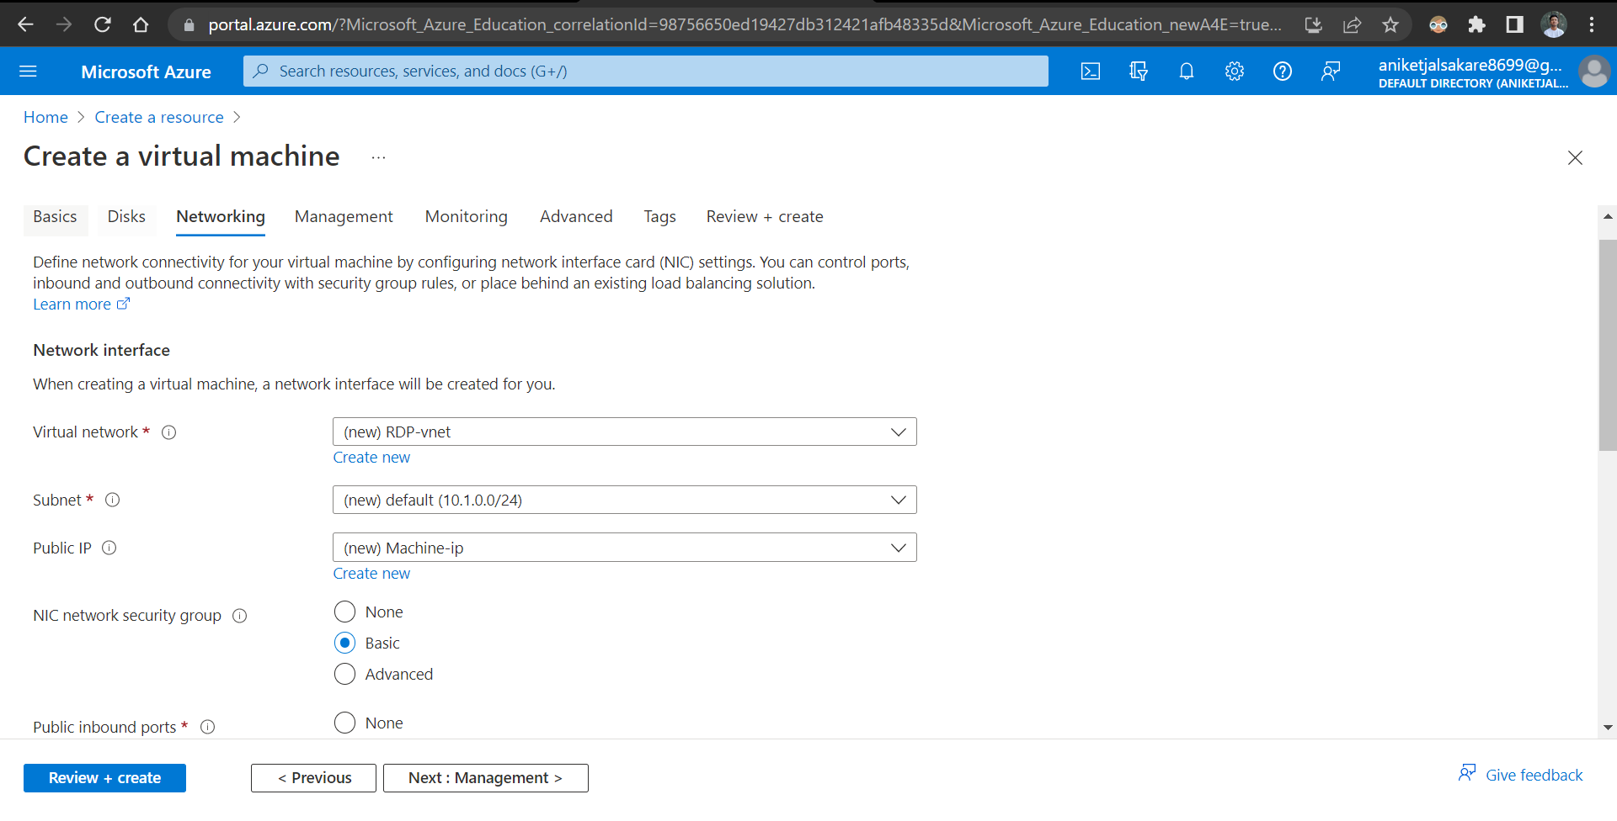

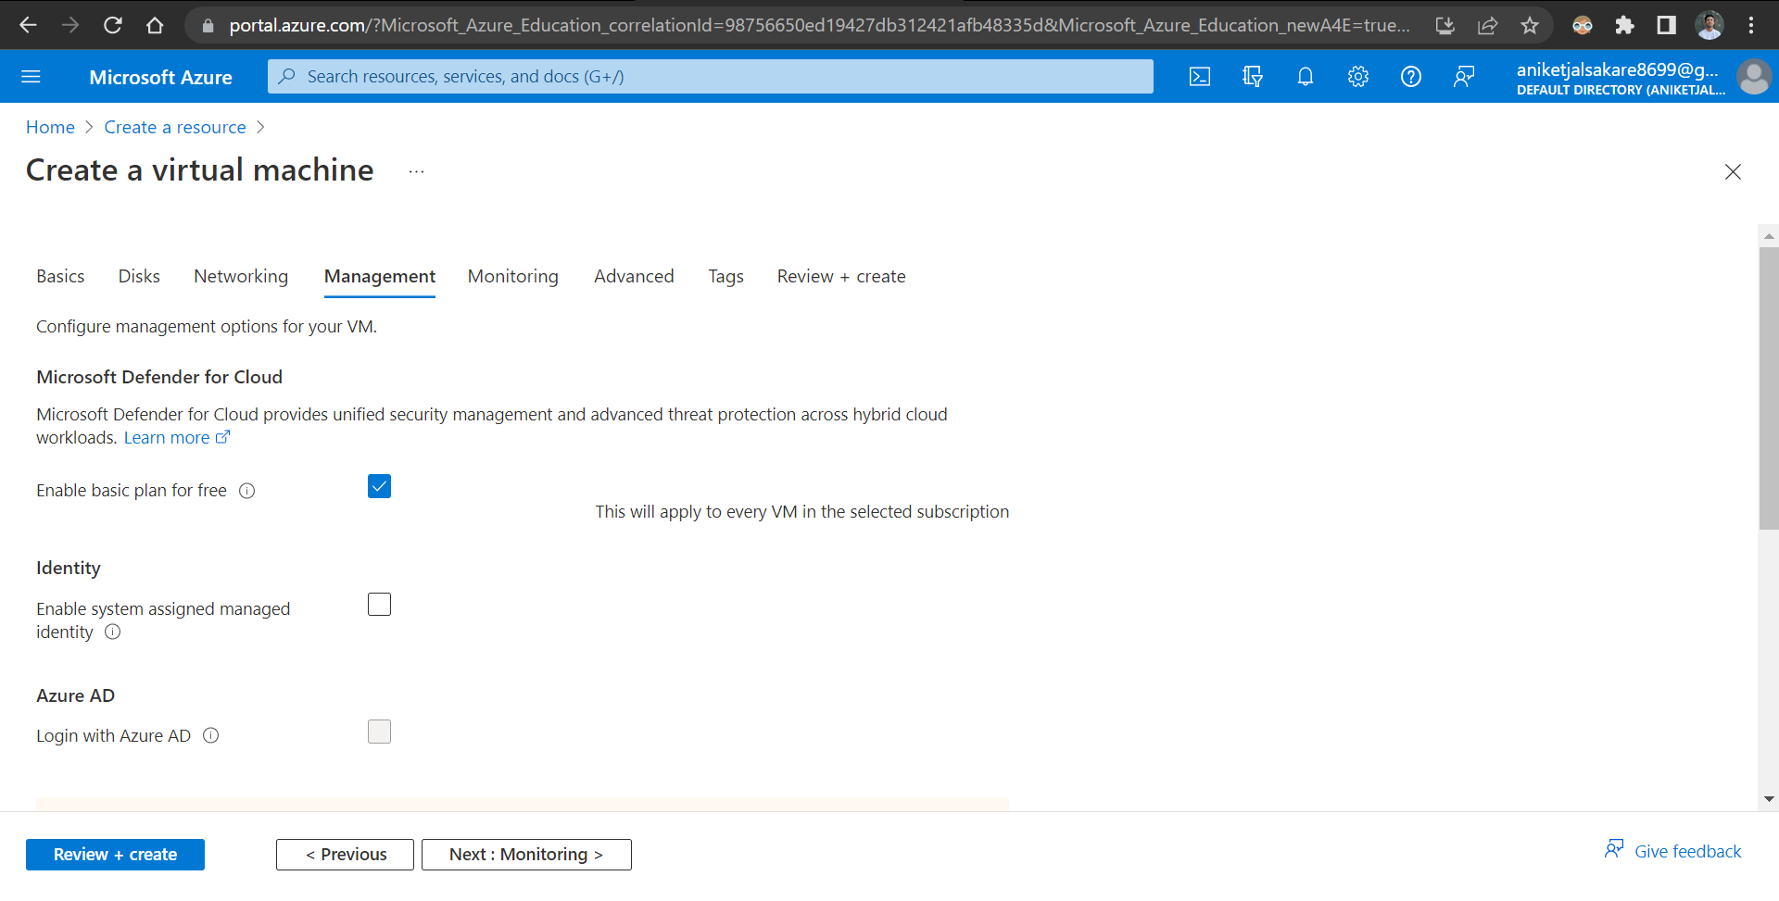

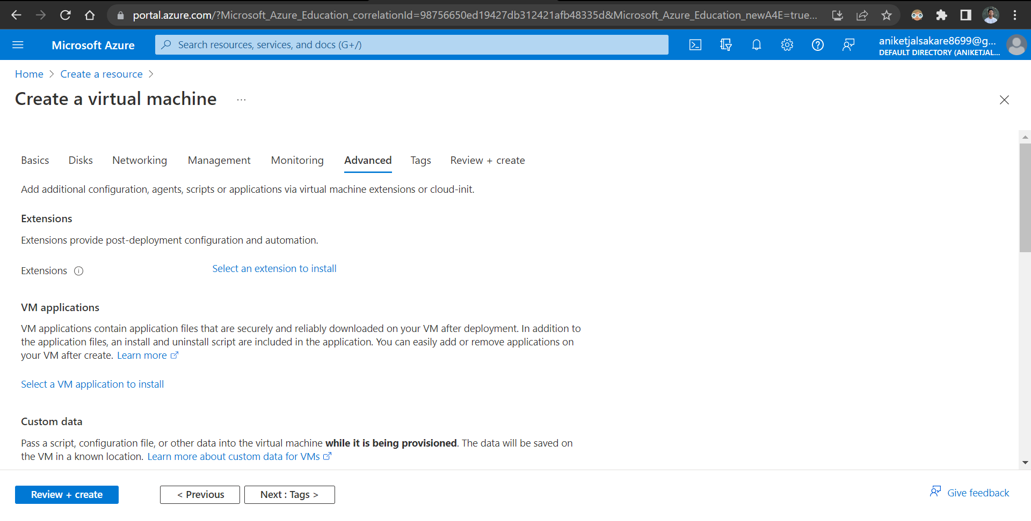

Add TAG

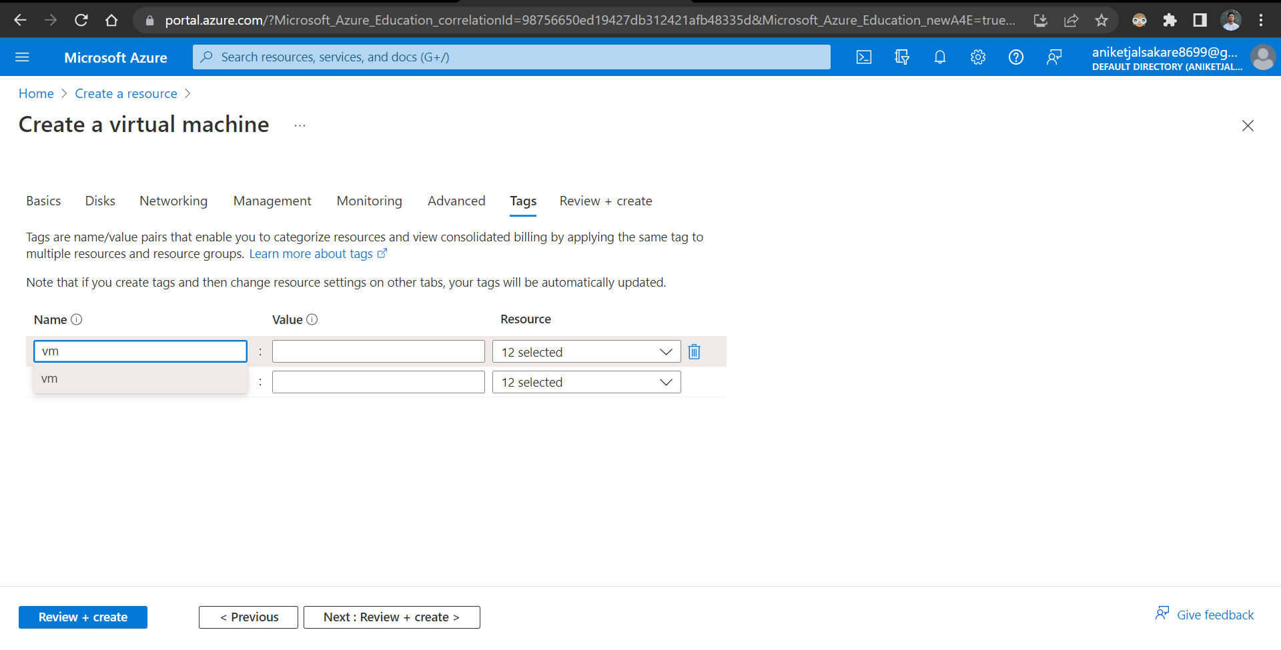

(Validation should passed) At Last Click REVIEW + CREATE.

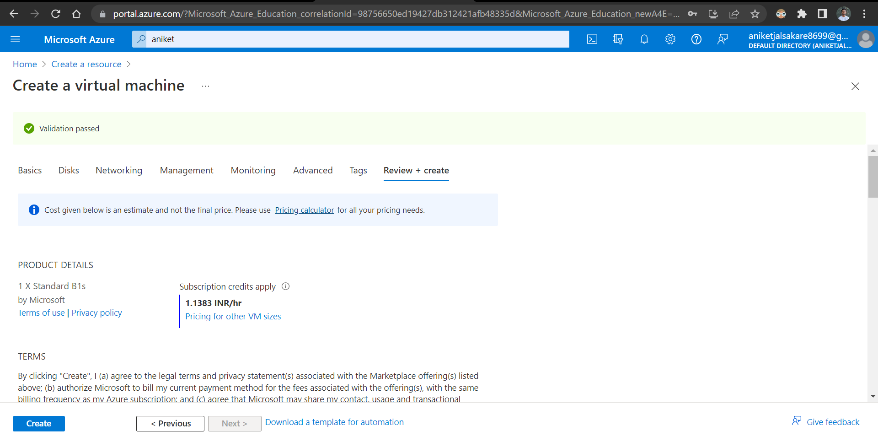

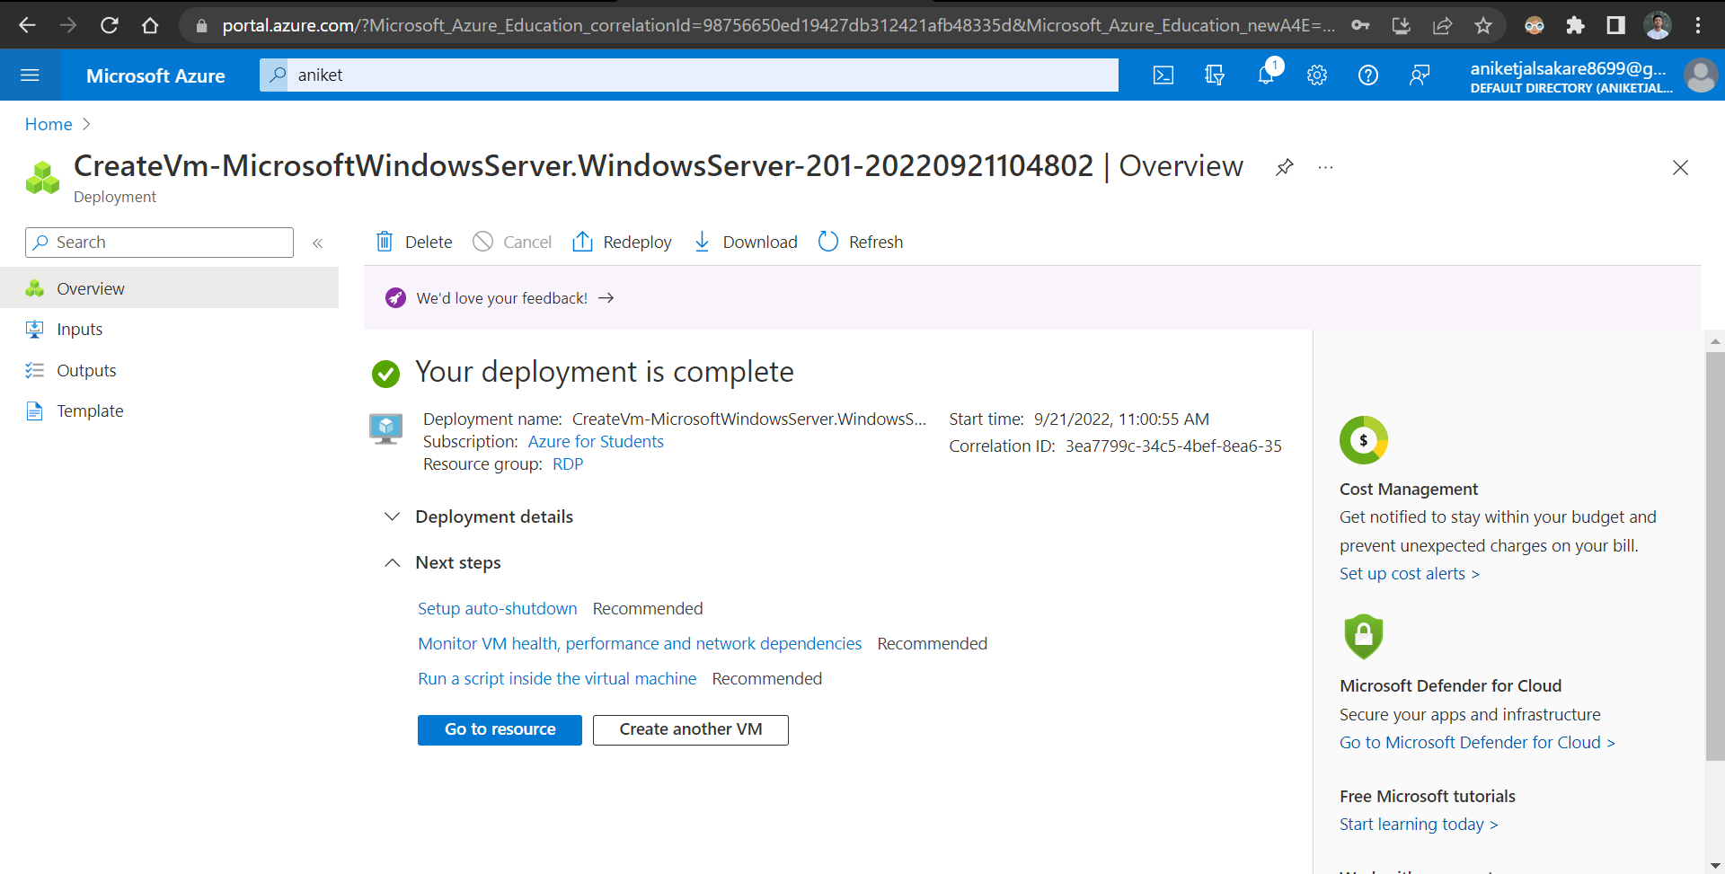

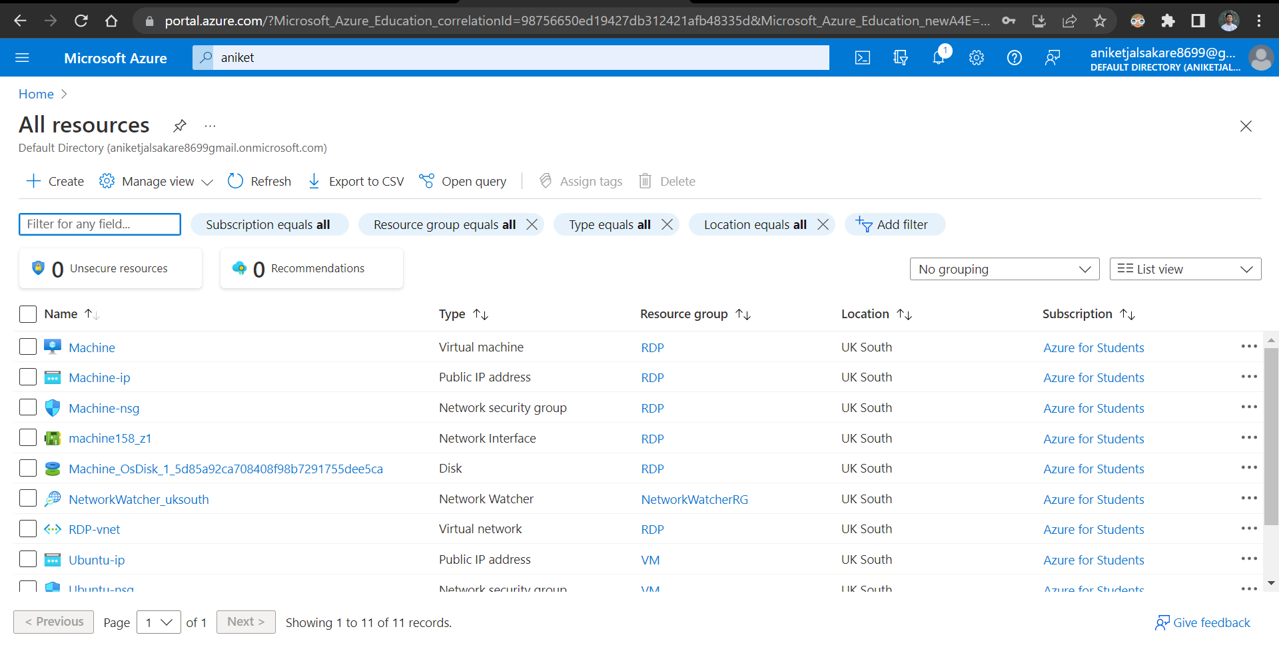

Download RDP File after deployment to your Local Machine

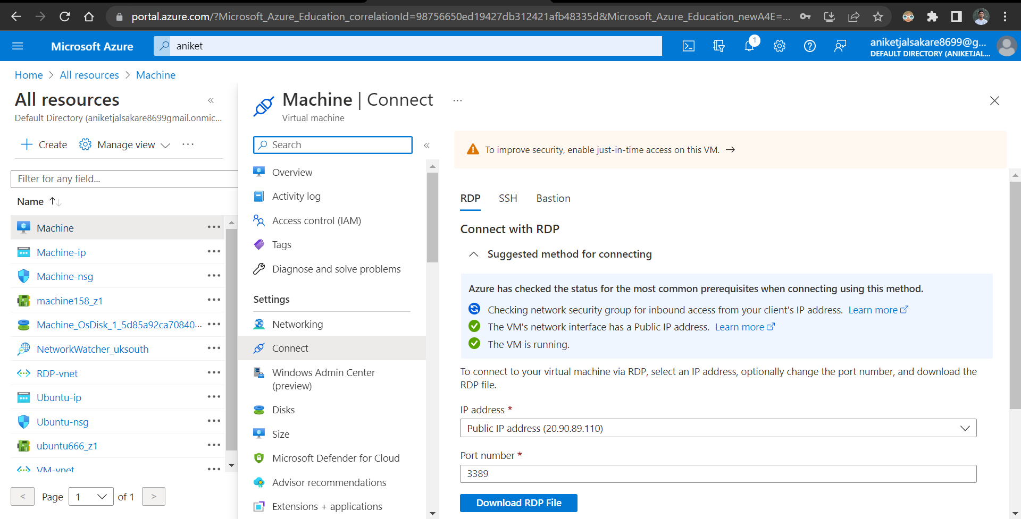

Add details about username, password & public ip. | Connect to Virtual Machine.

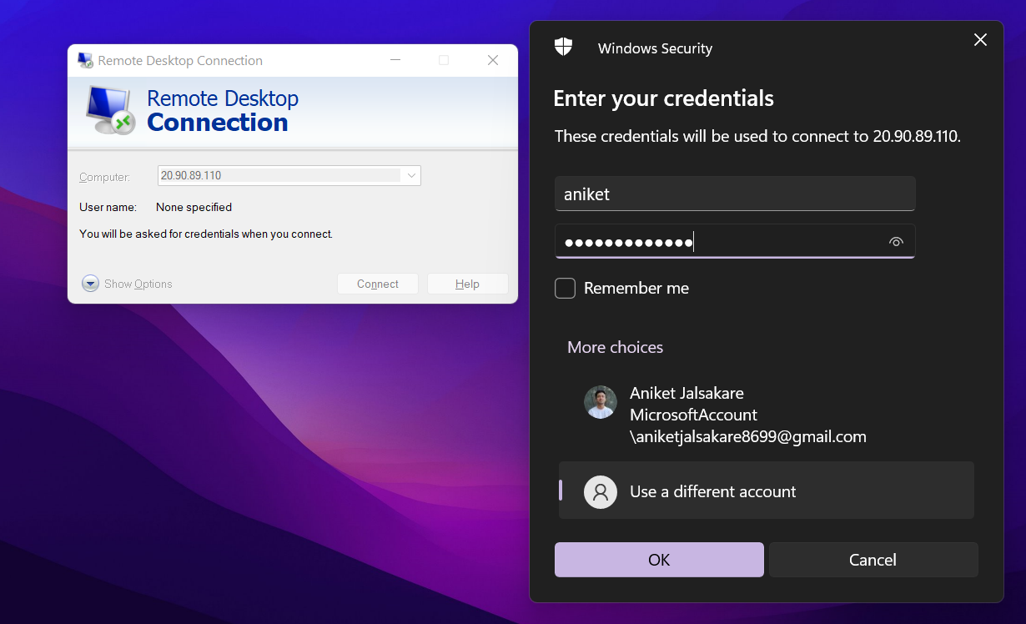

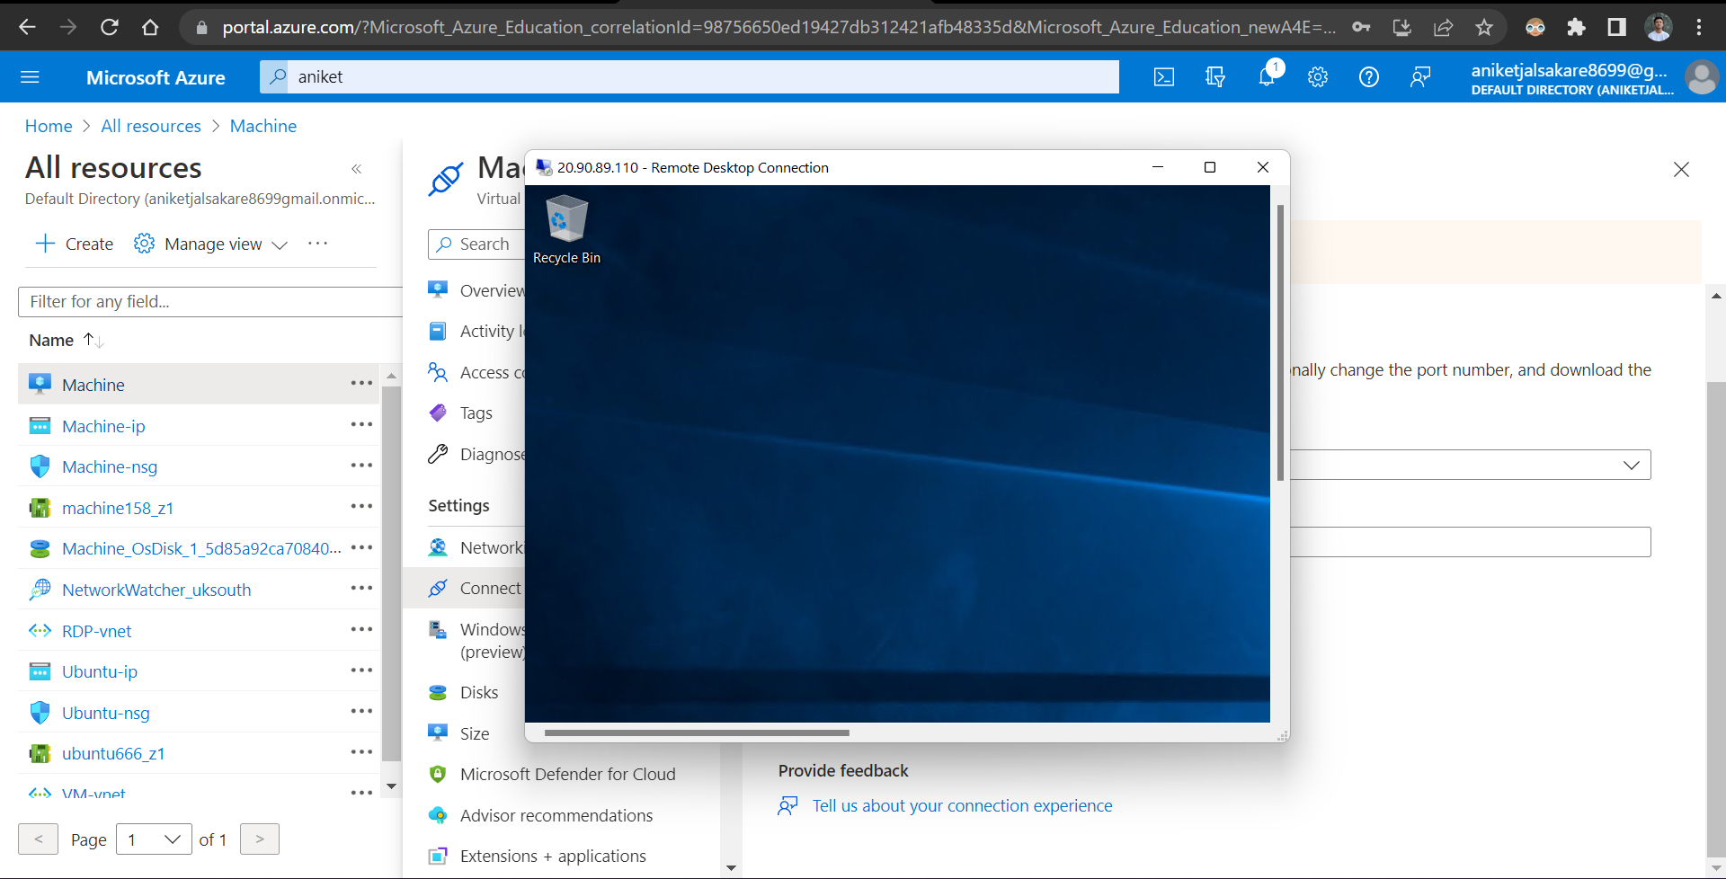

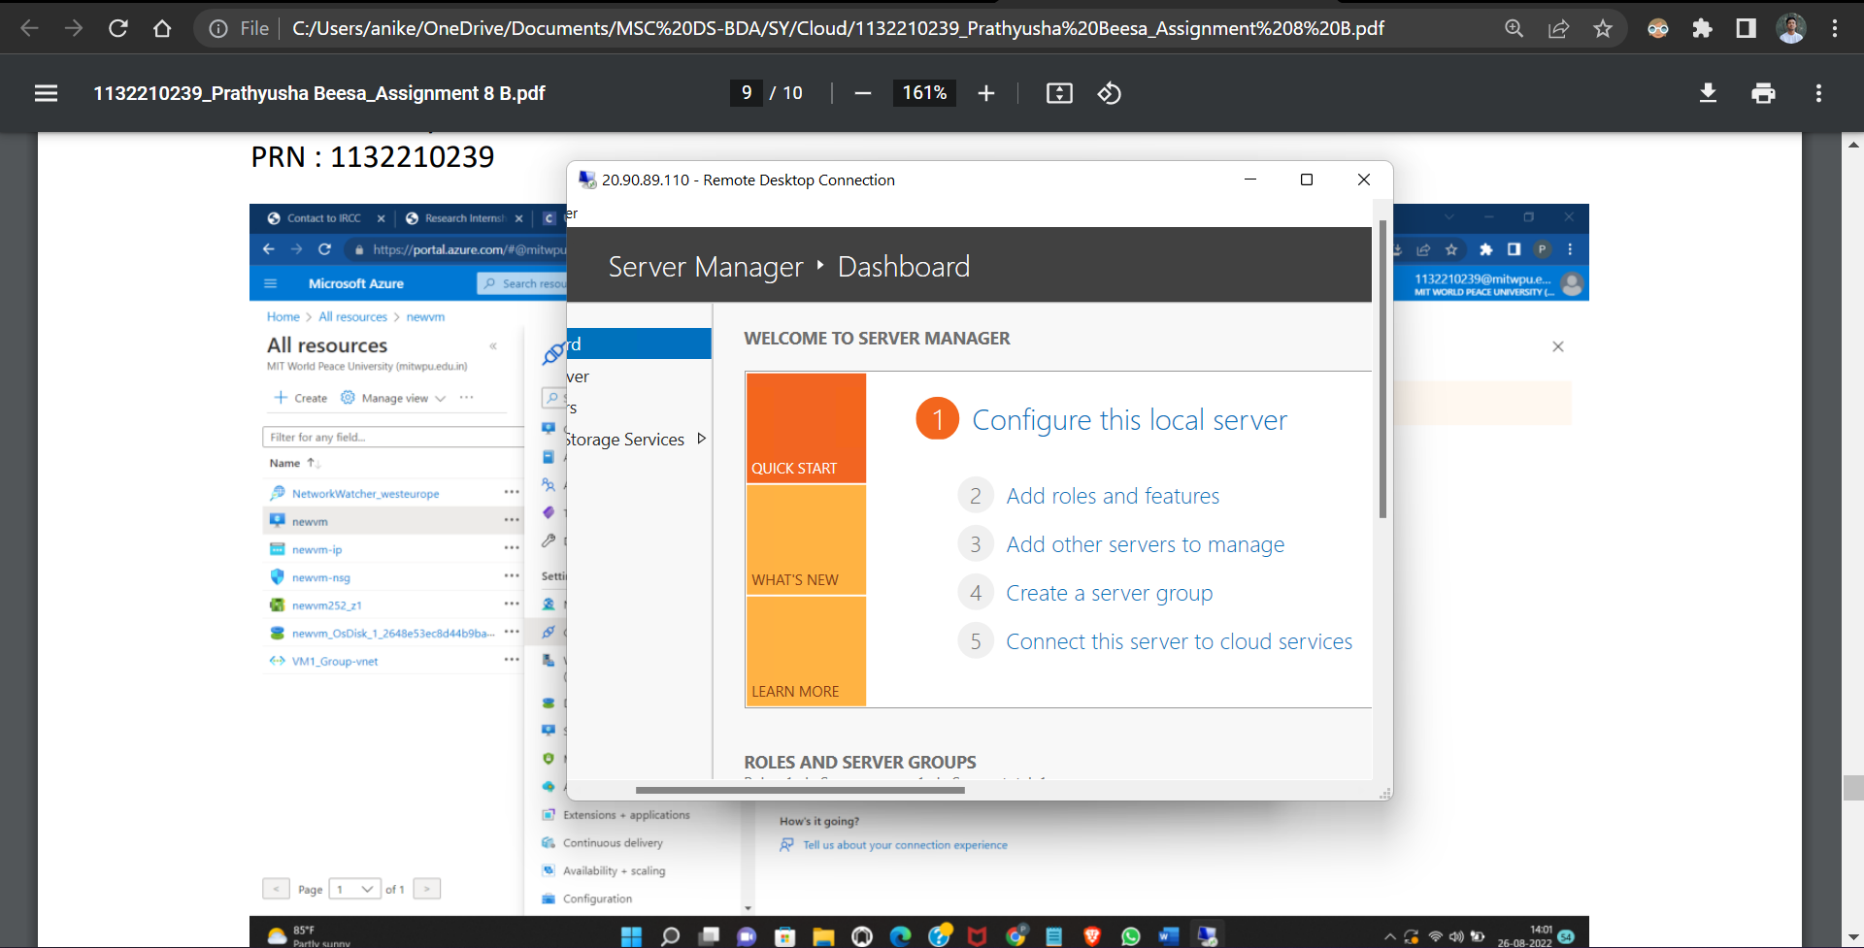

Browse & Install softwares from Internet.

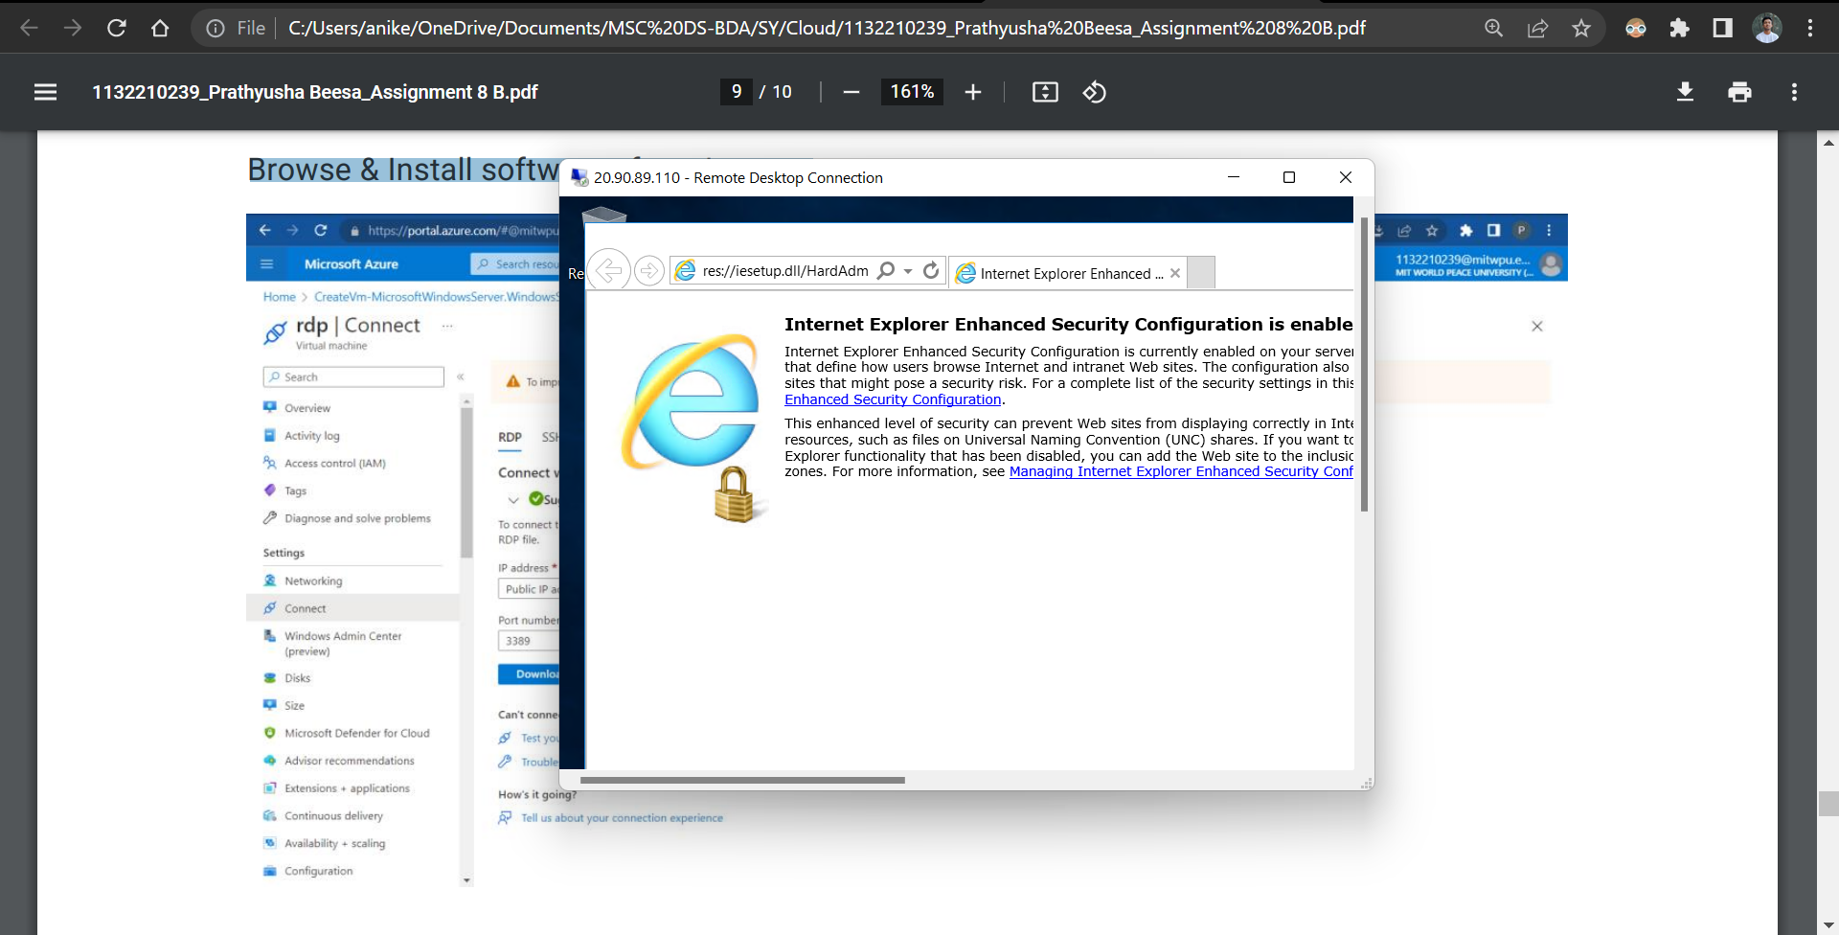

At Last, Go to ALL Resources TAB | SELECT & DELETE the resources.

