ChatMotion: Communication app with Machine Learning Hand Gesture
Daseco, Lejeune
Basila, Angel
Tuscano, Remmel
Gabanan, Mary Ann
Morales, Avrielle Joy

ChatMotion is an innovative communication web application that uses machine learning–powered hand gesture recognition to enable users to interact, send commands, and communicate more naturally. By translating hand movements captured through a device camera into meaningful actions or messages, ChatMotion enhances accessibility and creates a more intuitive way of interacting with a digital platform.

- People with speech or hearing impairments — offering an alternative way to communicate using hand gestures.
- Students and educators — enabling interactive classroom communication or presentations.
- Professionals — for hands-free controls during meetings, multitasking, or hands-busy work environments.
- General users — anyone seeking a modern, gesture-based communication interface.

ChatMotion focuses on recognizing hand gestures through machine learning and converting them into predefined actions such as sending text messages, triggering commands, navigating UI components, or selecting features inside the app. It acts as a bridge between human gestures and digital communication, making interaction more natural and efficient.

ChatMotion: User Manual Procedure
Step 1: Open the App and Prepare
- Launch the ChatMotion app.
- Select a contact or chat session you wish to communicate with.
- Hold your hand into view of the device’s camera. The app will usually show a small live video feed or a hand outline to guide you.
Step 2: Make the Gesture
- Form the hand gesture you want to use (ex. Making a thumbs up)
- Hold the gesture steady for a moment (usually three seconds)
*The app is watching your hand and trying to figure out the gesture.
Step 3: Confirm the action
- Look at the screen. As you hold the gesture, the corresponding text or action command will appear near the bottom of the screen.
*Example: If you make a “thumbs up”, the word “Yes” will appear. If you show your “palm” the word “Hello” will appear. If you show a “folded hands” the word “Please” will appear.
- Wait for the action to execute. The app automatically takes the action assigned to the gesture.

DOCUMENTATION
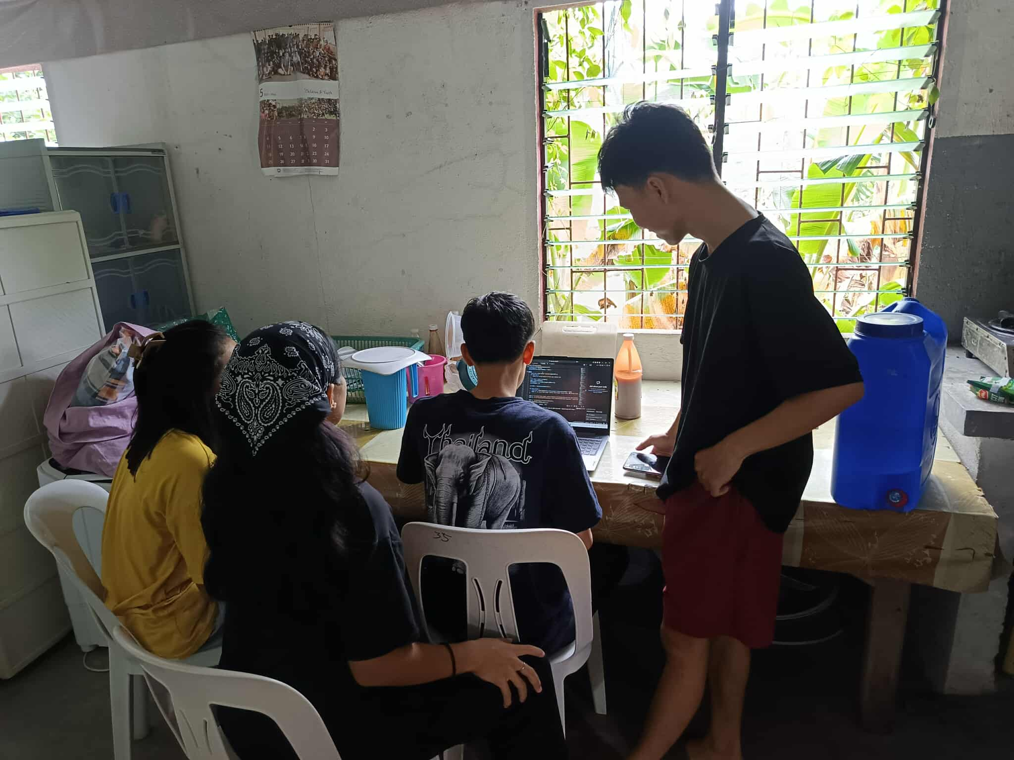
November 15, 2025

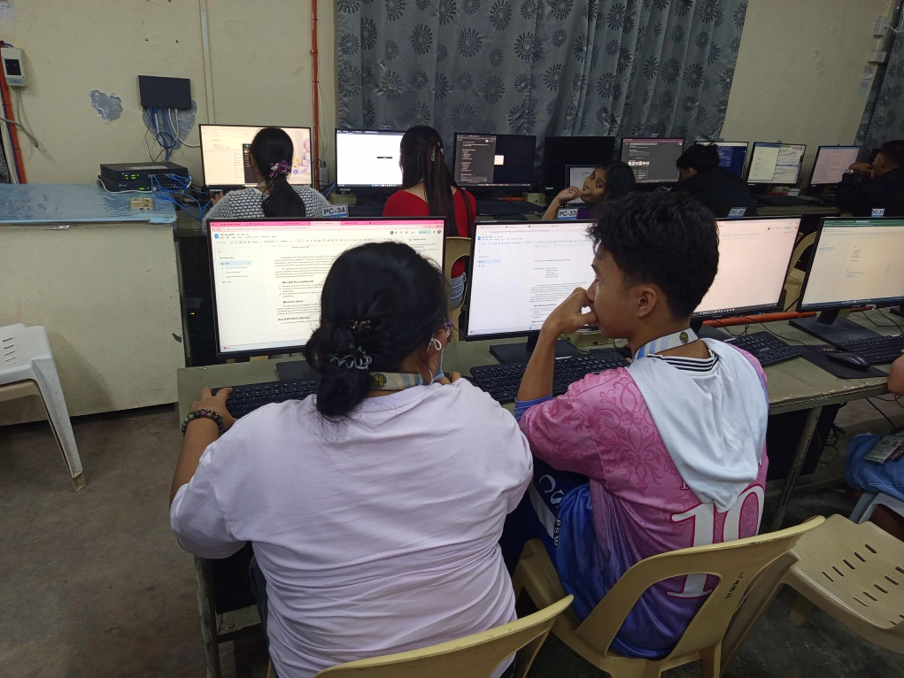
November 22, 2025

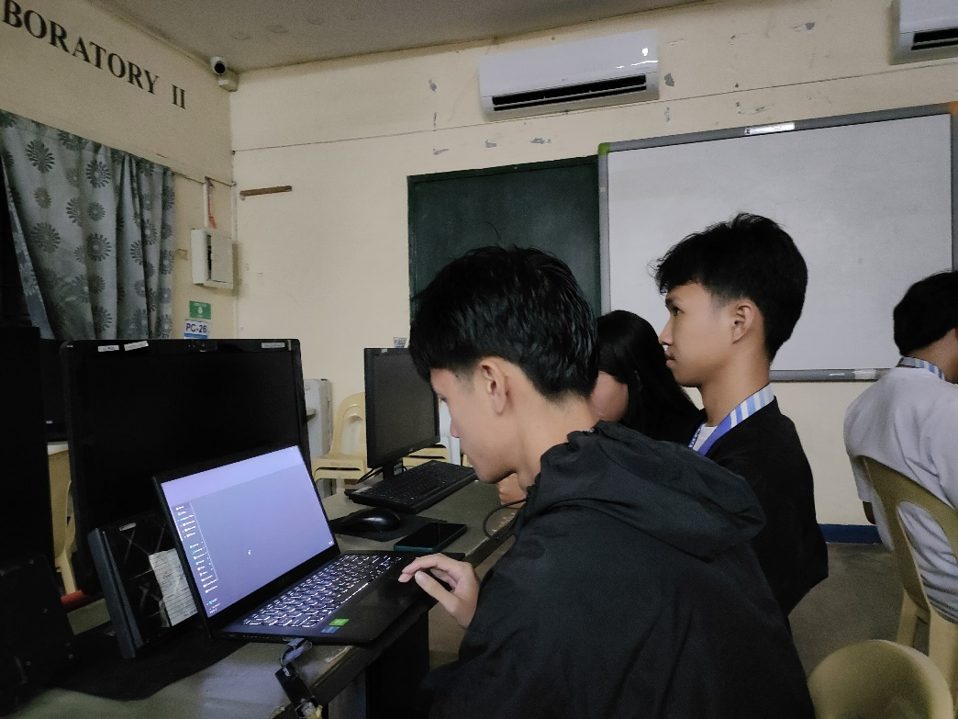
November 29, 2025

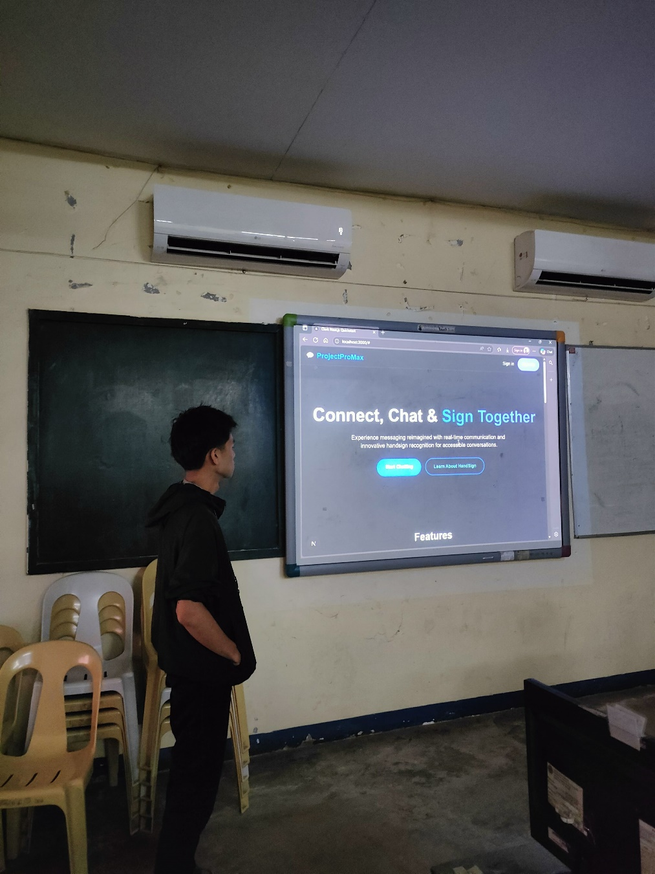

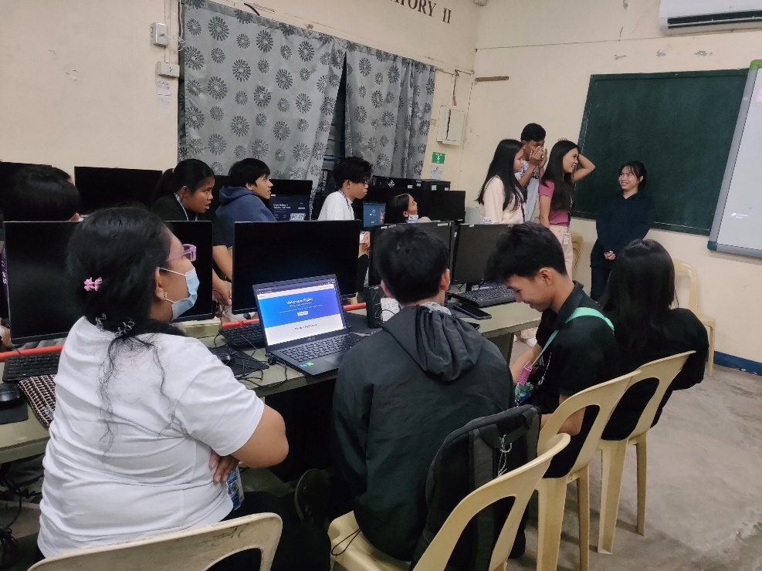
December 06, 2025

