Tactile Maps Data Pipeline
This project turns an overhead video of a blind or visually-impaired (BVI) participant exploring a printed tactile map into structured timing data: how long they spent on the map, which rooms and symbols they touched, for how long, how many times, in what order, and with which hand. It runs on every session video in the study with no per-participant or per-map tuning, and flags any run whose tracking needs a human check.
For per-function developer reference see documentation/CODEBASE.md; for the full write-up with evaluation numbers see documentation/PROJECT_WRITEUP.md; for an interactive diagram open documentation/architecture.html.

1. What Tactile Maps Are
A tactile map is a floor plan read by touch instead of by sight. Walls and corridors are printed as raised lines; landmarks such as stairs, elevators, restrooms, doors, reception desks and hazards are printed as raised symbols; and larger regions (a corridor, a dangerous area) can be filled with a raised texture such as dots, dashes or diagonal hatching. A legend explains what each symbol means, the same idea as a sighted floor plan's key, felt instead of read.
The maps in this study are printed on standard US Letter paper (8.5 × 11 in) using swell-form (raised-line) printing. Every map is a building floor plan of roughly 8–12 rooms around a central corridor, with symbols placed in rooms and on walls.
Designing good tactile symbols is an open research question: which raised shape should mean "elevator", which should mean "emergency exit", and does a given shape get recognised on the first pass or confused with its neighbours? That can only be answered with user studies, and this pipeline is the measurement tool for one.

1.1 The symbol legend
The study's legend has 32 entries, grouped by the referent (the real-world thing a symbol stands for). It lives in legends/symbol_legend.json, with one image per symbol in legends/symbols/<code>.png and the printed reference sheets in legends/symbol_legend_1.png … _3.png. Each entry has a numeric ID, a short code (used in file names), a referent, a plain-language description of its raised shape, and a placement:
- free: a stand-alone mark inside a room (a letter "E", a star, a triangle).
- wall: a mark drawn on a wall line, marking a door or exit (a circle on the wall).
- gap: a break in a wall line (a plain doorway).
- area: a texture filling a whole room (dashed lines, rows of dots, hatching).
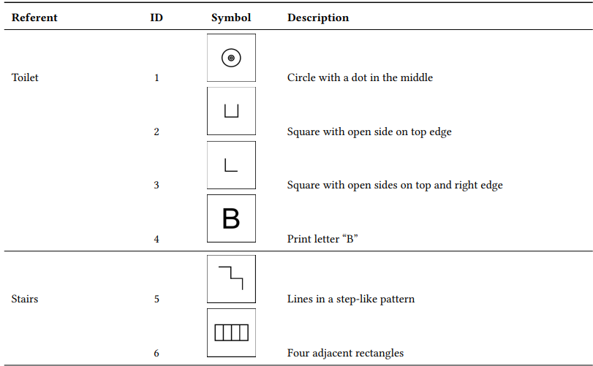
One page of the printed legend (legends/symbol_legend_1.png). symbol_identification.py cuts its matching templates from these pages automatically.
ID | Code | Referent | Description | Placement
1 | P9 | Toilet | Circle with a dot in the middle | free
2 | P26 | Toilet | Square with open side on top edge | free
3 | P34 | Toilet | Square with open sides on top and right edge | free
4 | B | Toilet | Print letter "B" | free
5 | Stair | Stairs | Lines in a step-like pattern | free
6 | P7 | Stairs | Four adjacent rectangles | free
7 | P35 | Stairs | Rectangle | free
8 | S | Stairs | Print letter "S" | free
9 | P54 | Elevator | Two adjacent rectangles | free
10 | P72 | Elevator | Top half of two adjacent rectangles | free
11 | E | Elevator | Print letter "E" | free
12 | P27 | Elevator | Square with open side on right edge | free
13 | P6 | Door / Emergency exit | Circle | wall
14 | gap | Door / Emergency exit | Gap or break in wall | gap
15 | P95 | Door / Emergency exit | Gap or break with vertical lines | wall
16 | P99 | Door / Emergency exit | Four dots in a cross-like pattern | wall
17 | P29 | Door / Emergency exit | Square with open side on bottom edge | wall
18 | P48 | Door / Emergency exit | Circle with horizontal line through center | wall
19 | P48_flipped | Door / Emergency exit | Circle with vertical line through center | wall
20 | P10 | Dangerous / Inaccessible area | Cross | free
21 | P17 | Dangerous / Inaccessible area | Triangle | free
22 | P98 | Dangerous / Inaccessible area | X | free
23 | P42 | Dangerous / Inaccessible area | Diamond | free
24 | P47 | Dangerous / Inaccessible area | Circle with diagonal line through center | free
25 | A10 | Dangerous / Inaccessible area | Area filled with diagonal lines | area
26 | L4 | Corridor | Dashed line | area
27 | A9 | Corridor | Diagonal lines | area
28 | A11 | Corridor | Horizontal dots | area
29 | A11_staggered | Corridor | Diagonal dots | area
30 | R | Reception | Print letter "R" | free
31 | P41 | Reception | Star | free
32 | P11 | Reception | Square | free

2. How Participants Interact With a Map

2.1 Reading a map by touch
A participant explores the page with their fingertips, usually the index finger of one or both hands. They trace raised lines to find walls and corridors, sweep across open areas, and pause on raised marks to work out what they are. Some symbols are recognised instantly; others are traced two or three times before the reader is sure.
Exploration is not a clean scan. Readers sweep, backtrack and revisit a spot to double-check it, building a mental model of the space from touch alone. A common two-handed strategy is to anchor one finger on a known landmark as a reference point while the other hand searches. That is exactly what this project measures: not only whether a participant eventually finds something, but how long it takes, how many passes it takes, which hand did the work, and which symbols or layouts cause the most backtracking.

2.2 The study protocol
- 20 participants, S-1 to S-20.
- 9 referents, one session each: Corridor, Door, Emergency Exit, Stair, Elevator, Bathroom, Inaccessible Area, Dangerous Area, Reception.
- For each referent, the participant first chose the symbol they preferred from the legend's options for that referent (recorded in column B of the study's Results sheet).
- The session for that referent then uses a distractor floorplan built around the chosen symbol: distractor_floorplan_<code>.png. Each floorplan contains the target symbol three times, mixed in among other (distractor) symbols, and the participant is asked to find all of them by touch. Map E, for example, has three "E" (elevator) symbols.
- A camera looks straight down at the table and records the whole session, from before the map is placed until the participant finishes.
- Planned sessions: 20 × 9 = 180. 178 videos exist; S-13's Stair and Reception sessions were recorded but never uploaded.

3. The User Data

3.1 Dataset at a glance
Measure | Value
Session videos | 178 (all processed)
Total footage | 4.52 h, 487,244 frames
Video length | median 46 s, range 7.7 s – 14.3 min
Longest tasks (median) | Emergency 153 s, Door 98 s
Shortest tasks (median) | Elevator 33 s, Bathroom 35 s, Inaccessible 35 s
Floorplan PNGs | 34 in the repo, 30 used in the study
Rooms per map (auto-detected) | 8–12, median 11
Symbols per map (auto-detected) | 0–22, median 20 (the 0s are the corridor-pattern maps A9, A11, L4, where the target is an area texture)

3.2 The session videos (.mp4)
Each video is one participant's session for one referent, filmed from a fixed overhead camera (e.g. S-19_Elevator.mp4 is 1920 × 1080 at 29.97 fps). What a typical frame contains:
- the printed tactile map, at any rotation, often upside-down relative to the PNG, and sometimes face-down or off-camera at the start;
- a second sheet lying next to the map, which the pipeline must not confuse with the map;
- the participant's hands and forearms, frequently covering large parts of the page and several of its corners;
- the page sliding and rotating as it is explored, sometimes partly out of frame;
- varying lighting, skin tone, sleeves, jewellery, and other objects on the desk (phones, bottles).
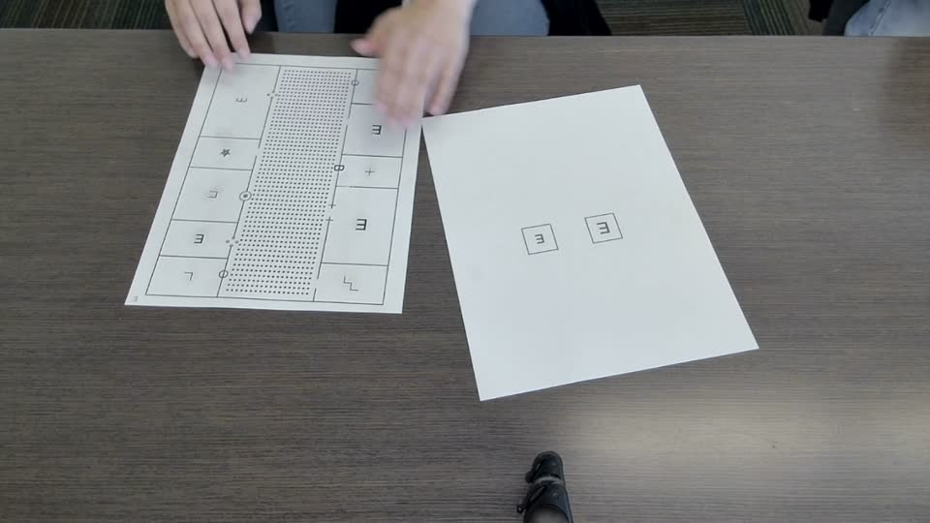
A real frame from S-19_Elevator.mp4 at 60 s: the map (left, rotated 180° relative to its PNG) with its dotted corridor, the second sheet (right), and the participant's hands.
Videos are not tracked in git because they are too large. The team's copies live on the lab Drive and are copied into mp4_user_data/ before a run.

3.3 The floorplan images (.png)
Each PNG in png_reference_maps/ is the exact digital source the printed raised-line map was made from. The pipeline uses it as ground truth for where every wall, room and symbol is. All are 816 × 1056 px, which is US Letter at 96 px/in, so 1 px = 1/96 in on the printed page.
- Walls are thin black lines; rooms are the white space they enclose; there are no room labels in the image. Rooms are found automatically.
- Symbols are drawn in black at the size they are printed.
- Area textures (dots, dashes, hatching) fill some rooms.
- Some Drive copies have a transparent background. The pipeline now composites any transparent PNG onto white automatically, so this no longer breaks tracing.
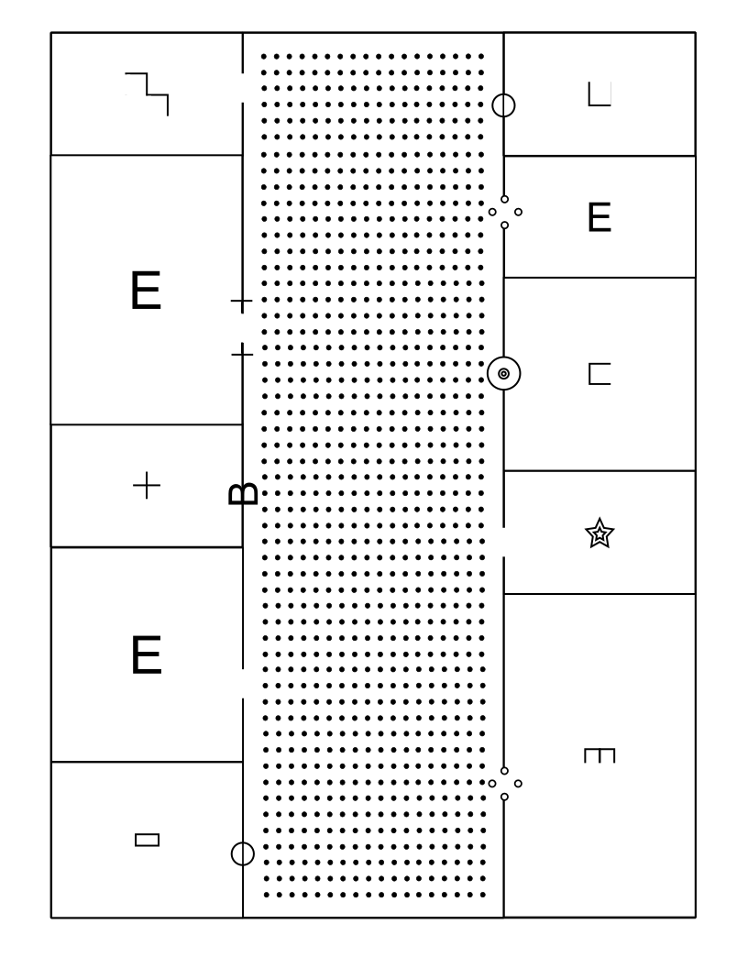
distractor_floorplan_E.png: the Elevator map built around legend #11 ("E"), with three E symbols among distractors and an A11 dotted corridor.

3.4 Other inputs
Input | Location | What it is
Symbol legend | legends/symbol_legend.json, legends/symbols/<code>.png | The 32 legend entries (§1.1) and one template image per symbol
Hand model | hand_landmarker.task | Google MediaPipe Hand Landmarker model (21 landmarks per hand)
Video → map pairing | PAIRS in loop_pipeline.py | Which PNG goes with which video, taken from column B of the Results sheet
Manual corners (optional) | manual_corners.json | Hand-placed paper corners for runs the tracker can't start on its own

4. Naming Conventions
Thing | Pattern | Example
Participant | S-<N>, N = 1–20 | S-19
Session video | S-<N>_<Referent>.mp4 | S-19_Elevator.mp4
Referent names in video files | Corridor, Door, Emergency, Stair, Elevator, Bathroom, Inaccessible, Dangerous, Reception | S-4_Inaccessible.mp4
Floorplan PNG | distractor_floorplan_<legend code>.png | distractor_floorplan_P48_flipped.png
Legend symbol image | legends/symbols/<legend code>.png | legends/symbols/P48_flipped.png
Run output folder | data/<YYYY-MM-DD_HH-MM-SS>__<map name>__<video name>/ | data/2026-10-28_05-25-36__distractor_floorplan_E__S-19_Elevator/
Room | Room <n> (numbered by detection order) | Room 6
Symbol | <referent> #<legend ID>, repeats numbered in reading order | Elevator #11, Door / Emergency exit #14 (1)
Room with a symbol or pattern | <symbol> (<room>) | Stairs #5 (Room 1), Corridor #28 (Room 6)

Legend codes come in a few forms: P-numbers (P9, P48) are pictogram IDs from the symbol set, A-codes (A9, A10, A11) are area textures, L4 is the dashed-line texture, and single letters (B, E, R, S) are print letters.

Known quirks in the data
- S-1_EmergencyExit.mp4 is the one Emergency video not named …_Emergency.mp4.
- S-13 has no Stair or Reception video (never uploaded), so there are 178 videos, not 180.
- Several map files exist in two versions: P29 vs doors_P29, A9 vs corridor_A9, and A11 vs A11_staggered. The pairing used for each is a best guess, documented in png_reference_maps/README.md, and should be confirmed against the Results sheet.
- Four PNGs in the repo (34 total) are not used by any session; 30 are.

5. What Data We Are Extracting
The pipeline answers the questions a researcher would otherwise answer by scrubbing through every video with a stopwatch:
- How long did the participant spend on the map at all?
- Which rooms and symbols did they touch, how many times, and for how long?
- Did they find all three target symbols, or brush past or miss some?
- In what order did they move through the rooms, including revisits?
- Did they use one hand or both, and what did each hand do?
- Did the paper move during the session?

Definitions used throughout
Term | Meaning
Interaction time | Total time at least one index fingertip was on the map. A plain stopwatch: no grace period, no minimum.
Visit | A contact with a room or symbol lasting ≥ 1 s. It starts on the first frame a fingertip is inside and ends once no fingertip has been inside for 0.4 s (bridging brief MediaPipe dropouts). Two hands inside at once count as one visit.
Brush | A contact shorter than 1 s: a finger passing over.
Status | Each room/symbol ends as visited (≥ 1 visit), brushed (touched, never a full visit) or missed (never touched).
Per-hand time | The same timer run on the left or right index fingertip alone. Left + Right can exceed the combined time, because overlap is counted once in the combined timer.
Entrance symbol | A wall-mounted symbol (door / exit). Timed over its own zone and attributed to the room(s) it leads into.

Everything is measured in the PNG's own pixel coordinates, so a room or symbol is the same region in every frame regardless of camera angle or paper motion, and pixel sizes convert directly to inches.

6. Pipeline Steps
run_pipeline.py <video> <map> processes one session in five stages. Stage 1 runs once per run; stages 2–4 run on every video frame; stage 5 runs at the end. Two principles drive the design:
- One coordinate system. Once the four paper corners are known in a frame, a homography maps any frame pixel to a PNG pixel. The homography is rebuilt from scratch every frame, so error never accumulates.
- The printed lines verify the crop. A candidate crop is accepted only if the ink seen in the frame, warped into PNG space, lines up with the ink in the PNG. That single scoring rubric chooses the orientation, rejects the second sheet and the blank back of the page, and grades every frame.
INPUTS floorplan PNG video hand_landmarker.task
STAGE 1 edge_tracing -> room_tracking -> symbol_identification (once) -> map.json
STAGE 2 auto_crop: paper_locator, corner_fitting, crop_checker, paper_model (every frame)
-> 4 corners -> homography H (frame px -> map px)
STAGE 3 finger_tracking: MediaPipe index tips -> map px, Left/Right (every frame)
STAGE 4 timing + SymbolTiming: map, room, symbol, entrance, per-hand timers (every frame)
STAGE 5 data_export -> summary.csv, room_order.csv, corner_motion.csv, ... (end of run)

Stage 1: Understand the map (once per run)
paper_locator.ReferenceMap loads the PNG and builds everything later stages need, saved as map.json in the run folder.
- Load and flatten. Transparent PNGs are composited onto white.
- Ink mask (edge_tracing.py). Morphological black-hat with a 9 px kernel highlights thin dark strokes against white; a threshold of 30 grey levels marks ink. Black-hat ignores slow lighting gradients, so the same code works on the PNG and on camera frames.
- Classify ink by mark size. Each connected component is classed by its extent: dots ≤ 12 px, walls ≥ 80 px (≥ 40 px on video frames), symbols in between.
- Wall line graph. A Hough transform finds wall segments; segments within 3°, 4 px offset and 8 px gap are merged. Nodes are placed at line ends, corners and T-junctions (8 px tolerance), giving a graph of nodes and edges with length and angle.
- Find textured areas (texture_region). Wherever ink covers > 11% of a 41 px window over ≥ 4000 px, pulled 12 px back from surrounding walls, the region is marked as texture. Scoring and alignment ignore these regions (the camera blurs them into a grey smear).
- Detect rooms (room_tracking.py):
  - Seal doorways by thickening walls by a sealing width.
  - Every enclosed white region not touching the border and ≥ 0.2% of the map becomes a room seed.
  - A nearest-seed distance transform assigns every non-wall pixel inside the map outline to a room, so rooms reach back out to the real walls.
  - Each room is saved as a polygon with area, centroid, bounding box and size in inches.
  - The sealing width is chosen per map by choose_gap: 16 widths (1.5–9% of the map) are tried and the smallest giving the most common room count wins (map E: 33 px, 11 rooms).
- Find symbols (symbol_identification.py) by placement:
  - Free-standing: symbol-sized ink marks, minus textured areas.
  - Wall: erase straight wall runs ≥ 45 px (horizontal and vertical morphological opening); leftovers 10–80 px across are wall symbols.
  - Gap: along each wall line, a 10–70 px stretch with no ink. A gap and wall marks within 20 px are merged into one door.
- Recognise symbols. Each mark is skeletonised (Zhang–Suen), scaled into a 48 × 48 box preserving aspect ratio, and compared by chamfer distance to templates cut from the legend pages. Free symbols are compared upright (other rotations +1 px penalty, since orientation can change meaning, e.g. #2 vs #12). Wall symbols are rotated so their wall is horizontal and tried both ways round. Best match wins if ≤ 1.5 px, otherwise "Unknown symbol".
- Recognise area patterns (#25–29) by texture statistics: share of dots / dashes / lines, whether dots sit in rows or diagonals, and line thickness. Nearest legend pattern wins if within 0.5; the room is labelled with it (e.g. "Corridor #28 (Room 6)").
- Entrances. Each wall symbol records entrance_to (rooms it touches, minus the corridor) and an entrance_zone (the mark + 18 px) that its timer watches.
- Name each symbol <referent> #<legend ID>, numbering repeats in reading order. Names hand-edited in a previous run's map.json carry over to the next run of the same map.
- Precompute scoring tables: a distance transform per ink class and nearest-ink lookups for alignment, all excluding textured areas.
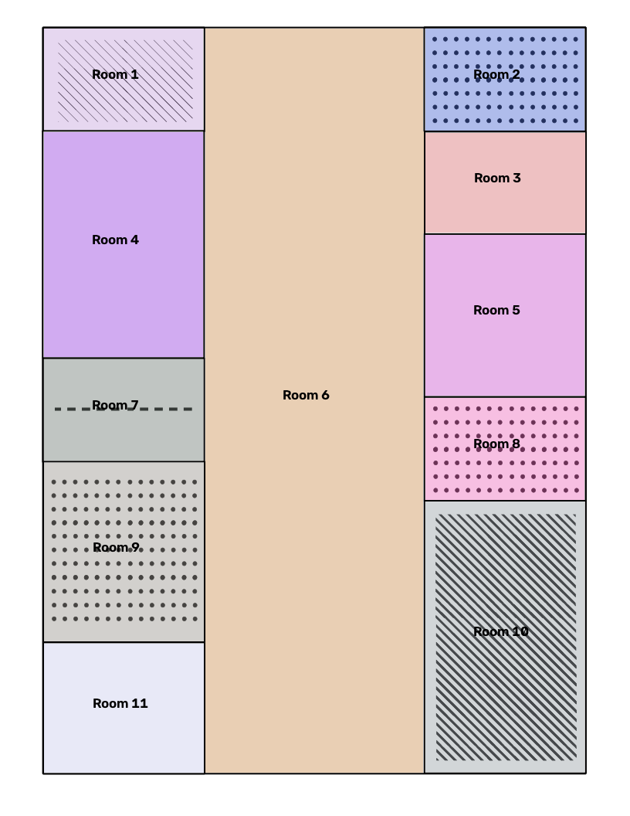
Automatic room detection on distractor_floorplan_A11.png. Each coloured region is one detected room; corridor textures are recognised as area-pattern symbols ("Corridor #28", "Dangerous / Inaccessible area #25").

Stage 2: Find and track the paper (every frame)
The output of this stage is the crop: the map's four corners in the frame, ordered as the PNG's top-left, top-right, bottom-right, bottom-left. Running order is in auto_crop.AutoCrop.update; image processing is in paper_locator, corner_fitting, crop_checker and paper_model.

2a. The scoring rubric (`paper_locator.alignment_score`)
- Warp the frame's traced ink into PNG space through the candidate homography.
- Classify warped ink into walls / symbols / dots using PNG-scale size thresholds.
- Per class, compare only against the PNG's ink of the same class with a 5 px tolerance: precision (traced near printed), recall (printed near traced), and F-β with β = 0.5 (precision weighted 2×, so occlusion costs little but misalignment costs a lot).
- Score = 0.4·F(walls) + 0.4·F(symbols) + 0.2·F(dots), renormalised if a class is absent. Textured areas are ignored; symbols and dots may stand in for each other (blur flips dashes between classes); printed pixels hidden by an occluder don't count against recall, and a class with < 15% of its pixels visible is skipped.
On S-19 (map E): correct orientation 0.98–0.99, rotated 180° ~0.40, rotated 90°/270° 0.10–0.14, the second sheet 0.03–0.04, blank back of page < 0.07. Thresholds: 0.60 to first lock or recover, 0.40 per frame once tracking.

2b. Before first lock: whole-frame search (`AutoCrop.locate`, every 10th frame)
- Paper mask: Otsu brightness split minus colourful (skin-like) pixels, plus a second mask from the paper's learned colour.
- Candidate outlines: each paper blob is fit with a quadrilateral (Canny + Hough → four side lines → intersections). A side hidden under an arm is completed from the PNG aspect ratio at 0.85×, 1× and 1.15× its distance. More candidates come from clusters of traced walls (traced_map_quads), which works when the paper outline is broken or merged with the other sheet.
- Try all four orientations of each outline.
- Sanity checks (check_quad): corners within 25° of square, aspect within 35% of the PNG's, area ≥ 3% of the frame.
- Pre-score all candidates; refine the best three with ICP (2d).
- Lock if the best scores ≥ 0.60 and passes the outline check (2e); ≥ 0.75 if part of the map is off-frame.

2c. Paper model: what is covering the page (`paper_model.PaperModel`)
- Learn this video's paper colour: every 15 confirmed frames scoring ≥ 0.60, sample the crop's non-ink pixels (brightest half, trimmed to 3×MAD) in LAB and blend lightness median and a/b mean and spread, 25% new.
- Classify a pixel as paper if its a/b lies within 3.5σ of the paper colour and it isn't much darker. Skin separates on a* (paper 126–128, pale skin 138–142); dark sleeves and shadows fail the lightness test.
- Occluders = non-paper regions after an 11 px disc opening (removes thin printed strokes), dilated by an 8 px margin (hand outlines and shadows trace as long dark "walls").
- Drop ink on or along occluders before any candidate is fit or scored, and pass the visibility mask to the rubric. Runs at half resolution (~12 ms).

2d. After lock: per-frame tracking
- Trace near the paper only: edge tracing is limited to last frame's crop grown by 35%.
- Remove occluders using the paper model.
- Candidate A, line ICP (refine_with_traced_lines): up to 2,500 traced pixels are warped into PNG space and paired with the nearest printed wall/symbol pixel; the homography is re-fit with RANSAC (3 px). Pairing radii shrink over five rounds: 14 → 10 → 7 → 5 → 4 px. Dots are excluded (their regular spacing lets a shifted crop still fit).
- Candidate B, paper edges (only if A < 0.60): paper-blob edges are sorted into top/right/bottom/left using last frame's crop (±20°), sampled every 4 px, weighted by angle agreement, and fit with a Huber line (outliers beyond median + 4×MAD dropped). Sides are intersected into corners, snapped with cornerSubPix (ignored if it moves > 8 px), then ICP-refined. With three sides visible, the fourth comes from last frame's proportions.
- Check and judge every candidate: check_quad plus a jump limit (no corner moves > 8% of the frame diagonal per frame), the outline check, and the rubric. Best candidate ≥ 0.40 wins.
- Stabilise: if ≥ 2 corners are within 2 px of last frame, keep the old crop (keep_if_stationary); otherwise blend 65% new / 35% old.
- Outlier corner fix: if three corners moved ≤ 6 px and one moved ≥ 18 px (and ≥ 3× the others), predict the odd one from the other three.

2e. Outline check (`outline_agreement`)
On maps with evenly sized rooms, a crop shifted by exactly one room still lines walls up with other walls and scores 0.5–0.6. The outline check takes 160 samples around the crop border and compares brightness 8 px inside vs 8 px outside; inside must be ≥ 25 grey levels brighter. Correct crops with hands on the page score 0.81–0.82; one-room-off crops 0.47–0.57; threshold 0.65. Where there's no paper/desk contrast (map on top of the other sheet, sleeve over the edge), a failing crop is still accepted if the judgeable edge points pass and lines score ≥ 0.60, or, while tracking, lines score ≥ 0.75 and no corner moved > 2% of the frame diagonal. On the benchmark, 463 deliberately wrong crops scored at most 0.72, so neither bypass lets a wrong crop through.

2f. Recovery when nothing passes (in order)
- Shift search (shift_candidates, every 3 frames): traced walls and symbols in PNG space are cross-correlated with the PNG's over shifts up to ±35% using one FFT; the 5 strongest peaks each seed an ICP refinement.
- PNG backup (PngBackup): SIFT/ORB matching between frame and PNG near the last crop, MAGSAC homography. Needs ≥ 14 inliers, ≤ 3 px error, ≥ 3.5% coverage, area 0.65–1.55× last frame's, score ≥ 0.35 and the outline check.
- Optical-flow backup (FlowBackup): pyramidal Lucas–Kanade on up to 700 paper features, forward–backward error < 1.5 px, homography error < 2 px.
- Hold the last crop, with a whole-frame search every 10 frames in case the page was turned or slid under the hands.
Once found, the crop is never dropped: every remaining frame has a crop, either confirmed or held. If the page slides partly out of frame, tracking continues while ≥ 35% of the map is visible; off-frame corners are placed by ICP, the remaining edges, or the backups.

2g. Source labels
Every frame records how its crop was obtained. These labels drive the quality metrics in tracking_quality.json.
Label | Meaning | Confirmed?
searching | Map not found yet | —
found | Whole-frame search locked on | yes
lines | Candidate A (line ICP on last crop) | yes
edges | Candidate B (paper-edge fit) | yes
realigned | Shift search | yes
PNG | SIFT/ORB backup | yes
manual | Corners placed by hand | yes
flow | Optical flow only | no
held | Last crop kept | no

Stage 3: Finger tracking (every frame)
finger_tracking.FingerTracker:
- Crop and enlarge: crop the frame around the paper with 22% horizontal / 30% vertical margins (so incoming arms are included) and upscale up to 2.5× (~1280 px max). Small hands are the usual reason MediaPipe misses one.
- Detect: MediaPipe Hand Landmarker in VIDEO mode, up to 2 hands, low thresholds (detection 0.25, presence 0.25, tracking 0.35). Keep the index fingertip (landmark 8) of each hand.
- Project: crop px → frame px → map px through this frame's homography. Flag on_paper if inside the map; ignore tips more than 50% of the map size outside it.
- Stable identities: match hands to last frame's by wrist position, solving both jointly (most matches, then least total movement; a jump > 200 px is a new hand). Left/Right comes from a fading, confidence-weighted memory of MediaPipe's own handedness (70% kept per frame); two visible hands always get different labels. On S-19, MediaPipe's raw labels were right for 3588 of 3592 two-hand detections.
- Trails are drawn per hand (left red, right blue) and broken at gaps and jumps > 140 px.

Stage 4: Timing visits (every frame)
timing.Timing, extended by symbol_identification.SymbolTiming, steps one timer per region every frame:
Timer | Region | Rule
Map interaction (InteractionTimer) | Whole map | Runs on every frame ≥ 1 fingertip is on the map; pauses otherwise
Room | The room's exact pixels (one array lookup in the room-label image) | Visit rules (§5)
Symbol | Symbol bounding box + 6 px | Visit rules
Entrance symbol | Mark + 18 px (entrance_zone) | Visit rules

Every timer runs three times: once on both fingertips, once on the left only, once on the right only. At the end of the video (or on q), open visits are closed.

Stage 5: Export (end of run)
data_export.save_data_files writes the run folder (§7). Every CSV is a single plain table that opens directly in Excel or Google Sheets. Times are plain seconds (12.34), because Sheets misreads M:SS.ss as a time of day.

Batch processing and quality control
Tool | Purpose
run_pipeline.py <video> <map> [--no-display] | One session. With a window: crop overlay (PNG lines in cyan), fingertips, live timers (t), trails and rooms (f), debug views (e, w); Space pauses to fix the crop by hand.
loop_pipeline.py | Runs all 178 pairs in PAIRS, each in its own process so one crash doesn't stop the batch; lists flagged runs at the end.
flag_runs.py | Writes data/flagged_runs.csv: map never found, finger on map < 50% of the video, or < 95% of the video processed.
place_corners.py / manual_crop.py | Step to a frame, drag the four corners, save to manual_corners.json; the next run starts from them.
benchmark.py | Regression test: 80 labelled frames from 10 videos, graded by mean corner error.
label_symbols.py | Optional: hand-draw extra symbol or room boxes.
dashboard.py | Legacy: rebuilds the old HTML dashboard from older runs. No longer part of the standard output.

Intended workflow: batch everything → flag → fix flagged runs by hand → re-run only those.

7. Output Data
Each run creates one folder. The timestamp comes first so folders sort chronologically; re-running a video creates a new folder and never overwrites.
data/<YYYY-MM-DD_HH-MM-SS>__<map name>__<video name>/
data/2026-10-28_05-25-36__distractor_floorplan_E__S-19_Elevator/
File | Contents
summary.csv | Per-room and per-symbol visits and time, overall and per hand, plus room size in inches
room_order.csv | Every room visit in time order, revisits included: the participant's path
corner_motion.csv | 4 samples/s: each paper corner's movement (frame px) and each index fingertip's position and movement (map px)
corner_motion.json | The corner motion vectors as one list per corner
finger_positions.json | Every frame's left and right index fingertip in map px (or null)
map.json | The map as understood: wall graph, rooms (polygons, sizes, patterns), symbols (names, legend IDs, match distances, boxes, entrances)
floorplan.png | Copy of the PNG used
finger_paths.png | Left (red) and right (blue) fingertip trails drawn on the floorplan
tracking_quality.json | Whether the run needs a human check, with reasons and per-source frame counts

7.1 summary.csv
One row for the whole map (Entire map, whose Room Time is the main interaction timer), one per room, then one per symbol that belongs to no room. Cells that don't apply are blank, not 0. Columns:
Group | Columns
Room symbol | Room Symbol, Room Symbol Visits, Room Symbol Time, Room Symbol Time (Left), Room Symbol Time (Right): the free-standing symbol(s) or area pattern in the room
Entrance symbol | Entrance Symbol, Entrance Symbol Visits, Entrance Symbol Time, … (Left), … (Right): the wall mark(s) leading into the room
Room | Room Visits, Room Time, Room Time (Left), Room Time (Right), Room Dimensions (width, height in inches)

Example (S-1, Corridor task, map L4, selected columns):
Room Symbol | Visits | Time | Left | Right | Room Time | Left | Right | Dimensions
Entire map |  |  |  |  | 70.07 | 66.30 | 60.06 | (8.5, 11)
Corridor #26 (Room 2) | 3 | 9.24 | 2.23 | 8.58 | 9.24 | 2.23 | 8.58 | (2.15, 1.38)
Corridor #26 (Room 10) | 5 | 26.99 | 3.34 | 26.56 | 26.99 | 3.34 | 26.56 | (2.15, 3.65)
Room 6 |  |  |  |  | 30.30 | 30.26 | 0.00 | (2.95, 10.03)
Room 11 |  |  |  |  | 0.00 | 0.00 | 0.00 | (2.16, 1.74)

Reading it: 70 s on the map; Room 10 (a dashed-line corridor) explored mostly with the right hand; Room 6 only with the left; Room 11 never visited.

7.2 room_order.csv
Order,Time Entered (s),Time Exited (s),Total Time (s)
Corridor #28 (Room 6),23.89,25.26,1.37
Stairs #5 (Room 1),25.32,30.73,5.41
...
Rows can overlap in time when the two hands are in different rooms.

7.3 corner_motion.csv
Frame #,Timestamp (s),TL dx,TL dy,TR dx,TR dy,BR dx,BR dy,BL dx,BL dy,
"Left Index (x, y)","Right Index (x, y)",Left Index dx,Left Index dy,Right Index dx,Right Index dy
Sampled 4×/s. Blank corner cells: map not found yet. Blank fingertip cells: that hand wasn't seen. Supports questions like "did the participant move the paper?" and "did they anchor one finger while sweeping with the other?"

7.4 finger_positions.json
[{"frame": 1, "t_ms": 33, "Left": null, "Right": null},
{"frame": 2, "t_ms": 67, "Left": [412.3, 588.1], "Right": null}, ...]
One entry per frame; positions are [x, y] in PNG pixels. Combined with the symbol boxes in map.json, this gives first-touch / time-to-find for any symbol.

7.5 tracking_quality.json
{ "status": "ok", "reasons": [], "first_found_s": 21.0,
"tracked_after_found": 0.929, "longest_unconfirmed_s": 6.5,
"frames": {"lines": 2523, "held": 195, "edges": 24, "realigned": 2,
"flow": 1, "found": 1, "searching": 629} }
status is "check" if the map was never found, fewer than 70% of frames after first lock were confirmed, or the crop went unconfirmed for more than 10 s at a stretch.

7.6 finger_paths.png
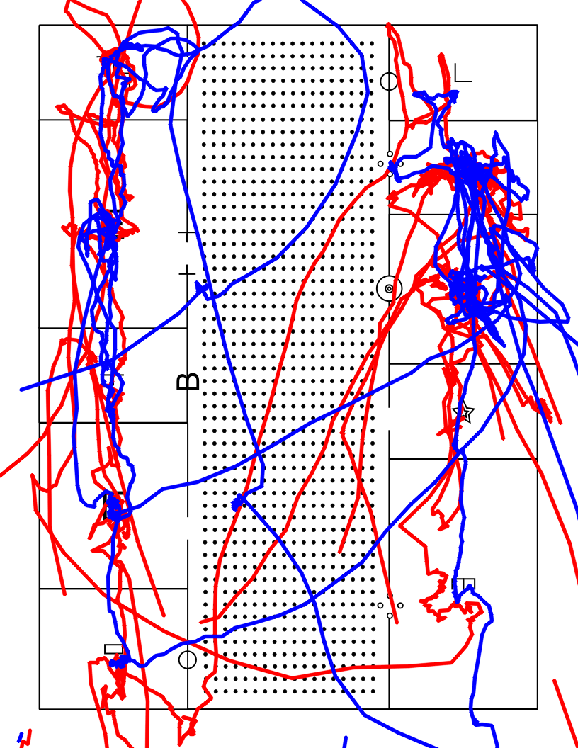
Real output from S-19_Elevator on map E: left (red) and right (blue) index-fingertip trails in PNG coordinates. Dense clusters are the spots the participant stopped to read.

7.7 Google Sheets import
google_sheets/import_run.gs is an Apps Script that adds a Tactile Maps → Import run CSVs… menu to a Sheet. Pick the whole data/ folder or individual runs; it creates one tab per run named <map> - <video>, with summary.csv, room_order.csv and corner_motion.csv side by side as native Sheets tables. It imports one run per server call to stay within Apps Script's 6-minute limit, and reads whatever columns each CSV has, so export-format changes need no script changes.

8. Current Results and Limitations
Measure | Result (all 178 sessions, runs dated 26–28 Oct 2026)
Runs completed | 178 / 178
Passed automatic quality check | 160 (89.9%)
Flagged for human check | 18 (10.1%); 4 never found the map: S-1_Door, S-3_Stair, S-11_Corridor, S-15_Corridor
Time to first find the map | median 1.8 s (max 84.7 s)
Frames confirmed after first lock | median 100%, mean 94%
Crop source across all frames | lines 83.8%, searching 7.0%, held 5.0%, edges 2.8%, other < 1.5%
Crop benchmark (75 frames with map visible) | 72 correct, 2 missed, 1 wrong; median corner error ~3 px
Symbol recognition | 527 symbols found; 35 (6.6%) "Unknown"; target symbol recognised 3/3 on 25 of 30 maps
Speed | ~3–6 frames/s including MediaPipe (~10 min per 2-min video)

- Fingertip-to-room timings have not yet been validated against hand-coded timings.
- Only the index fingertip is tracked; palm or other-finger exploration isn't counted.
- Corridor-pattern maps (L4, A9, A11) are harder to lock because their only distinguishing print blurs on camera.
- Wall symbols and doorways are only detected on horizontal or vertical walls.
- Handedness assumes an unmirrored camera.
- Symbol first-touch time isn't in the CSVs yet (computable from finger_positions.json + map.json).
- Ctrl+C or a crash saves only map.json; press q to stop and save.
Next steps: validate timings against human coders on a sample of sessions, add time-to-find per target symbol to summary.csv, and aggregate per-referent / per-symbol comparisons across all participants.

