Antonio, Adrian John BSIT-MI181

Ebrada, Ismael

Wireframe

Step 1:

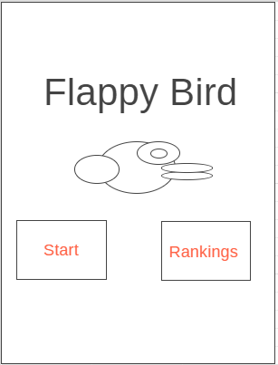

Step 2:

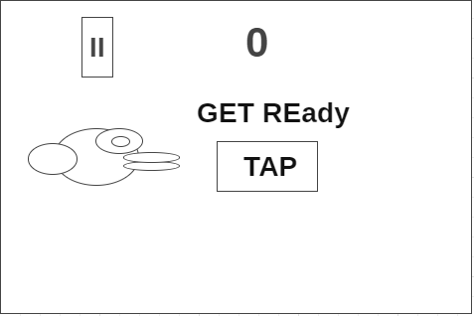

Step 3:

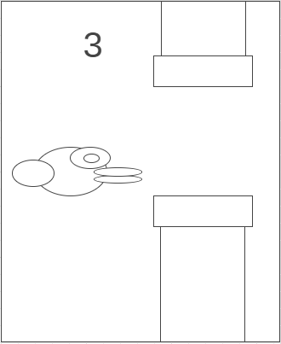

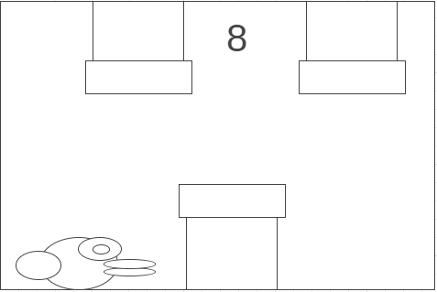

Step 4:

Step 5:

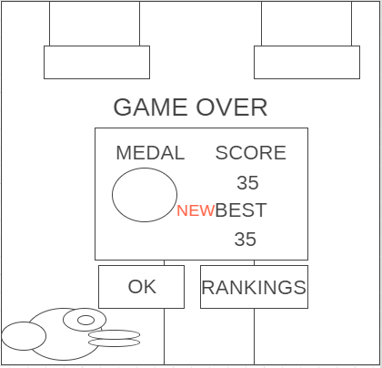

**Mockups and Prototype:**

What you’re seeing right now is the colored version of the flappy bird. If the user taps the play button. The user will proceed to the gameplay of the application *(See Figure 1.1)*. If, however, user taps the ranking button (The one that has 1, 2, 3 button), they will be transferred to the ranking interface *(See Figure 1.5)*

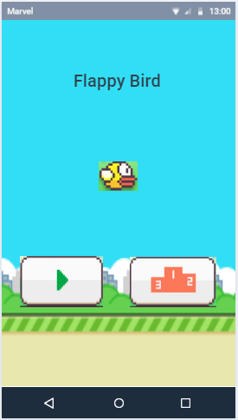

Figure 1.0

This is the gameplay of the application. The rules of this game is to prevent the bird from falling by tapping the screen of your phone, you will also need to cross between the green tunnels to get a score and survive.

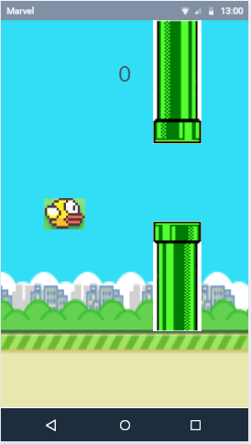 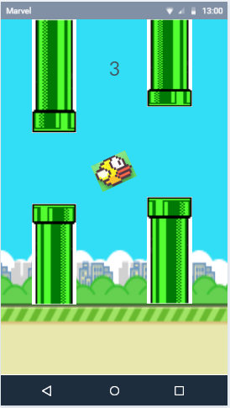

Figure 1.1

However, if the bird stumbled upon to the green tunnels, the game will result in gameover *(See Figure 1.3)*.

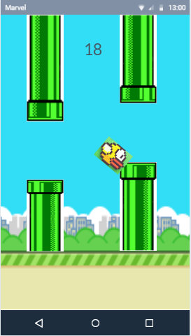

Figure 1.2

Despite the user lost, he/she can still play by clicking the play button, however, their score will start from zero. They can also click the rankings button to see who got the highest score and the lowest score.

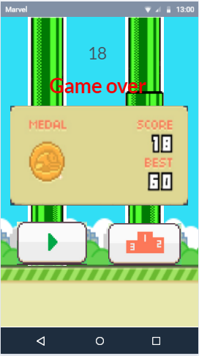

Figure 1.3

This is the ranking interface of the Flappy Bird. The user can tap the back button to go back to the game.

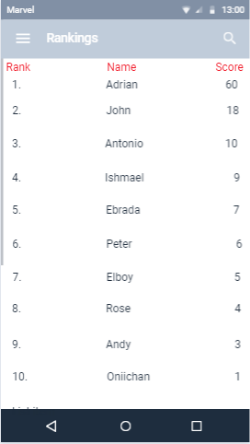

Figure 1.4

Used tools to make this happen:

[https://wireframe.cc](https://wireframe.cc/)

[https://marvelapp.com](https://marvelapp.com/)