
International Journal of Computer Sciences and Engineering Open Access
Research/ Review/Survey Paper Volume-5, Issue-8 E-ISSN: 2347-2693

A SURVEY ON ENERGY EFFICIENT TREE- BASED DATA AGGREGATION TECHNIQUES IN WIRELESS SENSOR NETWORKS

Nitu Elza John¹, Jyotsna A ²

¹ Department Of Computer Science and Engineering, Rajagiri School of Engineering and Technology ,Ernakulam.
² Department Of Computer Science and Engineering, Rajagiri School of Engineering and Technology ,Ernakulam

e-mail: nituelzajohn@gmail.com, jyotsnaa@rajagiritech.edu.in

Available online at: www.ijcseonline.org
Received: 00/…./2017, Revised: 00/…./2017, Accepted: 18/May/2017, Published: 30/Aug/2017
Abstract— Wireless Sensor Network consists of tiny sensor nodes for sensing and data processing. These sensor nodes have low memory and limited energy. A large amount of energy is consumed during transmission and reception of data. This leads to failure of sensor nodes. To overcome these limitations and to prolong the network lifetime different data aggregation techniques can be adapted. Through data aggregation, data can be aggregated and gathered at the sink node in an energy efficient manner. Data redundancies can also be eliminated and network lifetime can be increased. In this paper, a survey on energy efficient tree-based data aggregation techniques in wireless sensor network is discussed. In tree architecture, all nodes are organized in the form of a tree and can be adapted for continuous monitoring applications. Power Consumption is less during data transmission in a tree-based aggregation when compared to cluster or grid-based aggregation.
Keywords— wireless sensor network; data aggregation; network lifetime; energy consumption; tree based.

Introduction
There has been an increase in the use of wireless sensor network over the past few years. It can be used in the applications such as Military Applications, industrial monitoring, Health Applications, Air pollution monitoring, Water quality monitoring, Environmental Applications, Healthcare monitoring, Home Applications, Commercial Applications, Area monitoring, Forest fire detection, Landslide detection etc.

The wireless sensor networks are infrastructure less network and contain tiny sensor nodes which measure temperature, pressure, light intensity, humidity, motion etc. These sensor nodes are light weighted, low cost and low powered. Sensor nodes have sensing, data processing capabilities and convey the sensed data to the sink. The data sensed by these sensor nodes are transmitted to the base station where it can be further processed. The sensor nodes deployed in different locations, collect the data and routes to sink node. The routing can be done in a multi-hop fashion.

The sensor node consists of transceiver, microcontroller, external memory, power source and analog to digital converter. Figure 1 represents the architecture of sensor node. The microcontroller processes data and controls the other components in the sensor node. The transceiver includes a transmitter and a receiver in order to transmit and receive the packets. A large amount of energy is consumed during transmission and reception. The external memory includes the user memory for storing the user data and programming memory for programming the device.

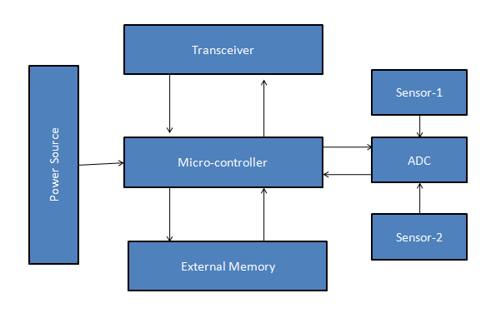
Figure 1: Sensor node architecture

A large amount of energy is consumed during transmitting and receiving the data. If any of the nodes fails it will affect the network topology. So rather than sending all the data packets directly to the sink node, it is better to combine the data packets before transmitting to the base station [10]. This can be done by introducing an intermediate node, whose duty is to collect all the sensed data from the sensor nodes and transmit to the base station. This results in energy conservation and increases the network lifetime. Thus data aggregation techniques can be adapted to collect the data.

Data aggregation is a process of collecting, gathering and aggregating the sensed data. The data collection is done in an energy efficient manner so that the network lifetime can be increased. There are different types of data aggregation techniques such as structured, structureless and other types of network [12].The structured aggregation requires specific architecture for performing data aggregation whereas the structure-less architecture does not require any structure. Structured network architectures include flat network, hierarchical network, location-based network etc.
In Hierarchical based data aggregation data is aggregated at the intermediate nodes before transmitting to the sink node. The hierarchical network includes cluster network, tree network etc.
In Cluster-Based data aggregation whole network is divided into different clusters. Each cluster will be having a cluster head. The cluster head aggregates the sensed data from the nodes within the clusters.
In Tree-Based Data Aggregation [15], all nodes are organized in form of a tree. The intermediate nodes collect data from the leaf nodes and transmit to the root node that is the sink node.
In Location based approach, the position of each sensor node is identified based on the location. The nodes location can be identified based on the incoming signal strength or by using the Global Positioning System.

TABLE 1: COMPARISON OF DATA AGGREGATION APPROACHES
Network type | Advantage | Limitation
Structure less | During node failure,  reconstruction of the  structure is not required | Difficult in making routing  decisions and  performing aggregation
Cluster and Tree | Energy  consumption can be reduced | Node recovery is difficult
Tree | During data transmission power Consumption is  less | Failure of intermediate node affects the topology

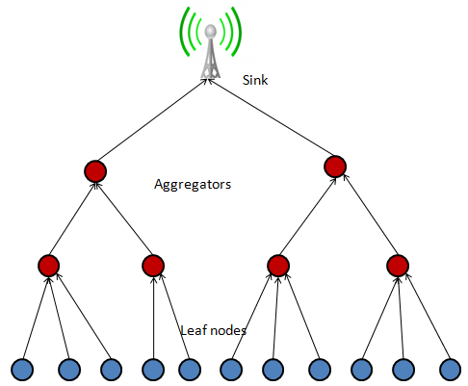
Figure 2: Tree based data aggregation in wireless sensor networks.
In this paper, a survey on energy efficient tree based data aggregation methods for wireless sensor networks is discussed. In tree based data aggregation all nodes are organized in the form of tree. The intermediate node gather and aggregate data sensed by the sensor nodes and transmits to the base station. This method reduces the energy consumption and increases the network life time. Power Consumption is less during data transmission in a tree based aggregation when compared to cluster or grid based aggregation. Figure 2 represents a tree based data aggregation.
The remainder of this study is organized as follows. Section II reviews different tree based data aggregation techniques. Section III concludes the study.

lITERATURE REVIEW

A Two-Tier Adaptive Data Aggregation Approach for M2M Group-Communication

In paper [1], propose a two-tier aggregation for multi-target applications (TTAMAs), where data aggregation is done in two phases. At first, it computes the network spanning tree containing all the nodes and later it prunes the spanning tree. Pruning is done to find the set of TTAMA trees. The network spanning tree uses prim's algorithm to find the minimum cost spanning tree. In Prim's algorithm each node will be considered as a single tree and new nodes can be added to the spanning tree.

The two-tier aggregation model includes two types of traffic group to aggregate the data from each node, Internal Group Traffic (IGT) and External Group Traffic (EGT). In Internal Group Traffic (IGT), the data is aggregated from nodes within the same group. For this data aggregation, TTAMA uses Constant Output Aggregation Functions (COAF), which aggregates data using mathematical functions such as Maximum, Minimum, Count, Sum and Average [6]. In External Group Traffic (EGT) the data is aggregated from nodes of a different group. For this data aggregation, TTAMA uses the Payload Merger Aggregation Function (PMAF) which merges payloads from a different group into single message [7]. The main aim of this data aggregation is to combine the data from different nodes during routing so that the amount of data can be reduced before it is transmitted to the sink node [8]. Data aggregation allows the devices to reduce the energy consumption in the communication process, by eliminating data redundancy [9].

Figure 3 represents a two-tier aggregation model. It includes two aggregation functions such as Constant Output Aggregation Functions (COAF) and Payload Merger Aggregation Function (PMAF).Here the first aggregation tier is performed within each group using COAF. In the second aggregation tier, it aggregates the External Group Traffic (EGT) using PMAF. The COAF output from different groups will be merged using PMAF.
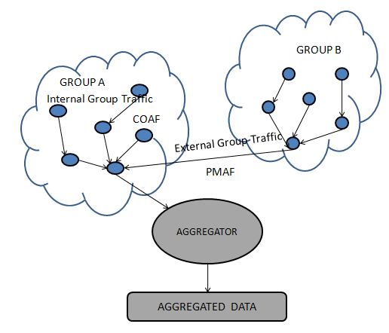
Figure 3: Two-tier aggregation model

Data aggregation using fitting functions

In paper [2], propose Tree-based data aggregation approach in wireless sensor network using fitting functions. In this paper, first data aggregation is done for the set of nodes and later fitting functions are used. During data aggregation, the data redundancy is checked. Similar data sets will be having a similarity greater than a given threshold and this similarity can be computed using Jaccard Similarity. This filtering is done to eliminate redundant data. The fitting functions are used to send the data parameters along with the function. Both aggregation and prefix filtering are done. Finally, data cleaning process is done in order to remove the outliers.

Tree-based Data Aggregation Mechanism (TDAM)

In paper [3], propose a Tree-based Data Aggregation Mechanism (TDAM) in wireless sensor networks, which includes a tree-based structure for aggregating data. Its main aim is to reduce the unnecessary power consumption and transmit the data in an energy efficient manner. TDAM includes three phases such as Sensor node building, Layer construction phase, and Data aggregation phase. Sensor node building phase includes a large number of sensor nodes and a sink node to receive aggregated data sensed by the sensor nodes. Sink node will be having more power when compared to other sensor nodes. Also, it is having more computing capability. Here in order to construct a tree network the hop count value is considered. The hop count value is the number of hops between the node and the sink. Sink becomes the root of the tree. During layer construction phase a network layer is constructed. Sink broadcast a Network Layer Construction Packet (NLCP) to all the other nodes within the tree network. At each node on receiving the NLCP compares its hop count value with that of the sink node. If the hop count value is less than or equal to the current node hop count value then it will be updated to the candidate information table and is broadcasted. Otherwise, it will drop the NLCP. Thus a layer is constructed. During data aggregation phase the sensed data is collected from the sensor node and is transmitted to the sink node. The path through which the data is to be aggregated and transmitted is determined by comparing the remaining energy of the candidate parent. Redundant is eliminated by using XOR function.

Cluster-based Minimal Spanning Tree (CMST)

In paper [4], propose An Energy Efficient Routing Scheme for Wireless Sensor Networks, which includes a two-layer hierarchical routing protocol. The routing protocol includes two phases, such as Cluster formation phase and Data transmission phase. During cluster formation phase, clustering is done using the set of nodes. Here the nodes are grouped into different clusters. Each cluster is having a cluster head, which aggregates the sensed data collected from the sensor nodes within the cluster.

The cluster formation phase can be done using LEACH (Low Energy Adaptive Clustering Hierarchy) algorithm. LEACH is a hierarchical routing protocol for Wireless Sensor Network. In LEACH algorithm, the sensor nodes form a cluster and each cluster will be having a cluster head. The cluster head routes the data to the sink node. In LEACH the cluster formation includes two phases: a setup phase and steady phase. During the setup phase, each sensor node generates a random number between 0 and 1. If the random number is less than a threshold, the node broadcast itself as a cluster head. All other nodes on receiving the broadcast will join the cluster head based on the signal strength. The nodes within one cluster will send an acknowledgment signal to the corresponding cluster head. During the steady phase, the nodes within each cluster send their data to the cluster head using a TDMA (Time Division Multiple Access) schedule. In TDMA schedule, it assigns time slots to each node. The nodes send their data during each time slot. The cluster head aggregates the sensed data from sensor nodes and sends it to the base station.

A tree network is formed using all the cluster head nodes. In order to send data to the cluster head Minimum Spanning Tree (MST) is being used so that the shortest distance can be selected. During data transmission phase, the token passing approach is done, where the head node passes the token to its neighbouring nodes. This continues until the head node receives the token back. When a token is received by the head node it collects all the information regarding the sensor node ID and the network topology. Finally, the head node executes a scheduling algorithm SHORT (Shortest Hop Routing Tree for Wireless Sensor Networks), in order to generate the communication pairs. This method increases the network lifetime and takes less time to complete each round. Figure 4 represents a token passing approach where node c is elected as the head node. Node C sends the token to all the other nodes. This process continues till the token reaches back to the head node.

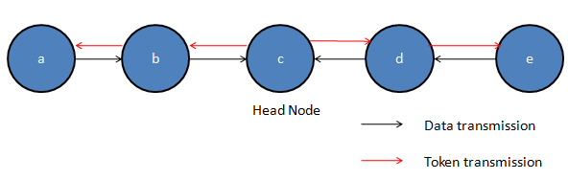
Figure 4: Token passing approach

Energy-efficient data collection protocol for wireless sensor network based on tree

In paper [5], propose an energy-efficient data collection protocol for wireless sensor network based on a tree (EEDCP-TB). Here the distribution of nodes within the wireless sensor network includes the forwarding nodes, the sensing nodes, and sink. Figure 5 represents the distribution of WSN nodes. The tree structure includes different layers. Layer 1 contains the sink node which collects all the sensed data. Layer 2 contains the forwarding nodes which acts as intermediate nodes and forwards the data from the sensor nodes to the sink node. Layer 3 contains the leaf nodes or the sensing nodes which monitors the environment and sends the sensed data to the forwarding nodes. This method includes two phases ie the establishment of data collection tree and the returning of sensing data. During the returning of the sensed data, the data from each node is aggregated and is forwarded to the sink node.
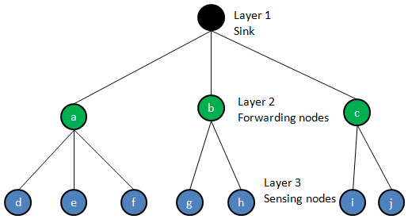
Figure 5: Distribution of WSN nodes

III CONCLUSION
A comprehensive survey on energy efficient tree based data aggregation is done. Since most of the energy is consumed during transmitting and receiving the sensed data, data aggregation has become an important issue. Data aggregation has played an important role in gathering and aggregating the sensed data and eliminating the redundant data. It reduces the network traffic and energy consumption and thus increasing the network lifetime and efficiency. Power Consumption is less during data transmission in a tree based aggregation when compared to cluster or grid based aggregation.

References
[1] Riker, André, Eduardo Cerqueira, Marilia Curado, and Edmundo Monteiro. "A two-tier adaptive data aggregation approach for M2M groupcommunication." IEEE Sensors Journal 16, no. 3 (2016): 823-835.
[2] Atoui, Ibrahim, Ali Ahmad, Maguy Medlej, Abdallah Makhoul, Samar Tawbe, and Abbas Hijazi. "Tree-based data aggregation approach in wireless sensor network using fitting functions." In Digital Information Processing and Communications (ICDIPC), 2016 Sixth International Conference on, pp. 146- 150. IEEE, 2016.
[3] Tsai, Chih-Hsiao, Hao-Yi Huang, Chih-Wei Hung, and Ying-Hong Wang. "TDAM: A Tree-based Data Aggregation Mechanism in wireless sensor networks." In Intelligent Signal Processing and Communications Systems (ISPACS), 2012 International Symposium on, pp. 827-832. IEEE, 2012.
[4] Liang, Chiu-Kuo, Yu-Jie Huang, and Jian-Da Lin. "An energy efficient routing scheme in wireless sensor networks." In Advanced Information Networking and Applications Workshops, 2008. AINAW 2008. 22nd International Conference on, pp. 916-921. IEEE, 2008.
[5] Jin, Yong-xian, Feng-zhen Chen, Gao-feng Che, and Wei Hu. "Energyefficient data collection protocol for wireless sensor network based on tree." In Wearable Computing Systems (APWCS), 2010 Asia-Pacific Conference on, pp. 82-85. IEEE, 2010.
[6] Boulis, Athanassios, Saurabh Ganeriwal, and Mani B. Srivastava. "Aggregation in sensor networks: an energy–accuracy trade-off." Ad hoc networks 1, no. 2 (2003): 317-331.
[7] Di Stasi, Giovanni, Jonas Karlsson, Stefano Avallone, Roberto Canonico, Andreas Kassler, and Anna Brunstrom. "Combining multi-path forwarding and packet aggregation for improved network performance in wireless mesh networks." Computer Networks 64 (2014): 26-37.
[8] J. N. Al-Karaki, R. Ul-Mustafa, and A. E. Kamal, “Data aggregation and routing in wireless sensor networks: Optimal and heuristic algorithms,” Comput. Netw., vol. 53, no. 7, pp. 945–960, 2009.
[9] J. He, S. Ji, Y. Pan, and Y. Li, “Constructing load-balanced data aggregation trees in probabilistic wireless sensor networks,” IEEE Trans. Parallel Distrib. Syst., vol. 25, no. 7, pp. 1681–1690, Jul. 2014.
[10] R. Kacimi, R. Dhaou, and A.-L. Beylot, “Load balancing techniques for lifetime maximizing in wireless sensor networks,” Ad Hoc Netw., vol. 11, no. 8, pp. 2172–2186, 2013.
[11] D. Luo, X. Zhu, X. Wu, and G. Chen, “Maximizing lifetime for the shortest path aggregation tree in wireless sensor networks,” in Proc. IEEE INFOCOM, Apr. 2011, pp. 1566–1574.
[12] Sasirekha, S., and S. Swamynathan. "A comparative study and analysis of data aggregation techniques in WSN." Indian Journal of Science and Technology 8, no. 26 (2015)
[13] Patil, Nandini S., and P. R. Patil. "Data aggregation in wireless sensor network." In IEEE international conference on computational intelligence and computing research, vol. 6. 2010.
[14] Harb, Hassan, Rami Tawil, Ali Jaber, and Abdallah Makhoul. "Filtering Techniques for Data Aggregation in Periodic Sensor Networks."
[15] Ramar, Chinnakaruppiah, and Kathavarayan Rubasoundar. "A survey on data aggregation techniques in wireless sensor networks." International Journal of Mobile NetworkDesignandInnovation 6,no.2(2015):81-91.

Authors Profile

Ms. Nitu Elza John pursed Bachelor of Technology in Computer science And Engineering from Saintgits College Of Engineering ,Kottayam, Kerala in year 2017. She is currently pursuing M.Tech in Computer Science And Information System from Rajagiri School of Engineering and Technology ,Ernakulam, Kerala since 2017. Her current research work focuses on Wireless Sensor Network.


Mrs. Jyotsna A is an Assistant Professor at Department of Computer Science And Engineering, Rajagiri School of Engineering And Technology. She has received her B.Tech in Computer Science and Engineering from the Kerala University, India and M.E. in Computer Science and Engineering from Noorul Islam University, India. Her current research interests include Wireless Sensor Networks, Web Services and development.

