Information Systems in Higher Educational Institutions

Ms. Neethu Tressa

Department of Computer Science, St. Joseph’s College (Autonomous), Irinjalakuda, Thrissur, Kerala

E-mail: neethutressa89@gmail.com
Ph: +91-9633152592

Abstract— Nowadays higher education has been a prime need for all for a better future. As the higher education is globally expanded to a great extend, anybody can attain this from anywhere. But still, the educational institutions have to play a big role to provide the students all the necessary resources on time for them to make their education a quality one. In such a situation, it has been proved that information systems can do wonders. This paper is intended to show how to help an institution in storing, analyzing, monitoring and improving all the academic information and status in an efficient way.

Keywords— Quality, Information System, Data Storage, Data Processing, Information Analysis

INTRODUCTION
The aim of education is always developing prominent human resources for the globe. The institution must provide various features including self-evaluation and self-assessment opportunities that facilitate the education system to ensure quality. With the aid of information systems, the institutions can have a routine improvement regardless of curricular activities carried out as usual.

In the following sections, the paper gives an insight into an introduction to information systems, need for and activities carried out in an educational information system.

Quality: Quality of education depends on quality of learners, learning environment, learning content, process and outcomes (UNICEF)

Information System: Information Systems is an academic study of systems with a specific reference to information and the complementary networks of hardware and software that people and organizations use to collect, filter, process, create and also distribute data [1].
An information system is composed of following major components [2]:
- Hardware: The physical parts or components of a computer.
- Software: Includes the operating system and all the utilities that enable the computer to function.
- Data: Values given to a computer for processing.
- Procedures: Policies that control the process of a computer system.
- People: The major component of information system who is going to use the computer.
- Feedback: Information about processes carried out by the computer.
Four-level information system architecture for a typical organization can be depicted as follows, where each level encompasses its own responsibilities to make it an effective system [2].

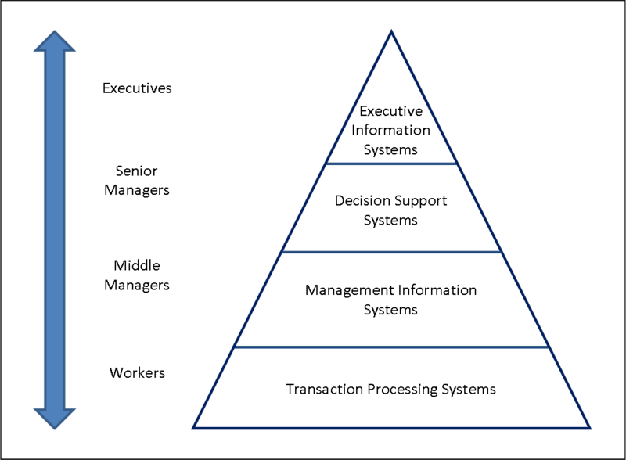
Figure1. Information System Architecture
- Transaction Processing Systems: used by employees in the organization.
- Management Information Systems: used by middle managers that help managing the organizational activities.
- Decision Support Systems: used by senior managers to take appropriate decisions for the proper functioning of the organization.
- Executive Information Systems: used by organization executives.

NEED FOR INFORMATION SYSTEMS
A highly capable information system can make an institution easier to handle its activities and responsibilities. An information system can be made to successfully collect and manage the necessary information thereby providing facility to constantly monitor the improvement in the institution’s held position. Manual processing of entire information in an institution can be automated by gaining the advantages of utilizing time and efforts. It can also create indicators that can manage the distribution and allocation of educational resources and services [3].
An educational information system can be considered with the following modules:
- Administrator: Principal or an in-charge who will control the information system activities.
- Teaching Faculty: Assigned faculty members will collect and store the data regarding teaching aids, infrastructure facilities and students’ assessment information. He/she will also be responsible for a successful feedback system with students and parents.
- Student: Each student can retrieve his assessment report and can self-evaluate his performance. He/she will get provision to present the modifications needed with the current education system.
- Parent: Parents will be having provisions for consistent communication with respective faculty members and for retrieving the assessment reports of their children. He/she will also get provision to present the modifications needed with the current education system.

ACTIVITIES IN AN EDUCATIONAL INFORMATION SYSTEM
An educational information system can be viewed with the following collection of ordered activities:

- Data Storage
- Data Processing
- Information Analysis
- Performance Monitoring
- Resources Identification
- Education System Improvement

Any institution with facilities of online data storage and access can implement an information system easily. The flow of activities can be represented diagrammatically as follows:
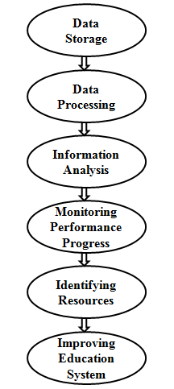
Figure2. Activities in an Educational Information System
Data Storage: This activity collects and stores all relevant data by the particular users of the information system. For reliable data storage, online data storage methods can be considered, such as Data Warehouse, Data Marts, and Data in the Cloud etc. These methods can store large amounts of data like our need.
Data Processing: During this activity, the stored data is processed to convert into relevant information set and organize it in a useful mode. This may involve validations, summarizations etc.
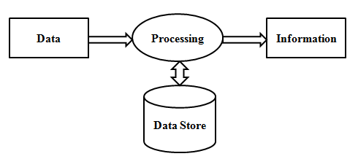
Figure3. Data Storage and Processing Activities
Information Analysis: Using statistical data analysis methods, this activity can aggregate the information, perform necessary calculations, interpret, evaluate and generate reports. The analysis methods may involve proportions/percentages, ratios, scoring/ranking etc. depending on our purpose [4].
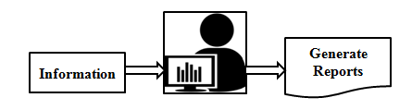
Figure4. Information Analysis Activity
Performance Monitoring: By verifying the generated reports, this activity can show the performance level of institution parameters such as infrastructure facilities, students’ score etc. so that the progress level can be identified easily.
Resources Identification: During this activity, all the factors and resources affecting the education system can be identified by retrieving the progress level of the institution parameters. For this, an active decision support system of the institution can assist well.
Education System Improvement: By identifying the resources further required or to be modified can be integrated into the existing institution in order to get an improved status.

CONCLUSION
Quality of education depends not only on a set of traditional books and papers, but also on quality of teaching, infrastructure facilities and highly on the motivation level of the students. A continuous process is necessary to evaluate and identify the required resources and parameters that can make the education system fruitful. This paper lightens to the need for information system in higher educational institutions in consistent monitoring and improvement of the education system.

References
- Emanuela BUCI, “Analysis and Impact of Information Systems on SMEs in Albania”, In the proceedings of IAC 2017, Vienna, Prague, p. 215, 2017.
- K. C. Laudon, J. P. Laudon, Ahmed Elragal, “Management Information System: Managing the Digital Firm”, Pearson, China, pp. 3-83, 1988.
- UNESCO, “Education Indicators: Technical Guidelines”, pp. 3-50, 2009
- Ian Peers, “Statistical Analysis for Education and Psychology Researchers”, London, pp. 33-248, 1996.

