INSTRUMENT LANDING SYSTEM AND ITS
MODELLING: GLIDE PATH

SHERVIN LIYA JOSE
ECE, ,
Rajagiri School of Engineering & Technology
Kakkand, Kerala
shervinliya@gmail.com

Abstract: Instrument landing system is an instrument based approach system which is used by modern aircrafts. An aircraft approaching a runway is guided by the ILS receivers in the aircraft by performing modulation depth comparisons. System that provides precision lateral and vertical guidance to aircraft approaching and landing on a runway, using a combination of radio signals. It is a radio navigation system which provides aircraft with horizontal and vertical guidance just before and during landing and at certain fixed points, indicates the distance to the reference point of landing necessary for an accurate landing approach in IFR (Instrument Flight Rules), in conditions of limited or reduced visibility. Glide path ILS signals transmitted from antenna array contains a modulation level, which will be analyzed at the cockpit for 0 DDM point. The accurate landing approach is a combined procedure of ILS receiver system and pilot.

Index terms: ILS, Glide path, Radio navigation system, IFR, DDM
- INTRODUCTION

Landing of an aircraft under any circumstances is an essential fact in present days, because the navigation via air has now become a common matter. As the dependency on aircrafts increased, the security of human life is also a major concern. International Civil Aviation Organization (ICAO) has implemented some standards regarding the safe landing of aircraft. Based upon these standards and rules, a system called Instrument Landing System has developed. The Instrument Landing System consists of mainly two components, localizer unit and a glide path [1]. In aviation electronics, a localizer which is the lateral component of the ILS guides to the runway center line while glide path, the elevation component provides vertical angle guidance. The pilot controls the aircraft so that the cross deviation indicator remains centered on the display to ensure that aircraft is following aligned to the glide path of approximately 3⁰ above horizontal (ground level) to remain above terrains and reach the runway at the proper touchdown point. ILS transmit RF carrier signal incorporated with information through an antenna array system. The transmitted signals are modulated at space and resultant signals are
received at cockpit. Glide path component consist of an array of three element dipole antenna which is operated in UHF frequency ie., 329 MHz to 335 MHz The RF signal is modulated by 90Hz and 150Hz signal at space and received at aircraft. The signals which are transmitted from aerial is

analyzed using a feedback antenna and can correct the modulation levels of signals. The transmitted modulated signals which we called as ILS signals in common, are analyzed and the variations provide information regarding the signals transmitted. Electric field strength pattern gives an excellent analysis of ILS. The aim is to develop an analysis tool for ILS signal and its pattern verification. Even though the system is much complicated, software implementation helps to understand and make it more simple in our communication era.

- PURPOSE AND USE OF ILS

The Instrument Landing System (ILS) [2] provides a means for safe landing of aircraft at airports under conditions of low ceilings and limited visibility. The use of the system materially reduces interruptions of service at airports resulting from bad weather by allowing operations to continue at lower weather minimums. The ILS also increases the traffic handling capacity of the airport under all weather conditions. The function of an ILS is to provide the PILOT or AUTOPILOT of a landing aircraft with the guidance to and along the surface of the runway. This guidance must be of very high integrity to ensure that each landing has a very high probability of success.

- PRINCIPLE OF ILS

ILS employs amplitude modulation of a radio frequency carrier to provide the guidance information. The modulating signals used in ILS are pure sine waves of 90 Hz and 150 Hz frequency. This handout deals with the characteristic features of signals radiated by localizer and glide path. Audio modulation frequencies of 90 and 150 Hz are used to provide right and left indication. When approaching for landing, the 150 Hz signal predominates on the right-hand side of the course and the 90 Hz on the left, the system uses amplitude modulation and hence the aircraft receiver must measure the difference in amplitudes of the detected tones to determine the aircraft position. This leads to the term Difference in Depth of Modulation (DDM). When the DDM is zero, the aircraft is correctly positioned. When a DDM exists, the pilot must correct the aircraft's position until the DDM is zero. The pointer needles of the CDI instrument are driven by the DDM.

- ILS WAVEFORM GENERATION CONCEPT

The ILS uses AM of the radio frequency carrier to provide the guidance information to the landing aircraft. The localizer works on VHF, and the glide path works on UHF frequency. Double Sideband Suppressed Carrier (DSB-SC) after modulation by a single frequency, three discrete sine waves are produced i.e., the carrier, the USB and LSB. No information is contained in the carrier, since it is of constant amplitude and frequency. All the information is contained in the sidebands i.e., 90 or 150 Hz. ILS guidance tones are contained only in the sidebands, the carrier being included as a standard by which the amplitude of the two tones may be ILS, the double sideband signal is comprised a radio frequency f, a 90 Hz upper sideband (f + 90 Hz), a 90 Hz lower sideband (f-90 Hz), a 150 Hz upper sideband (f + 150 Hz), and a 150 Hz lower sideband (f-150 Hz). This signal carrier and sidebands is designated CSB. The signal with sidebands only is designated as SBO. This is an RF signal in which the RF carrier is amplitude modulated by the audio frequencies of 90 HZ and 150 Hz. If V_{c} sin w_{c}t is the carrier signal, the resultant CSB signal is expressed by:

C _{ccsb} = A_{c} (1+m1 cos2πf₉₀t+m₂ cos 2πf₁₅₀t)
cos2π f_{c} t (1)

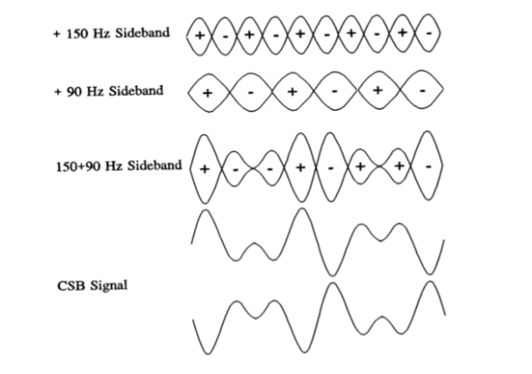
Fig.1.Kissing Pattern

The SBO signal is RF signal in which the RF carrier is amplitude modulated simultaneously by the frequencies of 90 Hz and 150 Hz with the carrier component removed. If Vc sinw_{c} t is the carrier signal, the resultant SBO signal is expressed by equation
C_{SBO} = -(cos₉₀t 2πf₉₀t+cos₁₅₀t2πf₁₅₀t)cos2πf_{c}t (2)
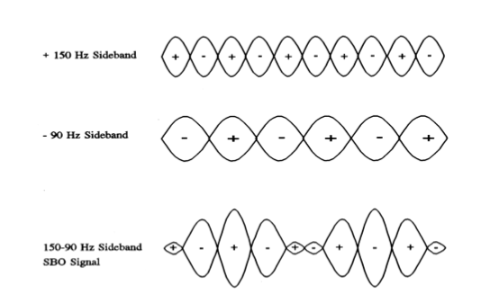
Fig.2. Five Finger Pattern

- Glide slope antenna array

Some sites require a system which provides a very high immunity from reflections, even at the expense of other factors. The answer for this is the quadrature clearance or M array system which is widely used with Norm arc Installations. This array consists of three aerial elements mounted vertically one above the other at heights H, 2H and 3H above the ground. The antenna system is called as M Array Antenna system. Each element is fed with the proportions of course CSB, course SBO and clearance CSB signals in order to transmit the glide path radiation pattern with the minimum of interference from the obstructions and rising ground lying directly in the glide path field as shown in Fig.3. The clearance radiation is phase advanced 90 on the course radiation to create a crossover region at 0.66 about the angle of elevation 9, and also being modulated to a depth of 60 with 150 Hz tone and 20 with 90 Hz tone, ensures high values of FLY UP DDM at low elevations. The array offers a potential improvement of 27.5 dB over the null reference array, with regard to glide path interference, assuming an overall reflection factor of 10. The DDM is linear throughout the glide path width, being 17.5 at 0.24θ
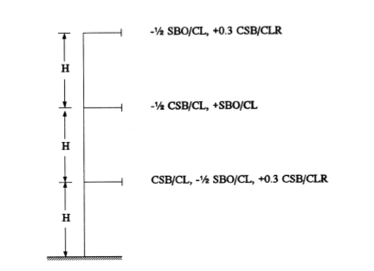

Fig.3. M Array Antenna

- Course CSB field strength pattern

The course CSB/CL is fed to the lower and middle elements, so that the lower element signal is twice as great as, and in RF antiphase with, the middle element signal. The height H is calculated from the equation H = λ/ (4 sin θ) where θ is the required glide path angle. The lower course CSB signal has a sinusoidal distribution, the field strength being given by the equation
F α sin(Hsin(θ)
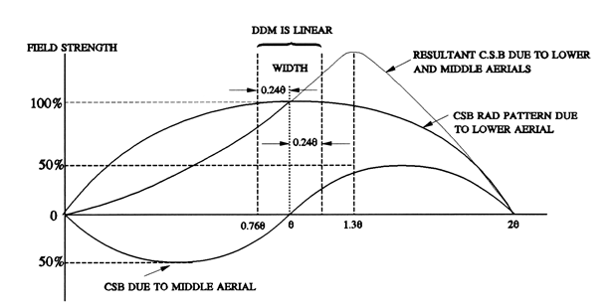
Fig.4. Course CSB pattern

The middle course CSB signal has sinusoidal distribution at twice the frequency, the field strength being given by the equation

F α 1/2 sin (2 H sin θ)
The resultant CSB distribution, obtained by vectorial addition of the two CSB signals has low values at low elevations and rises to maximum at about 1.3θ, the DDM distribution being linear within the glide path width angle 0.24 θ as shown in Fig.4.

- Course SBO field strength pattern

The course SBO signal is fed to all three aerial elements, so that the upper and the lower elements signals are half the amplitude of, and in R.F. antiphase with, the middle element signal. The lower course SBO signal has sinusoidal distribution the field strength being given by the equation
F α -1/2 sin (Hsin θ)
The middle course SBO signal has sinusoidal distribution at twice the frequency of the lower SBO signal, the field strength being given by equation
F α sin(2Hsinθ)
The upper course SB O signal has sinusoidal distribution at the three times the frequency of the lower SBO signal, the field strength being given by the equation
F α -1/2 sin(3H sinθ)
The resultant course SBO pattern is obtained by vectorial addition of the lower, middle and upper SBO distribution and has low values at low elevations, the first lobe maximum occurring at about 0.7θ. The resultant has a null at the glide angle and rises to a second lobe maximum at about 1.6θ. The distribution through the glide path width of 0.24θ is linear.
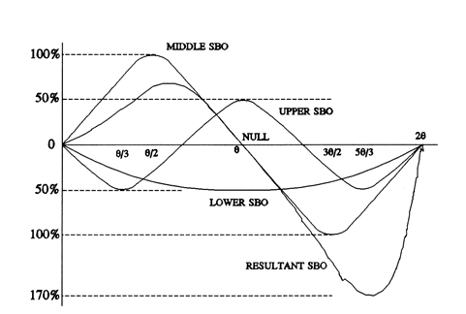

Fig.5. Course SBO pattern

- Clearance CSB Radiation

The clearance CSB is fed to the upper and lower aerial elements at a relative signal level of 30 of the course CSB signal, and in quadrature with it. Fig.6 shows the clearance CSB radiation.

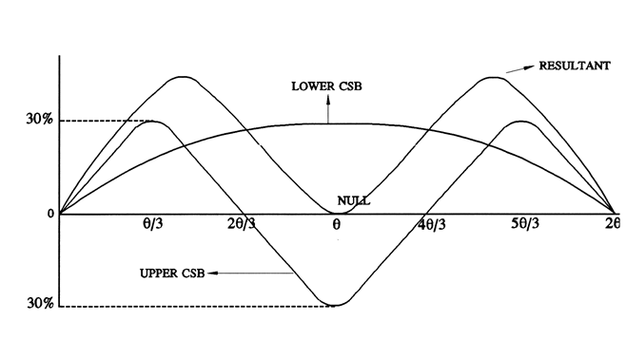
Fig.6. Clearance CSB pattern

The clearance CSB signal applied to the lower aerial element has sinusoidal distribution, the distribution being given by the equation
F α 0.3 sin (H sin θ)
The clearance CSB signal applied to the upper aerial element has a sinusoidal distribution at three times the frequency of the lower element, the distribution being given by the equation
F α 0.3 sin (3Hsinθ)
The distribution of the resultant CSB/CLR signal is symmetrical about the glide path angle, giving a null on the glide path angle and having maxima at 0.4θ and 1.6θ. The resultant clearance CSB signal being modulated to 60 percent depth with 150 Hz tone and to 20 percent with 90 Hz tone gives a depth of 40 percent indication at the aircraft receiver at lower angles than the cross-over angle of 0.6θ. This signal therefore produces a full scale FLY UP indication at the aircraft receiver as required. At the crossover angle, the relative amplitude of the course CSB carrier and the clearance CSB carrier become equal, but are phased in quadrature. Because of the high rate of change of the course CSB and clearance CSB through the cross-over region, the aircraft receiver will capture the stronger signal, ensuring that spurious indications are completely eliminated. Combined field strength pattern of the M-Array after feeding CSB and SBO in real time environment will be as shown in Fig.7.

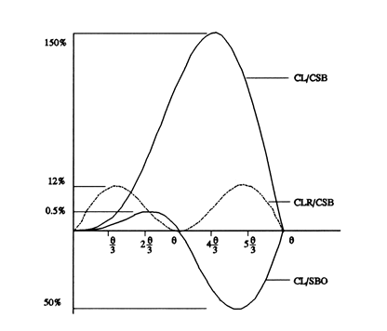
Fig.7. Combined field strength pattern

- SIMULATIONS AND EXPERIMENTAL RESULTS

- ILS signal simulation results

To achieve required coverage for localizer and glide path, two RF signals need to be radiated. These two signals are defined as CSB Signal; and SBO Signal. The CSB signal is a RF signal in which the RF carrier is amplitude modulated simultaneously by the audio frequencies of 90 HZ and 150 Hz. Simulation result done using Matlab is shown below, here RF carrier signal is modulated with 90 Hz signal for amplitude 2V. RF carrier frequency is 331.7 MHz RF signals in which the RF carrier is amplitude modulated simultaneously by the audio frequencies. This signal, looks like the waveform shown in Fig.8. The pattern formed is called as Kissing pattern. Similarly SBO signal is expressed by equation and the waveform is shown in Fig.9. The generated pattern is called as five finger pattern as it looks like pattern of fingers in hand.

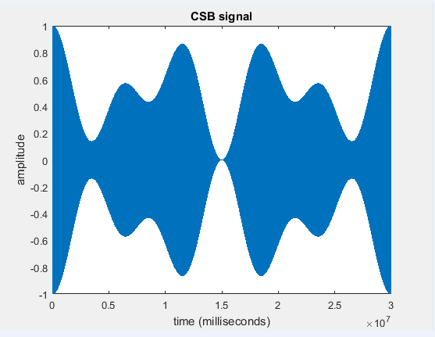

Fig.8. Kissing Pattern

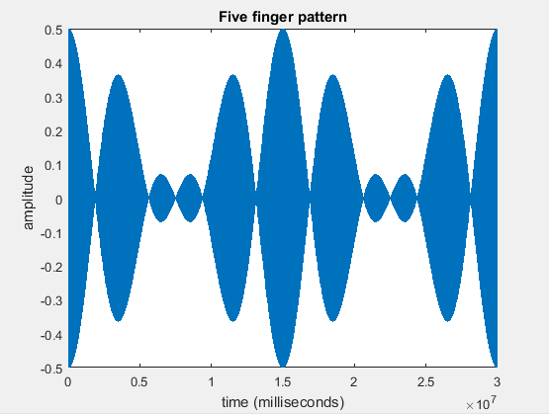

Fig.9. Five finger pattern

- Electric field strength results

The field strength pattern of CSB and SBO signals are plotted from real time environment setup. Figure10 shows the clearance CSB signal field pattern for lower, middle and the resultant field strength. The sum of electric fields is 0 at 3 degree angle, which refers to the null point. Fig.11 shows SBO course signal fed to lower, middle and upper antenna and resultant field strength. Here also resultant sum is null at 3 degree.
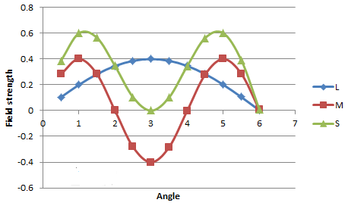
Fig.10. Clearance CSB pattern

Fig.12 indicates the resultant field strength pattern of course CSB. The signals fed to lower and middle antenna gives resultant field strength at 3 to 4 degree.

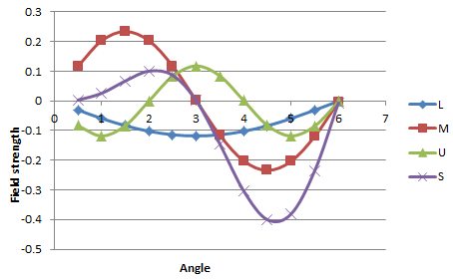
Fig.11. Course SBO pattern
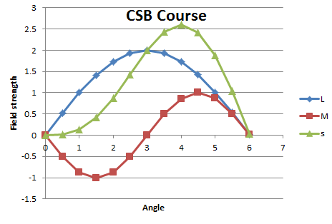
Fig.12. Course CSB pattern

The combined results of the electric field strength are given by Fig.13. By analyzing the graph we can conclude that CSB signal show resultant field strength at 3 degree, while SBO course and clearance CSB signal resultant value shows null point. Fig.13 shown below is the resultant pattern of dipole antenna electric field strength plotted in terms of amplitude and phase using equation and the resultant of three elements is plotted. When we compare it field strength of M Array system of dipole antenna, maximum field strength is pointed between 3 to 4 degree.

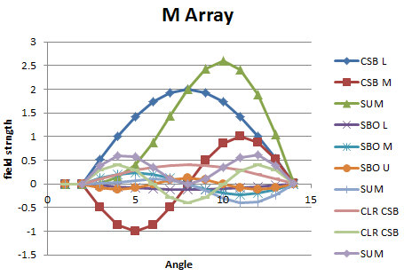
Fig.13. Combined M Array field strength

- CONCLUSION

The instrument landing system is well recognized by avionics society for its precise and safe landing assistance of aircraft under adverse environmental conditions. Landing of an aircraft is a critical risk factor which needs proper communication between the pilot and aerial spotters. The safe landing is assisted by the combined performance of a localizer, glide path and marker beacons. The concept of Instrument landing system is studied. The requirements of ILS are discussed and its signals generated. The glide path system is analyzed and simulated its antenna system. Electric field strength for various angles are plotted using real time values and analyzed. The 0 DDM value is obtained in between 3 to 4 degree, which is the touchdown angle of aircraft by ILS standards.

REFERENCES

[1] J.G. Lucas and A.C. Young (1978), The ILS Glide path: New Designs for Severe Sites, IEEE Trans. AES Vol - 14, no.6.
[2] ILS Thales 420 proficiency linked integrated course Manual, AAI, 2015.
[3] Daniel Stojcsics, Andras Molnar (2014), Autonomous takeff and landing control for small size unmanned aerial vehicles, computing and Informatics, Vol. 32, 1117-1130
[4] R.H. McFarland, (1990), ILS-A safe bet for your future landings, IEEE Trans. AES, 5- 15.
[5] C.B Watts (1990), Applications of slotted cable antennas in ILS, IEEE Trans. AES.
[6] M. M. Poulose, An improved computer model for ILS glideslope evaluation, pp. 2101–2103, Oct. 1998.
[7] J.R Fries (1971), Improvement of automating landing through the use of a space diversity ILS receiving system, IEEE Trans. AES.
[8] Aditya Gupta (2016), "Training seminar report on Airport Authority of India, Jaipur.
[9] ILS 420 Glide path 422 Technical Manual Part 3, Thales ATM GmbH Stuttgart Germany, 2004.

