
International Journal of Computer Sciences and Engineering Open Access
Research/ Review/Survey Paper Volume-5, Issue-8 E-ISSN: 2347-2693

Fuzzy and PI Based Speed Control of BLDC Motor using Bidirectional Converter for Electric Vehicle Application
Anjana. R¹, Jayan. M.V²

¹EEE Department, RIT,Kottayam, A.P.J. Abdul Kalam Technical University, India
² Professor, EEE Department, RIT,Kottayam, India

e-mail: anjanamrn24@gmail.com, jayanmv@rit.ac.in
*Corresponding Author: anjanamrn24@gmail.com, Tel.: 9496072998

Abstract— Fuzzy Logic Control can be used in BLDC motor to control the four quadrants of operation so as to avoid power loss. In this paper a Fuzzy based Controller for speed control of BLDC motor is done and it is compared with the conventional PI controller based speed control technique. In addition to this, a bi-directional converter is used to achieve battery charging during regeneration and to charge the battery externally as well in two different modes of operation by controlling the converter switches gating pulses. A boost converter is also suggested to improve the power quality during charging mode from the external AC source. This is well suited for electric vehicle applications.

Keywords— Brushless DC Motor, Regeneration, Bi-directional converter , Fuzzy Logic Controller(FLC), CC-CV Charging

Introduction
BLDC motors are basically synchronous motors with brushes replaced with electronic commutation .The stator windings work in conjunction with permanent magnets on the rotor to generate a nearly uniform flux density in the air gap. This permits the stator coils to be driven by a constant DC voltage.
Applications like Aerial robots that form an entirely new field of research, Mixer grinders – wherein the universal motors can be replaced for better energy efficiency, Biomedical field like use of Prosthetic limbs that are artificial limbs which can perform regular and daily works and then Regenerative charging control which forms an important part in Electric vehicles calls for the need of speed control in BLDC motors. This work basically deals with the speed control of BLDC machines along with the application for regenerative charging in Electric vehicles. A bidirectional converter [1] is used for achieving both motoring and regeneration. Also charging of the battery using an external AC source (110V- rms) is achieved using the same bi-directional converter. The power quality is improved with a Boost converter in this charging mode of operation. [2]. Comparison of PI and Bio – Inspired algorithm like fuzzy based speed control is done.[3]. The main objective of this paper is to design the bi-directional converter, and incorporate FLC based speed control of BLDC into it to achieve regenerative braking. Simulation of BLDC motor using MATLAB, Simulation of speed control using PI and Fuzzy Logic Controller and their comparison is done. Battery charging during braking is achieved. Also external battery charging is done. The power quality improvement is achieved using a Boost converter and the results are verified in the simulation.

MODELLING OF BLDC MOTOR
The model of the BLDC motor used for simulation is obtained by using a built-in model of a Permanent Magnet Synchronous Machine (PMSM) in the Matlab simulink. By providing the PMSM with electronic commutation and a three phase inverter, the BLDC motor model is created. Figure. 1 shows the BLDC motor with its voltage source inverter.

The inverter converts the DC voltage into AC and then the switches are turned ON by providing appropriate gating pulses according to the Hall sensor signals. Table I shows the switching pattern for the BLDC motor. The electronic commutator output based on the Hall effect sensors signals are listed. U,V, and W are the three phases.

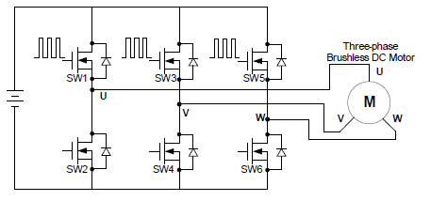
Figure.1 BLDC Motor with inverter.

TABLE I. ELECTRONIC COMMUTATOR OUTPUT.

HALL SIGNALS |  |  | SWITCHING SIGNALS
Ha | Hb | Hc | SW1 | SW2 | SW3 | SW4 | SW5 | SW6
0 | 0 | 0 | 0 | 0 | 0 | 0 | 0 | 0
0 | 0 | 1 | 0 | 0 | 0 | 1 | 1 | 0
0 | 1 | 0 | 0 | 1 | 1 | 0 | 0 | 0
0 | 1 | 1 | 0 | 1 | 0 | 0 | 1 | 0
1 | 0 | 0 | 1 | 0 | 0 | 0 | 0 | 1
1 | 0 | 1 | 1 | 0 | 0 | 1 | 0 | 0
1 | 1 | 0 | 0 | 0 | 1 | 0 | 0 | 1
1 | 1 | 1 | 0 | 0 | 0 | 0 | 0 | 0

III. Block diagrams for the suggested control

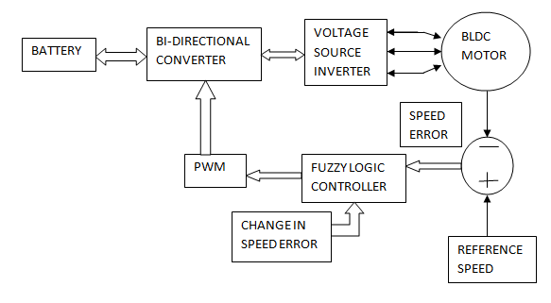
Figure.2 Block diagram for mode.1and 2

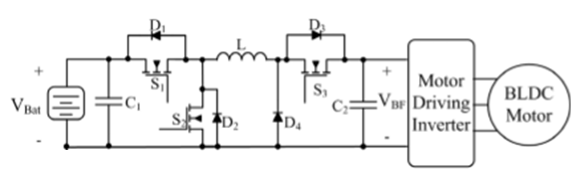
Figure.3 Circuit topology for mode.1and 2

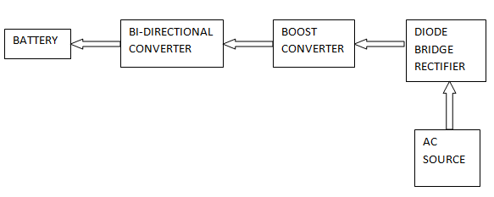
Figure.4 Block diagram for mode.3
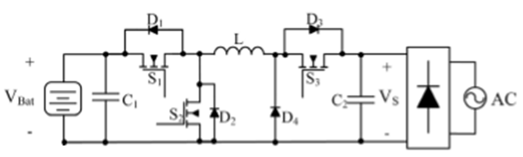
Figure.5 Circuit topology for mode.3

Figure. 2 and Figure. 3 shows the block diagram and circuit topologies for mode1,2 (forward motoring and regenerative braking) respectively. Figure 4 and Figure 5 shows the block diagram and circuit topology respectively for mode 3(battery charging from AC source).

BI-DIRECTIONAL CONVERTER
The Bi-directional converter used in the paper can act as a Buck converter and also a boost converter. It acts as a Buck converter during the forward motoring and as a Boost converter during the time of regenerative braking mode. Again during charging from AC source, Buck mode is used. A manual switch can be used to select the required mode of operation- either the forward motoring and regenerative braking mode or the battery charging mode from an external source.

- Design of Bi-directional Converter

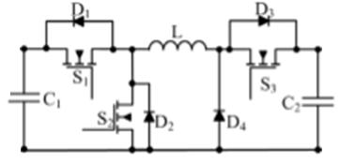
Figure.6 Circuit diagram of Bi-directional converter

(a) MODE 1 and 2

During forward motoring the Bi-directional converter will act in the Buck mode. When the speed is reduced during braking, regeneration occurs and at that time, the battery is charged in the Boost mode. A 24V motor is chosen for design and simulation analysis. The battery voltage is 64V and maximum current is taken to be 4A for the 6.5Ah battery. The back mf voltage is 15V. The switching frequency is taken as 5KHz throughout the simulation analysis. The voltage gain and the minimum value of inductance for Buck operation in the forward motoring mode is given by equation (1). The voltage gain and the minimum value of inductance for Boost operation in the regenerative braking mode is given by equation (2).

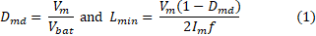
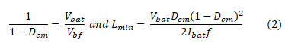

(b) MODE 3

During this mode, the battery is charged from an external AC source of 110V (rms). Again the converter acts in Buck mode for charging the battery. The voltage gain and minimum value of inductance for this mode is given by equation (3).

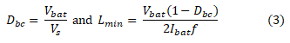
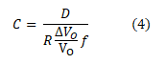
After substituting all the values, from equation (1), L_{min} = 750µH, from equation (2), L_{min} = 459µH and according to equation (3), L_{min} = 1.78mH. L = 2mH is chosen for the simulation analysis. The value of capacitance is obtained from equation (4) as 1200µF. However in design, it is useful to rearrange the capacitance in terms of specified voltage ripple.

BOOST CONVERTER

When charging of the battery is done from an external AC source, power quality of the system gets affected seriously. The power factor drops to around 0.5 and the Total Harmonic Distortion (THD) becomes as high as 45%., which is a huge deviation from the prescribed standards. Therefore the power quality needs to be maintained. The most common and simplest method is to use a Boost converter. The Boost converter here is designed for an output power of 100W and voltage, 200V. Figure. 7 shows the basic Boost converter circuit diagram.
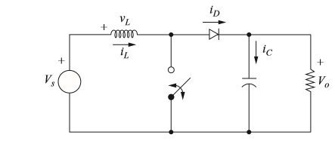
Figure.7 Circuit diagram of Boost converter

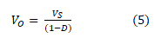
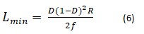
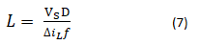
From equation (5), the Duty ratio is obtained as 0.222. The minimum value of inductance is calculated as 5.37mH from equation (6) and the capacitance value is chosen to be 222nF from equation (4). Boost converter helps to shape the inductor current and maintains the output voltage a constant.

FUZZY LOGIC CONTROLLER (FLC)

Fuzzy logic uses linguistic variables instead of numerical variables. The process of converting a numerical variable into a linguistic variable (fuzzy number) is called Fuzzification. The inputs for FLC are speed error (E) and change in speed error (CE). The reverse of Fuzzification is called Defuzzification that is conversion of output of FLC which is a fuzzy number into crisp value. The membership function of FLC is a graphical representation of the magnitude of participation of each input and output. Figure 8 shows the membership function for input variables ‘ERROR’ and ‘CHANGE IN ERROR’. Figure 9 shows membership function of output variable “PWM’.

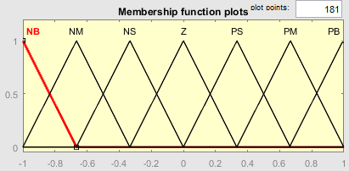

Figure.8 Membership function for ERROR and CHANGE IN ERROR

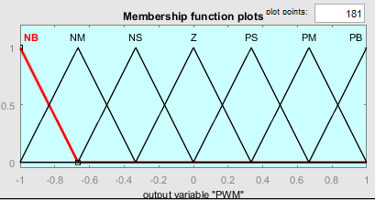

Figure.9 Membership function for PWM

TABLE II. RULE BASE FOR FUZZY LOGIC CONTROLLER

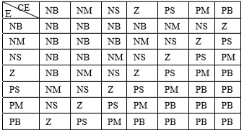

The processing stage is based on the rule base which is a collection of logic rules in the form of IF-THEN statements. Table II shows the rule base for speed control of BLDC motor. There are a total of 49 rules which are obtained by considering the output for various combinations of the inputs ERROR and CHANGE IN ERROR.

SIMULATION ANALYSIS

- Simulation Diagrams

The proposed system has been simulated by Matlab /Simulink software. The simulation results were obtained for a 500W, 24V BLDC motor. Figure 10 shows the Matlab simulation diagram for modes 1 and 2. FLC is used for speed control and PI controller is used for current control. This simulation is compared with PI based control wherein both speed and current controls are achieved using PI controller. Figure 11 shows the simulation diagram for battery charging mode from an external AC source.

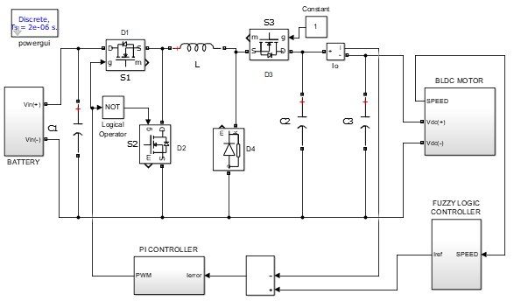

Figure.10 BLDC with FLC using Bi-directional converter – Mode 1&2

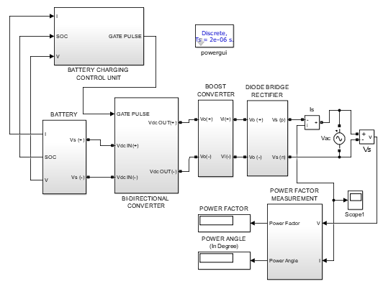

Figure.11 Battery charging mode with Boost converter – Mode 3
- Simulation Results

The simulation results show firstly the comparative analysis of speed control of BLDC motor and regenerative charging of the battery using PI and FLC. The charging mode of battery from an external AC source (110V rms) is also simulated by providing proper control to the battery current and voltage. CC-CV charging is done based on State Of Charge estimation.. The results with and without boost converter are included. The performance analysis of the designed Boost converter is presented.

Fig. 12 and 13 respectively shows the speed of BLDC motor and the corresponding Battery current profile with PI controller. Fig 14 and 15 respectively shows the speed of the motor and battery current with FLC. It can be seen that when FLC is used the speed waveform has some oscillations.

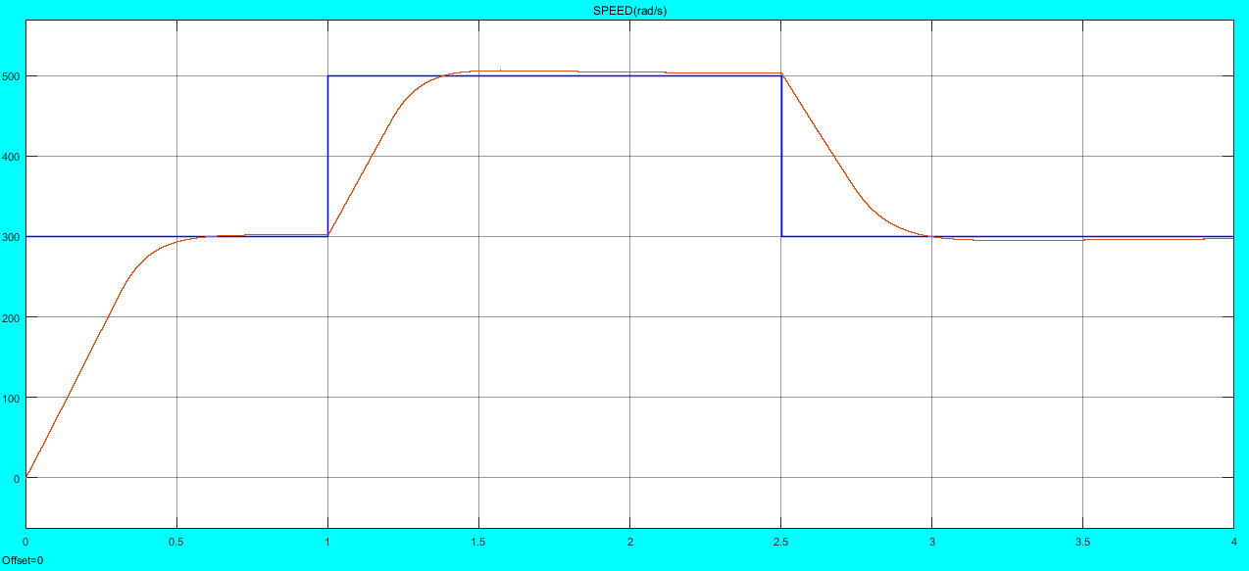
Figure.12 Speed waveform of BLDC motor with PI control

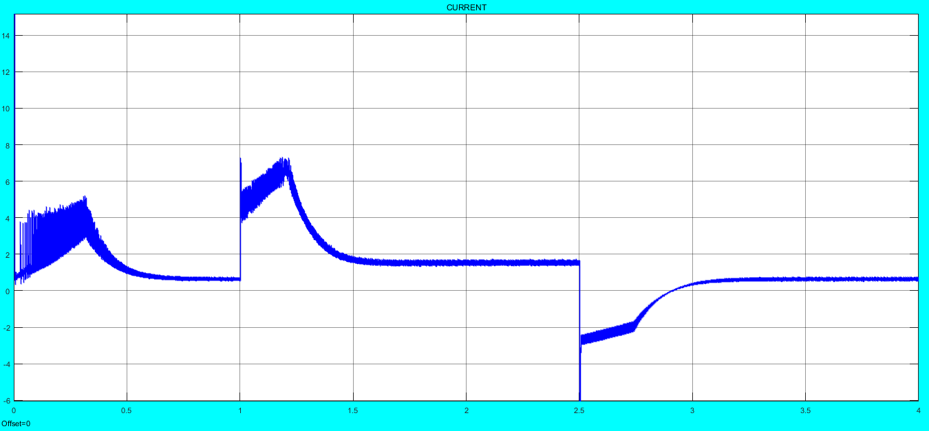
Figure.13 Battery current profile

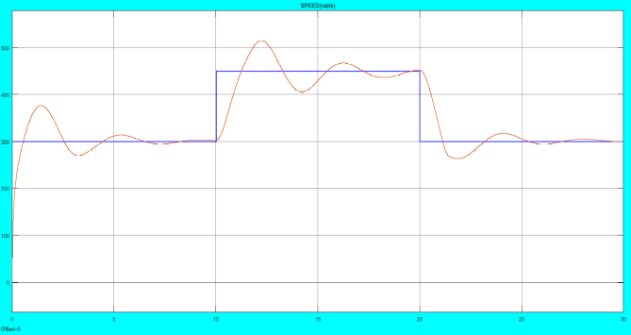
Figure.14 Speed waveform of BLDC motor with FLC
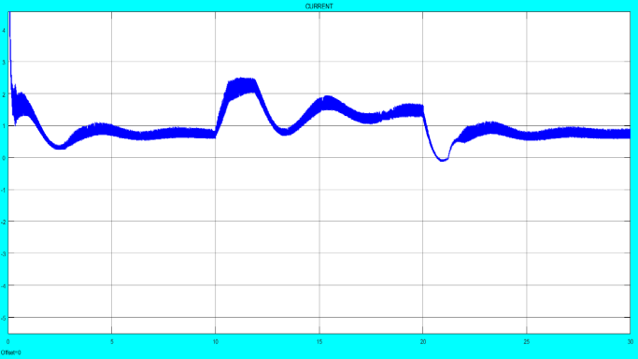
Figure.15Battery current profile

TABLE III. COMPARISON RESULTS FOR PI AND FLC FOR MODES 1&2

SL. NO. | PARAMETER | PI CONTROL | FLC
1 | Rise Time | 1.584µs | 792µs
2 | Settling Time | 940.4ns | 475µs
3 | Overshoot | 0.505% | 0.505%
4 | Undershoot | -0.505% | -0.505%
5 | Slew Rate | -100(/µs) | -150(/ms)

Fig 16 shows the battery charging from an AC source of 110V rms. The battery state of charge, current and voltage are plotted. Based on SOC, CC-CV charging method is adopted. CV (Constant Voltage) for SOC greater than 90% and CC (Constant Current) otherwise.

Fig 17 shows the THD (Total Harmonic Distortion) of the system without Boost converter. It can be seen that the THD is very high and the power factor is only 0.56 in this case. However by including a Boost converter the power factor can be made as high as 0.9 and THD can be improved to 3.28% which is acceptable, shown in Fig 17. The corresponding source current and output voltage waveforms can be seen in Figures 18 and 19 respectively. The current waveform is well shaped and output voltage becomes a constant at 200V, which is the designed value.

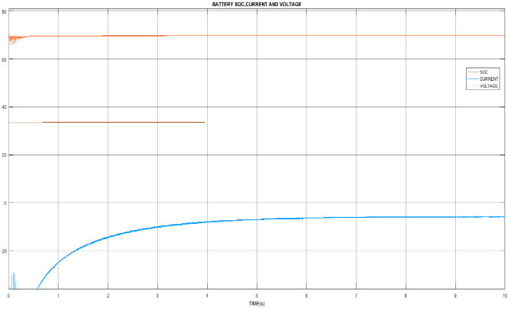
Figure.16 Battery charging profile

Table IV. SPECIFICATIONS OF THE BLDC MOTOR

SL.NO. | PARAMETER | VALUE
1 | Rated Voltage | 24V
2 | Rated Speed | 4000 rpm
3 | Maximum peak current | 10.6 rpm
4 | Number of poles | 8
5 | Rated Torque | 0.125Nm
6 | Resistance per phase | 0.36Ω
7 | Inductance per phase | 0.6mH
8 | Torque Constant | 0.036Nm/A
9 | Moment of inertia | 48*10⁻⁷ Kgm²
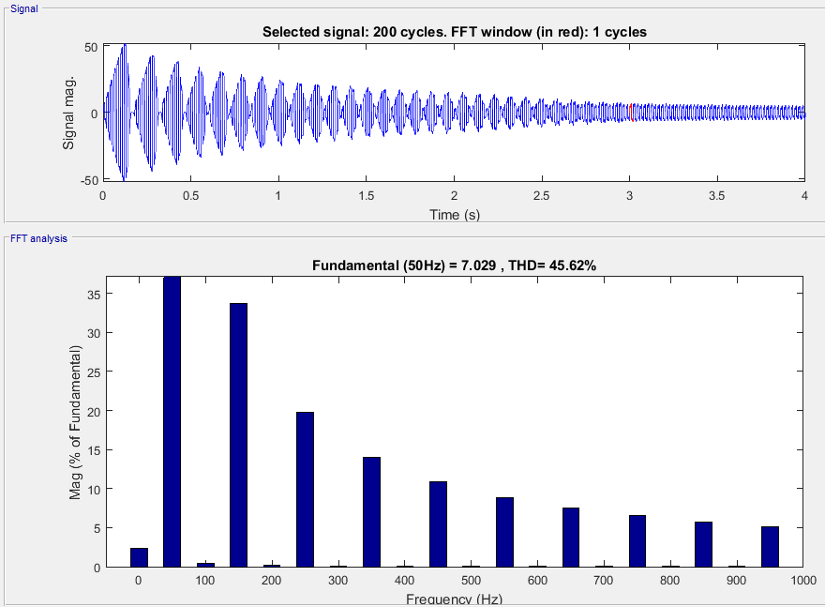

Figure.17. THD without Boost converter

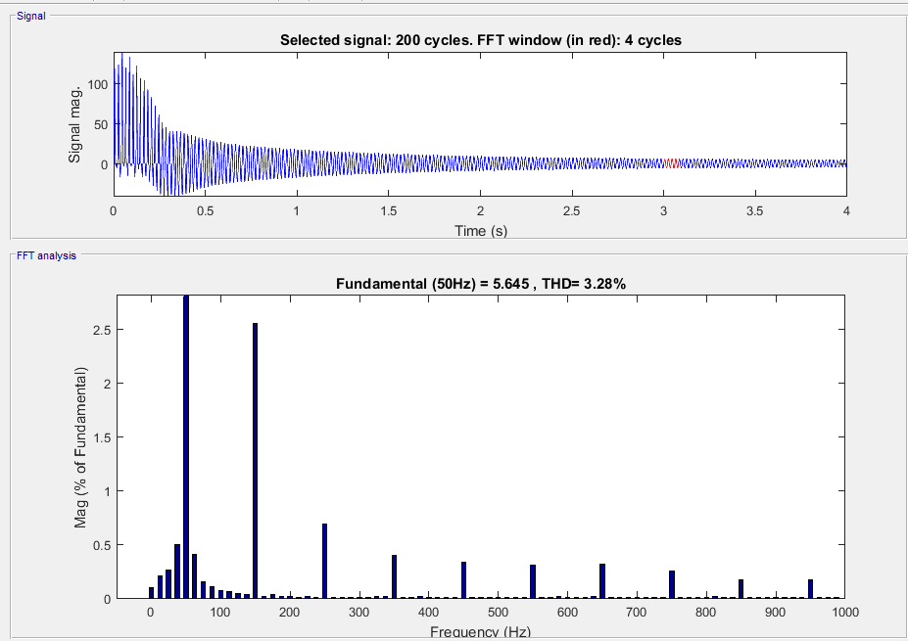

Figure.18. Improved THD with Boost converter
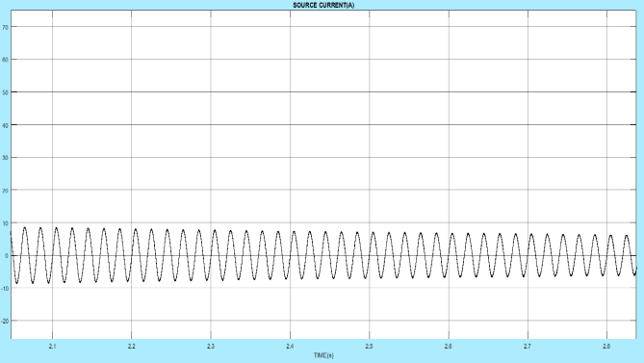

Figure19 Source current

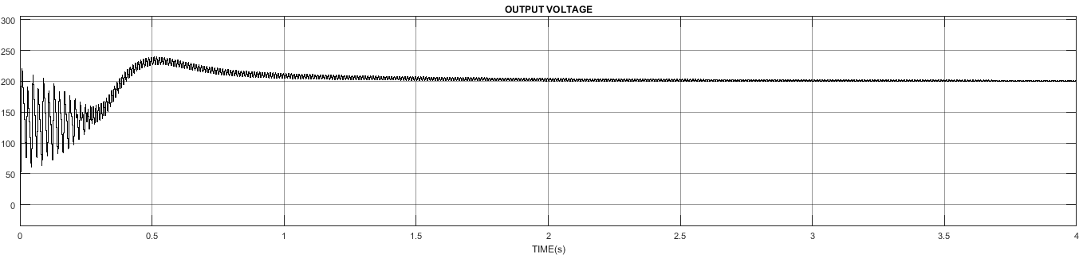

Figure.20 Output voltage of Boost converter

VIII. CONCLUSION

A Bi-directional converter fed BLDC motor drive is proposed, which best suits Electric Vehicle applications with provisions for regeneration and external battery charging. Performance of the suggested topology using PI and Fuzzy Logic Controllers are analysed and the results are presented. Use of Boost converter improves the THD and power

References
- Ananthababu, B., C. Ganesh, and C. V. Pavithra; “Fuzzy based speed control of BLDC motor with bidirectional DC-DC converter”; Green Engineering and Technologies (IC-GET), 2016 Online International Conference on. IEEE, 2016.
- Lin, Chang-Hua, Hom-Wei Liu, and Chien-Ming Wang. "Design and implementation of a bi-directional power converter for electric bike with charging feature." Industrial Electronics and Applications (ICIEA), 2010 the 5th IEEE Conference on. IEEE, 2010.
- Hee-Chul Lee; Chong-Eun Kim; Hong-Sun Park; Ki-Bum Park; Gun-Woo Moon; , "Current stress minimizing control scheme for power factor correction ( PFC ) boost pre-regulator," Power Electronics, 2007. ICPE '07. 7th International Conference on , vol., no., pp.1003-1006, 22-26 Oct. 2007.
- Kamal, Md Mustafa, Lini Mathew, and S. Chatterji. "Speed control of Brushless DC Motor using fuzzy based controllers." Electrical, Electronics and Computer Science (SCEECS), 2014 IEEE Students' Conference on. IEEE, 2014.
- Blessy, M. S., and M. Murugan. "Modeling and controlling of BLDC motor based fuzzy logic." Information Communication and Embedded Systems (ICICES), 2014 International Conference on. IEEE, 2014.
- Krishnan R, “Permanent magnet synchronous and brushless DC motor drives”, Boca Raton: CRC Press, 2010.
- Amiri, H., Afjei, E., Jahanmahin, M. and Mirzaee, V., 2011. “Brushless Dc Motor Power Factor Correction By Converters BOOST And SEPIC”. International Review of Automatic Control, 4(5), pp.688-693.

Authors Profile
Mrs.Anjana R pursed Bachelor of Technology in Electrical and Electronics Engineering from Toc H Intitute of Science and Technology under Cochin Univerity of Science and Technology in 2015. She is currently pursuing Masters in Electrical and Electronics Engineering with specialization in Industrial Drives and Control from Rajiv Gandhi Institute of Technology9RIT0,Kottayam.

Mr Jayan. M.V. pursed Bachelor of Technology from MAC Kothamangalm under in 1987. He took his Masters in Control Systems from PSG,Tech Coimbatore in 2003. He completed Ph.D. in Electrical Engineering from IISC Bangalore. His areas of interest are Power Systems and Electrical Machines. He has 17 years of teaching experience and 7 years of Industrial Experience.

