Dynamic Resource Allocation Algorithm using containers

Sayali vanjari1

Students 1

Department of Computer Engineering AEC, Chikhli ,,Amaravati University, India

***Abstract— High processing data and dynamic work load on servers results in resource depletion or resource exhausting. To overcome such situations, basic response is scaling the available resources, but rather than scaling the resources, we should use available resources optimally***

***Due to high processing cost of data most of data processing tasks becomes hard to maintain. But rather than scaling the available resources we can focus on better utilization of resources available to us and reducing the wastage of resources.***

***In server farms, most of the maintaining cost is due to cooling system and power consumption of servers in ideal state of servers. In past few years, data scientist and researcher developed many algorithms and models to allocate resource dynamically as an alternative for virtualization which is hypervisor based and requires static allocations of resources. Virtualized system holds resources even when it is ideal, this results in unfair resource allocation.***

***This paper uses Dynamic Node Selection Algorithm for Container Deployment for building a portal which will use Docker and Hadoop in combine for better resource utilization and increase processing speed.***

***Keywords—Big Data, Map-Reduce, Containerization, Docker, Fuzzy Interface System***

I. INTRODUCTION

Energy consumption rate of the server farms is way more than the actual energy required for the processing. Huge part of the energy is wasted on running the servers ideal and on cooling system of the server farm. This can be avoided by better utilization of servers for every situation in dynamic load distribution. Currently there are some framework which are used to share resources in cluster for workload management. For cloud computing environment various runtime parameter set statistically which lead to unbalanced resource allocation in cluster. By adding and removing resources at run time we can make cloud platform flexible and cost efficient. For this purpose, we use containerization. Nowadays, containerization gained popularity by various major vendors like Microsoft, google, amazon as an alternative to virtual machine.

To assign the load on proper nodes firstly, determine the status of each active node in the network, then pass it to the fuzzy interface system(FIS) which dynamically calculates workload on each node and then node selection algorithm for container deployment(NSCD) is used to deploy containers on the best node in the cluster.

1. Theoretical background
2. According to the proposal, for unreliable nature of distributed systems which is used by cloud providers should have another alternative. So author proposed XtreemFS, a file system for cheap scale-out solution for storage.
3. Proposed that, rather than providing statically configured computing resources, system should provide computing resources on demand. This encourages cost efficient usage of computing resources.
4. Authors presented a Container-as-a-Service (CaaS) framework to deploy workflow or applications automatically across multiple vendor systems. Containers allow services to run in isolated environments without the extra overhead of running entirely separate operating systems. But, the problems of how to effectively manage computing resources for containers remain open, because multiple applications sharing the same resources can result in substantial resource contention among the applications in the containers.
5. Proposed an adaptive control scheme by serializing applications for the cases of overutilization of CPU resources, where the quality of services in the cluster was considered as a multidimensional objective function. authors proposed a solution by extending the concept of time slicing to the level of virtualization container.
6. Proposed "Fuzzy logic based dynamic load balancing in virtualized data centres". Authors developed a dynamic fuzzy load balancing algorithm which allows system to select next virtual machine based on resource utilization to schedule upcoming job.
7. Described node selection algorithm for container deployment(NSCD), where a Fuzzy Inference System (FIS) is applied to dynamically predict the most proper node (server) where the selected containers will be deployed. This algorithm is used for better utilization of resources and reduction in the data processing cost. This is the basic algorithm used in our architecture. We used Hadoop for the better handling of big data and some alteration in the algorithm which reduces complexity at some level. We are using Best Fit approach for allocation of nodes.
8. DOCKER

Docker is a tool for management of container. Containers provides kernel level virtualization which is light weight than virtual machine. Management of containers such as creating, deploying them becomes simplified by Docker. Application’s environment and related dependencies are bundled in a single package, ready to deploy.

1. Methodology

Rate of growing data with time in this modern age is enormous. Data can be unstructured or semi-structured generated from various heterogeneous systems. To create environment that provides computation and distributed storage across cluster of resources we use Hadoop. Hadoop implicitly distributes load on clusters. Hadoop can handle data processing in the provided cluster.

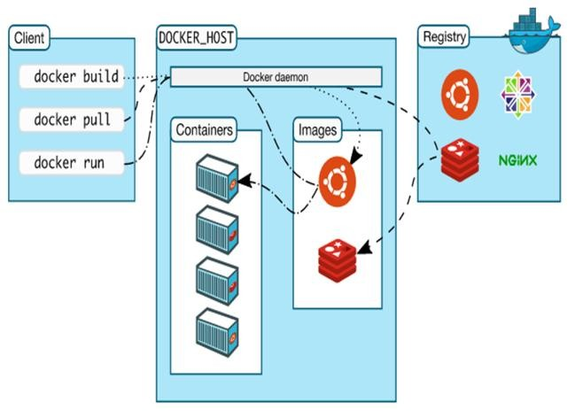For better resource utilization and eliminating of overheads of virtual machine we are using Docker. It is easy to deploy container using Docker. Hadoop is structured in container, so we can easily move processing environment for Hadoop. This helps in dynamic adaption of available resource. Dynamic Node Selection Algorithm for Container Deployment, monitors resource availability and usage of nodes, which is useful for node selection based on container’s

requirements and resource availability.

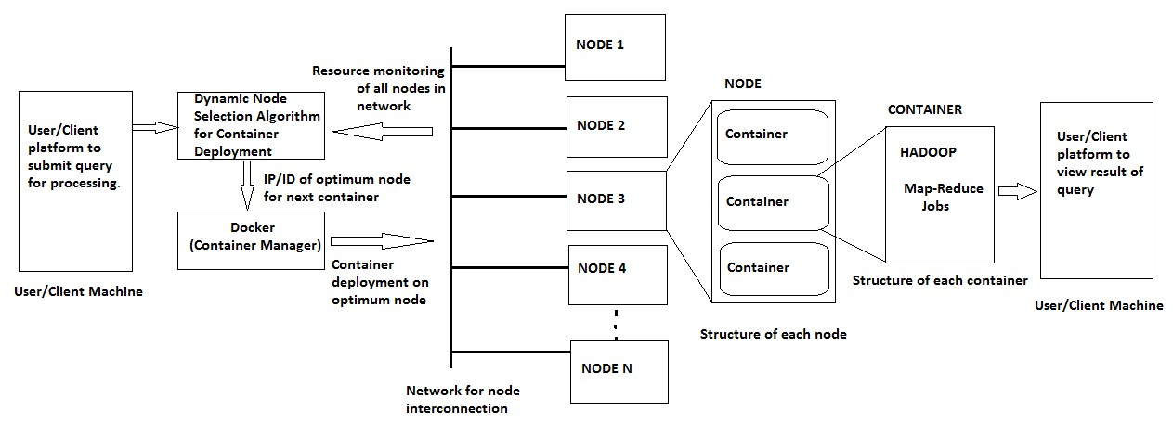



Thank you for using [www.freepdfconvert.com](http://www.freepdfconvert.com/) service!

Only two pages are converted. Please Sign Up to convert all pages. <https://www.freepdfconvert.com/membership>