Implementation and analysis of k-Barrier coverage in Wireless Sensor Networks

# Ms. Anagha S. Anand

M.Tech Scholar Computer Networks and Security

Government Engineering College Wayanad Kerala, India-670 644

Email: [anucek2016@gmail.com](mailto:anucek2016@gmail.com)

# Dr. Anitha. V. S.

Professor, Head of the Department Computer Science Engineering Government Engineering College Wayanad Kerala, India-670 644

Email: [anitha](mailto:anithavs@gecwyd.ac.in)[vs@gecwyd.ac.in](mailto:vs@gecwyd.ac.in)

***Abstract*—Coverage area regarding a particular sensor means the area that can be monitored using a sensor. Barrier cov- erage enhances the intrusion detection that can be done with a directional sensor. Omni-directional sensors senses the data surrounding it in all directions with a predefined boundary, whereas directional sensors are used to obtain data from a particular direction of area which will be the region of interest. Barrier coverage is a critical issue in most of the border security applications. This paper deals with the protocol used for the implementation of k-barrier coverage. k is a variable which is used to denote the number of times an intruders path is detected across the protected belt area. The region of interest will be highly protected when the value of k is high.**

**Index Terms: Barrier coverage, Directional sensors, Mobile sensors, Path coverage, Bounded belt area**

1. INTRODUCTION

Wireless sensors are spatially distributed in a particular area which are autonomous. According to the need for the application, sensors are used to obtain changes in geograph- ical, environmental, chemical conditions etc and passes the observed data through the network of sensor nodes to a central processing node where further calculations are carried out to obtain the results. Enhancement of k-barrier coverage results in greater success in the field of intrusion detection[1].

Directional sensors are commonly used in battle field, military surveillance applications, chemical reactors etc for the successful intruder detection[3]. The size and cost constraints of a wireless sensor network depends on the following factors:

* Energy efficiency
* Ease of use
* Self organisation capacity and healing power
* Reliability
* Computational speed
* Communication bandwidth

1. BARRIER COVERAGE AND SENSOR DEPLOYMENT

Coverage across a region can be achieved in terms of area coverage, point coverage, line coverage, border coverage, path coverage using spatially distributed wireless sensors. Here the paper is focusing on border coverage which is achieved by the detection of intruder’s path that is either congruent or normal to the boundaries of border. So we are considering k-barrier

coverage such that, the path of an intruder across a bounded belt region is detected k-times by distinct sensors.

Coverage and connectivity are the main two considerations in the process of sensor deployment. Our aim is to place min- imum number of sensor nodes to achieve k-barrier coverage and desired connectivity requirements. Now a days, there exist different kinds of sensor deployment models according to the necessity of the user as well as the application.

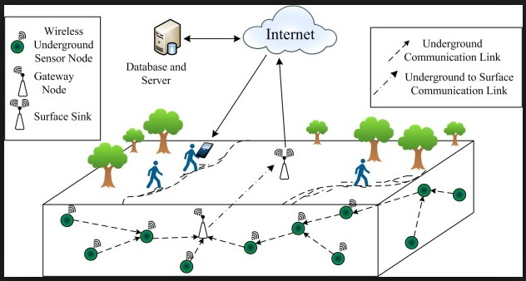

Fig. 1. Sensor deployment[4]

Stationary sensors are immovable, but they are low cost. Mobile sensors are able to change their region of interest according to the usage.

1. RELATED WORKS

Actually, in the concept of barrier coverage, we have to determine the penetration of intruder across the protected area. It is not necessary to cover most part of region of interest by the deployed sensors. The cost of sensor deployment is minimized and security is maximized[4]. The use of sleep and wake up algorithm is an efficient method to reduce the energy consumption[5]. The energy required for listening to the idle channel is almost same to that of sending or receiving data which is very much greater than that of sleep mode.

In Poisson point distribution model, sensors are distributed randomly and uniformly in a very large area[3]. Centralized and non-centralized deployment are the main two types of deployment models based on the control over the network.

A central node make control over the entire network system, whereas it’s failure may destruct the whole communication of the deployment.

Jonathan DeWitt et al[7] focus on the concept of alternation of distinct coverage paths. Energy efficiency and life time can be enhanced by the switching model concept.

To attain maximum coverage area, Shen et al[9] typically refer the use of mobile sensor. For majority of sensor appli- cations in security field, the node mobility is very important. Mobility of each sensor node should be energy efficient in order to maximize the lifetime of the network. An energy efficient relocation algorithm is also introduced in this paper. Kumar et al[6] explains the concept of k-barrier coverage. This paper introduces an algorithm to check whether the belt region is covered or not in terms of k-barrier. A belt region is defined with specific length and width. Sensor network with strong and weak barrier coverage is defined.

Junzhao Du et al [6] suggests the concept of Minimum cover set. All the virtual lattice groups should be covered within a virtual barrier. At the same time, barrier is removed after the retrieval of any of the node from these set. This concept is the backbone of minimum cover set.

Makhlouf Aliouat[9] et al proposed a method to enhance durability of the network by sink motion strategy. Usually the data collected from the sensor nodes are transferred to the sink node. If sink node is moved towards the cluster head, then it will be more advantageous. Sink node listens to the cluster head, checks and identifies the positions and later move towards them to attain data's. Sensing distance and intruder velocity are the basic parameters used in this concept. Samplings are taken according to the path of possible intruders. Moving speed and the direction is also required. So, sampling frequency is the number of samplings in a unit time. Time gap between two samplings are considered to be the sampling period.

Zhang et al[7] discuss the coverage for rotational directional sensors and introduced the strong coverage area problem for rotational directional sensors. Directional sensors with the capability of rotation are more help full in the field of security using wireless sensor networks. Barriers are alternatively selected such that, the mobile node used to deploy one barrier is excluded from the other barrier. Total number of mobile nodes Mb1 used to form barrier b1 and number of mobile nodes Mb2 used to form barrier b2 should be less than k.

Manel Boujelben, Habib Youssef et al[8] introduced the full- view barrier coverage model for camera sensor networks that consider the deployment density over the region of interest. In this papers the author relates the concept of coverage to that of kinetic theory of gas molecules. Coverage area, system parameters, density of networks, intruders features etc are also discussed.

Trap coverage is a new coverage model allowing the exis- tence of uncovered physical points in the RoI but restricts the size of coverage holes.

1. DESIGN AND METHODOLOGY

The concept of k-barrier coverage is a hot as well as relevant topic in the field of wireless sensor networks. Energy efficiency in the network with k-barrier coverage is definitely a critical issue. The problem Energy efficient minimum weighted barrier graph model is NP-hard(non-deterministic polynomial time hardness). After the proof of np-hard problem, the next section is the proposal of three phased novel weighted barrier model algorithm. The main sections are 1. Divide and conquer k- barrier model, 2. Probabilistic Barrier Model(1st,2nd,3rd modules) and 3. Grid Alternation Algorithm.

1. *Proving np-hard problem*

The aim is to prove that, minimum weighted energy efficient barrier graph model is np-hard.

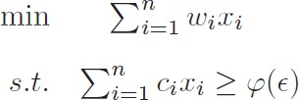

If Wi is the weight and Ci is the capacity of the network, then the following equation should be satisfied. It is only satisfied if it is in polynomial time.

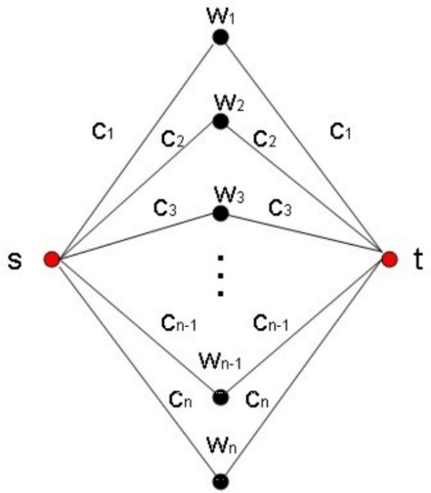

The given constraints are 0-1 integer linear programming. It is a np-hard problem, thus we can say that our problem is also np-hard.

1. *Divide and conquer k-barrier Model- Phase 1*

This section proposes the method for sensor deployment to achieve required barrier coverage. The idea is basically divided in to three phases. First of all in the case of 1- barrier coverage, simply Dijkstra’s algorithm is used to find the minimum number of mobile sensors necessary. Two-barrier coverage can be attained either with the help of Dijkstra's algorithm or using the concept of strong and weak barriers. Alternation of strong and weak barriers according to the application necessity will enhance the lifetime of network. In the case of barrier coverage greater than or equal to 3- barrier coverage, we are proposing the concept of max-flow min-cut algorithm to calculate the minimum number of sensors in order to achieve the goal. Mb, Mb1, Mb2 are the number of required sensor nodes. d is the distance provided and r is the range of a single sensor node. Later for the deployment of sensors, divide and conquer method in deployment area as well as two dimensional positioning of the landing point of each particular sensor is considered.

paths. The alternation of discrete barriers enhances the energy efficiency and lifetime of sensor nodes.

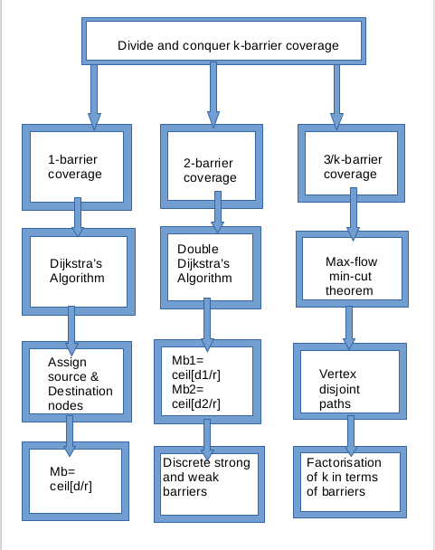

**Data:** k-barrier coverage using weighted barrier graph-2 barrier

**Result:** Approximate values for sensor deployment and requirements

initialization;

Assumption: All nodes with same sensing range and sensing angle(r,a), and the area of bounded belt region in terms of l and h;

**if** *k=2, based on Dijkstra’s algorithm* **then** Assign source and destination nodes (s and t respectively);

Place s and t on the left and right boundaries; Random deployment of remaining nodes;

d1= first shortest path distance; d2= second shortest path distance;

mb1=ceil[d1/r] - (Min no: of mobile nodes necessary along the path of d1);

mb1=ceil[d1/r] - (Min no: of mobile nodes necessary along the path of d2);

Fig. 2. Phases

**Data:** k-barrier coverage using weighted barrier graph-1 barrier

**Result:** Approximate values for sensor deployment and requirements

initialization;

Assumption: All nodes with same sensing range and sensing angle(r,a), and the area of bounded belt region in terms of l and h;

**while** *k=1* **do**

Dijkstra’s Algorithm on weighted barrier graph; Assign source and destination nodes (s and t respectively);

Place s and t on the left and right boundaries ; Random deployment of remaining nodes;

d= shortest path distance;

mb=ceil[d/r] - (Min no: of mobile nodes necessary);

## end

**Algorithm 1:** 1-barrier coverage model

Weighted barrier graph model is implemented using max- flow min-cut theorem. One stationary sensor is must in order to determine the remaining necessity. Using max-flow min- cut theorem, we can find the vertex disjoint paths inside a graph with minimum total length. Maximum flow among the minimum cut set is determined for the further calculations. Discrete barriers can be formed using the vertex disjoint

## else

Discrete strong and weak barrier formation;

ds= strong distance(direct euclidean distance btw v1 and v2);

mbs=ceil[ds/r] - (Min no: of mobile nodes to get strong barrier coverage);

dw= weak distance(horizontal distance btw v1 and v2);

mbw=ceil[dw/r] - (Min no: of mobile nodes to get weak barrier coverage);

## end

**Algorithm 2:** 2-barrier coverage model

1. *1-barrier formation*

One barrier formation is enhanced by the help of Dijkstra's algorithm. Dijkstra’s algorithm computes the nearest neighborhood of each nodes. One node is assigned as source and another one as sink node. After the calculation of shortest path from source to sink node, total weight on path is calculated. The quotient obtained by dividing total weight on the shortest path and coverage range is the number of minimum nodes further required.

1. *2-barrier formation*

By applying double Dijkstra's algorithm, two shortest paths from source to destination can be obtained. After obtaining the results, further proceedings are similar to that of the formation of 1-barrier. An alternative way is the combination of weak and strong barrier formation. Both weak and strong barriers can be formed such that sensor nodes are placed along the weak and strong distance. Weak distance is the direct horizontal distance between nodes whereas strong distance is the direct euclidean distance between two nodes.

**Data:** Novel approach of k-barrier coverage using weighted barrier graph for k-barrier

**Result:** Approximate values for sensor deployment and requirements

initialization;

Assumption: All nodes with same sensing range and sensing angle(r,a), and the area of bounded belt region in terms of l and h; **while** *k greater than 2, let k=t* **do**

Line based deployment of nodes on left and right

boundaries;

Random deployment of nodes inside belt area(Ensure weak distance between every neighbor nodes be : r less than (dist) less than 2r);

Divide belt area into rectangular cells with minimum t number of sensors inside the region;

Apply max-flow min-cut theorem; Obtain vertex disjoint paths;

calculate min no: of necessary mobile nodes;

## end

**Algorithm 3:** K-barrier coverage model

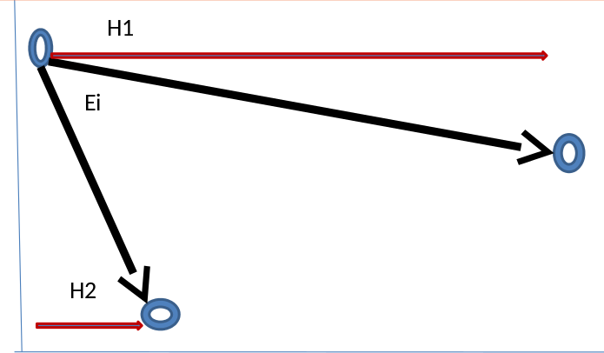

Fig. 3. Weak and strong distances

H1 and H2 are the horizontal distance between two nodes and Ei is the direct euclidean distance between them.

1. *3-barrier formation*

The main three concepts are 1. combination of max-flow min-cut theorem and weighted barrier model. 2. Centroid- centroid connectivity. 3. Virtual path identification. After the dependency analysis of number of nodes and the coverage of a single sensor node, using product consistency rule we have two results. 1. If the coverage of a single sensor node decreases d/n times, then the number of sensor nodes required to obtain barrier coverage increases to d/n-d times 2. If the coverage of a single sensor node increases d/n times, then the number of sensor nodes required to obtain barrier coverage increases to d/n+d times.

If each of the k sensor-disjoint barriers to be formed must contain at least one stationary sensor, determining the minimum number of mobile sensors required to form k-barrier coverage with pre-existing stationary sensors is equivalent to finding k vertex-disjoint paths on the WBG with the minimum total length. Max-flow min-cut theorem is used here. This theorem states that the maximum flow is equivalent to the capacity of the minimum cut-set.

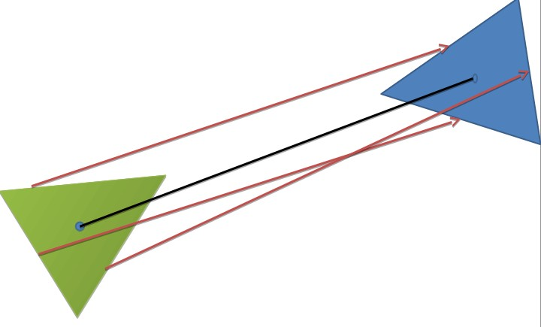

Fig. 4. Centroid-centroid connectivity

After calculating the centroid of a triangle from the given equation, virtual path along each sides are necessary to con- struct.

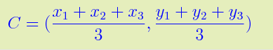

x1-y1,x2-y2,x3-y3 are the coordinates of three vertices of a triangle. C is the x-coordinate and y-coordinate of the centroid of the same triangle.

Method to find grid selection and grid alternation is based on the following algorithm. The belt region is divided in to uniform square grids. Ni is the column index of the grid and Mj is the row index of the grid.

**Data:** Grid selection and alternation initialization;

Select grid NiMj; j as 0;

**while** *Choose nearest and distinct neighborhood from Mj*+*1* **do**

options are;

* 1. grid N(i 1)M(j+1); 2. grid N(i+1)M(j+1);

*−*

## end

**if** *Option 1* **then**

1. Choose grid N(i 1)Mj;

*−*

1. K-barrier across v2 and v3

## else

1. choose grid NiM(j+1);
2. k barrier along v1 and v4

## end

If the next grid is NiM(j+1);

No further selection is required to keep barrier. Update current grid to next grid;

**while** *Right edge of grid reaches right boundary of belt*

## do

end

## end

**Algorithm 4:** Grid formation and alternation

1. PERFORMANCE ANALYSIS

The performance is analyzed using MATLAB simulation tool. The defined problem is actually np-hard and so this work proposes a novel model with defined protocols to achieve the goal. The given figure shows the relationship and result analysis of max-flow min-cut theorem and weighted barrier graph model using the parameters number of nodes and total distances. The result is clear that the number of nodes required is directly proportional to the distance.

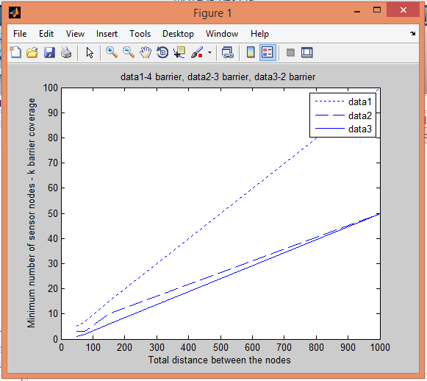

Fig. 5. Analysis of 2, 3, 4 barriers

We are considering the belt region with fixed length. If we are applying product-consistency rule, we get a relationship between the coverage of a single sensor and total number of nodes required to form vertex disjoint paths. Number of nodes to form vertex disjoint barrier is inversely proportional to the coverage of a single sensor node.

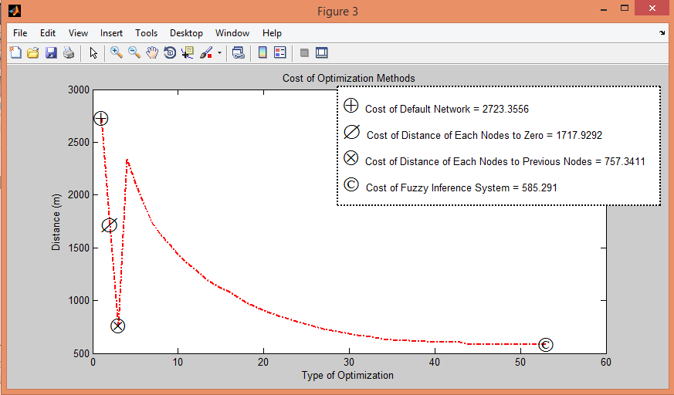

Fig. 6. Analysis of network

The Fig. 6 shows the relation between distance and degree of a node towards the others. Old method of Tabu search and the combination of fuzzy logic called as mamadani is used to predict the graph. Cost for the default network and the system is illustrated by simulation.

Based on the relationship between them we have two results

* If the coverage of a single sensor node decreases d/n times, then the number of sensor node required to obtain desired barrier coverage increases to d/n-d times.
* If the coverage of a single node increases d/n times, then the number of sensor nodes required to obtain barrier coverage decreases to d/n+d times.

As the coverage of a sensor node decreases with increase in lifetime, the above explained relationship helps a lot to fill the barrier gap with minimum number of sensor nodes. A specific percentage of decrease in the sensor coverage results in the requirement of corresponding increase in the percentage of number of extra sensor nodes required to fill the barrier gap.

1. CONCLUSION

Barrier coverage is a hot topic as well as a critical issue in wireless sensor network. The network deployment model, energy efficiency, cost effectiveness and life time of the net- work effect the performance of a dedicated hybrid directional wireless sensor network. Wireless sensor network consist of many nodes deployed in different areas. Coverage area regarding a particular sensor determines the intruders within the range is known as barrier coverage. It has great relevance in the military border protection, forest border protection etc. Different deployment strategies are discussed that can enhance the energy efficiency and lifetime of the network. The concept of cost regarding a particular sensor network depends on its lifetime. The proposed section deals with the method for sensor deployment to achieve required barrier coverage by the combination of max-flow min-cut and Dijkstra's algorithms.

REFERENCES

1. Zhibo Wan, Jilong Liao, Qing Cao, *k-Barrier Coverage in Hybrid Directional Sensor Networks*, 3rd ed. IEEE TRANSACTIONS ON MOBILE COMPUTING
2. Yahua Zhan Xingming Sun, Baowei Wang *K-Barrier Coverage Based on Integer Linear Programming* 2012 IEEE International Conference on Parallel and Distributed Systems
3. Shibo H, IEEE, Xiaowen Gong *Curve-Based Deployment- Wireless Sensor Networks* Member, IEEE, and Elisa Bertino, Fellow, IEEE
4. LAN LIU, BINY AND AND GUILIN CHEN *Strong Barrier Coverage in Mobile Camera Sensor Networks with Grid-Based Deployment*, 3rd ed. JOURNAL OF INFORMATION SCIENCE AND ENGINEERING XX, XXX-XXX (2015)
5. Anwar Saipulla Benyuan Liu Jie Wang *Airdropped Wireless Sensors*, 3rd ed. Member, IEEE, and Elisa Bertino, Fellow, IEEE
6. S.N.Kumar, T.Lai, and A. Arora, *StrongBarrier coverage with wire- less sensors*, 3rd ed. IEEE, and Elisa Bertino, Fellow
7. L. Zhang, J. Tang, and W. Zhang, ,“Strong barrier coverage with directional sensors,” *IEEE TRANSACTIONS ON NETWORKING.*,VOL. 26,NO. 2, FEBRUARY 2015
8. Manel Boujelben,Habib Youssef,Rania Mzid and Mohamed Abid ,“ On full-view coverage in camera sensor networks” ”*IEEE Transactions On Dependable And Secure Computing*,ICSI 2012, Part II, LNCS 7332, pp. 351359, 2012.
9. C. Shen, W. Cheng, X. Liao, and S. Peng, ,”Barrier coverage with mobile sensors ,” *Springer-Verlag Berlin Heidelberg 2012*, Vol. 3, No. 1, January 2014.
10. Junzhao Du, Member, IEEE, Kai Wang, Hui Liu, and Deke Guo, Member, IEEE ”Maximizing the Lifetime of k-Discrete Barrier Coverage using Mobile Sensors”, IEEE Transaction on Sensors Journal
11. Donghyun Kim, Senior Member, IEEE, Wei Wang, Junggab Son, Member, IEEE, Weili Wu, Senior Member, IEEE, Wonjun Lee, Senior Member, IEEE, Alade O. Tokuta, Member, IEEE ”Maximum Lifetime Combined Barrier-coverage of Weak Static Sensors and Strong Mobile Sensors”, IEEE TRANSACTIONS ON MOBILE COMPUTING, VOL.

XX, NO. XX, 2016

1. Jiming Chen, Senior Member, IEEE, Junkun Li, and Ten H. Lai ”Energy-Efficient Intrusion Detection with a Barrier of Probabilistic Sensors: Global and Local”, IEEE TRANSACTIONS ON WIRELESS COMMUNICATIONS
2. Junkun Li , Jiming Chen , Shibo He , Tian He , Yu Gu , Youxian Sun , ”On Energy-Efficient Trap Coverage in Wireless Sensor Networks”, ACM Transaction on Computer Networks