**Advanced Vehicle Pooling System**

Mrs.PrinceSaghayaBrighty#1, V.Deepika#2, B.JanaPriya#3 Department of Computer Science & Engineering, Sri Ramakrishna Engineering College, Coimbatore, Tamil Nadu, India.

**Abstract:- Vehicle pooling is a solution to the problems of traffic jams, pollution, and extra use of fuel. Our application is an attempt to make a system which is user friendly and provides an opportunity to share vehicles. The service will allow users to offer and request ride sharing journeys using their Android enabled phones. The main problem in vehicle pooling is how to find out who travels to the same destination as yours every day or who is interested in vehicle pooling. Using this developed android application vehicle owner can create a ride by giving information like source, destination, starting time of journey, available seats etc. Sharer will be able to provide inputs like source and destination. The dynamic vehicle pooling system relies on the information from two users i.e. ride creator or vehicle owner and ride seeker.**

**Keywords: vehicle pooling, Smart System**

**I. INTRODUCTION**

to the same destination or via destination. Also one should contact the people in their circle directly if they want to travel together with them. This application contains two medium namely owner and sharer. Owners are the one who initiate the travel and fix the destination and sharers are the one who accepts to travel with the owner.

Here our application mainly concentrates on simplicity and security and how to travel efficiently using multiple references.

**A.Vehicle Pooling**

Vehicle pooling system is the solution aims at solving problem by targeting all the vacant seats in the private vehicles.

Vehicle pooling system helps in reducing traffic congestion as number of vehicles on the road can be reduced significantly.

**Benefits of vehiclepooling:**

In recent past we are able to see a huge increase in the automobiles (car and bikes) in Our Environment, which gives lots of problems in controlling the parking and the toxic gases from automobiles which pollutes the environment. There are few people who wait for public transports to reach office. One of the best solutions to reduce these issues to a considerable amount would be to introduce a live android based mobile app for Car/Bike pooling.

This document is entitled as “**Advanced Vehiclepooling** **System**”is developed as a mobile application using clientserver tools programs like xml as front end, java as coding language and SQLlite server as backend. For mobile application Android SDK as the development kit, Eclipse as coding language.

The main purpose of this project is to reduce the travelling cost while travelling through private vehicles like car, cabs and etc from the same institute. In this fast life, individuals find difficult to interact with people due to lack of time even though they belong to same place as the destination. Still many people travelling alone in a car for long distance in the same institute. This makes more expensive for the traveler. According to the survey, group traveling will reduce the cost of travel, provides more secured, fuel efficiency, less pollutes the environment and etc. Group travel will give us more advantages than single travel.

In order to connect people, this Android application is developed to be connected with those people who are travelling

* Vehiclepooling enables some families to cut back to one car or to do without a car at all.
* If you don’t have a vehicle or don’t drive, Vehiclepooling allows you to consider jobs throughout the area.
* Vehiclepooling can provide you with new friendships and company for your commute.
* Vehiclepooling reduces air pollution and traffic congestion, something that benefits all of us!
* Vehiclepooling helps to combat rising traffic congestion, by filling the extra seats in your vehicle.
  + - 1. **LITERATURE SURVEY**
  1. Raza Hasan, Haftamu Menker Gebreyohannes, Abdul Hadi

Bhatti, Syed Imran Ali, Mohammed Sohali Hayat and Abeer Javed Syed, **“Smart Peer Car Pooling System”**, IEEE 3rd MEC International Conference, March 2016.

* + - This paper looks into the rapid growth of staff and students in Middle East College.
    - Problems like increase number of vehicles, traffic, parking problems, fuel combustion etc.
    - To overcome this problem Smart Peer Car Pooling System can be can be a solution for the given problems.
    - It is an effective means of reducing traffic congestion, waiting time, wastage of resources and fuel

consumption, improving social life, reducing the number of accidents and environmental pollution

1. Gerald Arnould, Djamel Khadraoui, Marcelo Armendariz, Juan C. Burguillo, Ana Peleteiro, **”** **A Transport Based**

**Clearing System for Dynamic Carpooling Business**

**Services”** IEEE 11thInternational Conference, 27 October2011.

* + Wireless communication and service platform is used to target vehicular networks, striving to reduce accidents and traffic congestion.

• Within the frame of this project, a dynamic

carpooling transport system was designed, reacting

in real time to events and user transport requests.

* + - The system have been prototyped, using the **Netlogo simulator** inorder to improve theefficiency.

1. S. Di Martino, R. Galiero, C. Giorio F. Ferrucci, F.Sarro “**A**

**Matchig-Algorithm based on the cloud and positioning systems to improve car pooling”**

* + - * In this paper, a solution for a Cloud computing-based platform is presented.
      * The system helps users to find the correct match of the owner and the sharer using the matching algorithm.
  1. Prathmesh J.,Avinash G.,Apurva J.,Smita Rukhande, Kalpana Wani, **"Pool’up-Carpooling using GPS’"**, International Conference on Global Computing(ICGC-2011).
     + In this paper carpooling generally makes use of three recent technological advances:
       - * GPS navigation devices to determine a driver's route and arrange the shared ride.
         * Pool' up is an application that adds on to the pool of already existing, useful software’s.
         * Pool up runs on a mobile and using GPS technology enables car pooling in a more efficient and flexible manner.
  2. Riccardo Manzini, Arrigo Pareschi **“A Decision-Support**

**System for the carpooling problem”** March 16, 2012

* + - This paper presents an original approach to solve the car pooling problem. It is based on hierarchical clustering models, which have been adopted by an original decision support system (DSS).
    - The DSS helps mobility managers to generate the pools and to design feasible paths for shared vehicles

**III. PROPOSED SYSTEM**

The users will have our developed carpooling android application installed in their android smart phones. The vehicle

pool process will be initiated by registering the users. Then users will be able to create and share rides.

The Carpooling application will be implemented in Android operating mobile phones. This system has the following features:

● User accounts for both the owner and sharer.

* Use GPS to track the location.
* Integrating google maps so that the owner can

provide his detailed route and then the potential sharer can view and decide their source and destination point.

* User profile which will have vehicle details like

vehicle registration number, model of the vehicle.

* Genderwise option is provided so that the women can share their ride with women.

**SYSTEM ARCHITECTURE**

The system architecture shows the actual working of the system. The sharer and owner are the two main actors that are involved in this system.

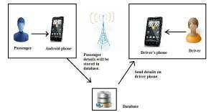

**ACTUAL WORKING OF THE SYSTEM**

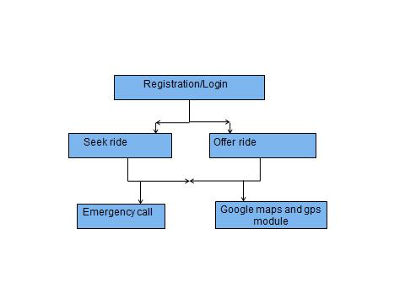

**MODULES**

* Owner
* Sharer
* Travel Confirmation
* Emergency call
* Google maps and gps module

**MODULE DESCRIPTION:**

**OWNER**

Sign up is the initial process of the project. Here the owner can create the free sign up with their personal details and create the travel details like vehicle type, vehicle number and amount. After entering the details the owner has to sign in and give their source and destination. Owner can be able to update their locations and view the sharer details. The owner can accept or ignore the sharer request.

**Owner Updating Source and Destination**

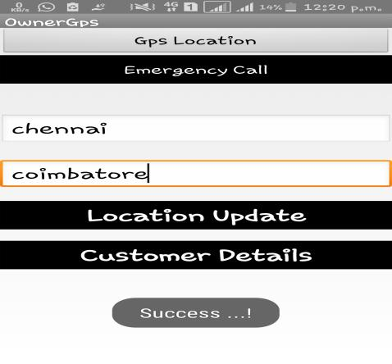

**Sharer Details**

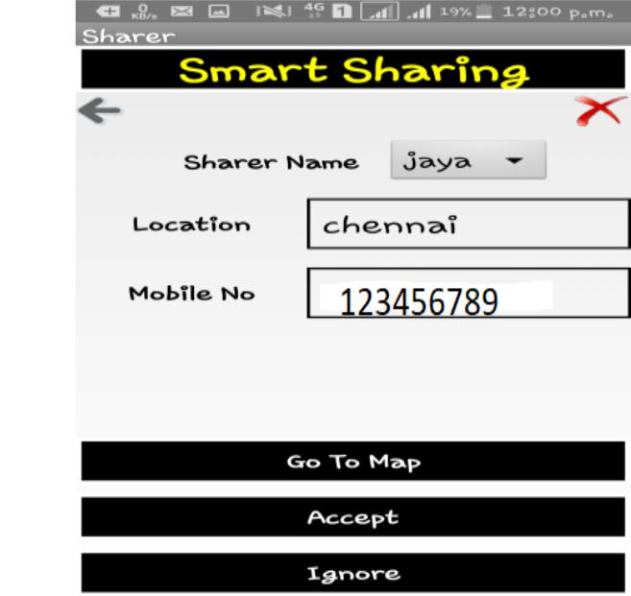

**SHARER**

The same process is for sharer. Sharer need to sign up with their personal details and need to update their source and destinations. Once the sharer selected the source and destination, they can see the owner’s basic details like name and vehicle details. A request will be sent to the owner from the sharer. Now owner can see the sharer’s request.



**Sharer Updating Source and Destination**

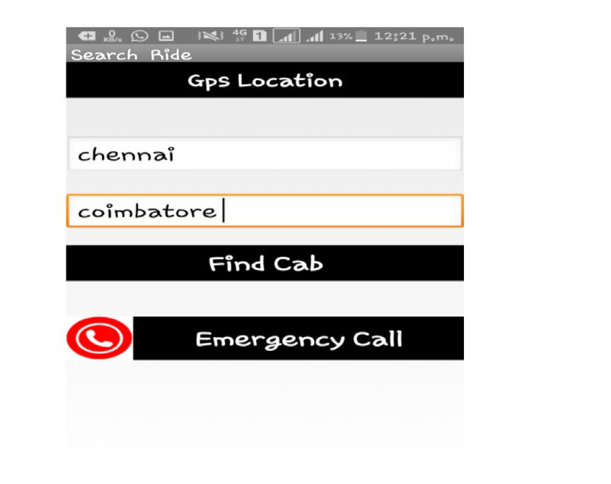

**Owner Details**

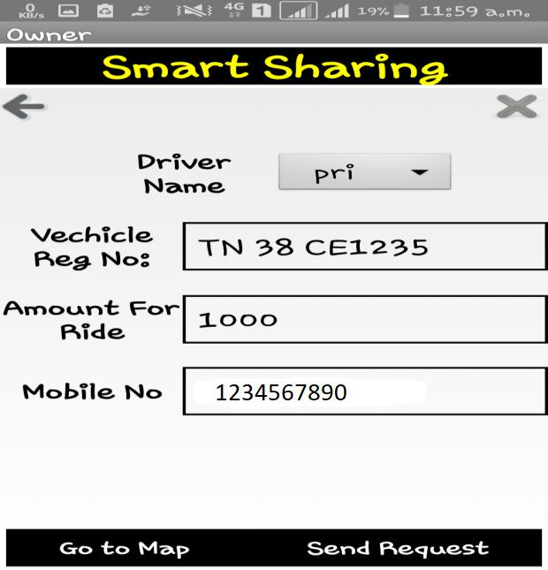

**TRAVEL CONFIRMATION**

The travel confirmation will be done by the owner only. The owner can view the sharer’s full details. The owner can either accept or ignore the sharer’s request. Once the owner

accepts the request the confirmation message will be sent to the sharer and vice versa.

**Accepted the request**

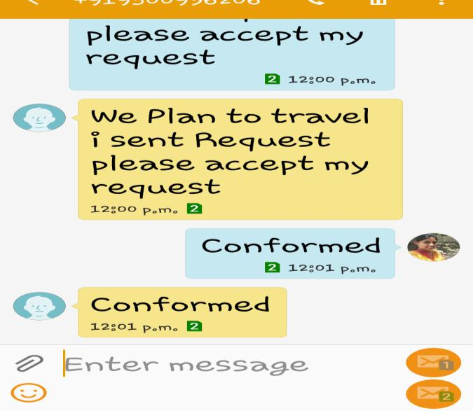

**Ignored the request**

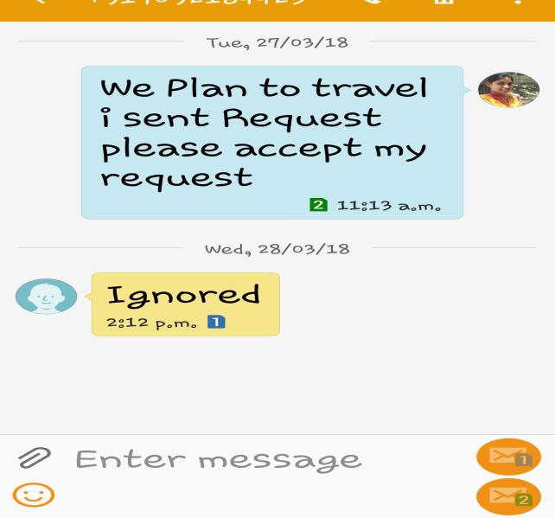

**EMERGENCY CALL**

If the owner or sharer feels unsafe during the ride or met with accidents they can click the emergency call button. It is used to inform the emergency contacts.

**GOOGLE MAPS AND GPS MODULE**

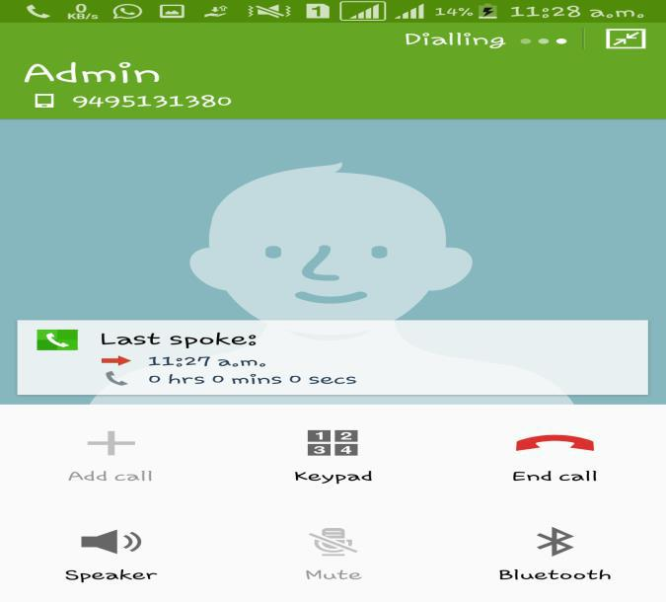

This application uses Google Maps API. This API is used to add maps to the application, which will inturn used to show user locations.

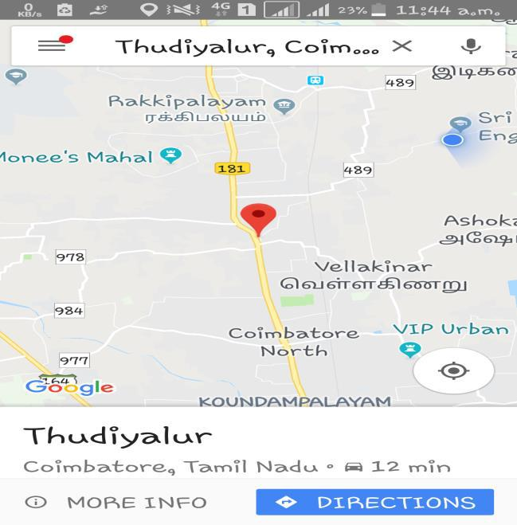

**REQUIREMENTS**

**Hardware Requirements**

1)Processor – Core2duo

2)Ram – 4GB

3)Hard Disk -1TB

**Software Requirements**

1)Windows 8.1

2)Java JDK

3)SQL Lite

4)Eclipse

**CONCLUSION**

Thus we propose to develop a **Advanced Vehicle** **pooling System** that can increase the vehicle occupancy andreduce problems like pollution, parking problems, fuel wastage, accidents and traffic problems. The best solutions to reduce these issues to a considerable amount would be to introduce a android based mobile app for vehicle pooling. we developed an application on android as it is more user-friendly and easily available. However there are future enhancements that can be done in future. Future enhancements include advanced payment system.

**REFERENCES**

1. Raza Hasan, Haftamu Menker Gebreyohannes, Abdul Hadi

Bhatti, Syed Imran Ali, Mohammed Sohali Hayat and Abeer Javed Syed, **“Smart Peer Car Pooling System”**, IEEE 3rd MEC International Conference, March 2016.

* 1. J. Xi, K. Curtin, W. Li and Y. Zhao, “**A New Model for a** **Carpool Matching Service**”,2015.

1. Riccardo Manzini, Arrigo Pareschi **“A Decision-Support**

**System for the carpooling problem”** March 16, 2012

1. Prathmesh J.,Avinash G.,Apurva J.,Smita Rukhande, Kalpana Wani, **"Pool’up-Carpooling using** **GPS’"**, International Conference on Global Computing(ICGC-2011).
2. Gerald Arnould, Djamel Khadraoui, Marcelo Armendariz,

Juan C. Burguillo, Ana Peleteiro,” **A Transport Based**

**Clearing System for Dynamic Carpooling Business**

**Services”** IEEE 11thInternational Conference, 27 October2011.

1. Kum Kum Dewan and Israr Ahmad,**”Carpooling:** **A Step** **to Reduce Congestion”**, February 2007
2. S. Di Martino, R. Galiero, C. Giorio F. Ferrucci, F.Sarro “**A**

**Matchig-Algorithm based on the cloud and positioning systems to improve car pooling”**