**WEARABLE DEVICE FOR FALL DETECTION USING 3-D ACCELEROMETER**

Nasiya.PM

PG Student(Department of Computer Science and Engineering)

Sahrdaya College of Engineering And Technology, Kodakara,Thrissur

Email: nasiya.pm2010@gmail.com

**ABSTRACT**

A fall detection device is needed to provide information to paramedics or family members when an elderly is falling. Helping for elderly falling can avoid fatal injuries or loss of life. In order for the falling device comfortably taken by the elderly, we proposed a wearable device that lightweight, using battery for power supply, and a low-energy consumption.Our proposed device consists of: 3-dimensional accelerometer as a sensor, a microcontroller and a communication device. The sensor provides accelerations of elderly body movements. Then, the microcontroller identifies position body and a falling from three-axis accelerations. We use parameter threshold in our proposed fall detection as a method that has success detect 75% in fall forward and 95% in fall backward. The proposed device also has a 100% success in providing information on normal activities, such as: standing or sitting, supine, face down, left and right, while the success rate for the e-health device by cooking hack is 92%.

***Keywords---- Fall Detection; Wearable Device; 3-D Accelerometer***

-----------------------------------------------------------------------------------------------------------------

1. **INTRODUCTION**

Over 60 years old, anybody can be categorized as elderly that have many problems within the health and physical condition. One risk that occurs in aged is falling caused byNminor accidents, loss of consciousness, balance the body heart failure, respiratory problems, drug side effects, and homely environmental and loss of consciousness [3]. The falling cause worse health or cause death when elderly not get help soon. This is because people unconscious or difficulty to inform their condition to others when and where they fell. For these reasons, immediately detection of the incident fall in order to get aids is an important to prevent fatal conditions. Then, a system which can provide information to families or paramedics when elderly is falling desperately needed. There are some methods approached of fall detection, one popular method uses an optical sensor (camera) that uses image processing to the observed differences in the captured image[4].

The system can identify whether the fall is an object or a human. The other method is to observe anomaly vibrations and sounds from the floor to identify anybody or a thing fall. Accelerometer sensor is widely used as a human sensor falls, which uses a 3-dimensional accelerometer sensor to detect a falling. The other research uses the internal accelerometer sensor on a smart phone. However, the fall detection device is few implementing uses a smart phone, since the smart phone is not designed to a clash when an aged fall. The purpose of this research is to develop a wearable device to detect a human body fall in accordance with the elderly conditions, namely: the device is light weight, uses a battery power supply and has low-energy consumption. Our proposed devices use a 3-dimensional accelerometer sensor, and some instrument placed at waist old people.The rest of this paper is organized as follows. SectionII describes the method and ideas of our proposed wearable device. Section III provides our simmulation result. Finally, Section IV concludes this paper.

1. **METHOD**

There are several methods for detecting anybody falling down, such as: threshold and machine learning. Machine learning methods have good accuracy. However, requires high computing cost, big physical size and large energy consumption. In[6], authors classify falling down and normal activity using SVM and artificial networks. Although the accuracy threshold method is not as good as the machine learning, threshold method is more suited implements wearable device and low energy consumption. Since computation of this method is simple and possible implement in the small size. The threshold parameters for fall detection are calculated from some of the sensors, e.g. 3-axis accelerometer, gyroscope, and tilt sensors.

1. *3-D accelerometer*

A three dimensional (3D) accelerometer is an electromechanical device that can measure a dynamic acceleration and a static acceleration in three directions coordinates x, y, and z as illustrated in figure 1. Dynamic acceleration is linear acceleration when the accelerometer moves, while the static acceleration is an inertia-acceleration. The inertia-acceleration is called G-Force (G), 1G = 9.80665 m/s2. This sensor is used to measuring orientation of a human body by calculating the inertia-acceleration on each axis. Thus, the output from the 3D accelerometer can be used to calculate the value of pitch, roll and yaw of anybody.



Fig. 1. 3-D Accelerometer Fig. 2. Pitch, roll and yaw

1. *Pitch, Roll and Yaw*

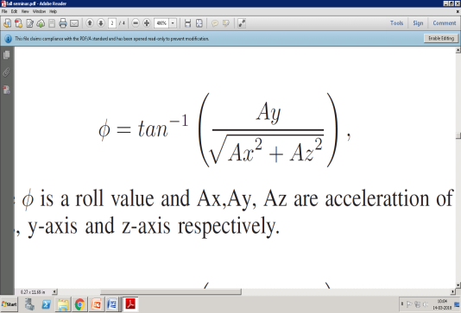 Any movements in the x, y and z coordinates measured as an angle. The roll, pitch and yaw are rotaries movement Fig. 1. 3-D Accelerometer of the x-axis, y-axis and z-axis to the plane shown in figure 2. In this paper, we do not explain yaw since fall detection algorithm only uses roll and pitch parameter. We can find the angle value of pitch and roll of the human body (figure 3) using the 3-D accelerometer with the following trigonometric equation:

*(1)*

where *φ* is a roll value and Ax,Ay, Az are accelerattion of the x-axis, y-axis and z-axis respectively.

*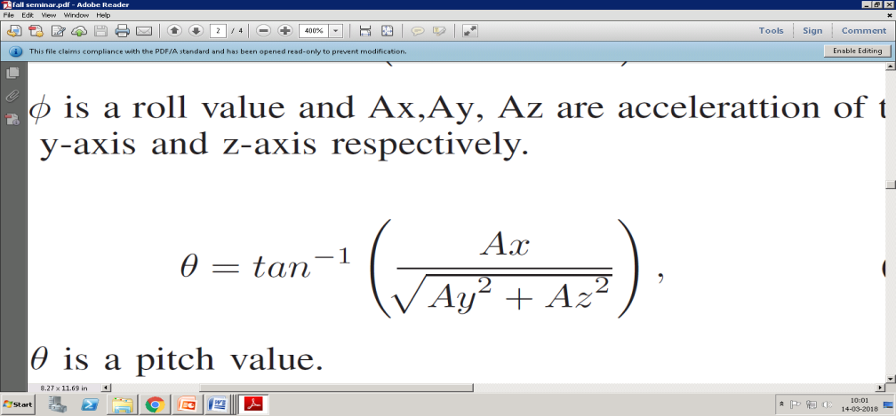 (2)*

where *θ* is a pitch value.

1. *Alpha*

The value of alpha (*α*) is the magnitude vector acceleration from the output of 3-D accelerometer (figure 4). The equation of magnitude the value of alpha (*α*) is the sum of squares linear acceleration in the x, y, and z axis of the accelerometer sensor with the following equation:

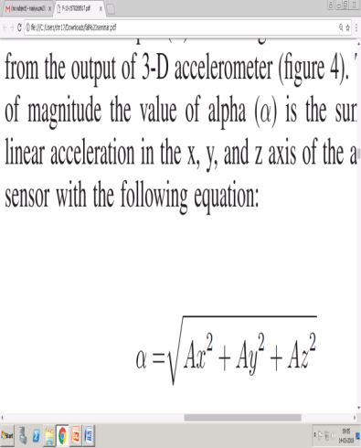 *(3)*

This value is used as the threshold value to determine the body orientation and fall of elderly.

 

Fig. 3. Angle values of pitch and roll Fig. 4. The value of alpha (*α*) at coordinates x, y and z

1. *Normal activities and fall Identifications*

The proposed device can detect falls and five normal activities that are standing or sitting, supine, face down, leftmlateral recumbent and right lateral recumbent. Fall could be detected to fall forward and fall backward. We used combination threshold of Ax, Ay, Az, *α*, *φ* , *θ* are the acceleration of x-axis, y-axis, z-axis, the value of alpha, roll, pitch. 3D accelerometer outputs from the prone position are visualized with two-dimensional graph as shown in figure 5 . Fig. 5. The acceleration of the x-axis, y-axis and z-axis in the prone positon Figure 5 shows the value of Ax in the prone position is always positive. Therefore, we use a threshold is 0.5, which mean the value of the acceleration in the x-axis greater than0.5. Meanwhile, the pitch values we use greater than equal 40, and the roll values between -40 until 40 as shown in figure 6. Figure 7 is used to find parameter of alpha, we use greater than 0.9. The threshold value of the output 3-D accelerometer

 

Fig. 5. The acceleration of the x-axis, y-axis and Fig. 6 The values of alpha (*α*) in the prone position

z- axis in the prone position

sensor in the sitting or standing, supine, prone, left and right positions as shown in table 1. In contrast to normal activity, fall has an accelerating in the x-axis and y-axis the rise suddenly. Our proposed device can detect two types falls that are: fall forward and fall backward. Fall forward is a change from standing to prone position. Some of the differences between fall forward and prone are: acceleration of the x-axis and z-axis in the fall forward is rising abruptly compare to the prone position. The figures 8, 9 and 10 are the output accelerometer in the fall forward. The alpha value in the prone position is 0.9 to 1.2, while the value of alpha of fall forward is above 1.2 as shown. Meanwhile fall backward is a sudden movement from standing to supine position. There some differences between falling backward and supine are: acceleration of the x-axis and z-axis in the falling backward is rising abruptly compare to the supine position. From the characteristics fall forward and fall backward mentioned in above, we can conclude the threshold parameters of them as shown in table 2. Our proposed device identifies the normal positions, fall forward and fall backward using threshold parameter in table I and table I.

1. **EXPERIMENT RESULTS**

In this section, we investigate performance of our proposed device when: used in normal activity and falling. The positions of normal activities are: standing or sitting, supine, face down, left and right.

1. *Normal Activities Experiments*

We test normal activity positions using two people as shown in figure 11, each position is 10 times trial each person. Results of the proposed device are compared to the e-health sensor. E health sensor is a hardware product manufactured by cooking hacks comprising sensors and data acquisition for medical applications. In figure 11, our proposed device better results are compared to e-health device in supine and prone positions. Meanwhile, the results in standing/sitting, left, right positions both our device and e-health device can detect perfectly in

all experiments.

 

Fig. 7. The acceleration of the x-axis, y-axis and z-axis when any body is Fig. 8. The values of pitch and roll falling forward

*B. Falls Experiments*

In our second experiment, we evaluated the implementation of our device when an old is falling. In Figure 12, We can see that our device better identification when elderly fall forward compares to fall backward. Our device success detects elderly fall forward is 95% meanwhile only 75% in fall backward.

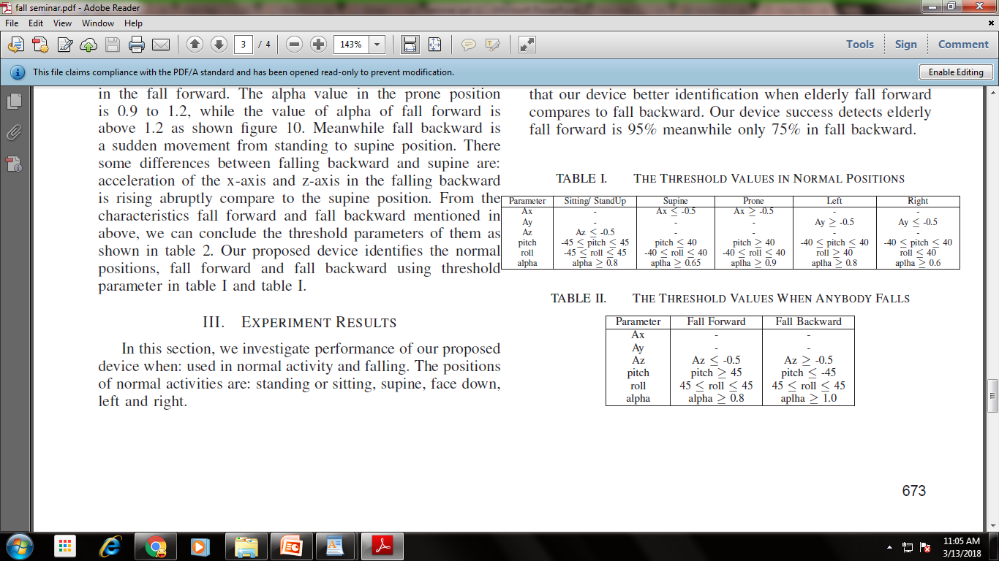 

 

Fig. 9. Normal activities experiments

Fig. 10. Detection qualities of normal activities



Fig. 11. Detection qualities when any body is falling

1. **CONCLUSION**

For measure robustness our proposed device, we compare the accuracy identification between our device and e-health device; During tested in standing/sitting, left, right positions, both our device and e-health device can detect perfectly in all experiments. However, our proposed device is a slightly better result in supine and prone positions compare to the e-health device. So we can conclude that our device has an average identification 100% meanwhile e-health device has 92%. In falling experiment, we cannot compare both like in normal activity experiments since the e-health device has not featured for fall detection. In this experiment, we merely measure quality of detection when anybody falling forward and falling backward. The proposed device success detects anybody falling forward is 95%. However, our device is only detected 75% in falling backward.

**REFERENCES**

[1] M. Peden, K. McGee, and G. Sharma, *The injury chart book: a*

*graphical overview of the global burden of injuries*, Geneva: World

Health Organization, vol. 5, 2002.

[2] K. E. Thomas, J. A. Stevens, K. Sarmiento, and M. M. Wald, *Fallrelated*

*traumatic brain injury deaths and hospitalizations among older*

*adultsunited states*,Journal of safety research, vol. 39, no. 3, pp. 269272,

2008.

[3] *Causes elderly people to fall*, http://www.agingcare.com/Articles/Fallsin-

elderly-people133953.htm, Accessed: May 18,2015.

[4] B. J. Lee, S. F. Su, and I. Rudas, *Content-independent image processing*

*based fall detection*, in System Science and Engineering (ICSSE), 2011

International Conference on, pp. 654659, IEEE, 2011.

[5] H. W. Tzeng and M. Y. Chen, *Design of fall detection system with*

*floor pressure and infrared image*, in System Science and Engineering

(ICSSE), 2010 International Conference on, pp. 131135, IEEE, 2010.

[6] T. Zhang, J. Wang, L. Xu, and P. Liu, *Fall detection by wearable*

*sensor and one-class svm algorithm*, in Intelligent Computing in Signal

Processing and Pattern Recognition, pp. 858863, Springer, 2006.