CMPE2150 Lab 04
  - Optoisolated TRIAC
Taylor, Moore, and Armstrong
18 Oct 2024
Table of contents

Optoisolated TRIAC for AC Control
- Using the parts listing for the CNT Year 2 Kit, determine which components $U_{1}$ and $Q_{1}$ would have to be for you to build the circuit below:
  - $U_{1}$:__________
  - $Q_{1}$: __________
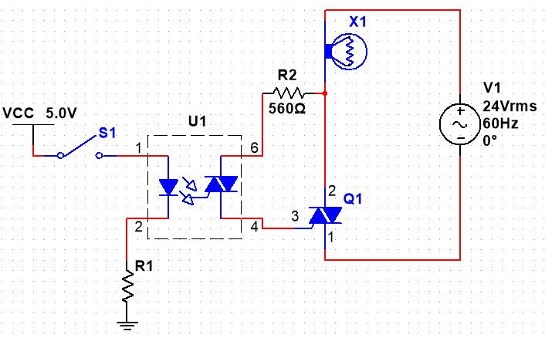
AC Control with Dual TRIACs and Optoisolation
- On the manufacturer’s specification sheet for $U_{1}$, locate the Typical forward voltage of the LED and, using the current shown for the test condition of the LED’s forward voltage, pick a suitable 10% standard resistor value for $R_{1}$ (select a value that allows slightly more than required if you have to choose between two): __________ $Ω$
- Using the manufacturer’s specification sheet for $Q_{1}$, determine the pinout for $Q_{1}$. It won’t likely match what you would guess from the schematic symbol!
- Build this circuit far to the right side of your breadboard (to leave space for project components later), using:
  - a normally-open pushbutton switch (PB-NO) for $S_{1}$,
  - the $24V_{AC}$ transformer from the CNT Year 2 Kit as $V_{1}$,
  - the $24V$ halogen light bulb from the CNT Year 2 Kit,
  - if you don’t have a bench power supply available, use $+5V_{DC}$ from the input of one of your PowerBRICKs or your CNT power supply board for $V_{CC}$.
  -  Warning
  - Recall that this is directly connected to the $5V$ supply of your USB port, so make sure your circuit is wired correctly in order to prevent possible damage to your computer.
- Wearing your safety glasses, verify that the lamp lights and goes off when you cycle the switch—don’t leave it on for very long at a time, as it will get hot enough to burn you and melt any plastic nearby, including your breadboard. It will also be quite bright, so try to avoid looking at it for long.

Build and Test
Once you are satisfied, build your circuit using the parts from your kit and demonstrate it for your instructor during class: __________

