Project 1:  
Connect Four

By: Alyssa Arntzen

February 3, 2019

**Introduction**

This is a Connect 4 Game for C++. Connect four is a game with a board that stands between the two players. It is a 7x6 board with holes on either side and an insert at the top.The players take turns dropping circular tiles into the columns. The tiles fall straight down so they take the lowest space available. The first to connect four of their tiles either horizontally, vertically, or diagonally wins.

**Summary**

Lines: 1140~

I started off writing the program as a two player game. I thought of the program with arrays and functions in mind but since we aren’t able to use them for this project, it is not complete. With 1000+ lines, I was only able to write code suitable for the first two moves. If I kept going, it would have gotten ridiculously repetitive so I will save the rest of the code for project 2. As I implemented a few more concepts, I decided I wanted to add an option to play against the computer, using random numbers. The code got long once again (since it was pretty much just the same code as if there were two players, just different inputs for whether if it was the 2nd player or computer) so I split it into two different versions. If arrays and functions would help I will implement the one player mode as well. I think the biggest challenge overall is that in only six weeks we are to understand each concept and implement them correctly into the project, and admittedly, I didn’t understand some concepts fully or I was unable to include them into the program, so I hope that Project 2 will allow me to implement more concepts.

**Psuedocode**

//Set random number seed

//Declare Variables

Number of rows, columns on board.   
Player one moves, Player two moves, Computer moves

Names of Players

//Display Intro

“Welcome to Connect Four”  
*Prompt user for name*

//Display board and ask user where they would like to place first tile

If user chooses column 1:

Display ‘X’ at column 1, row 1.

Computer then takes his turn via srand.

If computer chooses 1:  
 Display first four rows

Display fifth row with an ‘O’ in first column

Display sixth row with an ‘X’ in first column.

Else if computer chooses 2:

Display first five rows

Display sixth row with ‘X’ in first column and ‘O’ in second.

Else if computer chooses 3:

Display first five rows

Display sixth row with ‘X’ in first column and ‘O’ in third

Else if computer chooses 4:

Display first five rows

Display sixth row with ‘X’ in first column and ‘O’ in fourth

Else if computer chooses 5:

Display first five rows

Display sixth row with ‘X’ in first column and ‘O’ in fifth

Else if computer chooses 6:

Display first five rows

Display sixth row with ‘X’ in first column and ‘O’ in sixth.

Else computer chooses 7:

Display first five rows

Display sixth row with ‘X’ in first column and ‘O’ in seventh.

If user chooses column 2:

Display ‘X’ at column 2, row 1.

Computer then takes his turn via srand.

If computer chooses 1:  
 Display first five rows

Display sixth row with an ‘O’ in first column and ‘X’ in second.

Else if computer chooses 2:

Display first four rows

Display fifth row with ‘O’ in second

Display sixth row with ‘X’ in second.

Else if computer chooses 3:

Display first five rows

Display sixth row with ‘X’ in second column and ‘O’ in third

Else if computer chooses 4:

Display first five rows

Display sixth row with ‘X’ in second column and ‘O’ in fourth

Else if computer chooses 5:

Display first five rows

Display sixth row with ‘X’ in second column and ‘O’ in fifth

Else if computer chooses 6:

Display first five rows

Display sixth row with ‘X’ in second column and ‘O’ in sixth.

Else computer chooses 7:

Display first five rows

Display sixth row with ‘X’ in second column and ‘O’ in seventh.

If user chooses column 3:

Display ‘X’ at column 3, row 1.

Computer then takes his turn via srand.

If computer chooses 1:

Display first five rows

Display sixth row with an ‘O’ in first column

Display sixth row with an ‘O’ in first column and ‘X’ in third.

Else if computer chooses 2:

Display first five rows

Display sixth row with ‘X’ in third column and ‘O’ in second.

Else if computer chooses 3:

Display first four rows

Display fifth row with ‘O’ in third column

Display sixth row with ‘X’ in first column

Else if computer chooses 4:

Display first five rows

Display sixth row with ‘X’ in third column and ‘O’ in fourth

Else if computer chooses 5:

Display first five rows

Display sixth row with ‘X’ in third column and ‘O’ in fifth

Else if computer chooses 6:

Display first five rows

Display sixth row with ‘X’ in third column and ‘O’ in sixth.

Else computer chooses 7:

Display first five rows

Display sixth row with ‘X’ in third column and ‘O’ in seventh.

If user chooses column 4:

Display ‘X’ at column 4, row 1.

Computer then takes his turn via srand.

If computer chooses 1:

Display first five rows.

Display sixth row with an ‘O’ in first column and ‘X’ in fourth

Else if computer chooses 2:

Display first five rows

Display sixth row with ‘X’ in fourth column and ‘O’ in second.

Else if computer chooses 3:

Display first five

Display sixth row with ‘X’ in fourth column and computer in third

Else if computer chooses 4:

Display first four rows

Display fifth row with ‘O’ in fourth column

Display sixth row with ‘X’ in fourth column

Else if computer chooses 5:

Display first five rows

Display sixth row with ‘X’ in fourth column and ‘O’ in fifth

Else if computer chooses 6:

Display first five rows

Display sixth row with ‘X’ in fourth column and ‘O’ in sixth.

Else computer chooses 7:

Display first five rows

Display sixth row with ‘X’ in fourth column and ‘O’ in seventh.

If user chooses column 5:

Display ‘X’ at column 5, row 1.

Computer then takes his turn via srand.

If computer chooses 1:

Display first five rows.

Display sixth row with an ‘O’ in first column and ‘X’ in fifth.

Else if computer chooses 2:

Display first five rows

Display sixth row with ‘X’ in fifth column and ‘O’ in second.

Else if computer chooses 3:

Display first five

Display sixth row with ‘X’ in fifth column and ‘O’ in third

Else if computer chooses 4:

Display first five rows

Display sixth row with ‘X’ in fifth column and ‘O’ in fourth

Else if computer chooses 5:

Display first four rows

Display fifth row with ‘X’ in fifth column

Display sixth row ‘O’ in fifth column

Else if computer chooses 6:

Display first five rows

Display sixth row with ‘X’ in fifth column and ‘O’ in sixth.

Else computer chooses 7:

Display first five rows

Display sixth row with ‘X’ in fifth column and ‘O’ in seventh.

If user chooses column 6:

Display ‘X’ at column 6, row 1.

Computer then takes his turn via srand.

If computer chooses 1:

Display first five rows.

Display sixth row with an ‘O’ in first column and ‘X’ in sixth

Else if computer chooses 2:

Display first five rows

Display sixth row with ‘X’ in sixth column and ‘O’ in second.

Else if computer chooses 3:

Display first five

Display sixth row with ‘X’ in sixth column and computer in third

Else if computer chooses 4:

Display first five rows

Display sixth row with ‘O’ in fourth column, and ‘X’ in sixth

Else if computer chooses 5:

Display first five rows

Display sixth row with ‘X’ in sixth column and ‘O’ in fifth

Else if computer chooses 6:

Display first four rows

Display fifth row with ‘O’ in sixth column

Display sixth row with ‘X’ in sixth column

Else computer chooses 7:

Display first five rows

Display sixth row with ‘X’ in sixth column and ‘O’ in seventh.

If user chooses column 7:

Display ‘X’ at column 7, row 1.

Computer then takes his turn via srand.

If computer chooses 1:

Display first five rows.

Display sixth row with an ‘O’ in first column and ‘X’ in seventh

Else if computer chooses 2:

Display first five rows

Display sixth row with ‘X’ in sixth column and ‘O’ in seventh.

Else if computer chooses 3:

Display first five

Display sixth row with ‘X’ in sixth column and computer in seventh

Else if computer chooses 4:

Display first five rows

Display sixth row with ‘O’ in fourth column, and ‘X’ in seventh

Else if computer chooses 5:

Display first five rows

Display sixth row with ‘X’ in sixth column and ‘O’ in seventh

Else if computer chooses 6:

Display first five rows

Display sixth row with ‘X’ in seventh row and ‘O’ in sixth.

Else computer chooses 7:

Display first four rows

Display fifth row with ‘O’ in 7th column

Display sixth row with ‘X’ in 7th column

**Examples of Outputs**

With two players

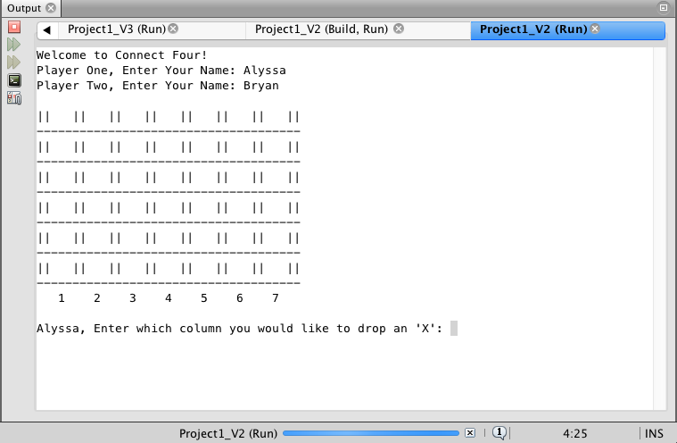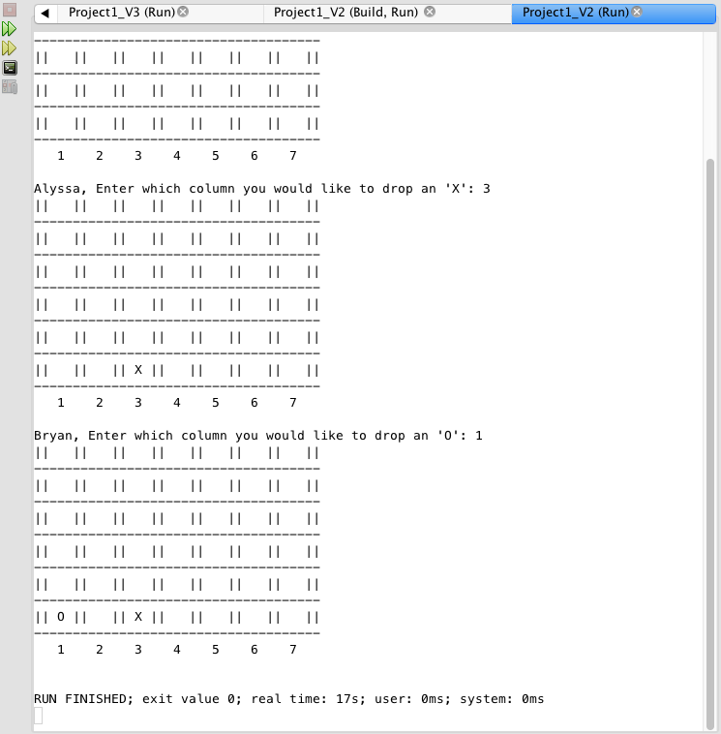

With one player  
  
