REGISTRATION AND BUS DETAILS
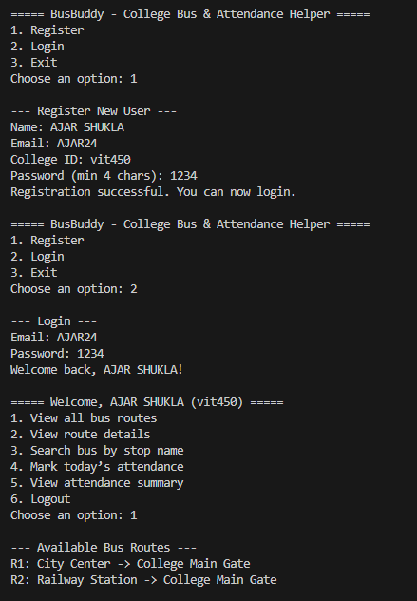

ATTENDANCE TRACKING
