This submission template is a convenient document for you to provide the screenshots and explanations for Lab 2, and is intended to be used in conjunction with the Lab 2 Instructions document. The instructions document illustrates how to correctly execute each SQL construct, explains important theoretical and practical details, and contains the complete set of instructions on how to complete this lab.

Name: Abdulrahman Jasim

Date: 11/7/2017

Note: Section One in the lab instructions is for your benefit, to teach you by example how to complete the exercises in Section Two. It is not necessary, however, to submit the screenshots for Section One.

SECTION TWO

2. Table creation commands

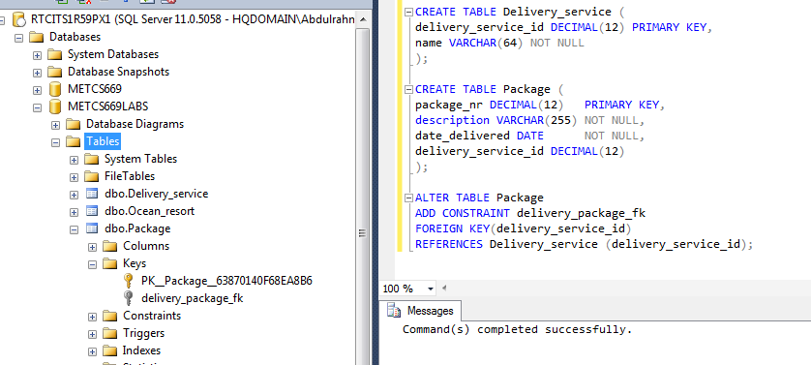

4. INSERT commands

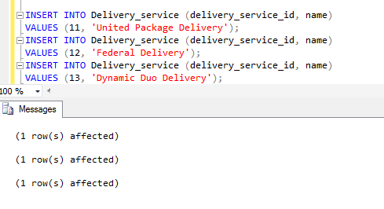

6. INSERT commands

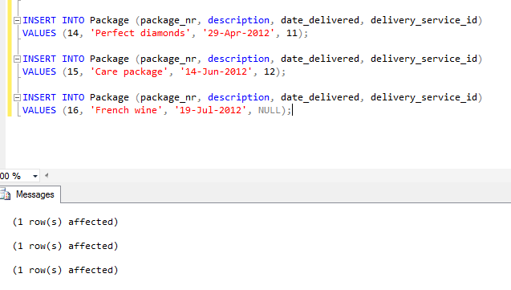

8. Invalid INSERT command

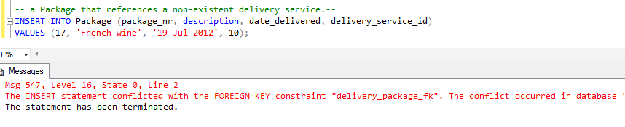
Msg 547, Level 16, State 0, Line 2
The INSERT statement conflicted with the FOREIGN KEY constraint "delivery_package_fk". The conflict occurred in database "METCS669LABS", table "dbo.Delivery_service", and column 'delivery_service_id'.
The statement has been terminated.

9. Diagnosis explanation
  - The insertion in step 8 failed because the foreign key was invalid and it did not exist
  - The Foreign key in the Package table is referencing to an ID in Delivery_service table that does not exist, and the error is pointing to the column ‘delivery_service_id’ in the table Delivery_service where the IDs are stored.

10. Join types explanation

- Inner JOIN: Returns the same records only when they exist in both tables.
- Outer JOIN: consist of left join, right join and full join.
- Left JOIN – Returns all the rows from the left table even if there is no match in the right table.
- Right JOIN – Returns all the rows from the right table even if there is no match in the left table.
- Full JOIN – Returns all the rows from both tables when there is a match in either left or right table.
The similarities between Inner and Outer joins are:
- Both Inner and Outer returns and combine data from two or more tables.
- Both Inner and Outer returns data from two or more tables when there is a match.
The difference between Inner and Outer joins is:
- Inner join does not return non matching row from two or more tables but Outer join does return non matching rows.

(I have used this link to help me answer question 10 https://technet.microsoft.com/en-us/library/ms187518(=sql.105).aspx)

12. First SQL query

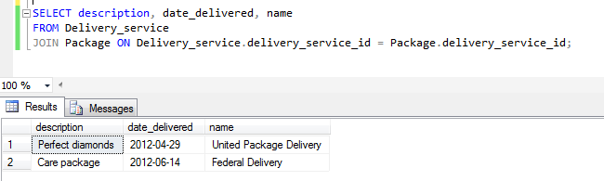

13. Missing row explanation

Because of the Null value of the foreign key (delivery_service_id) from the Insert statement.

INSERT INTO Package (package_nr, description, date_delivered, delivery_service_id)
VALUES (16, 'French wine', '19-Jul-2012', NULL);

And in the JOIN CLAUSE we are actually telling both tables to select only those records where Delivery_service.delivery_service_id = Package.delivery_service_id, and as I stated above that the Package id 16 has a NULL value for the delivery service.

15. Second SQL query

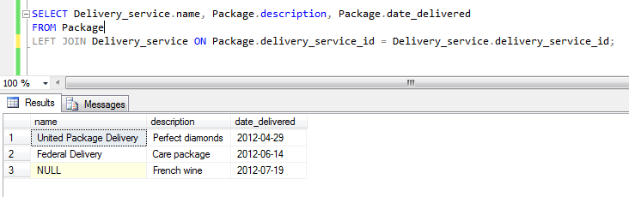

17. Third SQL query

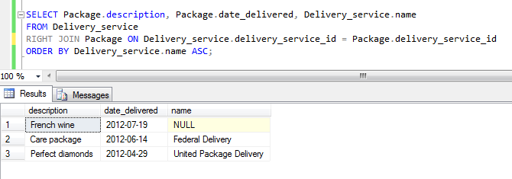

19. Fourth SQL query

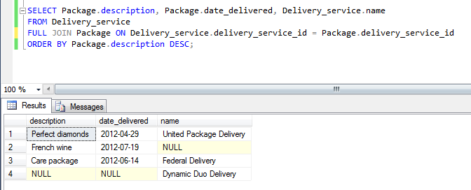

Use the Ask the Facilitators Discussion Board if you have any questions regarding the how to approach this assignment.

Save your assignment as lastnameFirstname_lab2.doc and submit it in the Assignments section of the course.

For help uploading files please refer to the Technical Support page in the syllabus.

Your lab submission will be evaluated according to the following rubric.

 | Letter Grade | Qualities Demonstrated by the Lab Submission
Correctness, completeness, and constitution  Measures the correctness and completeness of the results, and the quality of the constitution of the SQL constructs | A+ ➔ 100 | The results and explanations are entirely complete and correct for all steps. There are absolutely no technical or other errors present. There is no known way to improve the logic and makeup of any of the SQL constructs.
 | A ➔ 96 | One insignificant technical or other error is present, but otherwise the results and explanations are entirely complete and correct for all steps. Excluding the insignificant error, there is no known way to improve the makeup of any of the SQL constructs.
 | A- ➔ 92 | One or two consequential technical or other errors are present, but otherwise the results and explanations are entirely complete and correct for all steps. Excluding the one or two errors, there is no known way to improve the makeup of any of the SQL constructs.
 | B+ ➔ 88 | A few steps have significantly incomplete or incorrect results or explanations. The results and explanations are complete and correct for the remainder of the steps. The logic and makeup of most SQL constructs are sound.
 | B ➔ 85 | A few steps have significantly incomplete or incorrect results or explanations. The results and explanations are mostly complete and correct for the remainder of the steps, with the exception of a few insignificant technical or other errors. The logic and makeup of most SQL constructs are sound.
 | B- ➔ 82 | About ¼ of the steps have significantly incomplete or incorrect results or explanations. The results and explanations are complete and correct for the remainder of the steps. The logic and makeup of at least ¾ of the SQL constructs are sound.
 | C+ ➔ 78 | About ¼ of the steps have significantly incomplete or incorrect results or explanations. The results and explanations are mostly complete and correct for the remainder of the steps, with the exception of a few insignificant technical or other errors. The logic and makeup of at least ¾ of the SQL constructs are sound.
 | C ➔ 75 | About half of the steps have significantly incomplete or incorrect results or explanations. The results and explanations are complete and correct for the remainder of the steps. The logic and makeup of at least half of the SQL constructs are sound.
 | C- ➔ 72 | About half of the steps have significantly incomplete or incorrect results or explanations. The results and explanations are mostly complete and correct for the remainder of the steps, with the exception of a few insignificant technical or other errors. The logic and makeup of at least half of the SQL constructs are sound.
 | D ➔ 67 | About ¾ of the steps have significantly incomplete or incorrect results or explanations. The results and explanations are complete and correct for the remainder of the steps. The logic and makeup of at least ¼ of the SQL constructs are sound
 | F ➔ 0 | All or almost all of the steps have incomplete or incorrect results or explanations. The logic and makeup of all or almost all of the SQL constructs are unsound.

