This submission template is a convenient document for you to provide the screenshots and explanations for Lab 3, and is intended to be used in conjunction with the Lab 3 Instructions document. The instructions document illustrates how to correctly execute each SQL construct, explains important theoretical and practical details, and contains the complete set of instructions on how to complete this lab.

Name: Abdulrahman Jasim

Date: 11/14/2017
Note: Section One in the lab instructions is for your benefit, to teach you by example how to complete the exercises in Section Two. It is not necessary, however, to submit the screenshots for Section One.

SECTION TWO

2. CREAT TABLE/ALTER TABLE commands

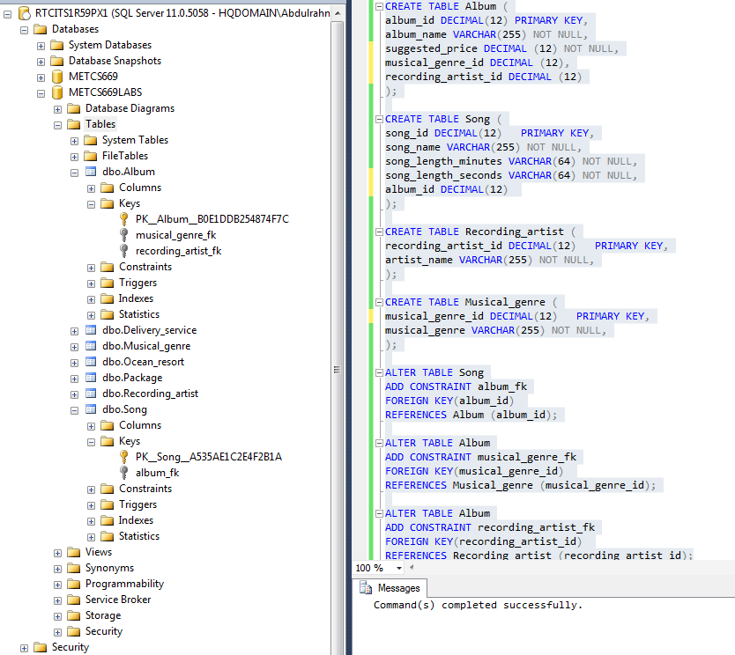

4. INSERT INTO commands

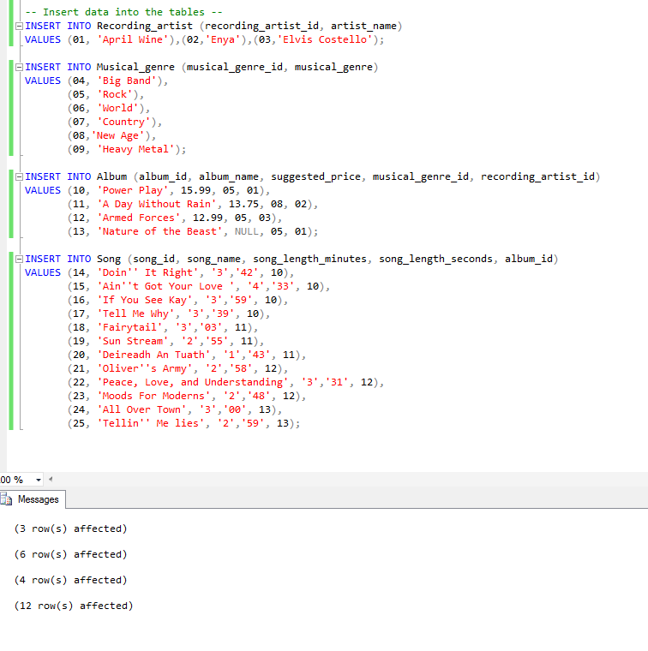

6. Counting query execution

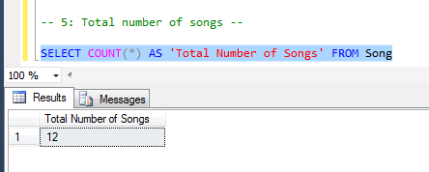

8. Two queries execution

- The highest suggested price
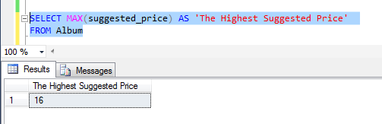

- The lowest suggested price
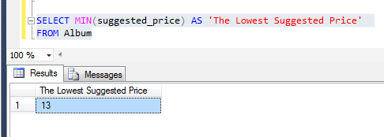

9. Different treatment explanation

Answer: The suggested price for album “Nature of the Beast” was treated differently, because the value is NULL, and therefore MIN and MAX functions ignored the suggested price for “Nature of the Beast” and this is another indication that NULL does not equal zero, if it was it would have been picked by MIN function.

11. Query execution

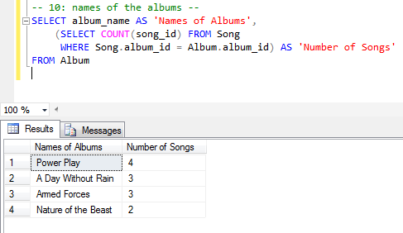

13. Query execution

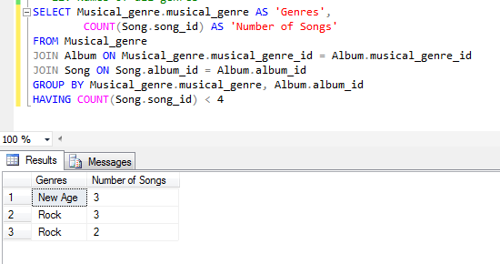

15. Query execution

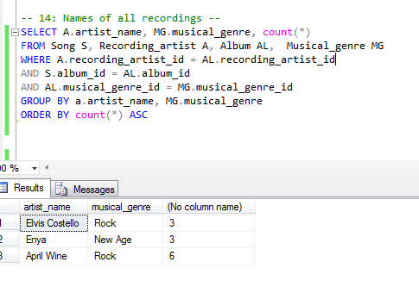

Use the Ask your Facilitator Discussion Board if you have any questions regarding the how to approach this lab.

Save your assignment as lastnameFirstname_lab3.doc and submit it in the Assignments section of the course.

For help uploading files please refer to the Technical Support page in the syllabus.
Your lab submission will be evaluated according to the following rubric.

 | Letter Grade | Qualities Demonstrated by the Lab Submission
Correctness, completeness, and constitution  Measures the correctness and completeness of the results, and the quality of the constitution of the SQL constructs | A+ ➔ 100 | The results and explanations are entirely complete and correct for all steps. There are absolutely no technical or other errors present. There is no known way to improve the logic and makeup of any of the SQL constructs.
 | A ➔ 96 | One insignificant technical or other error is present, but otherwise the results and explanations are entirely complete and correct for all steps. Excluding the insignificant error, there is no known way to improve the makeup of any of the SQL constructs.
 | A- ➔ 92 | One or two consequential technical or other errors are present, but otherwise the results and explanations are entirely complete and correct for all steps. Excluding the one or two errors, there is no known way to improve the makeup of any of the SQL constructs.
 | B+ ➔ 88 | A few steps have significantly incomplete or incorrect results or explanations. The results and explanations are complete and correct for the remainder of the steps. The logic and makeup of most SQL constructs are sound.
 | B ➔ 85 | A few steps have significantly incomplete or incorrect results or explanations. The results and explanations are mostly complete and correct for the remainder of the steps, with the exception of a few insignificant technical or other errors. The logic and makeup of most SQL constructs are sound.
 | B- ➔ 82 | About ¼ of the steps have significantly incomplete or incorrect results or explanations. The results and explanations are complete and correct for the remainder of the steps. The logic and makeup of at least ¾ of the SQL constructs are sound.
 | C+ ➔ 78 | About ¼ of the steps have significantly incomplete or incorrect results or explanations. The results and explanations are mostly complete and correct for the remainder of the steps, with the exception of a few insignificant technical or other errors. The logic and makeup of at least ¾ of the SQL constructs are sound.
 | C ➔ 75 | About half of the steps have significantly incomplete or incorrect results or explanations. The results and explanations are complete and correct for the remainder of the steps. The logic and makeup of at least half of the SQL constructs are sound.
 | C- ➔ 72 | About half of the steps have significantly incomplete or incorrect results or explanations. The results and explanations are mostly complete and correct for the remainder of the steps, with the exception of a few insignificant technical or other errors. The logic and makeup of at least half of the SQL constructs are sound.
 | D ➔ 67 | About ¾ of the steps have significantly incomplete or incorrect results or explanations. The results and explanations are complete and correct for the remainder of the steps. The logic and makeup of at least ¼ of the SQL constructs are sound
 | F ➔ 0 | All or almost all of the steps have incomplete or incorrect results or explanations. The logic and makeup of all or almost all of the SQL constructs are unsound.

