This submission template is a convenient document for you to provide the screenshots and explanations for Lab 4. This submission template is intended to be used in conjunction with the Lab 4 Instructions document. The instructions document illustrates how to correctly execute each SQL construct, explains important theoretical and practical details, and contains the complete set of instructions on how to complete this lab.

Name: Abdulrahman Jasim

Date: 11/21/2017
Section One – Stored Procedures

1. ERD creation

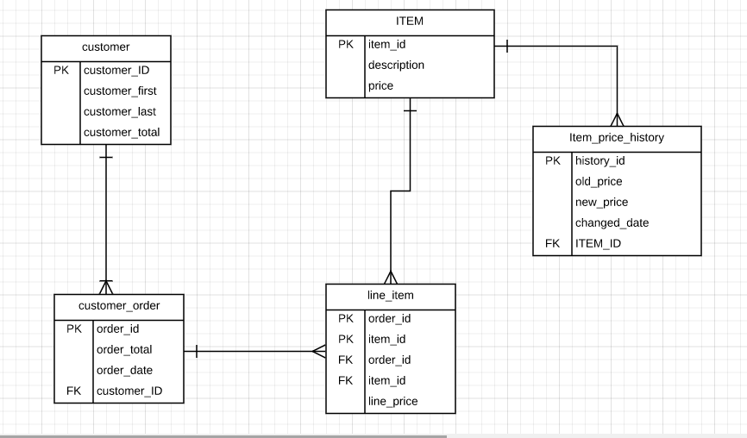
3. Stored procedure creation

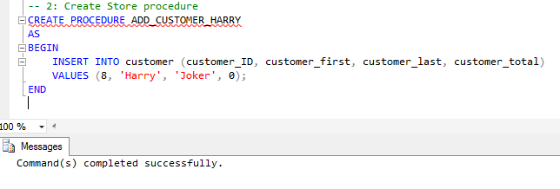

5. Stored procedure execution

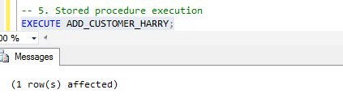

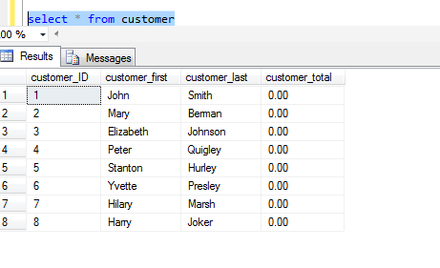
7. Stored procedure execution failure

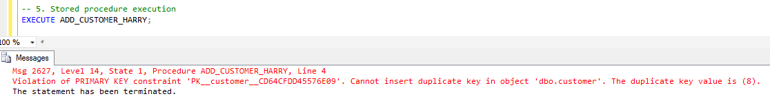

8. Reusable stored procedure creation

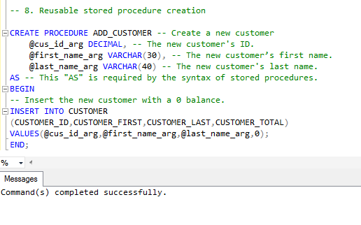
9. Reusable stored procedure execution

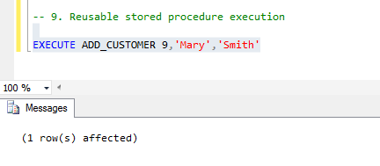

10. Stored procedure execution verification

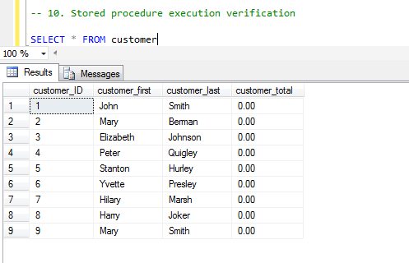

11. Fourth argument stored procedure creation

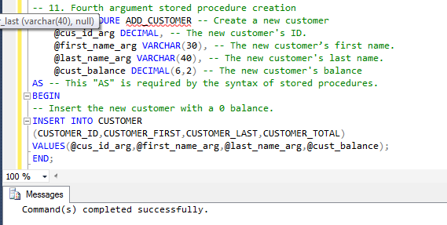

12. Fourth argument stored procedure execution
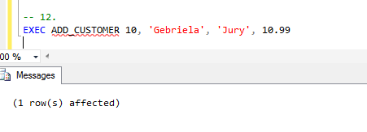

13. Stored procedure execution verification

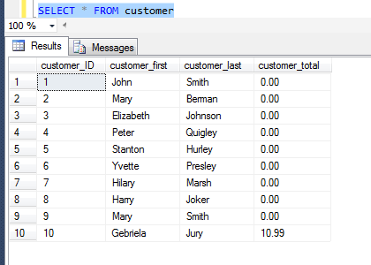

14. Deletion stored procedure creation and execution

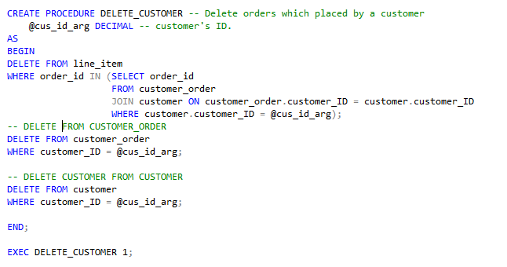

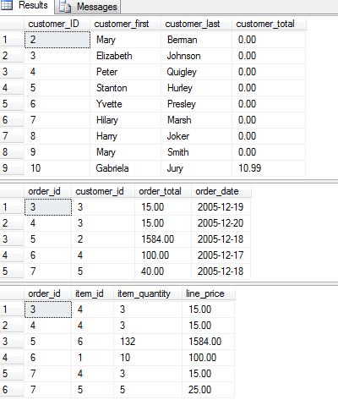
Section Two – Triggers

15. Trigger creation

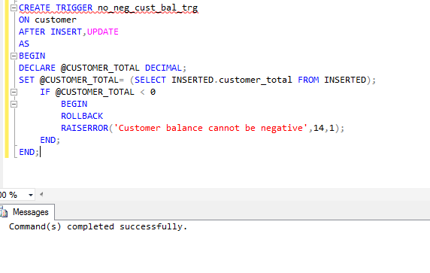

16. Negative balance insertion
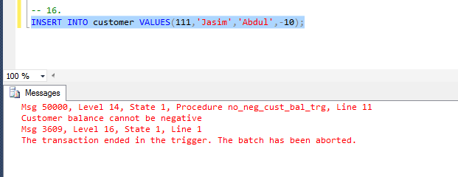

17. Trigger verification

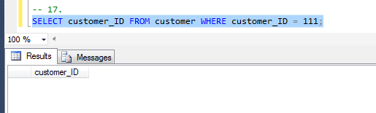
18. Last name trigger creation

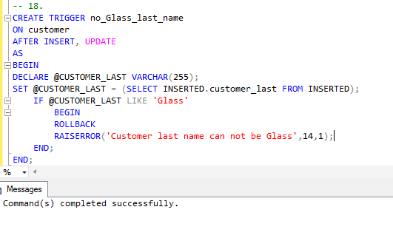
19. Illegal insertion

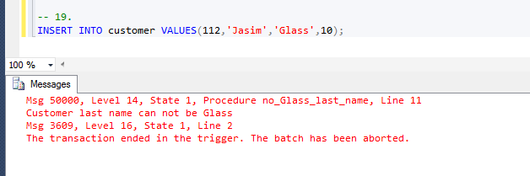

20. ERD creation with Item_price_history included
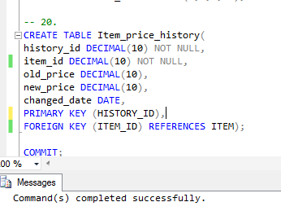
21. Item trigger creation
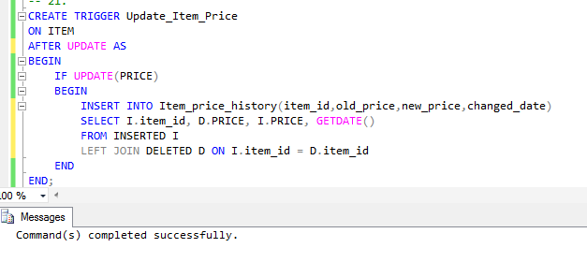

22. Price changes and trigger verification

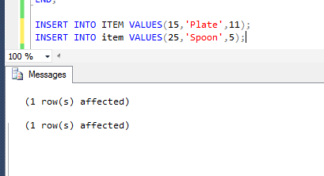

Use the Ask your Facilitator Discussion Board if you have any questions regarding the how to approach this assignment.

Save your assignment as lastnameFirstname_lab4.doc and submit it in the Assignments section of the course.

For help uploading files please refer to the Technical Support page in the syllabus.

Your lab submission will be evaluated according to the following rubric.
 | Letter Grade | Qualities Demonstrated by the Lab Submission
Correctness, completeness, and constitution  Measures the correctness and completeness of the results, and the quality of the constitution of the SQL constructs | A+ ➔ 100 | The results and explanations are entirely complete and correct for all steps. There are absolutely no technical or other errors present. There is no known way to improve the logic and makeup of any of the SQL constructs.
 | A ➔ 96 | One insignificant technical or other error is present, but otherwise the results and explanations are entirely complete and correct for all steps. Excluding the insignificant error, there is no known way to improve the makeup of any of the SQL constructs.
 | A- ➔ 92 | One or two consequential technical or other errors are present, but otherwise the results and explanations are entirely complete and correct for all steps. Excluding the one or two errors, there is no known way to improve the makeup of any of the SQL constructs.
 | B+ ➔ 88 | A few steps have significantly incomplete or incorrect results or explanations. The results and explanations are complete and correct for the remainder of the steps. The logic and makeup of most SQL constructs are sound.
 | B ➔ 85 | A few steps have significantly incomplete or incorrect results or explanations. The results and explanations are mostly complete and correct for the remainder of the steps, with the exception of a few insignificant technical or other errors. The logic and makeup of most SQL constructs are sound.
 | B- ➔ 82 | About ¼ of the steps have significantly incomplete or incorrect results or explanations. The results and explanations are complete and correct for the remainder of the steps. The logic and makeup of at least ¾ of the SQL constructs are sound.
 | C+ ➔ 78 | About ¼ of the steps have significantly incomplete or incorrect results or explanations. The results and explanations are mostly complete and correct for the remainder of the steps, with the exception of a few insignificant technical or other errors. The logic and makeup of at least ¾ of the SQL constructs are sound.
 | C ➔ 75 | About half of the steps have significantly incomplete or incorrect results or explanations. The results and explanations are complete and correct for the remainder of the steps. The logic and makeup of at least half of the SQL constructs are sound.
 | C- ➔ 72 | About half of the steps have significantly incomplete or incorrect results or explanations. The results and explanations are mostly complete and correct for the remainder of the steps, with the exception of a few insignificant technical or other errors. The logic and makeup of at least half of the SQL constructs are sound.
 | D ➔ 67 | About ¾ of the steps have significantly incomplete or incorrect results or explanations. The results and explanations are complete and correct for the remainder of the steps. The logic and makeup of at least ¼ of the SQL constructs are sound
 | F ➔ 0 | All or almost all of the steps have incomplete or incorrect results or explanations. The logic and makeup of all or almost all of the SQL constructs are unsound.

