This submission template is a convenient document for you to provide the screenshots and explanations for Lab 5. This submission template is intended to be used in conjunction with the Lab 5 Instructions document. The instructions document illustrates how to correctly execute each SQL construct, explains important theoretical and practical details, and contains the complete set of instructions on how to complete this lab.

Name: Abdulrahman Jasim

Date: 11/28/2017
Section One – Expressions and Value Manipulation

3. Two independent queries
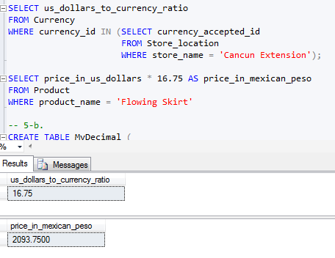

5. Data type size limitation

a. Explanation

DECIMAL is the data type which user can control the size limitation. DECIMAL consist of (Precision (p), and Scale (s)), precision represents the total number of digits allowed in that column, and the scale represents the number of digits to the right of the decimal point, for example if we define a value with DECIMAL (5,2) then that column can store a number like this 234.13.

b. Table creation

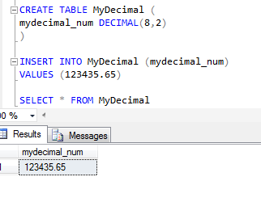

c. Insertion attempt

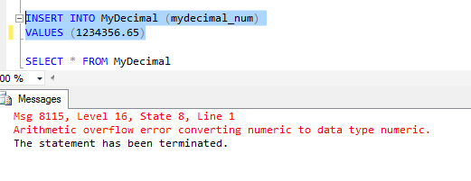
7. Expression and operator precedence explanation

Expression is a combination of values and operators that return a single value, as it stated in number 6. Example100.num is one value or operand then an operator (*) then another value 10.001 which return the result of the operation.
For example Select myTable.number12 * 10.2, this should multiply the value in number12 with 10.2 and return the result.

Operator precedence is a set of rules that evaluate the order of the SQL operators, which plays the role of what operator is processed first, so the higher precedence goes first as for the example of 1+2*3, 2*3 done first then + second, since multiplication has a higher precedence.

9. Datatype precedence explanation

SQL server has an order for data type precedence when it comes to combining two expressions of different data types, so the data type with the lower precedence is converted to the higher precedence.

11. Currency formatting

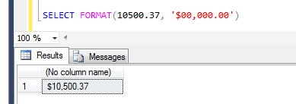

13. SQL client’s explanation

Because of the flexibility of the SQL clients the team or vendors are creating their SQL client to display the result per how they want to display.

Section Two – Subqueries

15. Subquery explanation

a. Subquery superiority explanation

Subquery or nested query are superior over the independent queries, because subquery can filter data from one table which is based on the data in another table and combine both in one single query, also subqueries are easier to read comparing to JOIN and other clauses which independent queries use.

b. Uncorrelated subquery explanation

Uncorrelated subquery is when a subquery does not reference an object in the parent table, or another way to put is when the inner query does not depend on the outer query. We can use uncorrelated subquery when sometime we want to pulling a value of an object based on an object which is based in another table, such as

SELECT first_name FROM Customer
WHERE tshirt_color = (SELECT tshirt FROM Clothes
WHERE color = ‘Red’);

16. Two queries combination

a. Screenshot

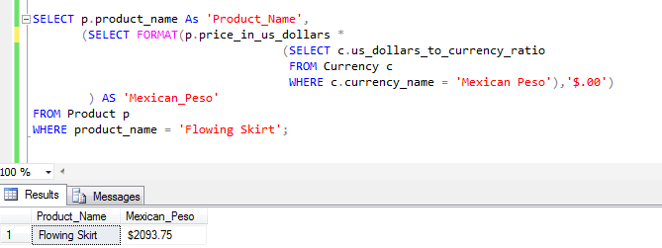

b. Explanation

The advantage of subquery used in the new solution it helped me write a single query to retrieve the data from three tables instead two independents queries, besides that the easy simplicity of the structure of the query makes it easier to understand and read the query than having two independent queries.

18. More and less expensive product use case

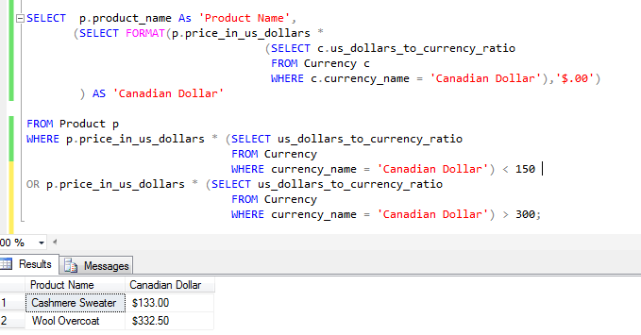

20. More complex use case

a. Part identification
The first query I started up with was to select the available products in all locations, and knowing the number of the locations which is 5, so I got that one done first.
Then I wrote the second query to select all the products and available sizes.
Then I merged them together using WHERE clause.
b. Independent queries
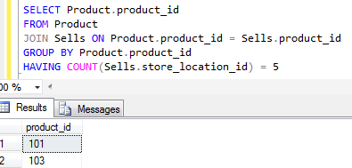

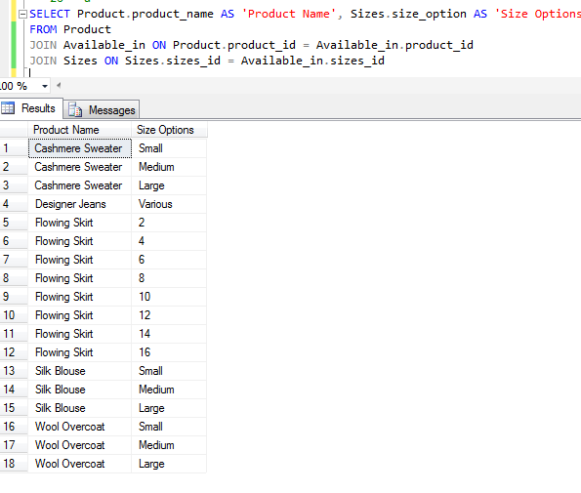
c. Full query
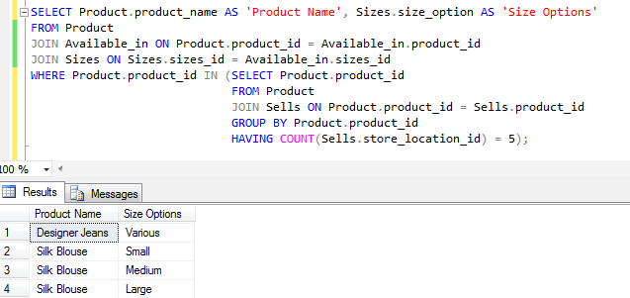
d. Explanation
The first query I started up with was to select the available products in all locations, and knowing the number of the locations which is 5, so I got that one done first.
Then I wrote the second query to select all the products and available sizes.
Then I merged them together using WHERE clause.

22. FROM clause solution

a. Screenshot

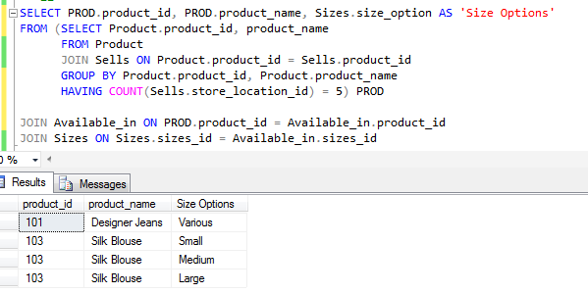
b. Explanation

The subquery selects product id and product name then having the number of store locations compared to the number of available store locations (5), then in outer query I join the following tables Available_in, product and sizes.

24. Correlated vs. uncorrelated explanation

Correlated subquery is when the object in the inner query (subquery) references to the object in the parent statement (outer query), so the inner query depends on the outer query.
Uncorrelated subquery is when the object in the inner query does not reference to the object in the outer query, so there is no dependency of inner query on the parent statement.

25. EXISTS solution

a. Screenshot
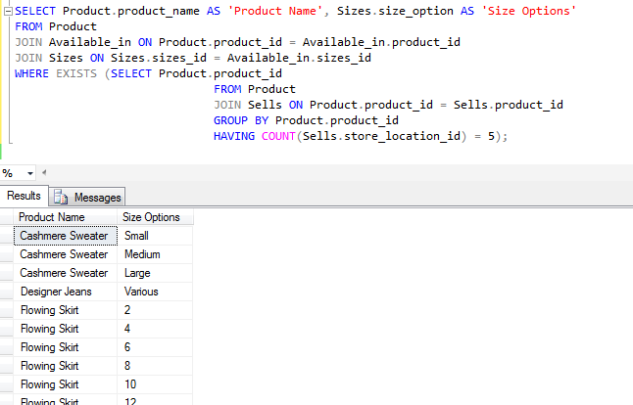

b. Explanation of changes
I have replaced the product id in WHERE clause with EXISTS
c. Explanation of better choice
I would use the solution in step 20, because it has less functions and easier for user to understand.

Use the Ask your Facilitator Discussion Board if you have any questions regarding the how to approach this assignment.

Save your assignment as lastnameFirstname_lab5.doc and submit it in the Assignments section of the course.

For help uploading files please refer to the Technical Support page in the syllabus.

Your lab submission will be evaluated according to the following rubric.
 | Letter Grade | Qualities Demonstrated by the Lab Submission
Correctness, completeness, and constitution  Measures the correctness and completeness of the results, and the quality of the constitution of the SQL constructs | A+ ➔ 100 | The results and explanations are entirely complete and correct for all steps. There are absolutely no technical or other errors present. There is no known way to improve the logic and makeup of any of the SQL constructs.
 | A ➔ 96 | One insignificant technical or other error is present, but otherwise the results and explanations are entirely complete and correct for all steps. Excluding the insignificant error, there is no known way to improve the makeup of any of the SQL constructs.
 | A- ➔ 92 | One or two consequential technical or other errors are present, but otherwise the results and explanations are entirely complete and correct for all steps. Excluding the one or two errors, there is no known way to improve the makeup of any of the SQL constructs.
 | B+ ➔ 88 | A few steps have significantly incomplete or incorrect results or explanations. The results and explanations are complete and correct for the remainder of the steps. The logic and makeup of most SQL constructs are sound.
 | B ➔ 85 | A few steps have significantly incomplete or incorrect results or explanations. The results and explanations are mostly complete and correct for the remainder of the steps, with the exception of a few insignificant technical or other errors. The logic and makeup of most SQL constructs are sound.
 | B- ➔ 82 | About ¼ of the steps have significantly incomplete or incorrect results or explanations. The results and explanations are complete and correct for the remainder of the steps. The logic and makeup of at least ¾ of the SQL constructs are sound.
 | C+ ➔ 78 | About ¼ of the steps have significantly incomplete or incorrect results or explanations. The results and explanations are mostly complete and correct for the remainder of the steps, with the exception of a few insignificant technical or other errors. The logic and makeup of at least ¾ of the SQL constructs are sound.
 | C ➔ 75 | About half of the steps have significantly incomplete or incorrect results or explanations. The results and explanations are complete and correct for the remainder of the steps. The logic and makeup of at least half of the SQL constructs are sound.
 | C- ➔ 72 | About half of the steps have significantly incomplete or incorrect results or explanations. The results and explanations are mostly complete and correct for the remainder of the steps, with the exception of a few insignificant technical or other errors. The logic and makeup of at least half of the SQL constructs are sound.
 | D ➔ 67 | About ¾ of the steps have significantly incomplete or incorrect results or explanations. The results and explanations are complete and correct for the remainder of the steps. The logic and makeup of at least ¼ of the SQL constructs are sound
 | F ➔ 0 | All or almost all of the steps have incomplete or incorrect results or explanations. The logic and makeup of all or almost all of the SQL constructs are unsound.

