**Homework #2: STAT_6305_01**

**Nikta Farsai & Shruti Natekar**

Ex 14.5

1. Hypothesis for AOV test:

H0: µ1 = µ2 = µ3 = µ4 i.e. the means of all 4 incentive plans are equal

Ha: At least one of the 4 incentive plan means differs from the rest

1. SAS Output:

|  |  |  |  |  |  |  |  |  |  |  |
| --- | --- | --- | --- | --- | --- | --- | --- | --- | --- | --- |
| Source | | DF | Sum of Squares | | | Mean Square | | F Value | | Pr > F |
| Model | | 3 | 236991.238 | | | 78997.079 | | 2.02 | | 0.1181 |
| Error | | 76 | 2971586.650 | | | 39099.824 | |  | |  |
| Corrected Total | | 79 | 3208577.888 | | |  | |  | |  |
|  | R-Square | | | Coeff Var | Root MSE | | unit Mean | |
|  | 0.073862 | | | 33.66663 | 197.7368 | | 587.3375 | |

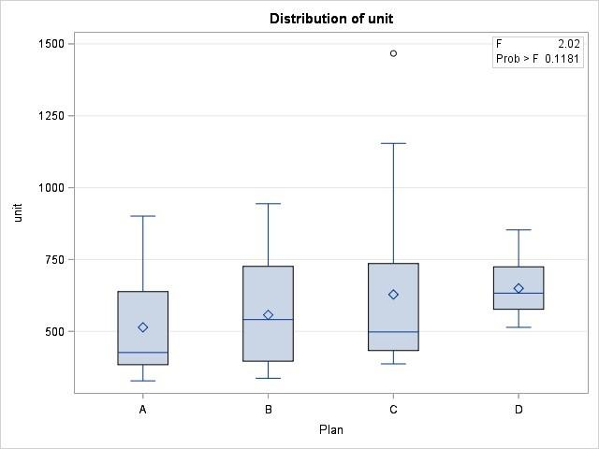

**Conclusion:** From SAS output, we got p-value as 0.1181 > α = 0.05, hence we don’t have significant evidences to reject to the null hypothesis and we can conclude that the mean output associated with the four incentive plans (B, C, D) are not significantly different.

1. As we do not reject the null hypothesis LSD procedure is not required.

**Conclusion:** After doing LSD procedure on SAS we found that means for incentive plans (B, C, D) are not significantly different and which is supporting our conclusion in part b) that means are equal.

SAS output:

The SAS System

The GLM Procedure

t Tests (LSD) for unit

Note: This test controls the Type I comparison wise error rate, not the experiment wise error rate.

|  |  |  |  |  |  |  |  |
| --- | --- | --- | --- | --- | --- | --- | --- |
| Alpha | | | | | 0.05 | | |
| Error Degrees of Freedom | | | | | 76 | | |
| Error Mean Square | | | | | 39099.82 | | |
| Critical Value of t | | | | | 1.99167 | | |
| Least Significant Difference | | | | | 124.54 | | |
|  | Means with the same letter are not significantly different. | | | | | |
|  | t Grouping | | Mean | N | | plan |
|  |  | A | 649.75 | 20 | | D |
|  |  | A |  |  | |  |
|  | B | A | 628.30 | 20 | | C |
|  | B | A |  |  | |  |
|  | B | A | 557.25 | 20 | | B |
|  | B |  |  |  | |  |
|  | B |  | 514.05 | 20 | | A |

Ex 14.6

1. Hypothesis for normality assumption check:

Ho: Residuals follow a normal distribution

Ha: They do not follow a normal distribution

SAS Output:

Normality assumption plot

The UNIVARIATE Procedure

Variable: res

|  |  |  |  |  |
| --- | --- | --- | --- | --- |
| Tests for Location: Mu0=0 | | | | |
| Test | Statistic | | p Value | |
| Student's t | t | 0 | Pr > |t| | 1.0000 |
| Sign | M | -9 | Pr >= |M| | 0.0567 |
| Signed Rank | S | -193.5 | Pr >= |S| | 0.3566 |

|  |  |  |  |  |
| --- | --- | --- | --- | --- |
| Tests for Normality | | | | |
| Test | Statistic | | p Value | |
| Shapiro-Wilk | W | 0.883261 | Pr < W | <0.0001 |
| Kolmogorov-Smirnov | D | 0.130241 | Pr > D | <0.0100 |
| Cramer-von Mises | W-Sq | 0.336338 | Pr > W-Sq | <0.0050 |
| Anderson-Darling | A-Sq | 2.081744 | Pr > A-Sq | <0.0050 |

|  |  |  |  |
| --- | --- | --- | --- |
|  | Moments | |  |
| N | 80 | Sum Weights | 80 |
| Mean | 0 | Sum Observations | 0 |
| Std Deviation | 193.945923 | Variance | 37615.0209 |
| Skewness | 1.50848376 | Kurtosis | 3.52245007 |
| Uncorrected SS | 2971586.65 | Corrected SS | 2971586.65 |
| Coeff Variation | . | Std Error Mean | 21.6838133 |

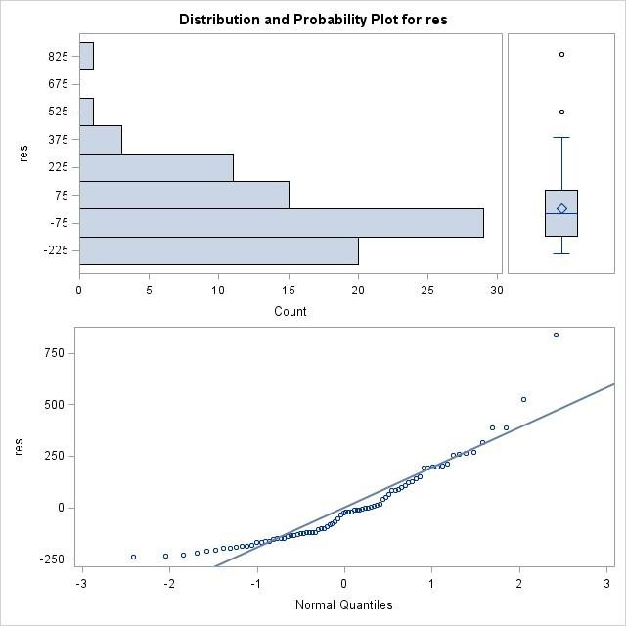

**Conclusion:** SAS output shows P-value = 0.0001, is much less than α = 0.05 and we reject the null hypothesis of normality.

Normality plots and skewness of the data is > 0, which interprets that data is positively skewed.

So, there are significant evidences of a violation of the normality condition.

1. Hypothesis for equal variances test:

Ho: Variances of residuals/responses of all incentive plans are equal

Ha: At least one of the variances of plans is different

SAS Output:

The GLM Procedure

|  |  |  |  |  |  |
| --- | --- | --- | --- | --- | --- |
| Levene's Test for Homogeneity of unit Variance ANOVA of Squared Deviations from Group Means | | | | | |
| Source | DF | Sum of Squares | Mean Square | F Value | Pr > F |
| plan | 3 | 5.551E10 | 1.85E10 | 2.69 | 0.0519 |
| Error | 76 | 5.22E11 | 6.8684E9 |  |  |

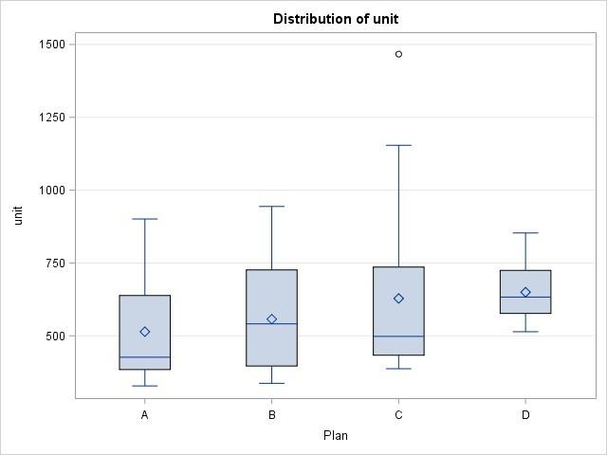

|  |  |  |  |
| --- | --- | --- | --- |
| Level of plan | N | unit | |
| Mean | Std Dev |
| A | 20 | 514.050000 | 171.780605 |
| B | 20 | 557.250000 | 184.425102 |
| C | 20 | 628.300000 | 290.147531 |
| D | 20 | 649.750000 | 93.233648 |

**Conclusion:** There are no significant evidences to say that variances of 3 incentive plans (B, C, D) were different from the control plan (A), hence, we fail to reject the null hypothesis that variances of all plans are equal compared to the control plan.

F = 2.69 < F0.95,3,76 = 2.72 (critical value) and p-value = 0.0519 which is slightly greater that α = 0.05 and we fail to reject the null hypothesis.

So, equal variances assumption is valid.