**Ex 9.7**

|  |  |  |  |  |  |
| --- | --- | --- | --- | --- | --- |
| Contrast | µ1 (1 km) | µ2 (5 km) | µ3 (10 km) | µ4 (20 km) | ∑ai2 |
| 20 Km Vs All 3 km (l1) | -1 | -1 | -1 | 3 | 12 |
| 10 Km Vs 1km & 5 km (l2) | -1 | -1 | 2 | 0 | 6 |
| 5 Km Vs 1 km (l3) | -1 | 1 | 0 | 0 | 2 |
| Means (¯yi.) | y1. = 2.2 | y2. = 4.6 | y3. = 21.2 | y4. = 31.4 |  |

**Hypothesis:**

H0: l = 0

Ha: l ≠ 0

**R.S:** Reject H0 if F = SSC / MSERROR > 2.86 (F0.05, 3, 36)

MSERROR = 0.245 (From AOV Table of SAS output)

l1 = - µ1 – µ2 – µ3 + 3 µ4

l2 = - µ1 - µ2 + 2 µ3

l3 = - µ1 + µ2

1. Contrast 1 (l1)

SSC1 = 60.39

F = SSC1/ MSERROR = 245.6 > 2.86 (F-critical value)

Hence, reject H0 and conclude that there is a significant evidence that mean oxygen content at 20 Km is different from the average of the mean oxygen content at 1 km, 5 km & 10 km.

1. Contrast 2 (l2)

SSC2 = 50.59

F = SSC2 / MSERROR = 205.73 > 2.86 (F-critical value)

Hence, reject H0 and conclude that there is a significant evidence that mean oxygen content at 10 Km is different from the average of the mean oxygen content at 1 km, 5 km.

1. Contrast 3 (l3)

SSC3 = 2.11

F = SSC3 / MSERROR = 8.59 > 2.86 (F-critical value)

Hence, reject H0 and conclude that there is a significant evidence that mean oxygen content at 5 Km is different from the average of the mean oxygen content at 1 km.

1. For l1 & l2: (-1) (-1) + (-1) (-1) + (-1) (2) + (3) (0) = 1 +1 -2 = 0

For l2 & l3: (-1) (-1) + (-1) (1) = 1-1 = 0

For l1 & l3: (-1) (-1) + (-1) (1) = 1-1 = 0

Hence, all three contrast statements are mutually orthogonal.

1. SSC1 + SSC2 + SSC3 = 60.39 + 50.59 + 2.11 = 113.09

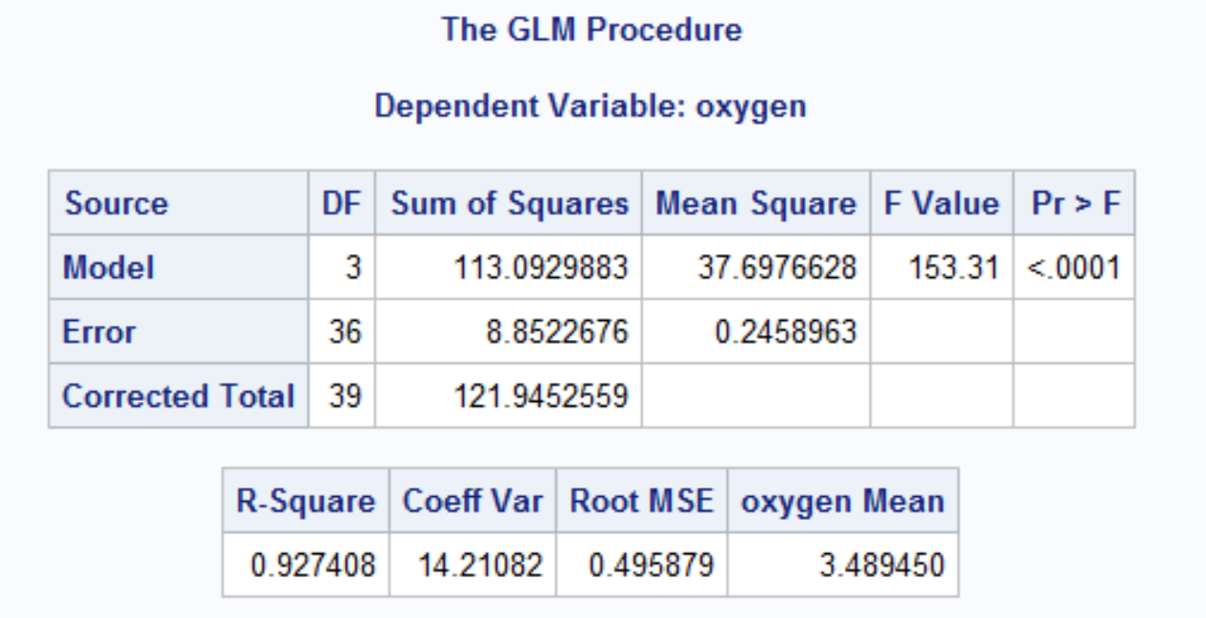

SSTRT = 113.09, from SAS output (sum of squares of model)

Therefore, Three contrast sum of squares total to SSTRT.

**Ex 9.12**

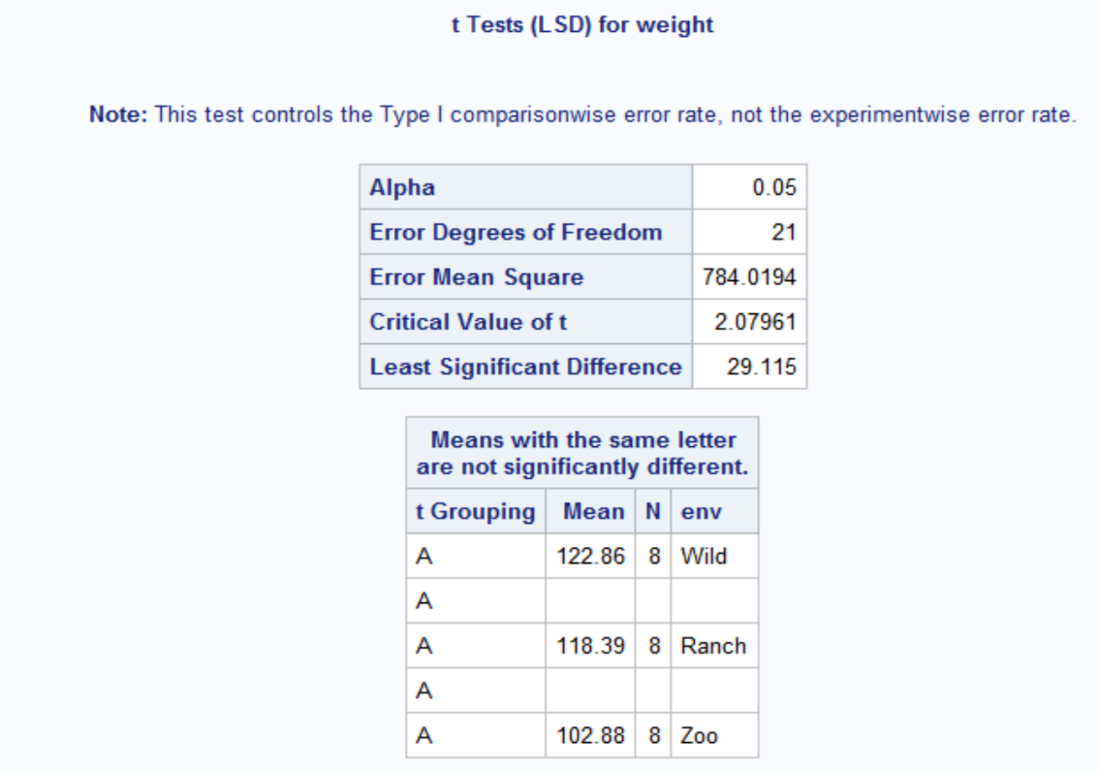

**Conclusion:** From SAS Output,we can conclude that there is no significant evidence to say that the mean weight of the deer raised in the wild or on a ranch is significantly higher than the mean weight of deer raised in a zoo.

Contrast of the average weight of deer raised in a zoo or on a ranch to the mean weight of deer raised in the wild.

|  |  |  |  |  |
| --- | --- | --- | --- | --- |
| Contrast | Zoo (µ1) | Ranch (µ2) | Wild (µ3) | ∑ai2 |
| Wild Vs Zoo | 1 | 0 | -1 | 2 |
| Wild Vs Ranch | 0 | 1 | -1 | 2 |

l1 = µ1 – µ3

l2 = µ2 – µ3

**Hypothesis:**

H0: l = 0

Ha: l ≠ 0

**R.S:** Reject H0 if F = SSC / MSERROR > 3.47 (F0.05, 2, 21)

MSERROR = 784.02 (From AOV Table of SAS output)

l1 = 102.88 - 122.86 = -19.98

SSC1 = n(l1)2 / ∑ ai2 = 8 (-19.98)2 / 2 = 1596.8

F = SSC1/ MSERROR = 1596.8/ 784.02 = 2.04 < 3.47 (F-critical value)

**Conclusion:** Hence, we fail to reject H0 and conclude that contrast for mean weight of deer raised in zoo to the mean weight of deer raised in a wild is not significantly different from zero.

l2 = 118.39 – 122.86 = -4.47

SSC2 = n(l2)2 / ∑ ai2 = 8 (-4.47)2 / 2 = 79.9

F = SSC2/ MSERROR = 79.9/ 784.02 = 0.102 < 3.47 (F-critical value)

**Conclusion:** Hence, we fail to reject H0 and conclude that contrast for mean weight of deer raised on a ranch to the mean weight of deer raised in a wild is not significantly different from zero.

**Ex 15.6**

1. Randomized complete block design model:

Yij = µ + ͳi + βj + €ij

i= Treatment: Type of music (3)

j= Blocks: Subject (7)

Parameter estimates:

Yij = 17.19 + 2.14*Classical Music

Yij = 17.19 - 0.71*Hardrock

Yij = 17.19 + 3.67*Subject1

Yij = 17.19 + 0.67*Subject2

Yij = 17.19 + 7.0* Subject3

Yij = 17.19 + 2.33* Subject4

Yij = 17.19 + 4.67*Subject5

Yij = 17.19 + 7.33*Subject6

E(Y) = 17.19 + 2.14*Classical Music – 0.71*Hardrock + 3.67*Subject1 + 0.67*Subject2 + 7.0* Subject3 + 2.33* Subject4 + 4.67*Subject5 + 7.33*Subject6

1. H0: µ1 = µ2 = µ3

Ha: At least one of the mean of type of music is different from other.

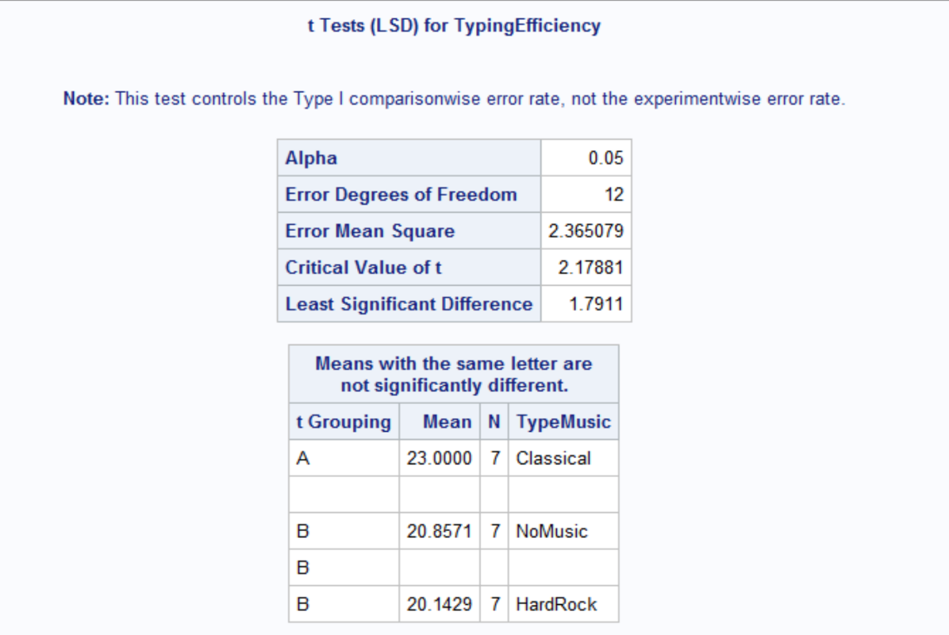

**Conclusion:** From the LSD procedure SAS output, we can conclude there are significant differences in Classical music type mean than No Music and Hard Rock Music type mean.

No Music and Hard rock music mean are not significantly different from each other.

**ANOVA model assumptions:**

1. Normality assumption:

H0: Residuals follow a normal distribution

Ha: Residuals do not follow a normal distribution

Result:

Shapiro-wilk test = 0.94

p-value = 0.2017

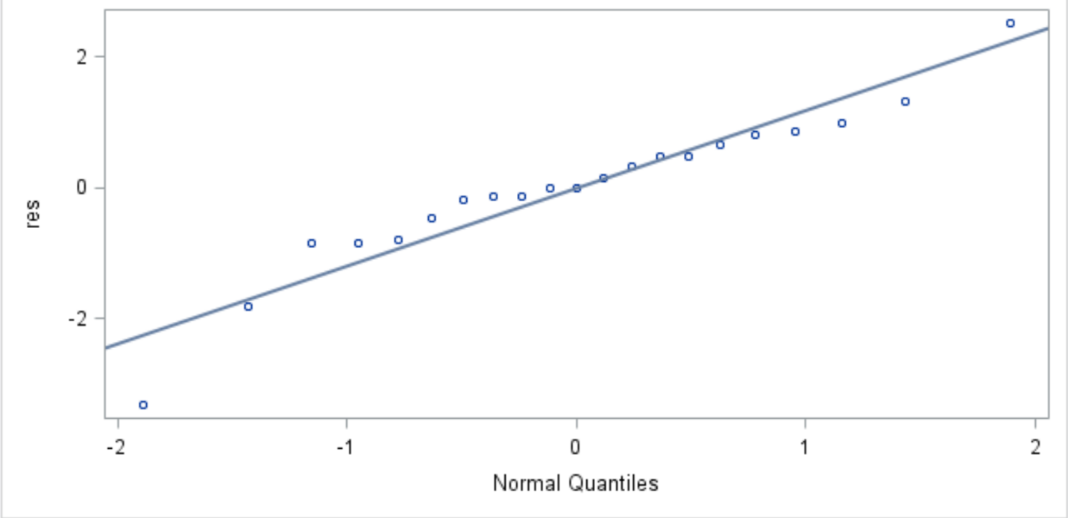

**Conclusion:** From, P-value > α = 0.05 and normality plot we can conclude that we fail to reject the null hypothesis and normality assumption is valid.

1. Equal variances assumption:

H0: Variances of residuals/ responses are equal

Ha: Variances are not equal

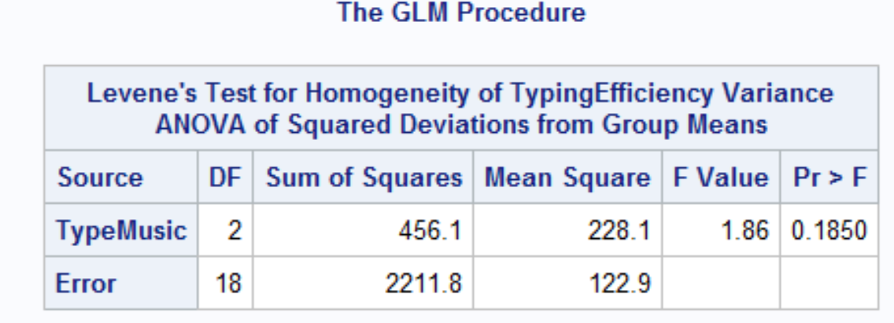

**Conclusion:** P-value = 0.1850 > 0.05, hence we fail to reject the null hypothesis and conclude that variances for all types of music are equal.

**Ex 15.10**

1. Latin Square Design model:

Yijk = µ + ͳk + βi + γj + €ijk

βi = driver (row Block 1) = 1,2,3,4

γj = model (column Block2) = 1,2,3,4

ͳk = blend (Treatment) = 1,2,3,4

1. ANOVA test:

H0: µ1 = µ2 = µ3 = µ4

Ha: At least one of the gasoline blend mean is significantly different than others.

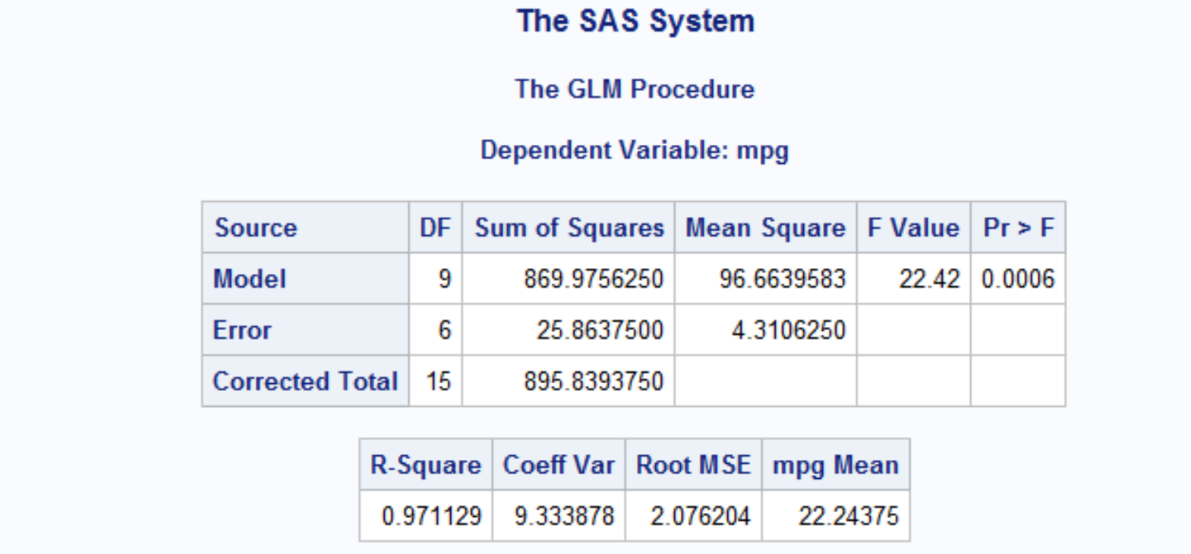

**Conclusion**: P-value = 0.0006 is significantly smaller than α = 0.05 and hence we reject the null hypothesis and conclude that at least one of the gasoline blend is different from all other three blends.

1. LSD Procedure output:

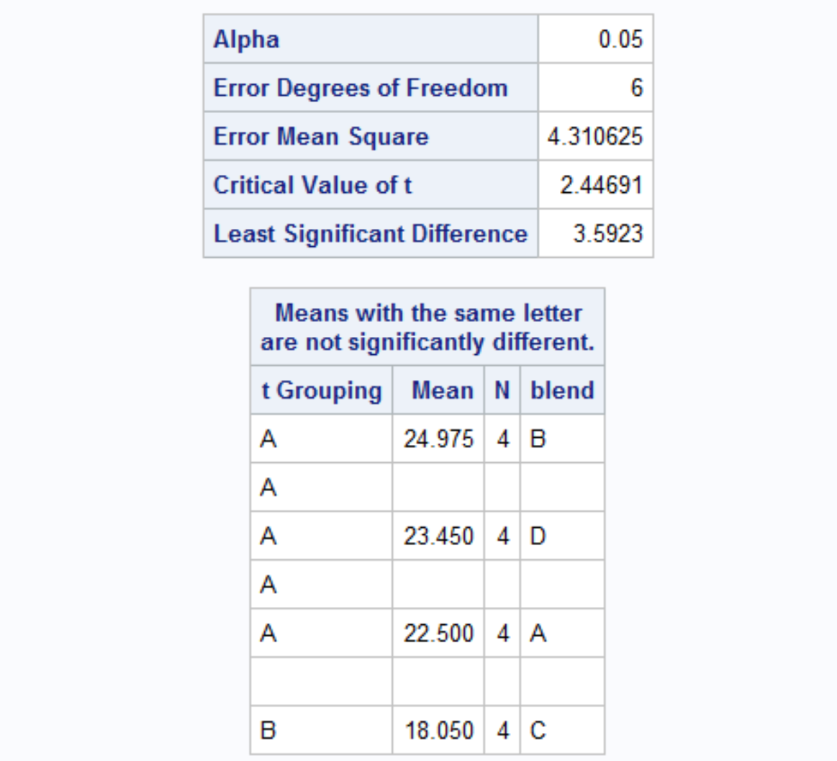

**Conclusion:** From LSD procedure SAS output, we can conclude that Blend C is significantly different than blends A, B & D. Hence, we can say that blends A, B & D are best gasoline blends, in which B has highest mileage (in mpg).

**Model Assumptions**:

1. Normality check:

H0: Residuals follow a normal distribution

Ha: Residuals do not follow a normal distribution

Result:

Shapiro-Wilk test W = 0.902

P-value = 0.08

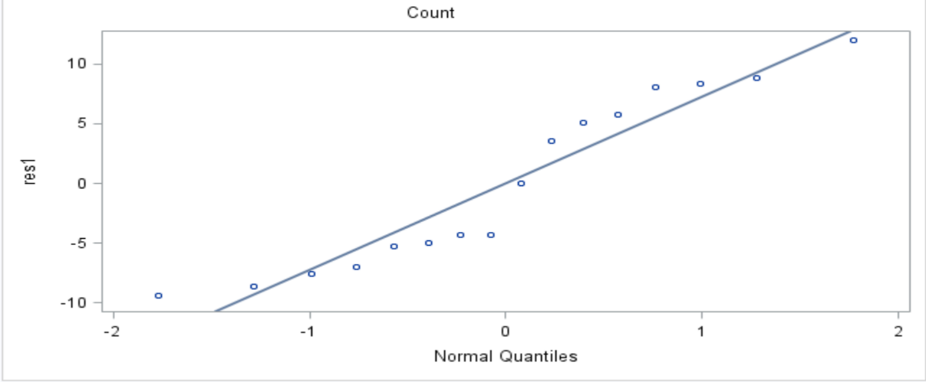

**Conclusion:** From normality test result and normality plot, we fail to reject the null hypothesis and conclude that residuals follow a normal distribution and normality is a valid assumption.

1. Equal Variances assumption:

H0: Variances of residuals/ responses are equal

Ha: Variances are not equal

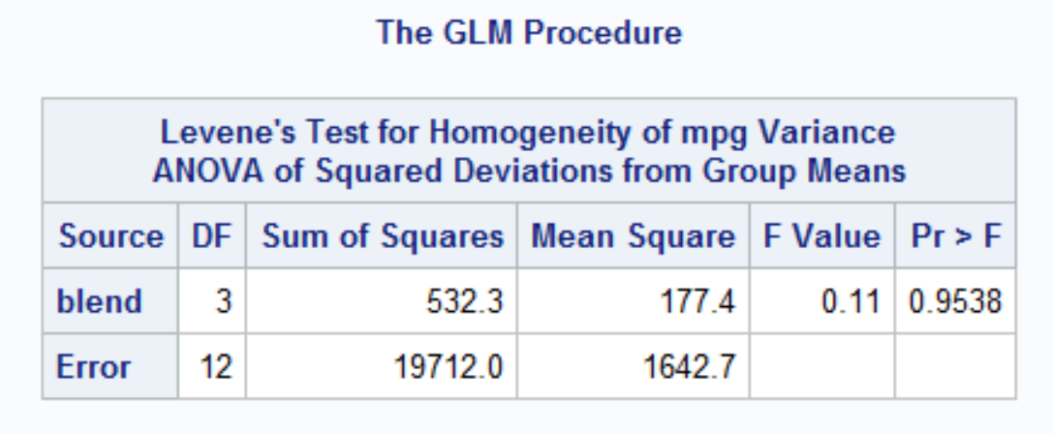

Result:

P-value = 0.95 > α = 0.05, Significant result

**Conclusion:** P-value is significant hence, we fail to reject the null hypothesis and conclude that equal variances assumption is valid.