**Homework 4**

**Shruti Natekar & Nikta Farsai**

**Ex 14.11**

1. Given data follows **Completely Randomized Design with factorial treatment structure** with 3 factors
2. Sweetener = Levels: 12% & 16%
3. Milkfat = Levels: 10%, 12% & 15%
4. Air = Levels: 5%, 10% & 15%
5. Factorial treatment structure Model:

**Yijkl = µ + ͳi + βj + γk + ͳβij + βγjk + ͳγij + €ijkl**

Milk fat=i=1,2,3

air=j=1,2,3

sweetener=k=1,2

ͳi = An effect due to sweetener = 2 levels

βj = An effect due to milkfat = 3 levels

γk = An effect due to air = 3 levels

ͳβij = An interaction effect of the sweetener with milkfat

βγjk = An interaction effect of the milkfat with air

ͳγij = An interaction effect of sweetener with air

€ijkl = A random error associated with the response (sensory ratings)

l = replications = 3

i*j*k*l = 54 observations

1. Profile plot of the effect of milkfat & air on ratings based on **12% level of sweeteners** 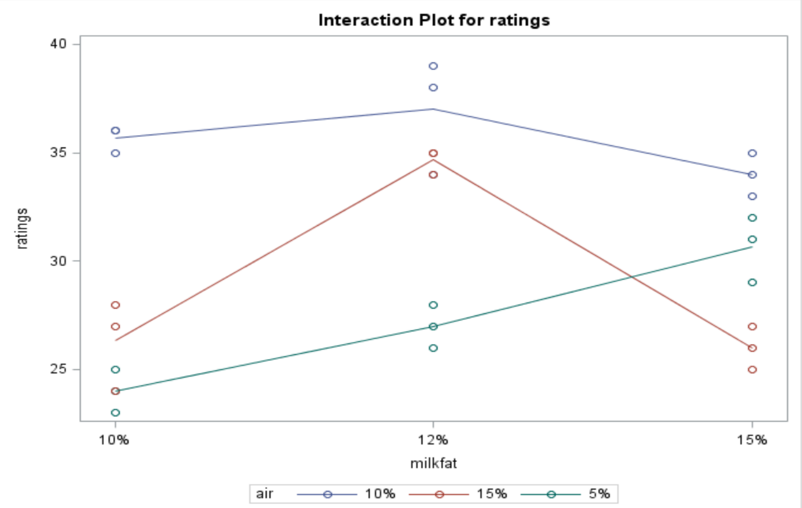

Profile plot of the effect of milkfat & air on ratings based on **16% level of sweeteners**

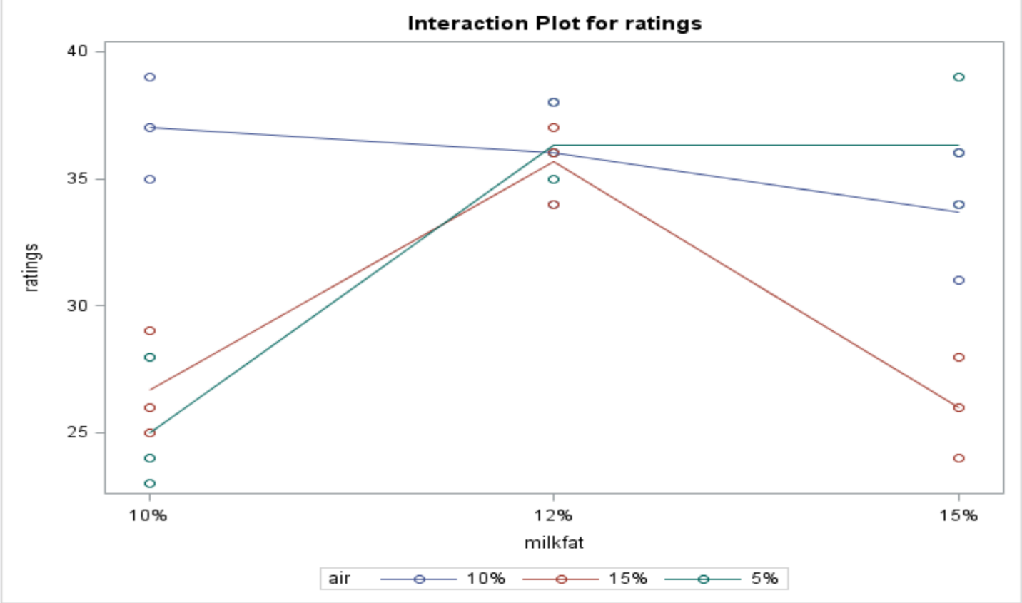

1. At 12% level of sweetener, there is no interaction between 10% & 12% levels of milkfat & all levels of air with mean sensory ratings. But, there is an interaction between 15% level of milkfat and 5% & 15% level of air with ratings. As the level of milkfat increases to 15%, the 5% level of air shows higher sensory rating, however, 15% level of air shows decreased sensory rating.

At 16%level of sweetener, there is no interaction between all levels of milkfat and 10% & 15% levels of air. But, there is an interaction between 5% level of air and all levels of milkfat with mean sensory ratings. At 5% air level, sensory rating increases as milkfat level increases from 10% to 15%.

**Conclusion:** Overall, we conclude that there appear to be a three-way interaction between the effects of percentage of sweetener, air, and milkfat in ice cream on the mean score rating.

**Ex 14.12**

1. Hypothesis for interaction:

H0: There is no effect of the percentage of sweetener, milkfat & air on the sensory ratings of ice cream

Ha: There is an effect of the percentage of sweetener, milkfat & air on sensory ratings of ice cream.

**R.S**: F > 2.63(critical value of F at α=0.05, df1=4, df2=36)

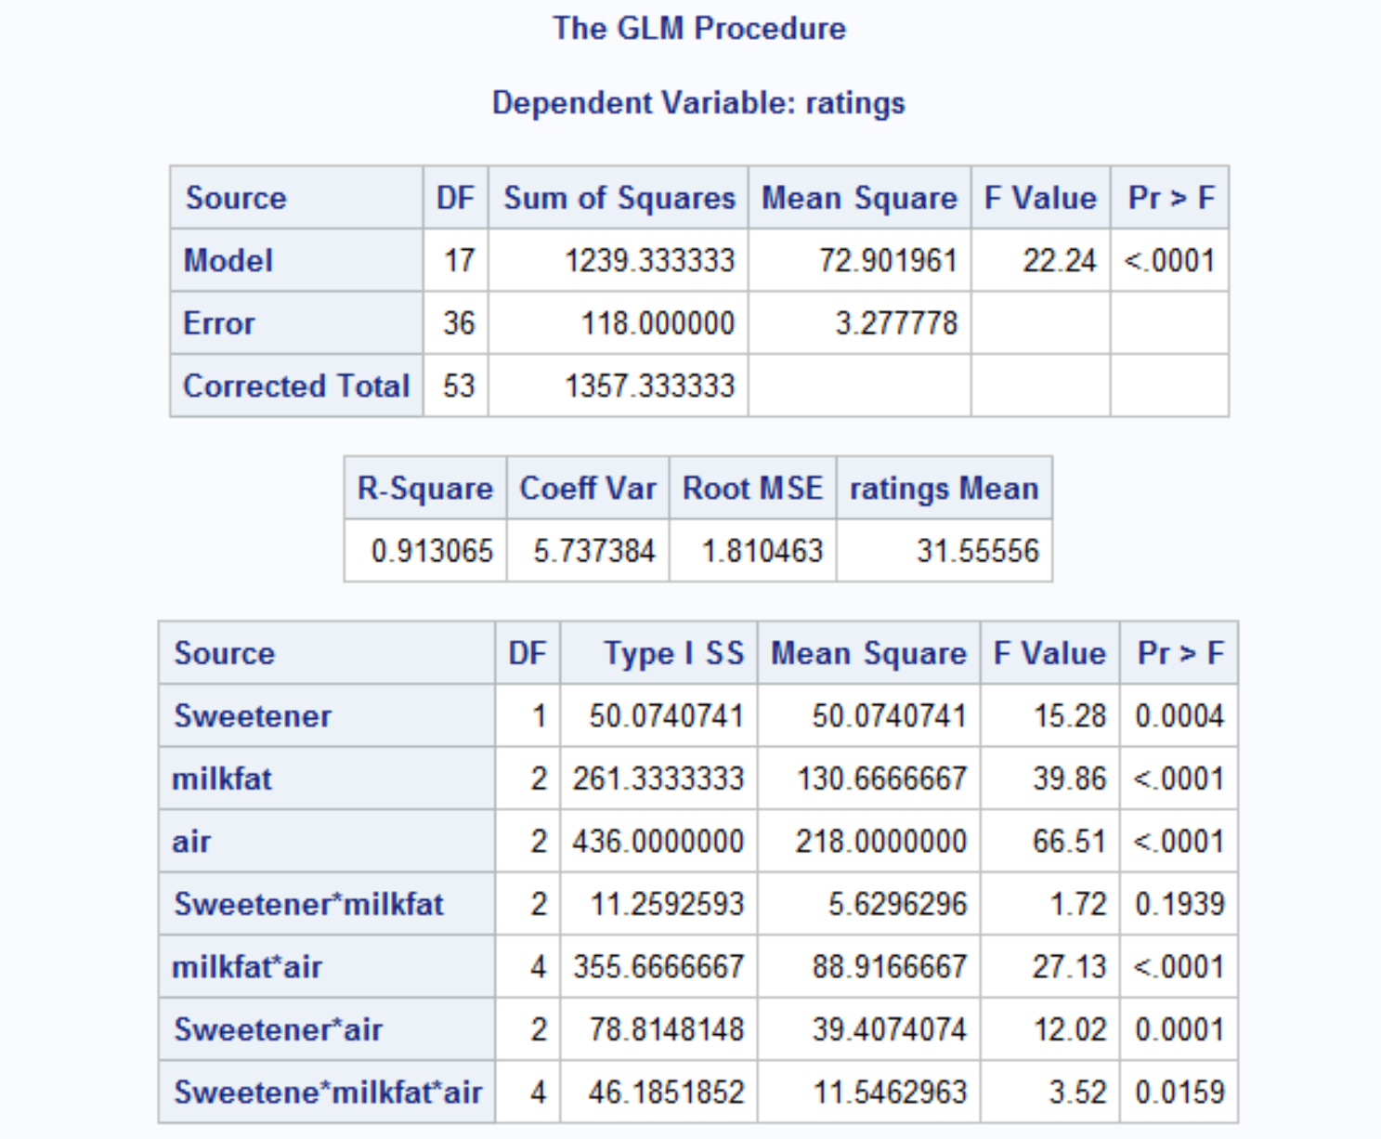

**Conclusion:** Form the AOV Table, by looking at F value of Sweetener*Milkfat*Air = 3.52 which does exceed 2.63 and p-value is 0.0159 < α=0.05, we reject the null hypothesis and conclude that there is an interaction between sweetener, milkfat & air levels with mean sensory ratings.

1. Conclusion from profile plot and F-test are consistent that there is an interaction between sweetener, milkfat & air levels with mean sensory ratings.

**Ex 14.13**

1. **Normality assumption:**

H0: Residuals follow a normal distribution

Ha: Residuals do not follow a normal distribution

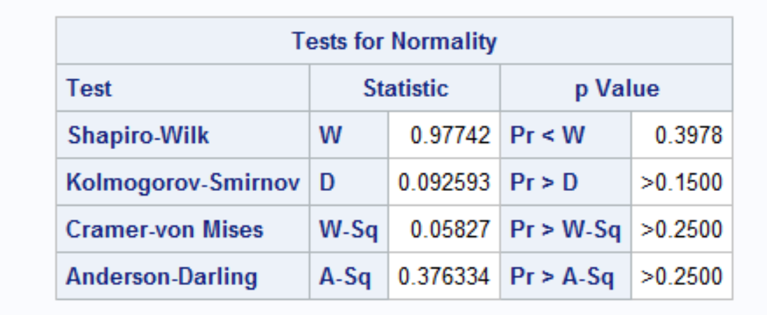

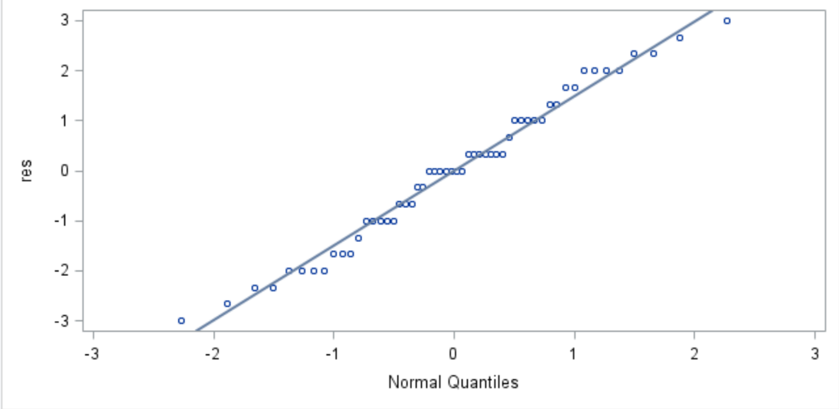

**Conclusion:** Shapiro-Wilk test = 0.98 and p-value = 0.3978 > α=0.05 hence, there are no significant evidences to reject the null hypothesis and we conclude that residuals follow a normal distribution.

1. **Equal variances assumption:**

H0: Variances of residuals are equal

Ha: Variances are not equal

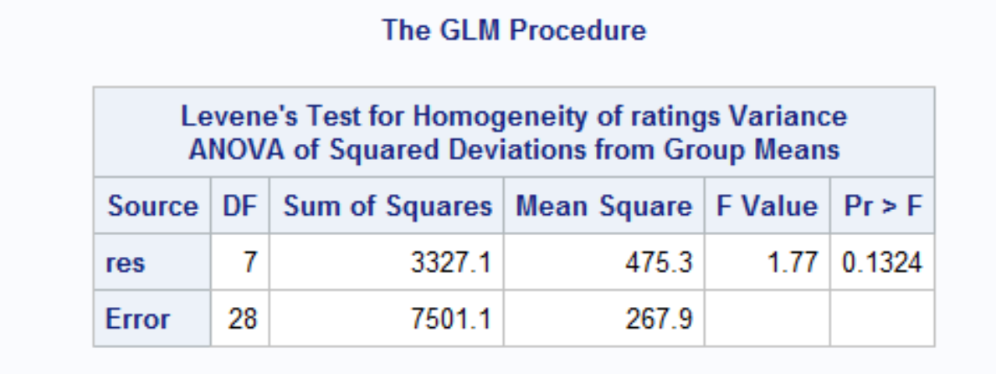

**Conclusion:** P-value = 0.1324 > α=0.05, hence we fail to reject the null hypothesis and conclude that residuals have equal variances.

**Ex 14.20**

1. Complete Randomized Design having factorial treatment structure with 2 factors
2. Copper rates (Cu): Levels = 4
3. Manganese rates (Mn): Levels = 4
4. Factorial treatment structure model:

**Yijk = µ + ͳi + βj + ͳβij + €ijk**

ͳi = effect due to copper = 4 levels

βj = effect due to manganese = 4 levels

ͳβij = Interaction effect of the copper and manganese on soybean yield

k = replications = 2

i*j*k = 32 observations

1. Profile plot of interaction between copper rates and manganese rates on soybean yields

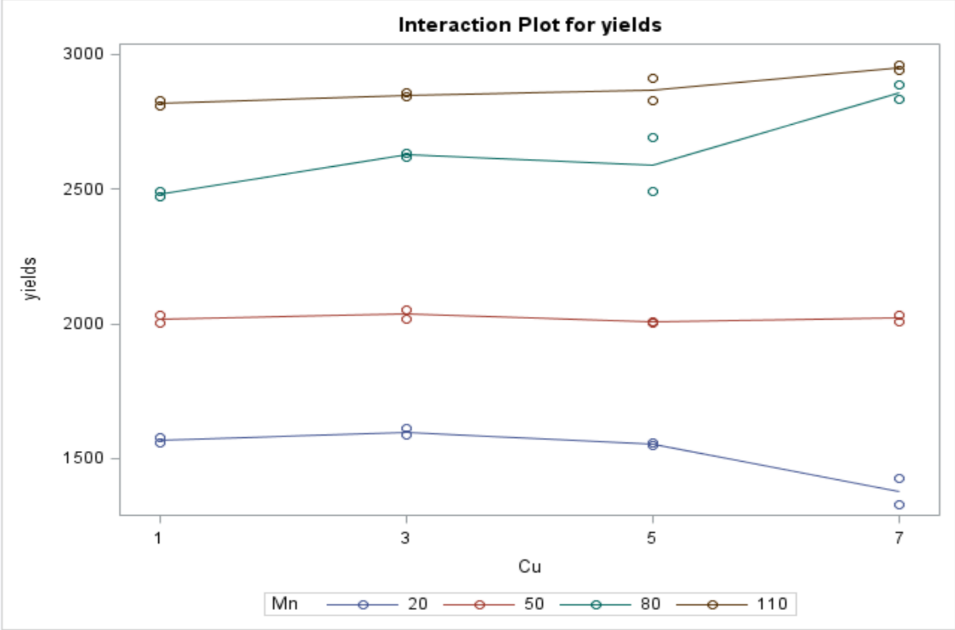

**Conclusion:** Profile plot shows that the levels of manganese are in ascending order though at different level of copper difference between yield changes. For higher levels of copper (5 & 7) and manganese (80 & 110) soybean yield is higher so that we can conclude that that there is an effect of copper and manganese on soybean yields at higher rates. Soybean yield in increasing as rates of copper and manganese are increasing.

**Ex 14.21**

1. F-test to check interaction between the effect of Mn and Cu on soybean yield.

Hypothesis for interaction:

H0: There is no effect of the rate of Cu & Mn on the soybean yield

Ha: There is an effect of the rate of Cu & Mn on the soybean yield

**R.S**: F > 2.54(critical value of F at α=0.05, df1=9, df2=16)

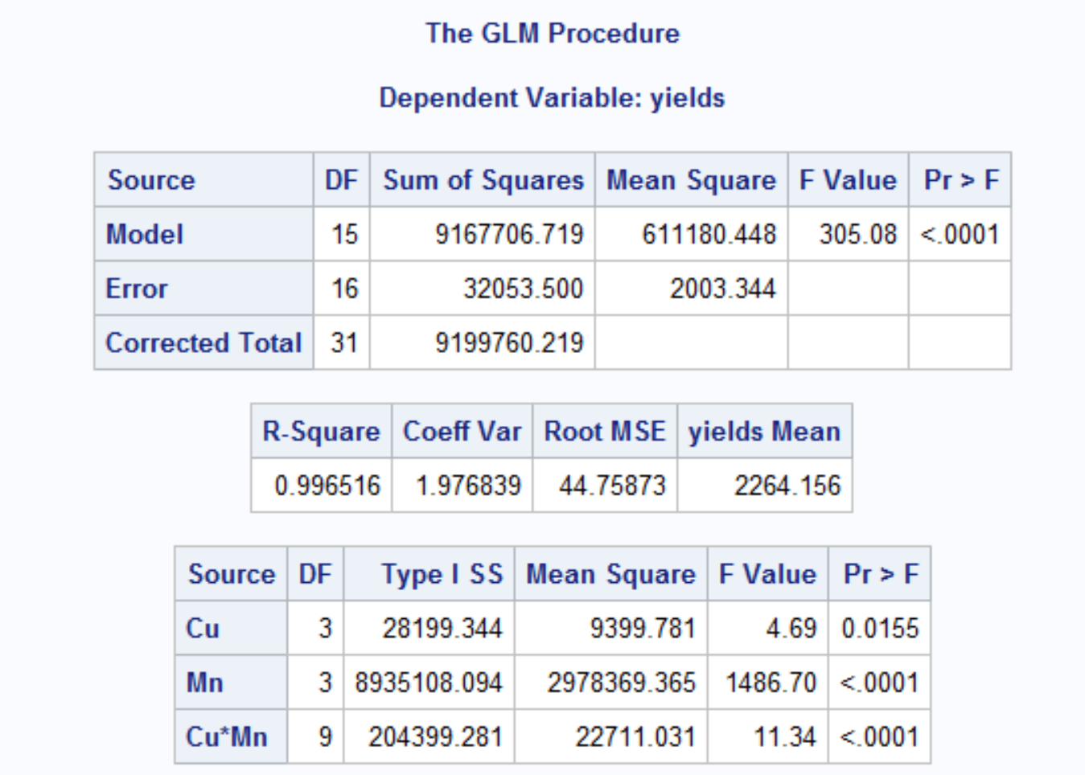

**Conclusion:** P-value = <.0001 which is significantly smaller than α=0.05 and F-test = 11.34 for interaction does exceed 2.54 and hence we can reject the null hypothesis and conclude that Copper rate and Manganese rate has an interaction effect on soybean yield.

1. Manganese level produce highest yield = **110**
2. Copper level produce highest yield = **7**
3. Combination of Manganese and copper produce highest yield = **110 & 7**