1. After running the pilot study, the researchers conduct a study involving 100 students. Twenty-five students were randomly assigned to each of the four methods of instruction: no instruction (control), piano lessons, computer video games, or instructor. The data are given in the attached excel sheet.
2. Conduct an analysis of variance and summarize your results in an ANOVA table.

**b.** Test the research hypothesis that there is a difference in mean effectiveness of the

methods of instruction. Use α=0.05.

**c.** Apply a multiple comparison procedure to determine pairwise differences in the

three methods. Use α=0.05.

**d.** Was there significant evidence that all three methods of instruction produced higher mean reasoning scores than the mean reasoning score for the control?

**e. Error assumption**

* Was there significant evidence of a violation of the normality condition?
* Was there significant evidence that the variance in reasoning scores was different for

the three methods and the control?

1. In class practice #1

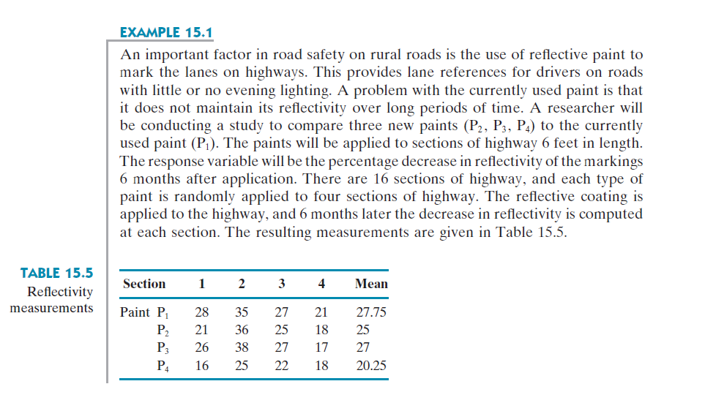

1. Conduct an analysis of variance and summarize your results in an ANOVA table.

**b.** Test the research hypothesis that there is a difference in mean reduction in reflectivity among the four paints. Use α=0.05.

**c.** Apply a multiple comparison procedure to determine pairwise differences in the

four paints. Use α=0.05.

1. In class practice #2

